SUBCOURSE EDITION
QM3517 A

COMMUNICATIVE SKILLS AT
COMPANY LEVEL



COMMUNICATIVE SKILLS AT COMPANY LEVEL

Subcourse Number QM3517

EDITION A

United States Army Combined Arms Support Command
Fort Lee, Virginia 23801-1809

8 Credit Hours

Edition Date: September 1993

SUBCOURSE OVERVIEW

This subcourse is designed to teach you communicative skills at the company level. Contained within this subcourse is instruction on how to write to inform or to direct, how to develop professional briefing techniques, and how to develop a command philosophy and a command philosophy paper. Also contained within this subcourse is instruction on the purpose, the proper use, and the development of the Noncommissioned Officer Evaluation Report (NCO-ER) and the US Army Officer Evaluation Report (OER).

There are no prerequisites for this subcourse.

This subcourse reflects the doctrine which was current at the time it was prepared. In your own work situation, always refer to the latest official publications.

Unless otherwise stated, the masculine gender of singular pronouns is used to refer to both men and women.

TERMINAL LEARNING OBJECTIVE

ACTION: You will write to inform or to direct; develop professional briefing techniques; develop a command philosophy and a command philosophy paper; and identify the purpose, the proper use, and the development of the NCO and the officer evaluation systems.

CONDITION: You will have information from AR 25-50, AR 623-105, AR 623-205, DA Pam 600-67, DA Pam 623-205 and FM 101-5.

i QM3517

STANDARD: To demonstrate competency of this task, you must achieve a minimum of 70 percent on the subcourse examination.

QM3517 ii

TABLE OF CONTENTS

Section Page

Subcourse Overview i

Lesson 1: Writing Procedures 1-1

Practice Exercise 1-59

Answer Key and Feedback 1-61

Lesson 2: Professional Briefing Techniques 2-1

Part A: Briefings 2-2

Part B: Delivery Aids 2-13

Part C: Briefing Structure 2-19

Practice Exercise 2-35

Answer Key and Feedback 2-37

Lesson 3: Command Philosophy Development 3-1

Practice Exercise 3-24

Answer Key and Feedback 3-25

Lesson 4: Noncommissioned Officer Evaluation
Report Development 4-1

Part A: Responsibilities of Noncommissioned
Officer Raters, Reviewer, and Rated
Individual 4-3

Part B: DA Form 2166-7-1 4-29

Part C: DA Form 2166-7 4-50

Practice Exercise 4-84

Answer Key and Feedback 4-87

iii QM3517

Lesson 5: Officer Evaluation Report Development 5-1

Part A: Responsibilities of Officer
Raters 5-3

Part B: DA Form 67-8-1 5-17

Part C: DA Form 67-8 5-26

Practice Exercise 5-56

Answer Key and Feedback 5-58

Appendix A: List of Acronyms A-1

Appendix B: Publication Extracts B-1

AR 623-105

Use the above publication extract to take this
subcourse. At the time we wrote this subcourse,
this was the current publication. In your own work
situation, always refer to the latest publications.

QM3517 iv

LESSON 1

WRITING PROCEDURES

Critical Task: 04-9007.01-0220

OVERVIEW

LESSON DESCRIPTION:

In this lesson, you will learn how to write to inform or to direct. You will learn how to identify your purpose for writing and how your writing will support the commander's intent. You will learn to determine the appropriate form or type of correspondence to use and how to prepare an outline that focuses on a clear, controlling idea and major supporting points. In addition, you will learn to prepare a draft, to check your draft for proper grammar and spelling, and to review and to revise your draft for clarity and compactness. You also will learn to proofread the final draft and to ask another to do the same.

TERMINAL LEARNING OBJECTIVE:

ACTION: Write to inform or to direct.

CONDITION: You will be given information from AR 25-50 and DA Pamphlet 600-67.

STANDARD: Writing to inform or direct will be in accordance with AR 25-50 and DA Pamphlet 600-67.

REFERENCES: The material contained in this lesson was derived from the following publications: AR 25-50 and DA Pamphlet 600-67.

INTRODUCTION

In carrying out your military duties, you will write to inform or to direct. Examples of this kind of writing are the information paper and the memorandum. Your goal is to present facts effectively and efficiently or to give direction clearly. You must set the example through clear and forceful writing. Effective Army writing transmits a clear message in a single, rapid reading. Effective Army writing is generally free of errors in grammar, mechanics, and usage. Good Army writing is concise, organized, and to the point.

1-1 QM3517

1. Identify Your Purpose for Writing.

The goal of all Army correspondence is effective communication. Too much Army writing does not communicate well. It confuses rather than clarifies. It is wordy rather than concise. It hides the main idea rather than getting to the point. Information overload and the complexity of the modern Army demand a more effective style and a new standard for writing. These new standards are the mandated Army style. They are not suggestions.

Army leaders lose too much time struggling with poor writing. Poor writing hinders decisions. You, as a leader, must make the new Army writing standard work for you and for the Army. Remember that the Army requires all commanders to uphold a common standard. To enforce this standard, employ the following guidelines:

o Issue guidance to establish uniform, effective writing standards.

o Be a mentor to your subordinates.

o Show the new standards by using examples.

Effective Army writing follows established guidelines. Publish the following guidelines as your office rules:

a. Know the Rules. Ensure that all personnel who write for you follow the rules for the new Army writing standard. The following subparagraphs describe these new rules.

(1) Put the Bottom Line First. Put the recommendation, the conclusion, or the reason for writing-the "bottom line"-in the first or the second paragraph, not at the end. In other words, begin with the main point. The strongest correspondence highlights the important information at the beginning. Figure 1-1 provides an example of writing in which the main point is hidden.

The correspondence in Figure 1-1 has many problems. It is wordy, impersonal, and passive. However, the major obstacle to its effectiveness is that it delays the most important information. Moving the main idea to the first sentence improves communication. Getting rid of unnecessary words and jargon helps, but putting the main point up front makes the most difference.

Figure 1-2 provides an example of writing in which the main point is up front.

QM3517 1-2

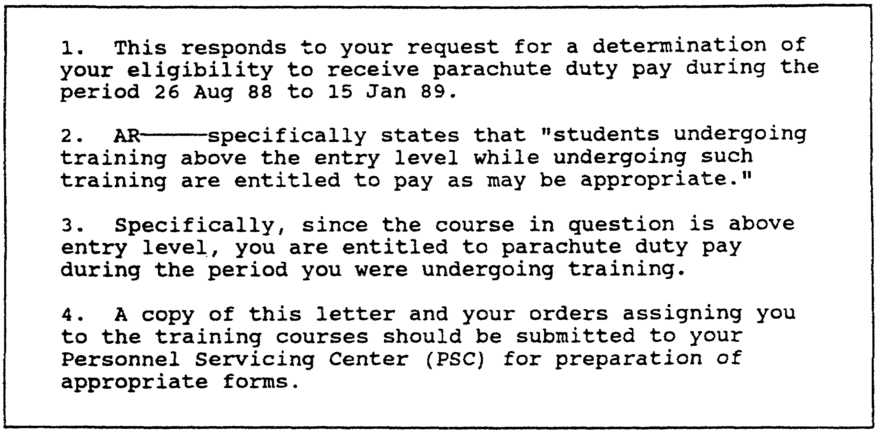

Figure 1-1. Example of writing with main point hidden.

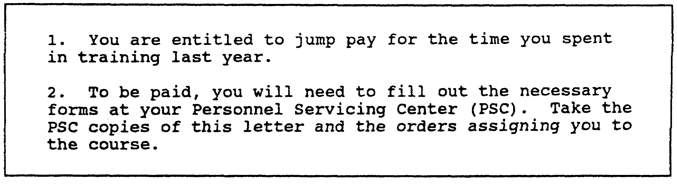

Figure 1-2. Example of writing with main point up front.

(2) Use the Active Voice. The example in Figure 1-2
uses the active voice. The active voice emphasizes the doer of
the action (action writing). Action writing shows who or what
does the action in the sentence or puts the doer before the verb.
The standard English sentence order (subject-verb-object) works
best. It speeds up the communication process and helps the
reader to understand the main point. Use the active voice to
create shorter sentences. Eliminate the passive voice to reduce
the number of the words in a sentence.

An example of a passive statement is "The PT test was passed by SGT Hayes". This example uses eight words. An example of the active voice is "SGT Hayes passed the PT test". This example uses six words.

1-3 QM3517

The passive voice is easy to recognize. A verb in the passive voice combines the following elements:

o Any form of "to be" ("am," "is", "are", "was", "were", "be", "being", "been").

o The past participle of a main verb (such as "completed" or "requested").

NOTE: Most past participles end in "-en" or "-ed."

Examples of verbal constructions that indicate the use of the passive voice are "is beaten," "was beaten," "are completed," and "were completed".

(3) Use Short Sentences. Keep sentences short. As a rule, try to limit the length of a sentence to an average of 15 words.

(4) Use Short Words. Use short words. Try to limit your use of words to those that have three of fewer syllables. Do not allow more than 15 percent of the total number of the words that you use to contain more than three syllables.

(5) Use Short Paragraphs. Write paragraphs that, with few exceptions, are no more than 1-inch deep.

(6) Use Correct Spelling, Grammar, and Punctuation. Use the dictionary, the thesaurus, and other writing tools to assist you in your writing. These tools, along with a good command of the English language, ensure that you use correct spelling, grammar, and punctuation.

(7) Use "I"," "You", and "We". For most kinds of writing, use "I", "you", and "we" as subjects of sentences instead of such constructions as "this office", "this headquarters", or "all individuals".

(8) Limit Your Correspondence. As much as possible, limit your correspondence to one page. Avoid sentences that begin with the following:

o "It is. . ."
o "There is . . ."
o "There are. . .”

b. Use the Correct Structure. Start with a clear, concise statement of the controlling idea and the main points that support that idea. Then, package your writing as described in subparagraph lb(2) of this lesson.

QM3517 1-4

(1) Begin with the Main Idea. As discussed in subparagraph la(l) of this lesson, require all staff writing to begin with the main idea (bottom line). The greatest weakness in ineffective writing is that it does not transmit a focused message quickly. Have subordinates start with the information that they would keep if they had to get rid of all the rest.

(2) Require Specific Packaging. Require all staff writing to be packaged specifically. Focus first on the main point to change the overall construction of Army writing. This restructuring, called packaging, is the framework of the new writing style. Packaging is not format. Begin to format after you package your writing to tailor it to a specific purpose. Package your writing by using the following procedure:

o Open with a short, clear purpose sentence.

o Next, put the recommendation, the conclusion, or the more important information as your main point. You can combine these first two steps in some correspondence.

o Then, clearly separate each section. Use short paragraph headings or section titles.

NOTE: Use a specific format if one is appropriate.

Figures 1-3 through 1-6 show examples of writing with and without packaging.

c. Use the Correct Tools. Some writing will not meet the new standards, despite clear staff writing guidelines and the fact that the new style focuses on only two essential changes. Most supervisors have little trouble identifying poor writing. Many, however, have problems knowing how to fix it or how to counsel someone else as to how to fix it. The quick-screen edit and the clarity index help to enforce the new standard. They are discussed in the following subparagraphs.

1-5 QM3517

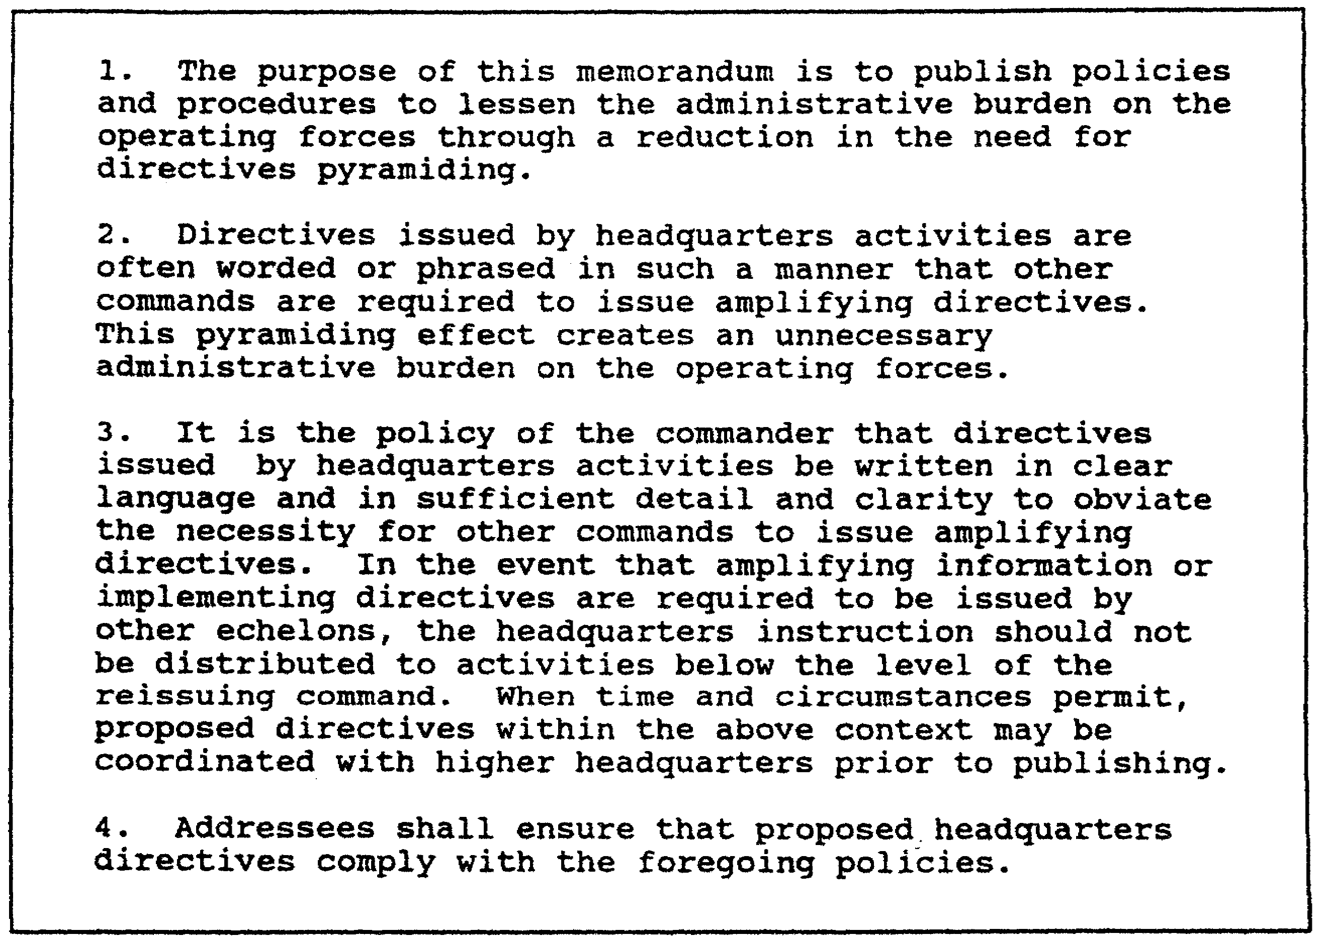

Figure 1-3. Example of writing without packaging.

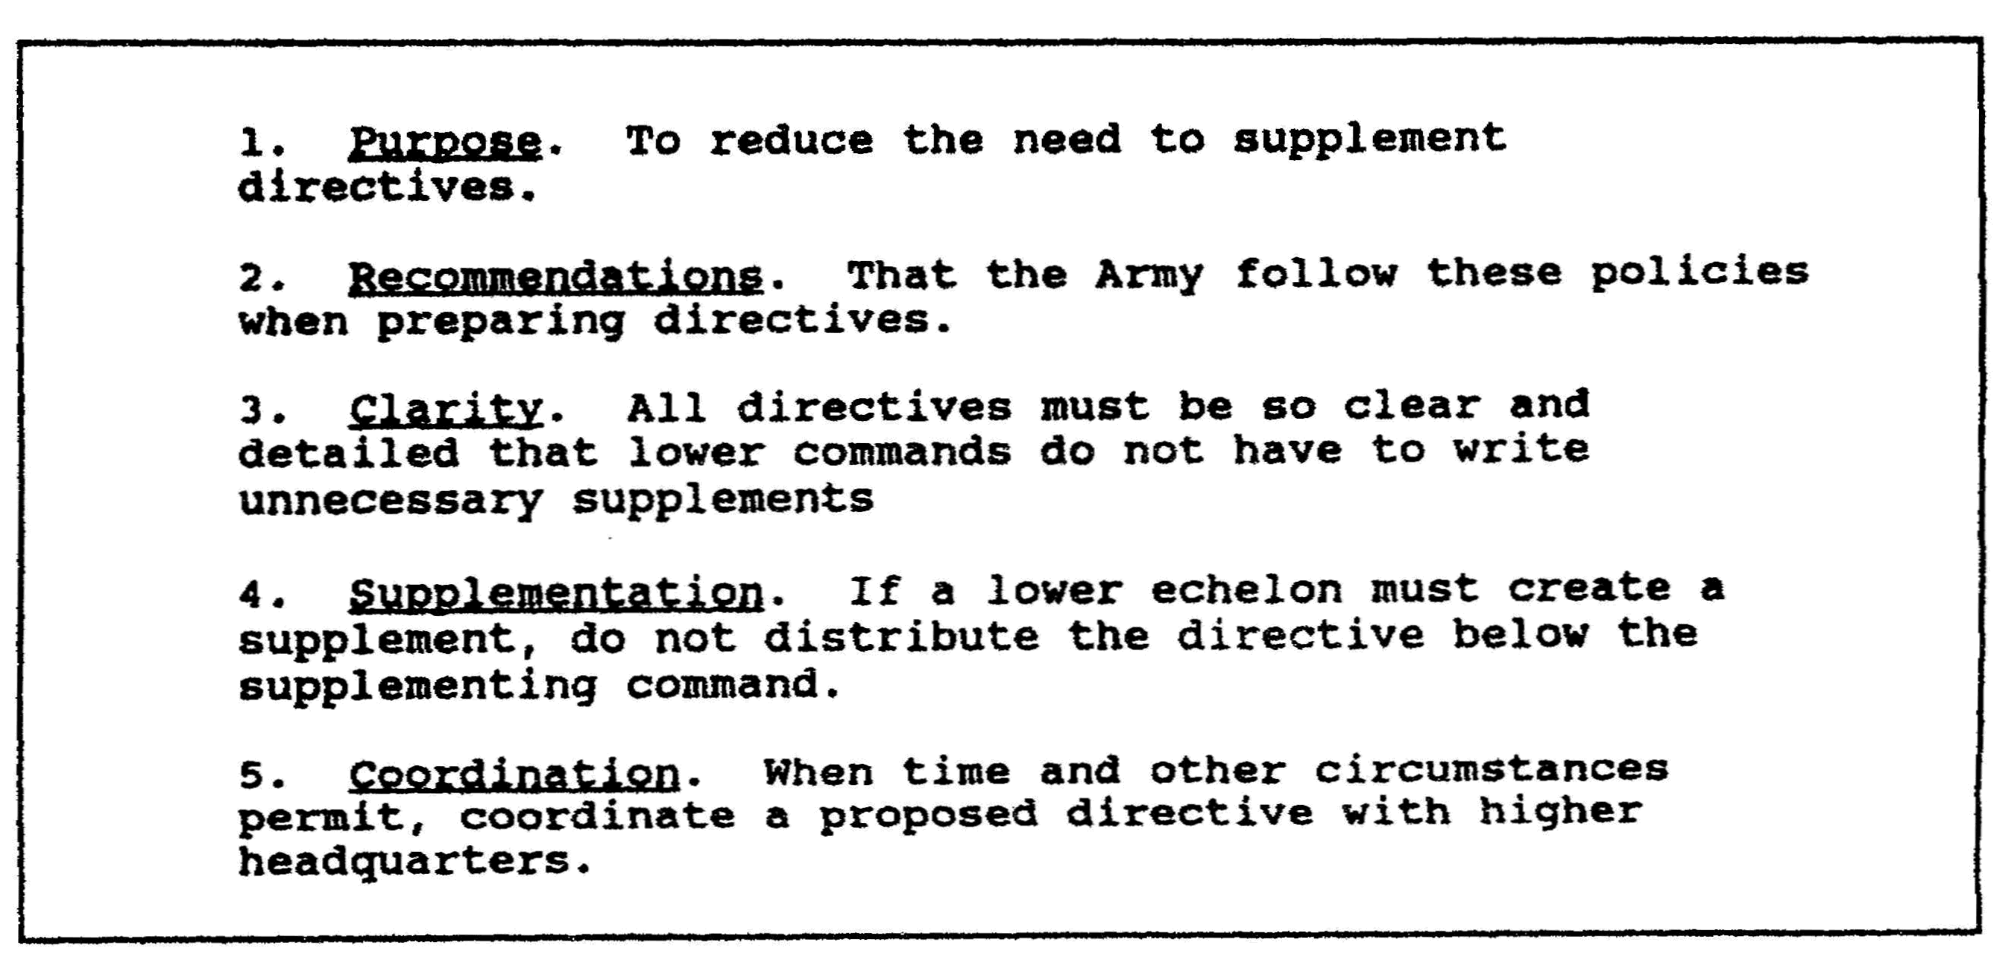

Figure 1-4. Example of writing with packaging.
QM3517 1-6

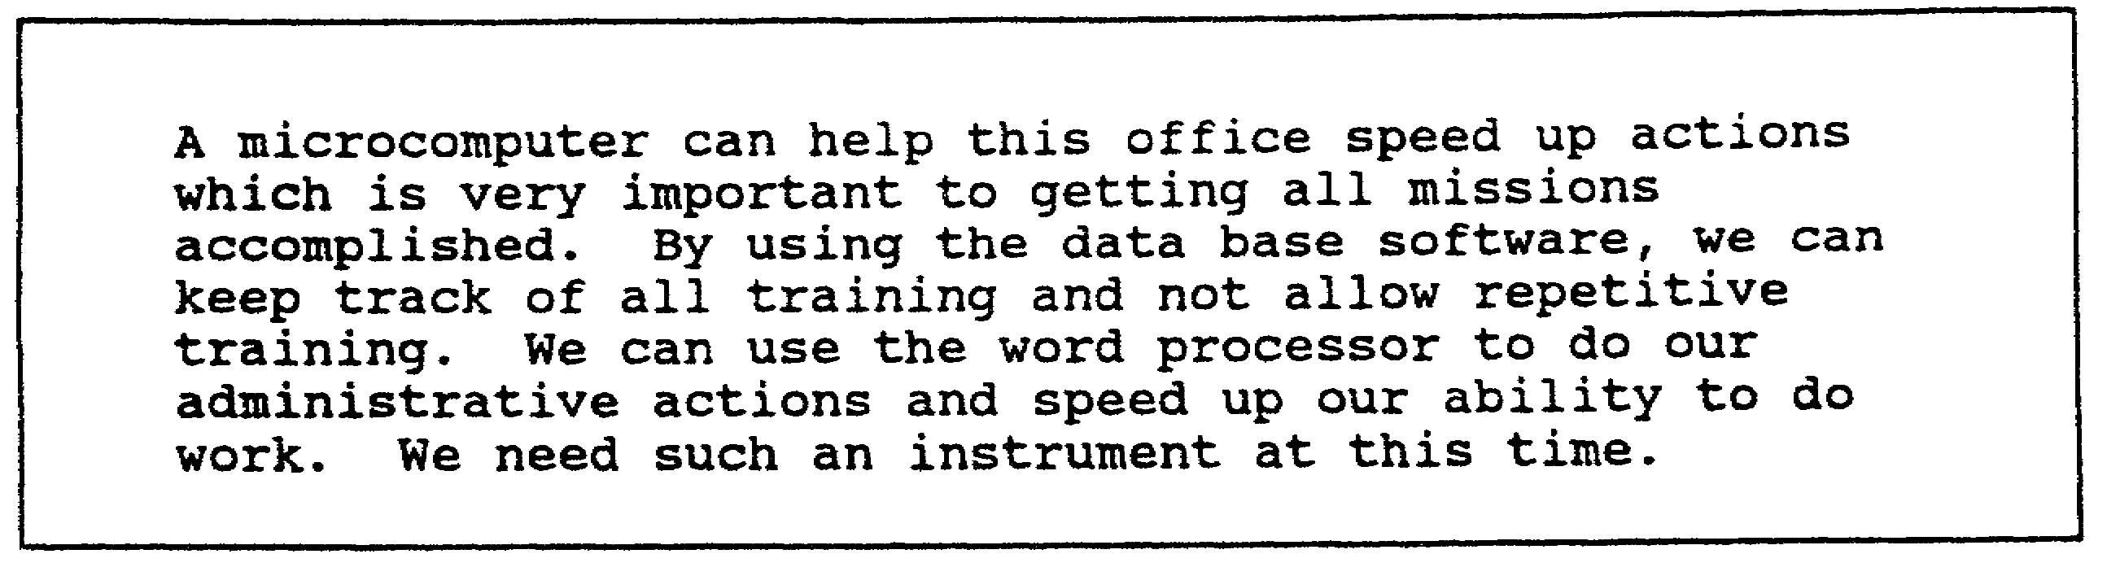

Figure 1-5. Example of writing without packaging.

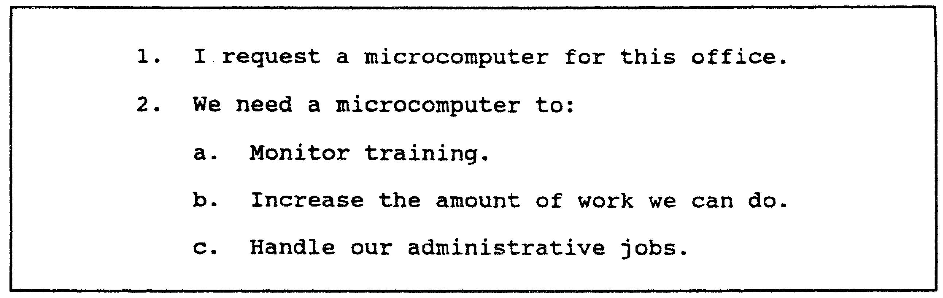

Figure 1-6. Example of writing with packaging.

(1) Use the Quick-Screen Edit. The quick-screen edit identifies major violations of the Army standard for writing. To use the quick-screen edit, use a highlighter, a pencil, or a pen. In a single, rapid reading, highlight, circle, or underline the following:

o The purpose of the writing (bottom line).

o Any forms of the verb "to be" that are used with a past participle. By doing so, you identify the passive voice.

o Any unnecessary long words or jargon.

o Any spelling, punctuation, or grammar mistakes.

Revise the four targeted areas. In your revision, use the following guidelines:

o Move the bottom line to the beginning of the writing if it is not there already.

o Change only the other highlighted problems.

1-7 QM3517

o Check the writing for packaging.

Figure 1-7 shows an example of highlighting using the quick-screen edit. The underlined bold type in Figure 1-7 represents the use of highlighting. Figure 1-8 shows the revised example.

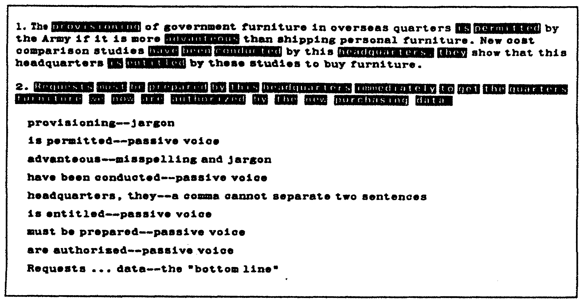

Figure 1-7. Example of quick-screen edit.

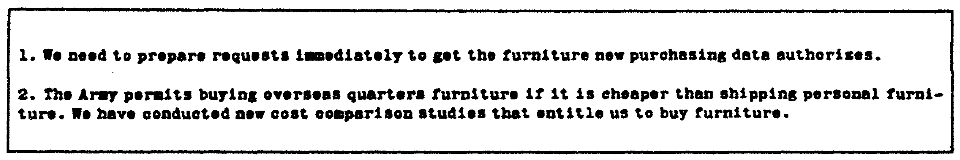

Figure 1-8. Example of revised writing.

The quick-screen edit is quick because you read the writing only once. It is effective because you highlight specific errors. It is a screen because you highlight only the errors that are distracting.

With the quick-screen edit, you show subordinates exactly what to revise without requiring a complete rewrite.

(2) Use the Clarity Index. Some writing problems do not lend themselves to a quick-screen edit. However, you may use the clarity index to pinpoint two other major reasons why the writing that often arrives on your desk is confusing and difficult to read.

QM3517 1-8

(a) Long Words and Sentences. Long words and long sentences make writing difficult to read. Such writing does not meet the new standards of Army writing. The clarity index provides a yardstick to measure the readability of writing. If you suspect that writing is not effective, then use this yardstick to help to quantify the problem.

(b) Clarity Index Formula. The clarity index is based on word and sentence length. Select a sample of 200 or fewer words, and use the following formula:

o Count the number of the sentences.

o Count the number of the words.

o Divide the number of the words by the number of the sentences to get the average sentence length. Your target average is 15 words per sentence.

o Count the number of the long words (the words that have three or more syllables).

o Divide the number of the long words by the total number of the words to determine the percentage of the long words. Your target is 15 percent.

o Add the average sentence length to the percentage of the long words.

o The sum is the clarity index. Your target is 30.

For a graphic representation of the formula, see Figure 1-9.

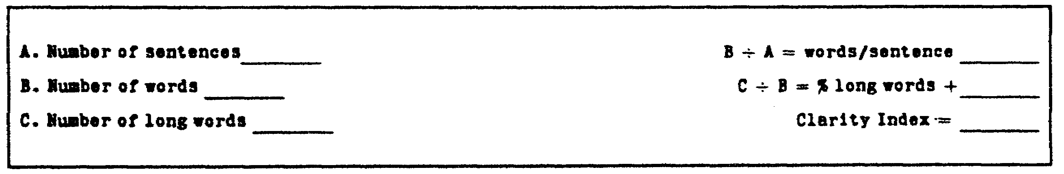

Figure 1-9. Computing clarity index.

If you eliminate the long words and the long sentences without changing your meaning, then you make your writing clearer. You do not produce simplistic papers or insult your reader's intelligence. Instead, you save time and increase your reader's understanding.

1-9 QM3517

Use the clarity index once to quantify the density of a piece of your writing. Then, periodically monitor your writing. See Figure 1-10 and Figure 1-11 for examples of how to compute a clarity index.

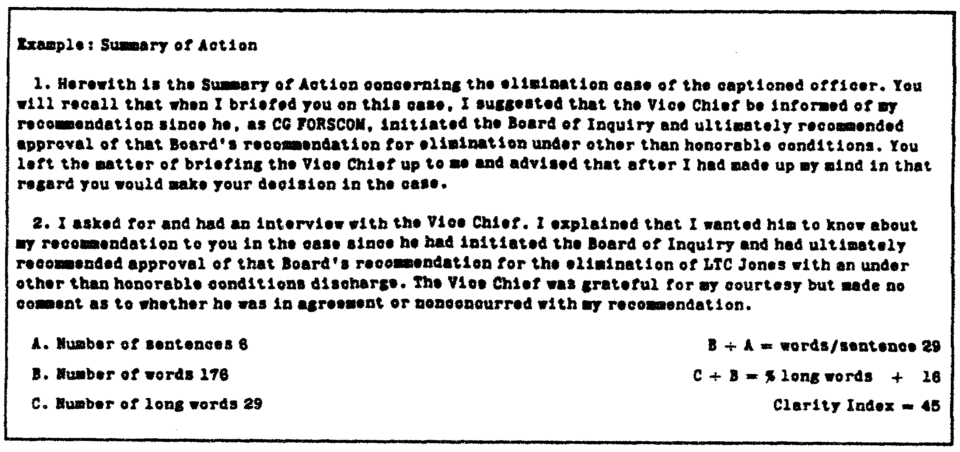

Figure 1-10. Clarity index of original writing.

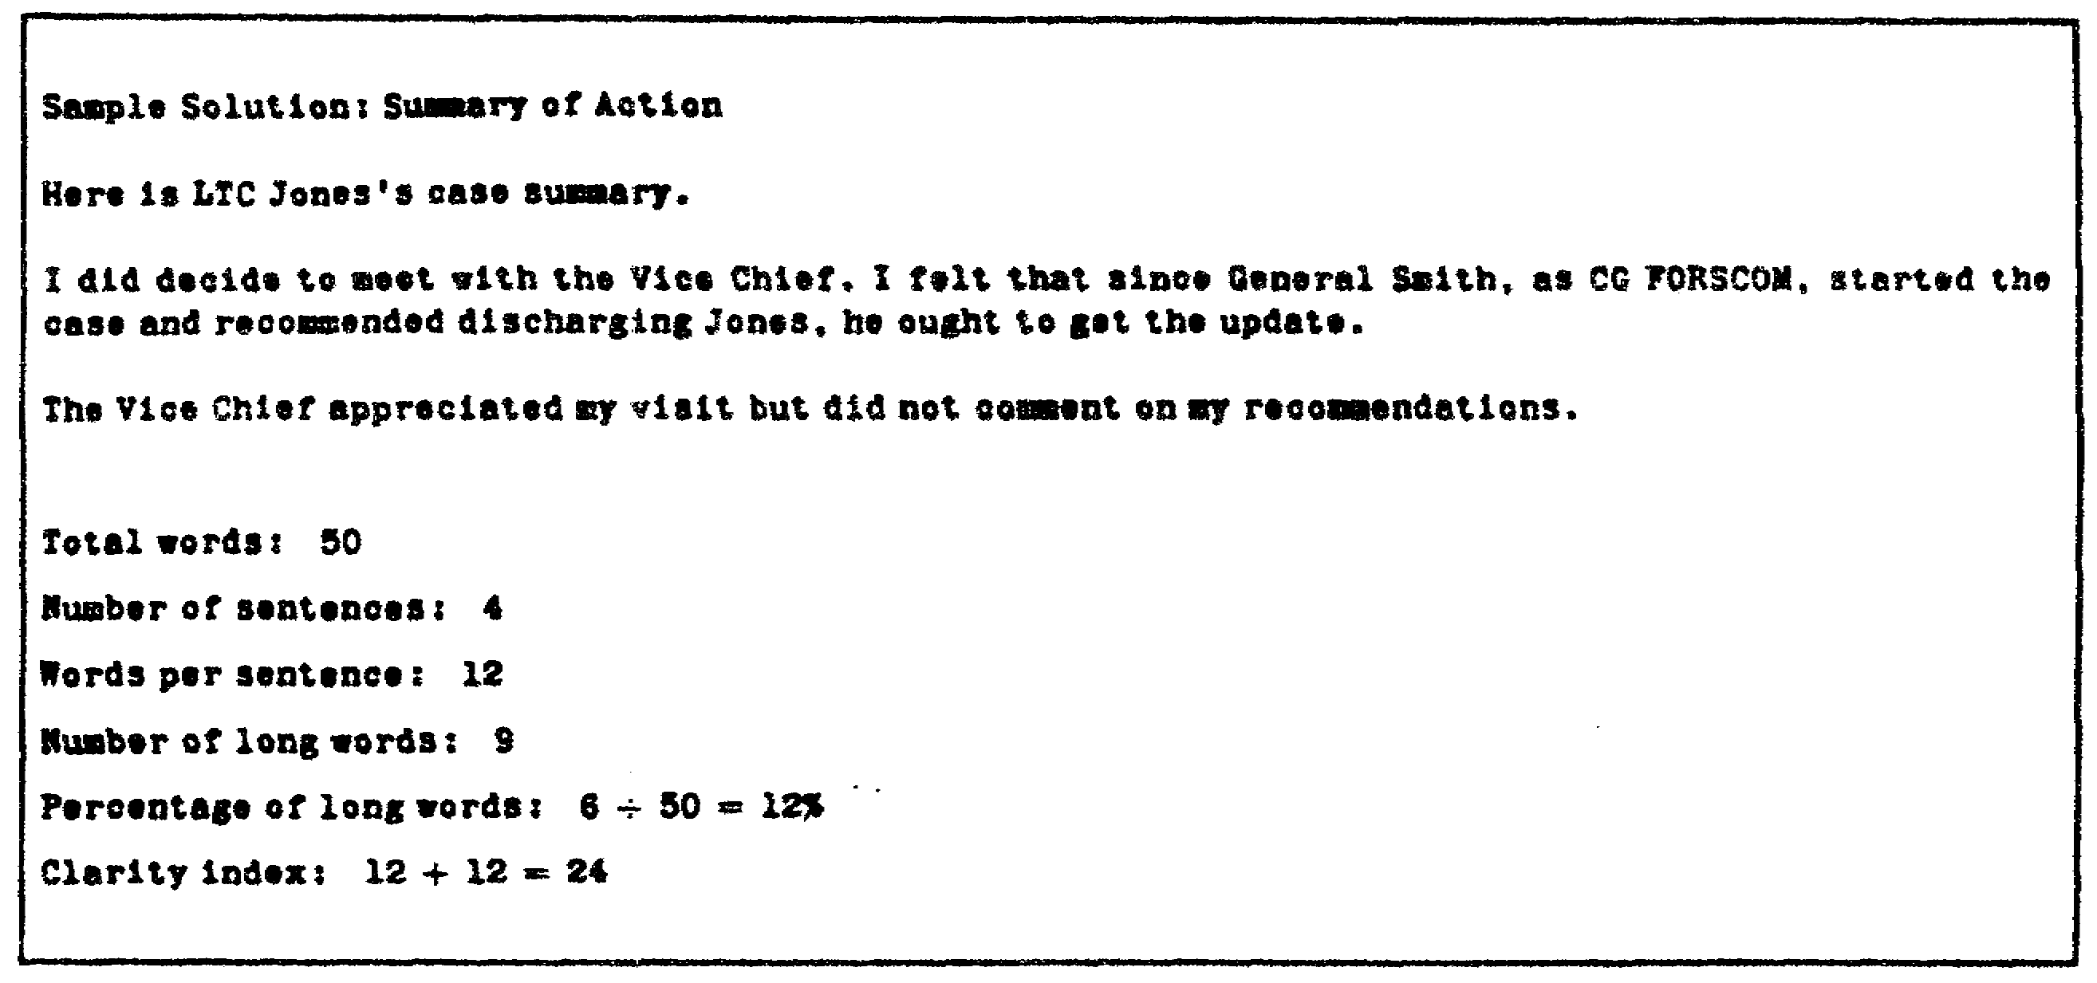

Figure 1-11. Clarity index of revised writing.

Use the following rules of thumb for the clarity index:

o If the clarity index is below 20, then your writing is too abrupt.

QM3517 1-10

o If the clarity index is over 40, then your writing is difficult to understand.

o Aim for an index of 30.

d. Provide Examples. The examples in Figure 1-12 through Figure 1-17 demonstrate the results of applying the leadership guidelines in this lesson to the new standard of Army writing. Read and compare the examples in Figures 1-12 through 1-17. Do not accept writing like that which is labeled "poor writing." Accept only writing like that which is labeled "good writing." Use Figure 1-12 through Figure 1-17 as examples for your subordinates.

The memorandum that is shown in Figure 1-12 has a clarity index of 42, which is too high. The paper has the following problems:

o It is too long.
o It is filled with jargon.
o It uses the passive voice.
o It is not focused.

Packaging has been used for the writing that is shown in Figure 1-13. The use of packaging brings the recommendation to the top and eliminates unnecessary verbiage. The example that is shown in Figure 1-13 has a clarity index of 23.

Much of the writing that is shown in Figure 1-14 is error-riddled or contains Army jargon in an attempt to sound "serious" and "military." Writing such as this slows communication and sends the wrong message about the writer. Note the difference in Figure 1-15.

The other examples of standards in this lesson reflect the dramatic difference that brevity makes in bringing about more effective writing. Although the example that is shown in Figure 1-16 is short, it has a more basic packaging problem. Notice that the writing that is shown in Figure 1-17 does not look markedly shorter, although it is shorter. This document's legal nature does mean that some things cannot be deleted. However, it is much improved because the bottom line is up front and the paragraphs are short. Packaging speeds communication.

1-11 QM3517

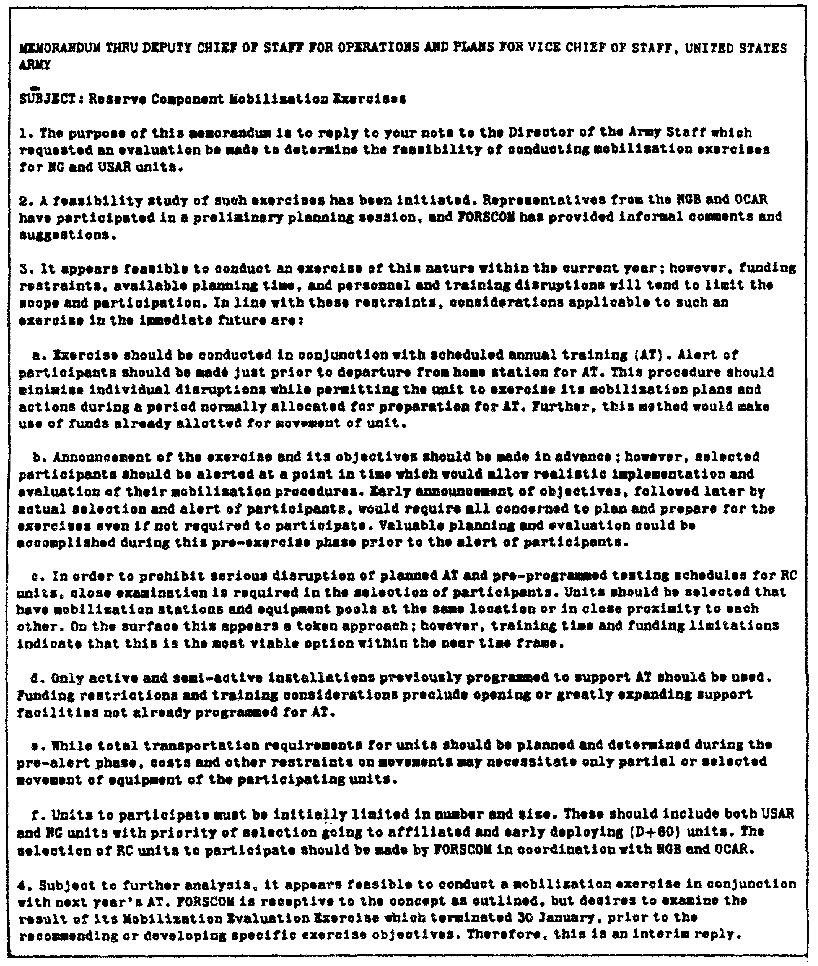

Figure 1-12. Memorandum--example of poor writing.

QM3517 1-12

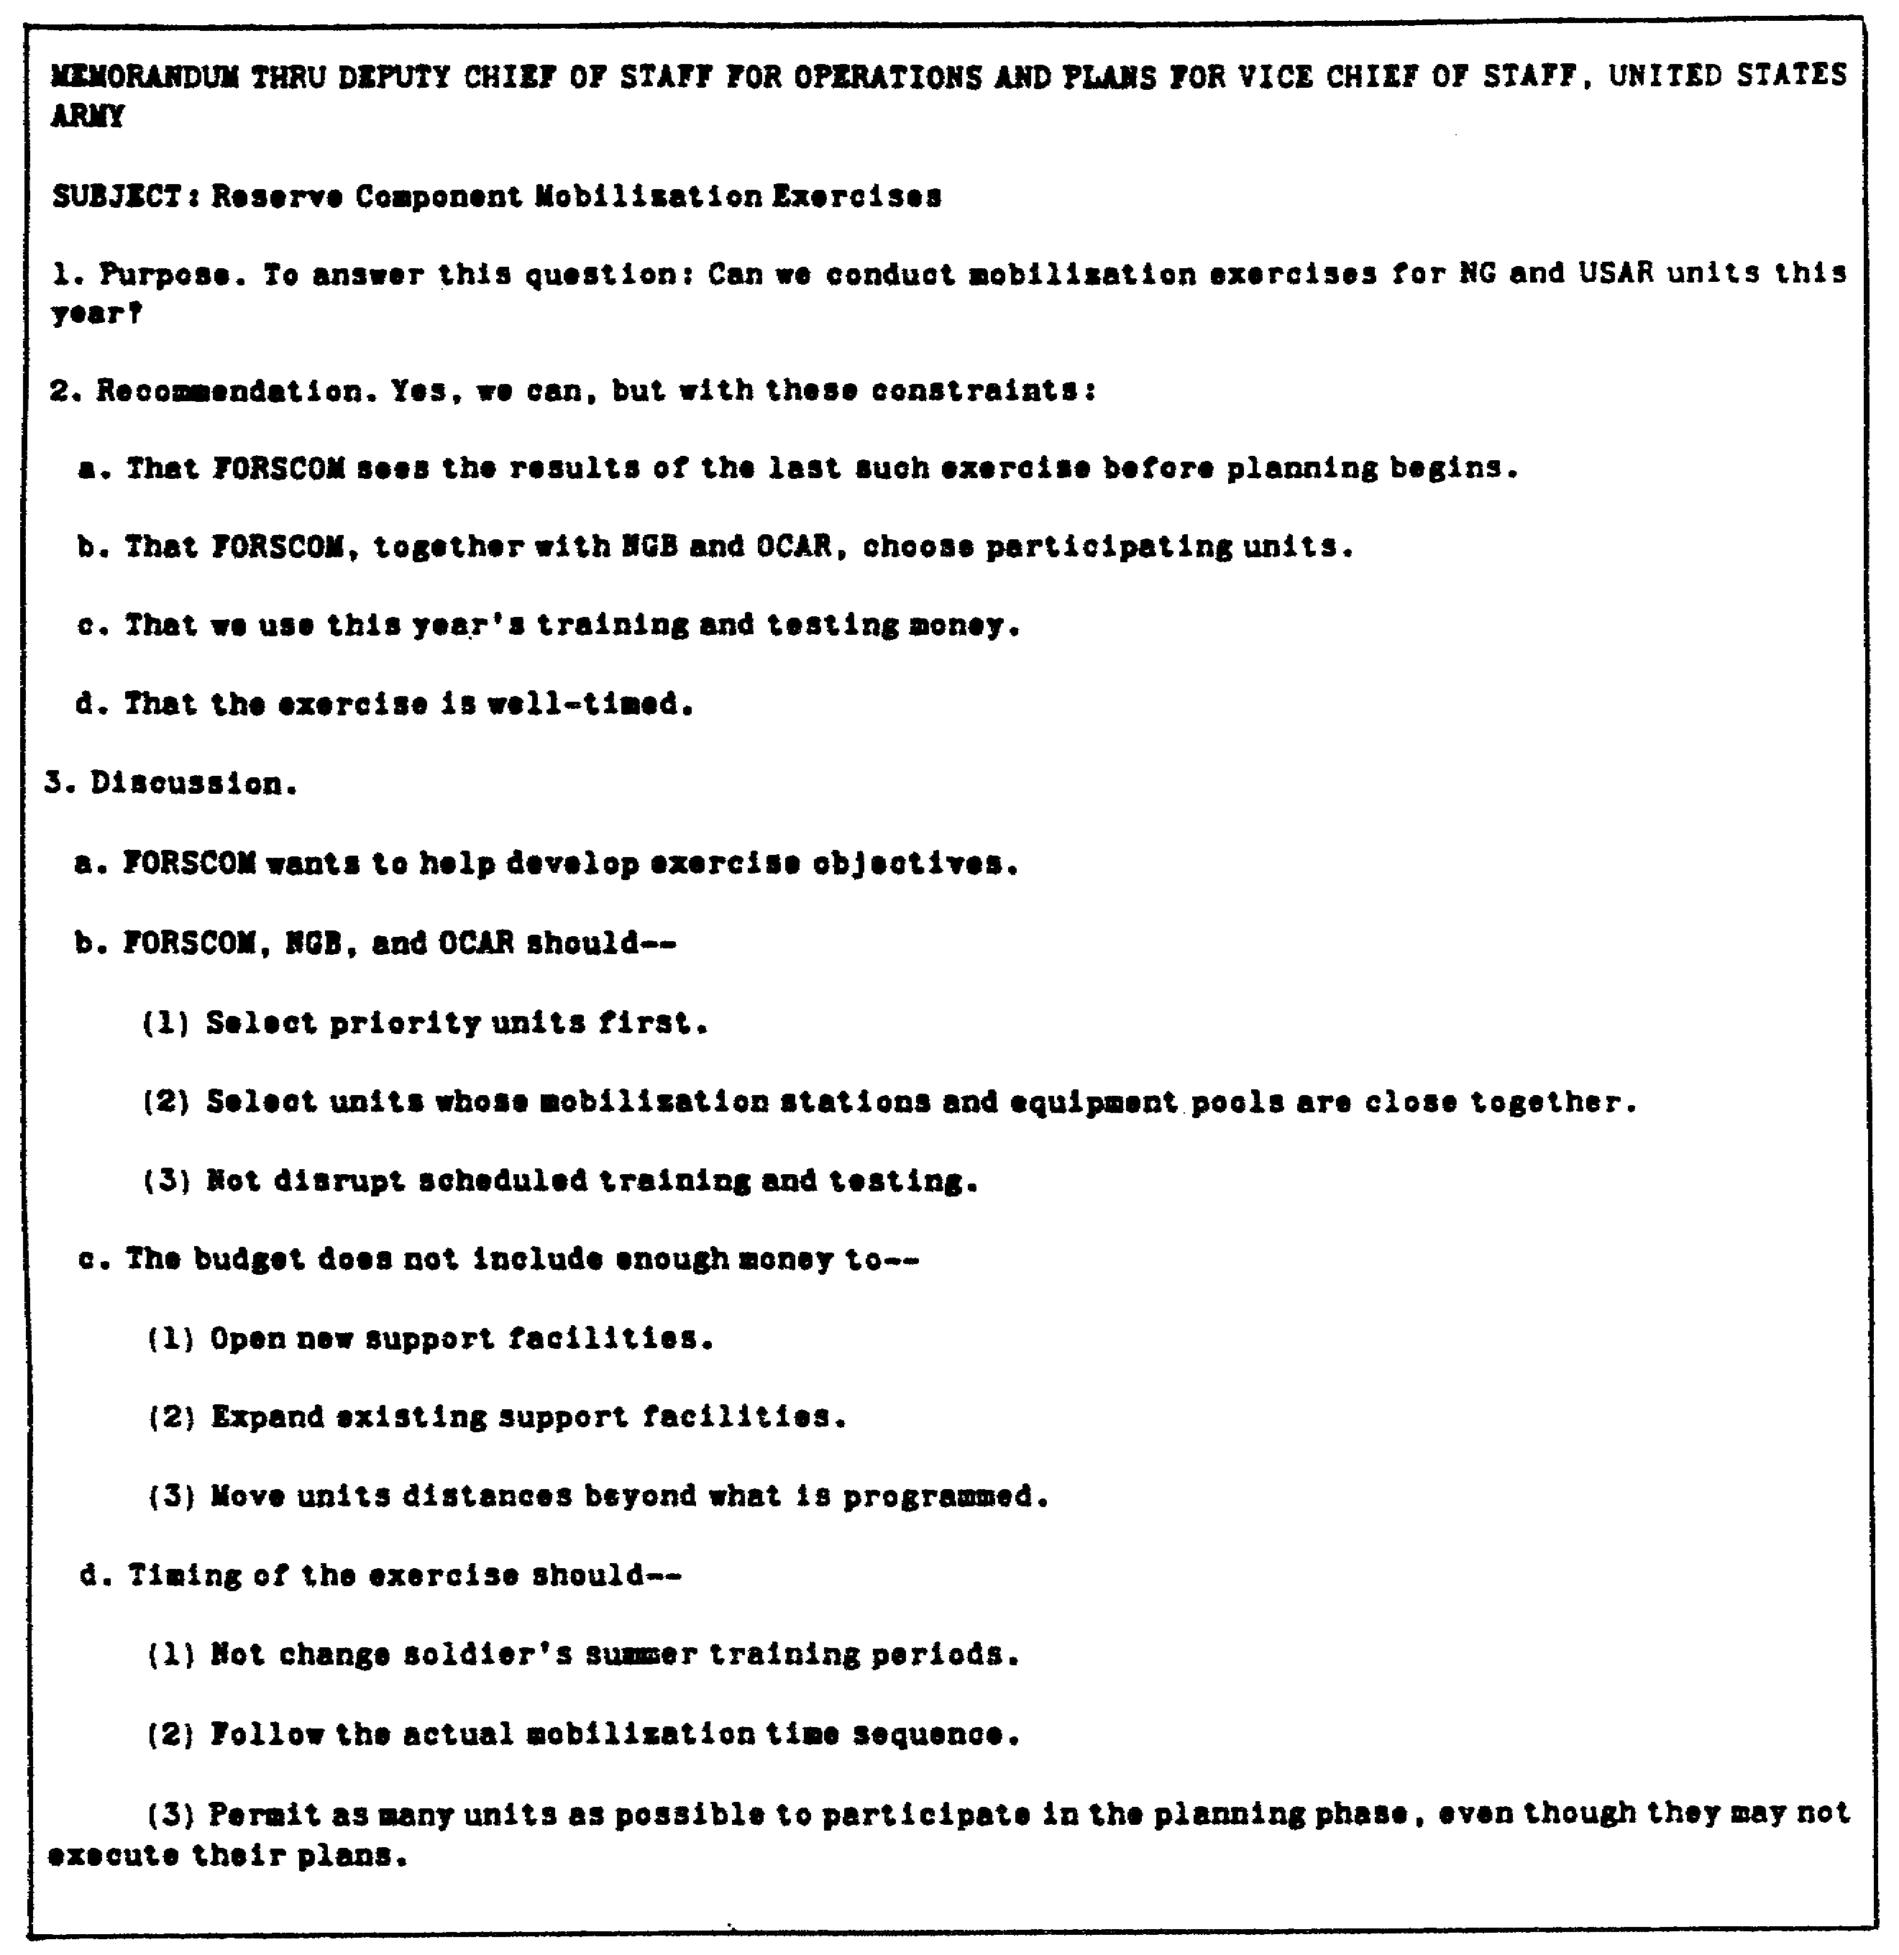

Figure 1-13. Memorandum--example of good writing.

1-13 QM3517

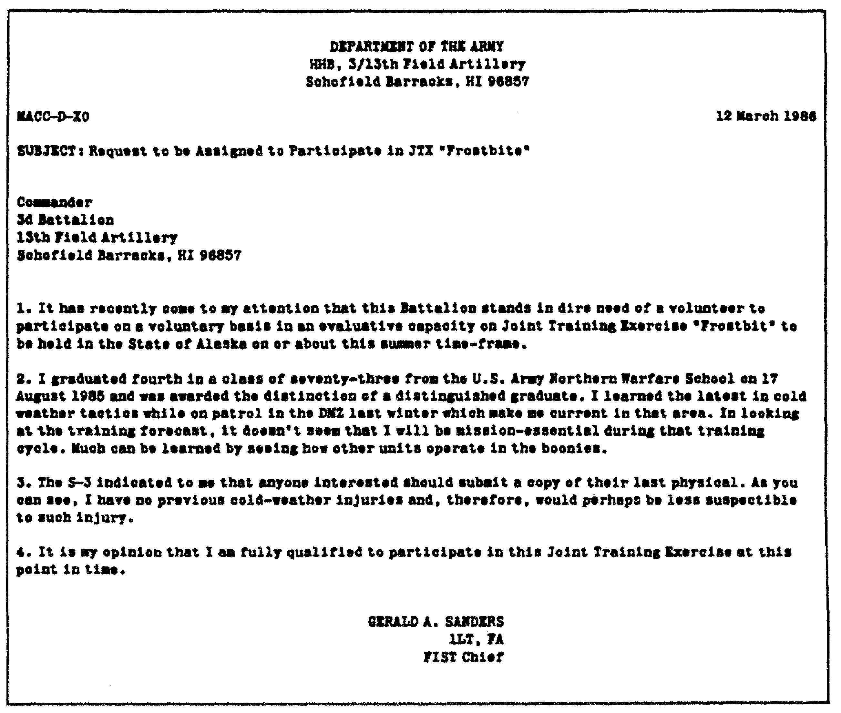

Figure 1-14. Military letter--example of poor writing.

QM3517 1-14

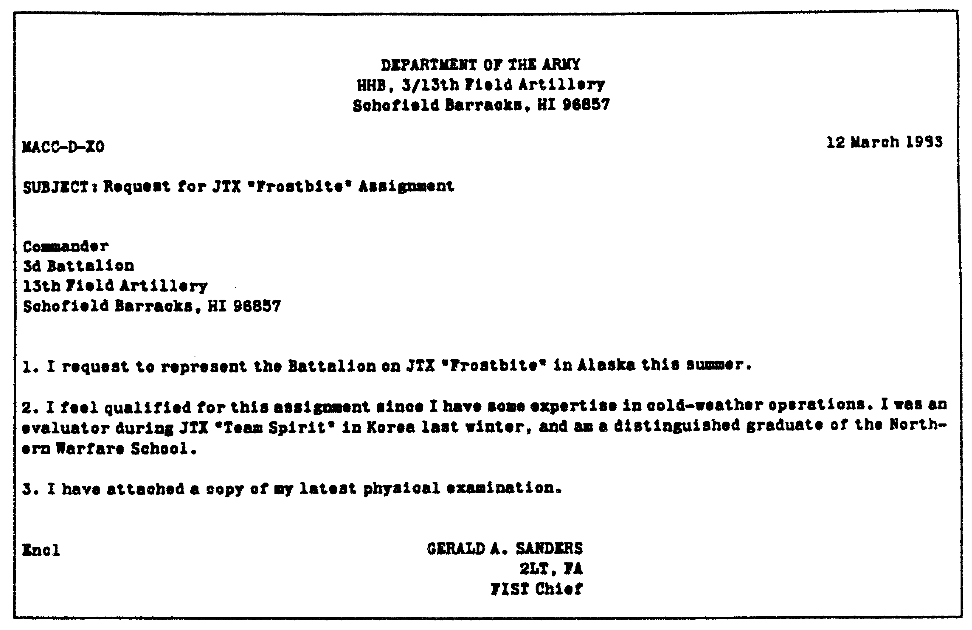
Figure 1-15. Military letter--example of good writing.

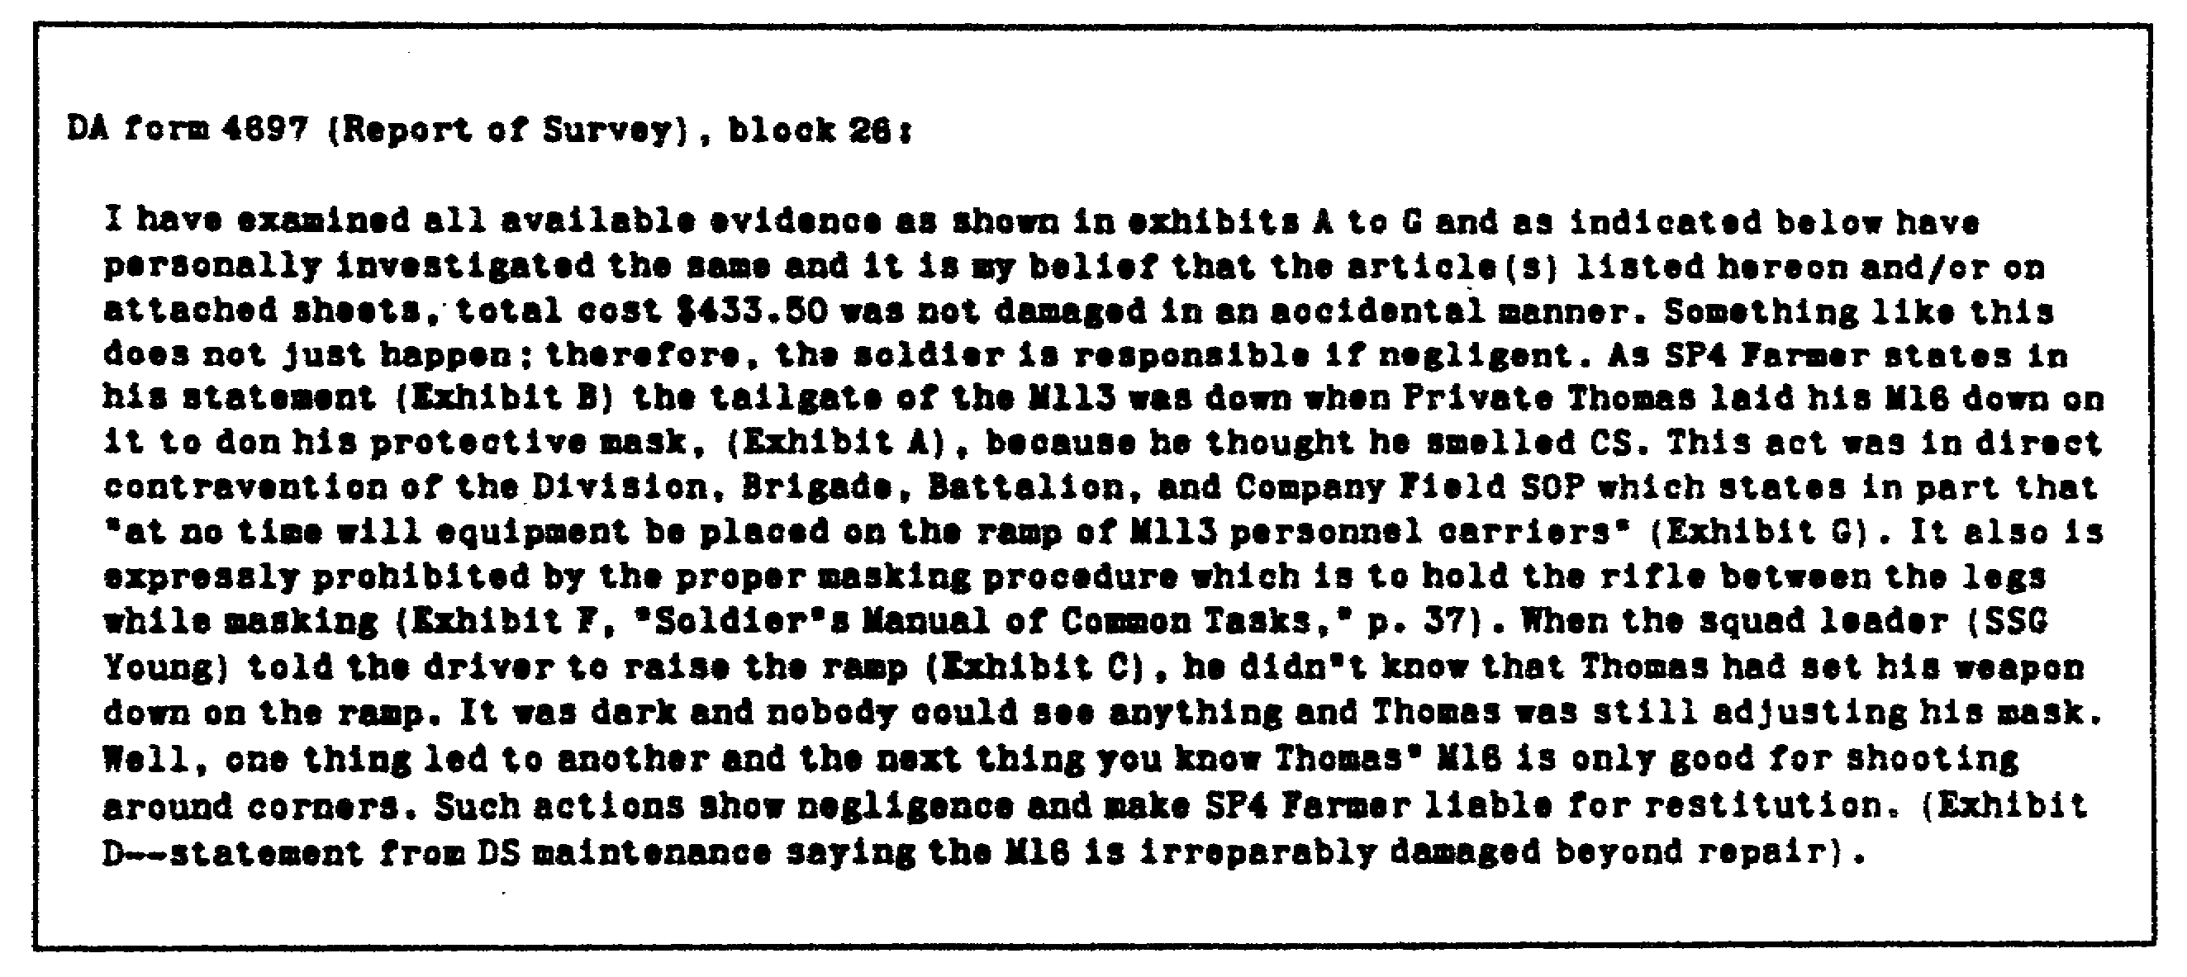

Figure 1-16. DA Form 4697 (Report of Survey).

1-15 QM3517

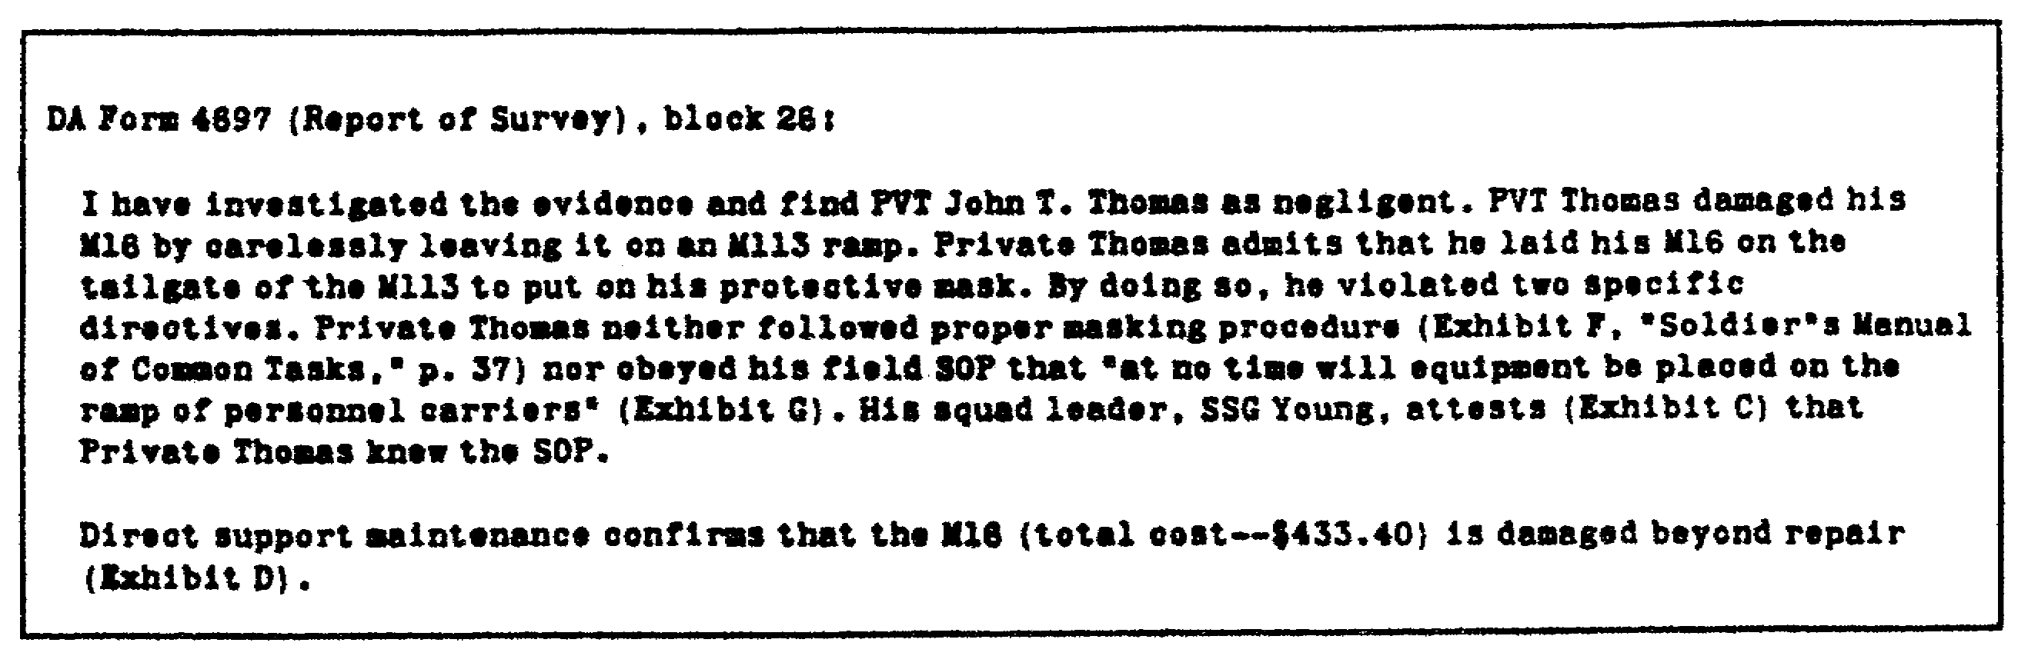

Figure 1-17. DA Form 4697 (Report of Survey).

2. Use Appropriate Forms and Types of, Correspondence.

Several appropriate forms and types of correspondence are available for your use. Among these are the following:

o Memorandum.
o Endorsement.
o Comment.
o Letter.

Use these forms and types of correspondence as discussed in the following subparagraphs.

a. Memorandums. There are two types of memorandums: formal and informal. The following subparagraphs discuss these two types of memorandums.

(1) Formal Memorandums. Use the formal memorandum for correspondence that you send outside the headquarters, the command, the installation, or similar identifiable organizational elements.

(2) Informal Memorandums. Use the informal memorandum for correspondence that is internal to the headquarters, to the command, or similarly identifiable organizational elements.

NOTE: Refer to DA Memorandum (Memo) 340-15 for correspondence that originates within the Army staff (ARSTAF) or secretariat agencies.

b. General Rules for Memorandums. The following general rules apply to both formal and informal memorandums:

QM3517 1-16

(1) Paper. Use standard 8 1/2- by 11-inch paper. Use the standard-size paper unless there is a good reason to use a larger size.

(2) Original Pages. For formal memorandums, use white letterhead stationery for the first page. Use plain white paper for continuing pages. Type or print the informal memorandum on plain white paper. Do not use letterhead.

(3) Copies. Prepare only the number of the copies that you need. For all the copies, use manifold carbon sets when they are available. These are cheaper to use than photocopies. When manifold carbon sets are not available, make photo copies.

(4) Dates. Write, type, or stamp the day, the month, and the year on the memorandum.

(5) Margins. The standard margin is 1 inch for both the left margin and the right margin.

(6) Type Styles. Use the preferred standard pica, courier 10-pitch, or similar large type styles. However, if 10-pitch-type styles are not available, then use the type style that is available. DO NOT buy new equipment if the available typewriter is in 12 pitch. Use it until it no longer works.

(7) Dot-Matrix Versus Letter Quality Print. Generally, you can read letter-quality print easier than you can read dot-matrix print. Use a dot-matrix printer only if it produces easy-to-read copy. DO NOT use dot-matrix-printed correspondence when you correspond outside the Army. Also, do not use dot-matrix-printed correspondence when you correspond with any of the following individuals:

o Chief of Staff or to the Vice Chief of Staff of the Army.

o Secretary, Assistant Secretaries, or Under Secretaries of the Army.

(8) Spacing. Single-space the text. Double-space between the paragraphs and the subparagraphs.

(9) Number of Pages. There is no maximum limit to the number of pages for a memorandum. However, try to limit he number of pages to two. Provide additional information through the use of enclosures on attachments.

(10) Abbreviations. Use the abbreviations that are authorized in AR 310-50 (Authorized Abbreviations, and Brevity Codes) for military correspondence. For abbreviations that are

1-17 QM3517

not contained in AR 310-50, use standard dictionaries. You can abbreviate ranks for military and personal correspondence.

(a) Letters. For letters, use only the common abbreviations that are found in standard dictionaries. DO NOT use military abbreviations or acronyms in letters that are addressed to persons outside the Department of Defense (DOD). For letters, spell out your rank in full.

(b) Brevity Codes. Use the brevity codes that are authorized in AR 310-50. Any time that you use a brevity code three or more times, identify it. After its identification, provide the brevity code in parentheses. Thereafter, use only the brevity code. Use brevity codes in formal correspondence only when each brevity code that you use appears three or more times.

(c) Acronyms. Spell out uncommon terms the first time that you use them. When you use an acronym in formal correspondence, spell it out the first time that you use it. Thereafter, use only the acronym.

(11) Signature Block (General). Type the signature block of military officials on three lines so that the name (in upper case) is on the first line; the rank and the branch of service are on the second line; and the title is on the third line. If the title requires an extra line, you are authorized to use a fourth line. Indent the beginning of the fourth line two spaces. Begin typing on the third space.

Type the signature block of civilian officials on two lines so that the name (in upper case) is on the first line and the title is on the second line. If the title requires an extra line, you are authorized to use a third line. Indent the beginning of the third line two spaces. Begin typing on the third space.

NOTE: DO NOT use abbreviations or titles that denote academic degrees, religious orders, or fraternal orders in the signature blocks on official correspondence unless their use benefits or improves the image of the Army.

NOTE: DO NOT use "(P)” (meaning that the signer is promotable) after the rank for personal benefit. You may use it if its use benefits the Army or as an address for such things as congratulatory notes.

QM3517 1-18

Enter the name of the person who signs the military correspondence. Ensure that you type, stamp, or print the name of the person in CAPITAL LETTERS identical to the individual's signature except when either of the following conditions applies:

o You must use "Commanding" for commanders to denote the active exercise of authority.

o You benefit or improve the image of the Army by using abbreviations or titles that denote academic degrees, religious orders, or fraternal orders.

Federal statute requires the use of the phrase "Commander's Signature" on certain forms. All other forms use one of the following phrases:

o "Authorized Signature."
o "Signature of Approving Authority."
o "Signature of Reviewing Authority."
o Other phrases as appropriate.

The requiring document states who signs as the "Authorized Signature" and how to obtain authentication.

Civilians who are attached to, or who are serving with, multiple service organizations do not use "DAC" on a signature block.

c. Format for Memorandums. When you write a memorandum, use the modified block-style format. The format has the following three parts:

o Heading.
o Body
o Closing.

The following subparagraphs discuss these parts:

(1) Heading. The heading has six elements. They are as follows:

o Office or reference symbol.
o Modern Army Recordkeeping System (MARKS) number.
o Date.
o Suspense date.
o "MEMORANDUM FOR" line.
o "Subject" line.

Figure 1-18 through Figure 1-20 provide additional instruction on how to use, how to prepare, and how to continue a memorandum.

1-19 QM3517

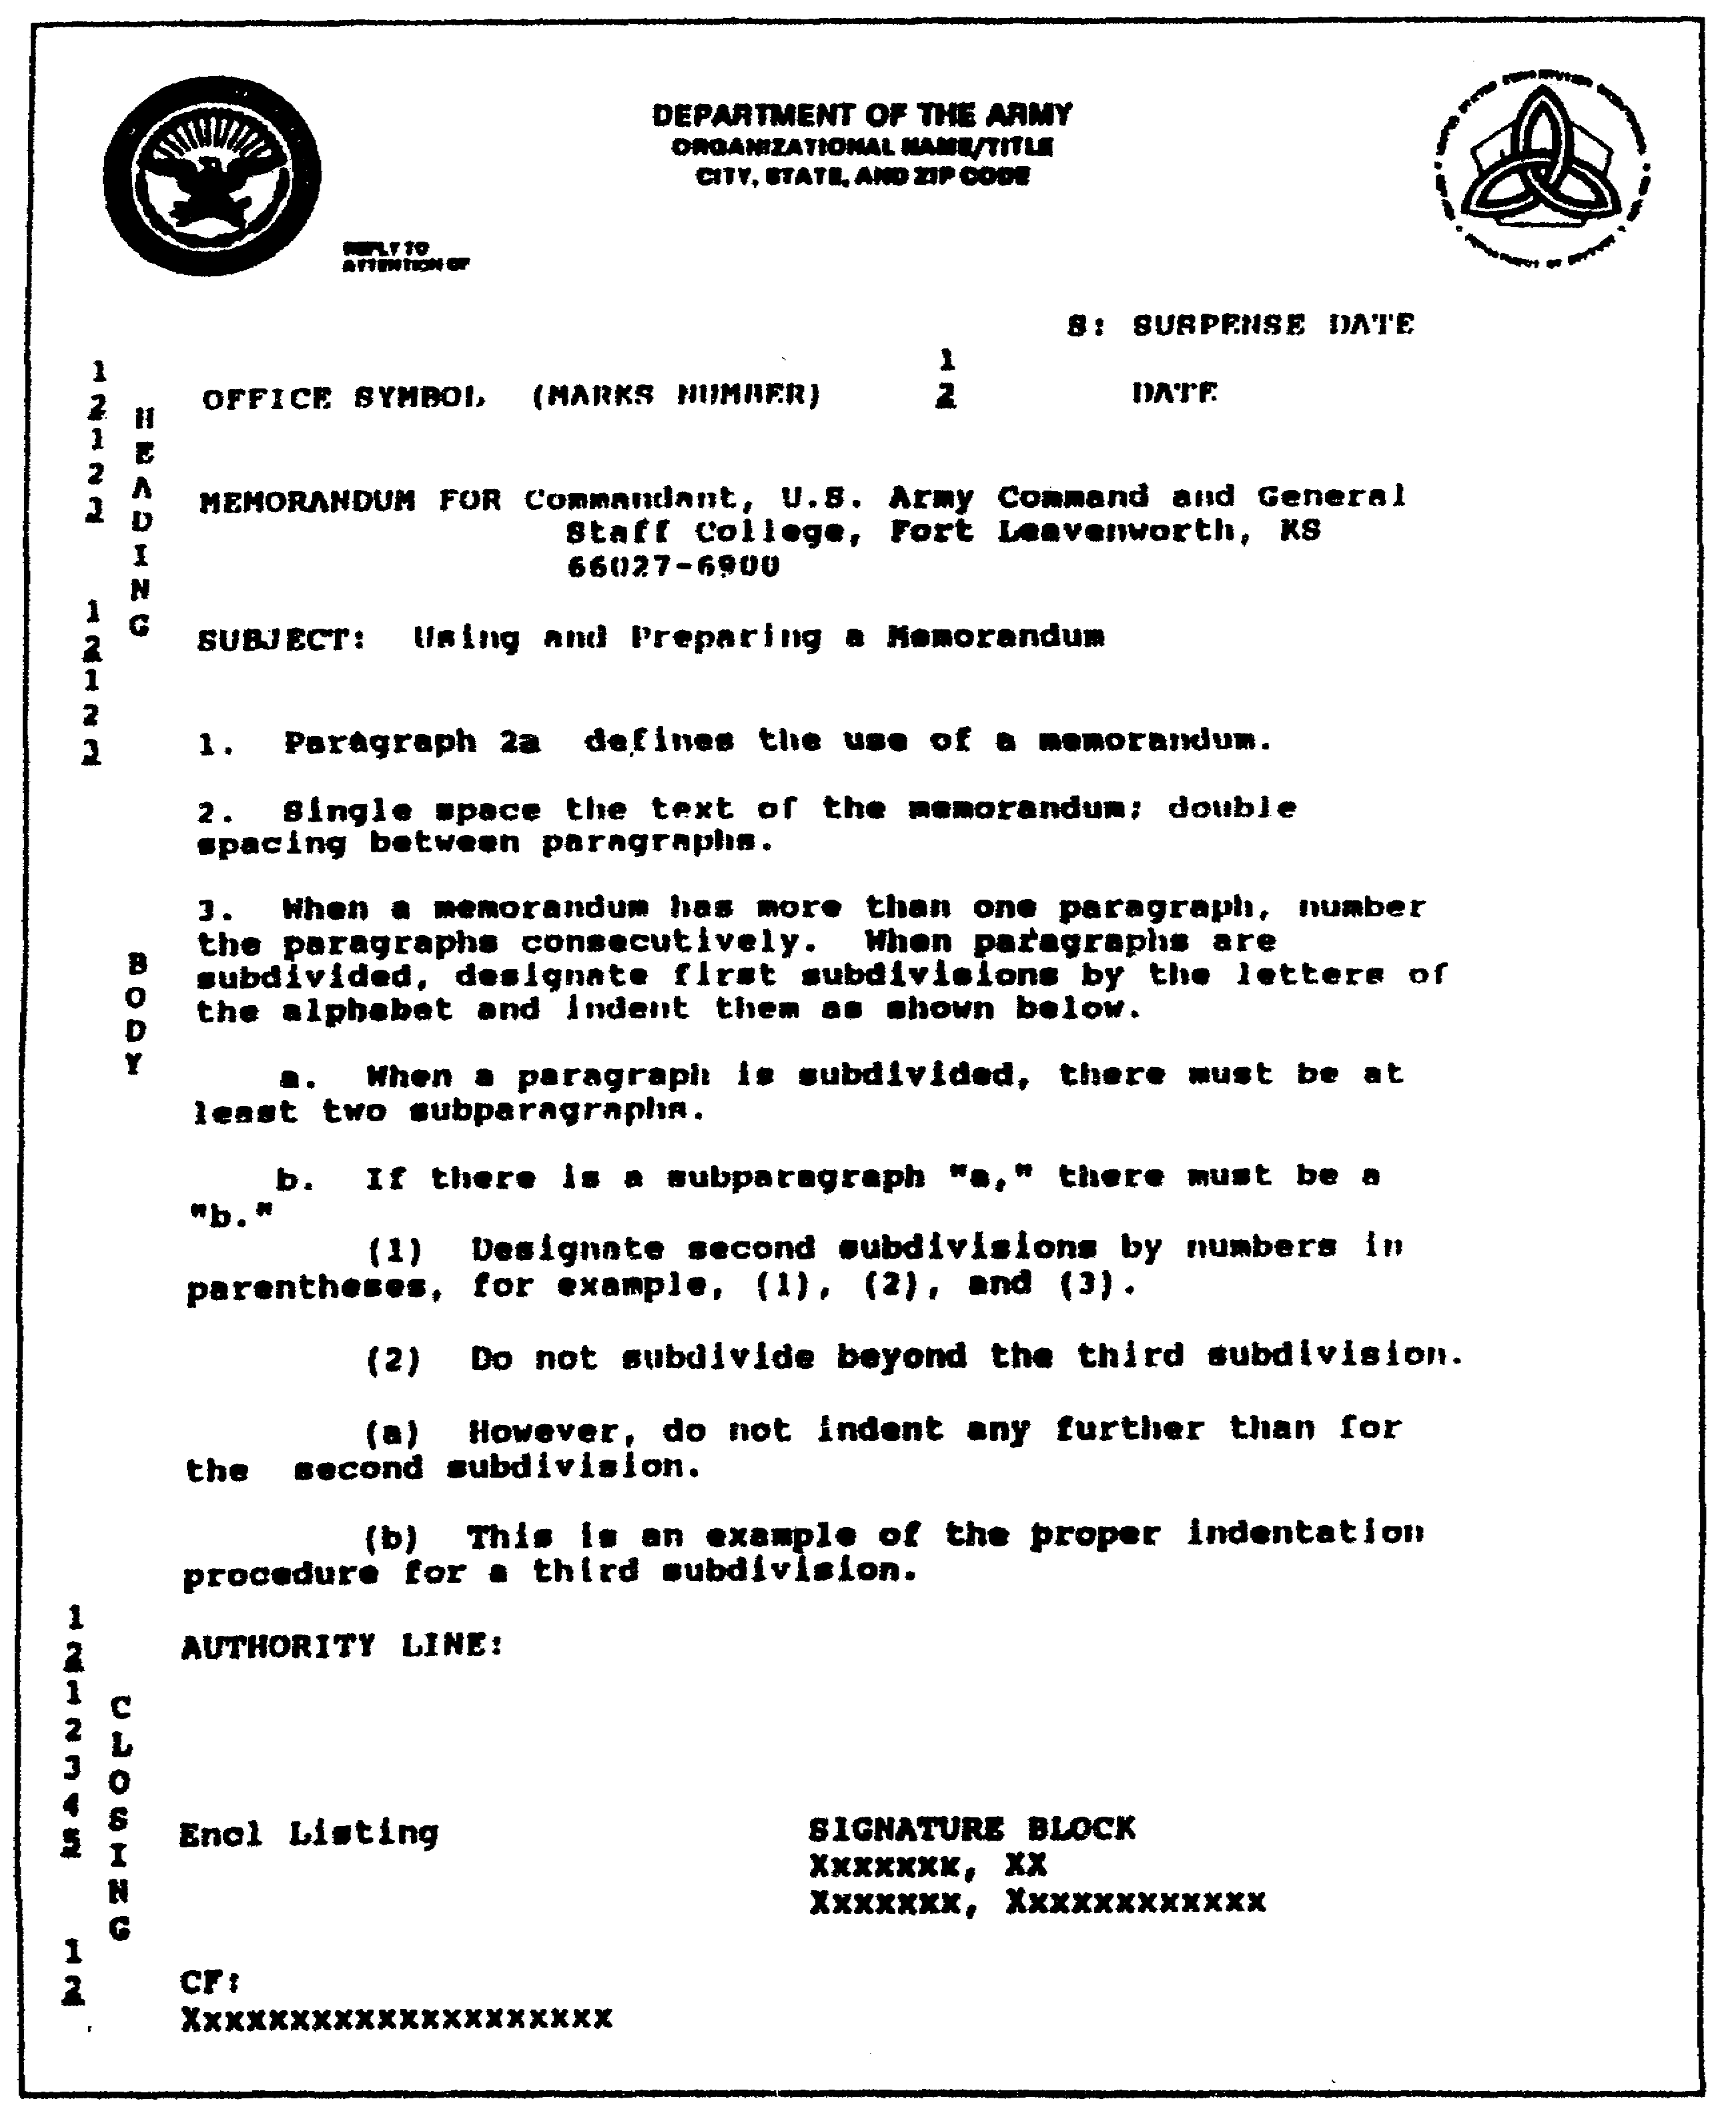

Figure 1-18. Using and preparing a memorandum.

QM3517 1-20

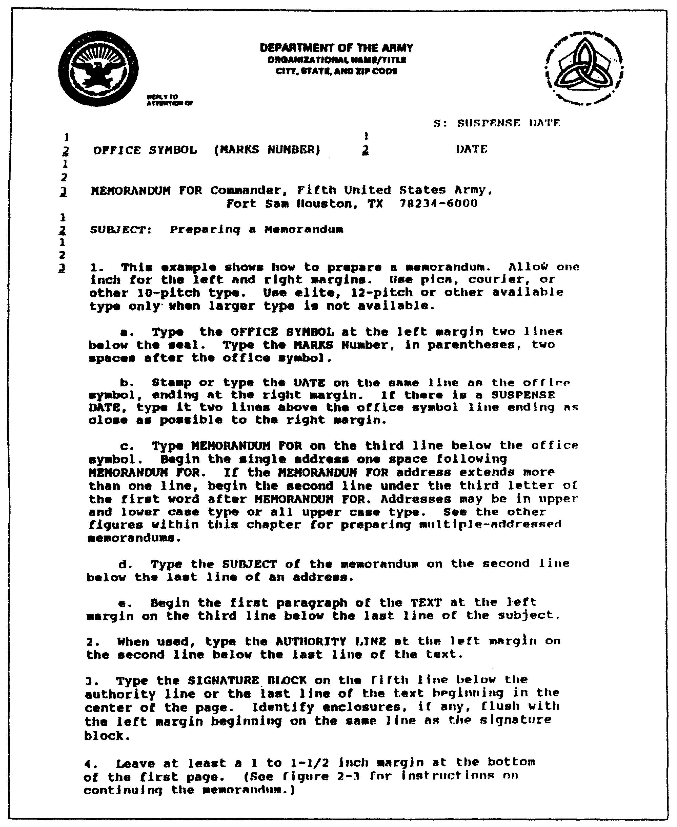

Figure 1-19. Preparing a memorandum.

1-21 QM3517

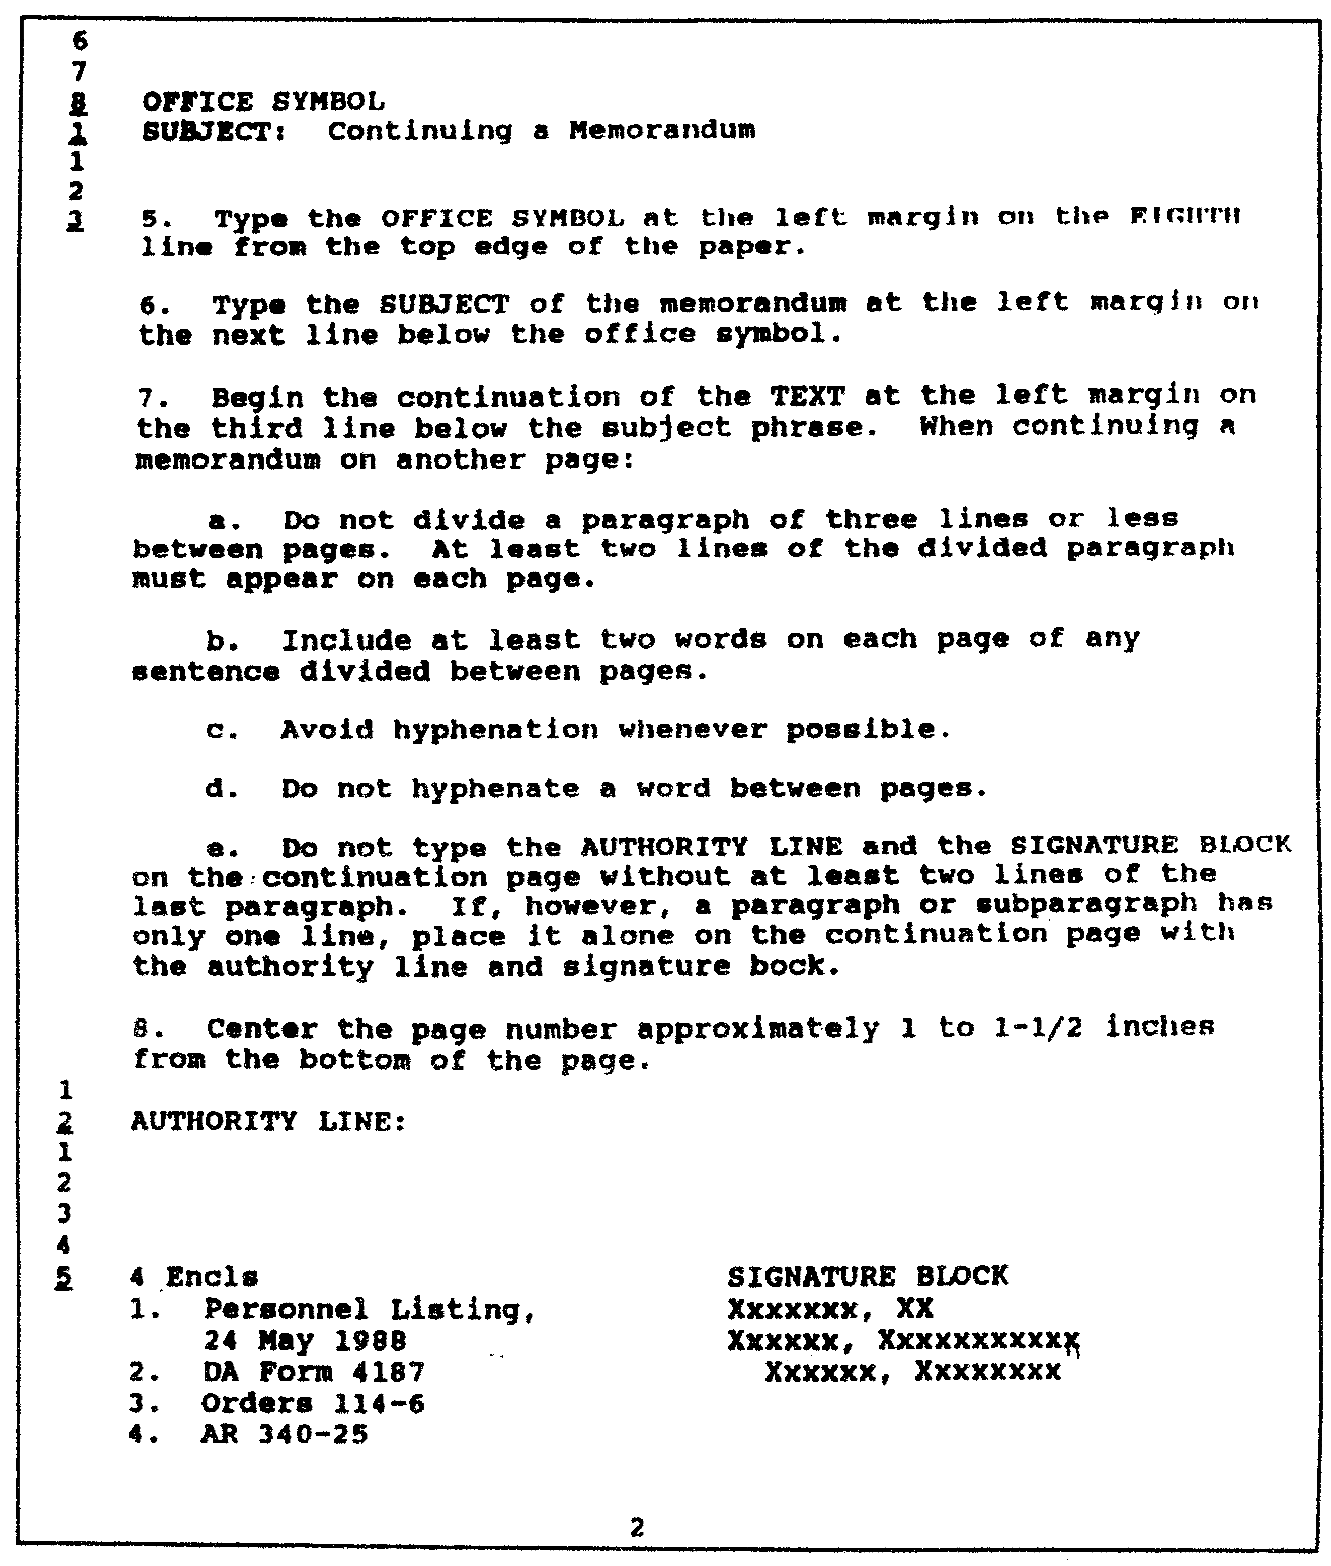

Figure 1-20. Continuing a memorandum.

QM3517 1-22

The following subparagraphs discuss the six heading elements:

(a) Office Symbol or Reference Symbol. Type the office symbol or the reference symbol on the second line below the seal. The symbol names your office. Example: SAIS-PSP. DO NOT use computer identification codes or word processing codes as part of the office symbol or the reference symbol. Neither computer identification codes nor word processing codes mean anything to your reader. However, you may use these codes on the file copy. You may follow the office symbol or the reference symbol with other information when it is needed and if it is not part of the subject line. The following data are some examples of such additional information:

o Individual's name.

o Individual's primary military occupational specialty (MOS).

o Individual's social security number (SSN).

o Individual's rank.

o Contract number.

o Bill-of-lading number.

(b) Modern Army Recordkeeping System. The action officer adds the MARKS number when he writes the draft. He places the MARKS file number in parentheses two spaces following the office symbol or the reference symbol. See AR 25-400-2 (The Modern Army Recordkeeping System [MARKS]). Use SSNs only in official military personnel matters.

NOTE: Do not crowd the office symbol or the reference symbol line. Write lengthy information on a second line.

(c) Date. Put the date on the same line as the office symbol or the reference symbol. End the date even with the right margin. Express the date in the following order:

o Day.
o Month.
o Year.

Express the day in numerals. Spell out the month if you do not abbreviate the year (January 1988). Abbreviate the month if you abbreviate the year (Jan 88, but not January 88 or Jan 1988). Express the year with two digits when you abbreviate the month.

1-23 QM3517

Express the year with four digits when you spell out the month. An exception to this rule occurs when the date stamp uses the abbreviated month and the four-digit year. In this case, type or stamp the date.

Use digital dates (02/07/88, 020788) only when automated data processing procedures require it. Keep an abbreviated date on one line. DO NOT, for example, end a line with the day and start the next line with the month. When you spell out the month, you may put the year and the month on separate lines.

(d) Suspense Date. Use a suspense date if you need a reply by a certain date. DO NOT impose a suspense date for no compelling reason. Put the suspense date at the right margin on the same line as the Reply to Attention Of or one space above the date of the memorandum. Set the suspense date. Consider the transmission time to the reader, the time that the reader needs to gather the information, and the transmission time for the return reply.

(e) MEMORANDUM FOR Line. Type "MEMORANDUM FOR" on the third line below the office symbol. Write to the office that you expect to complete the action. DO NOT simply address an action to a headquarters if you know which element of that headquarters will receive the action. An exception occurs when you send correspondence to a Headquarters, Department of the Army (HQDA) ARSTAF element. Use a person's name only if there is a good reason. If you use a person's name, then place it in parentheses after the office symbol.

For single-address memorandums, put the "MEMORANDUM FOR" and the address on the same line.

Multiple-address memorandums are addressed to more than one reader and fewer than six readers.

If you send a memorandum to more than five readers, use the SEE DISTRIBUTION format for the address, as shown in Figure 1-21. Type the words "SEE DISTRIBUTION" one space after the words "MEMORANDUM FOR." On the second line below the last line of the signature block or the enclosure listing, whichever is lower, type "DISTRIBUTION" and block the addresses as shown in Figure 1-21. If it is necessary to do so, continue the distribution list on the second page, as shown in Figure 1-22. Also, if it is necessary to do so, type the complete distribution list on a separate page.

QM3517 1-24

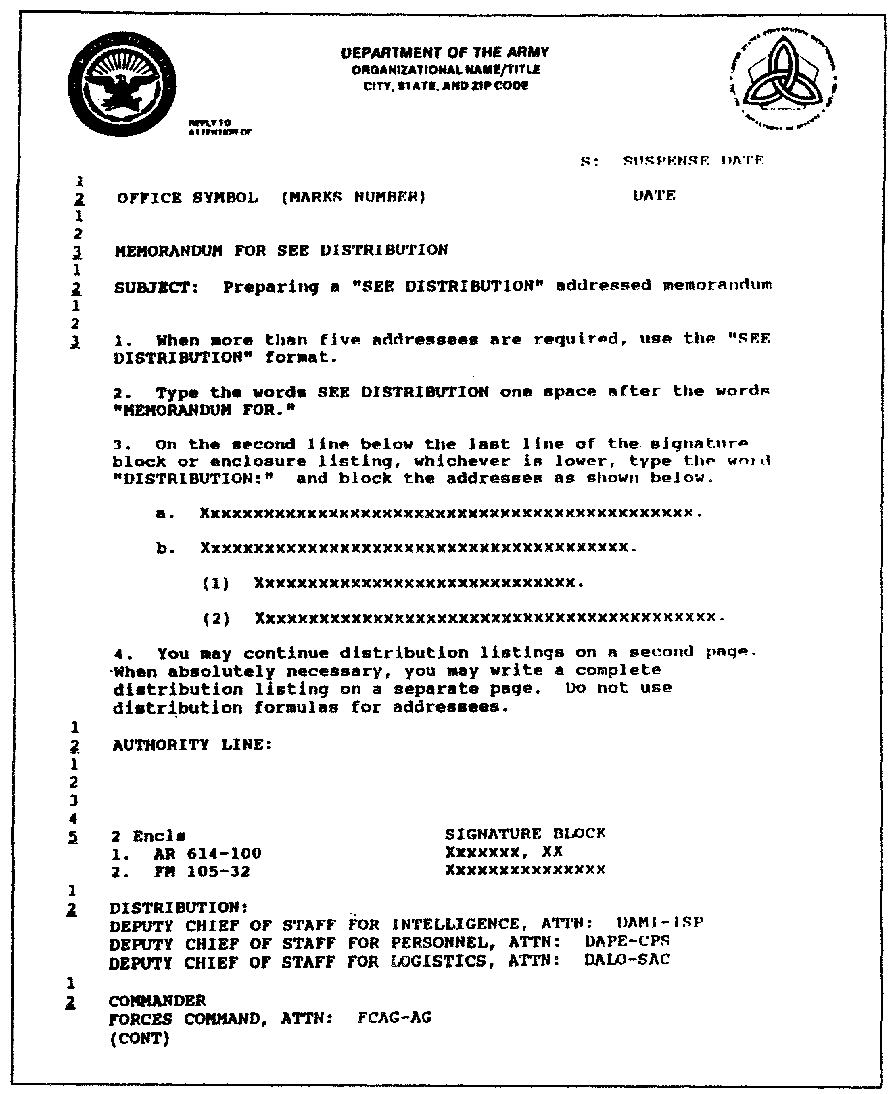

Figure 1-21. Preparing a SEE DISTRIBUTION memorandum.

1-25 QM3517

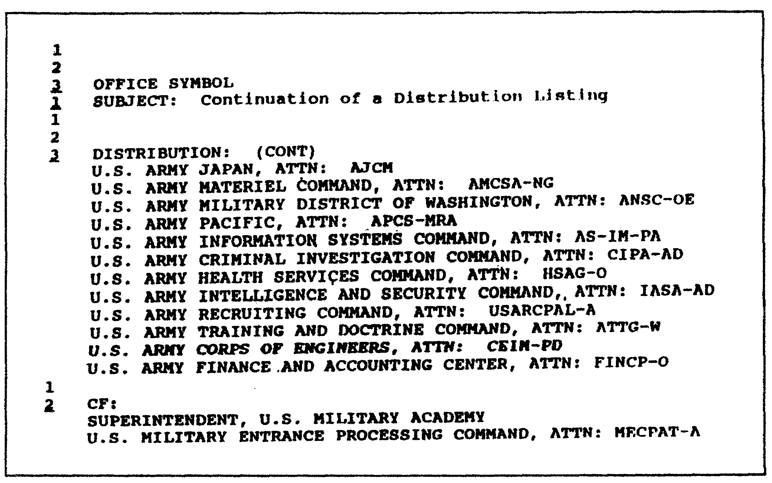

Figure 1-22. Continuation of a distribution listing.

Show the complete address on the envelope for an addressee on a SEE DISTRIBUTION list. Otherwise, the US Postal Service cannot deliver the letter.

Use a THRU memorandum to inform those who need to know. Give them the opportunity to comment, especially if their approval or disapproval has an impact on the action. Figure 1-23 shows the format for a single THRU memorandum. Use the format shown in Figure 1-24 to send the THRU memorandum to more than one reader.

NOTE: For specifics on organizational formats other than company-level communications, see AR 25-50.

(f) SUBJECT Line. Type the subject line on the second line below the last line of the address. Use only one subject. Write the subject in 10 or fewer words, if possible. If the subject needs more than 10 words, limit the number of the words and use authorized abbreviations. If the subject is more than one line, then begin the second line flush with the left margin. Regardless of the subject line, make it clear. Type "SUBJECT:" in UPPERCASE LETTERS.

QM3517 1-26

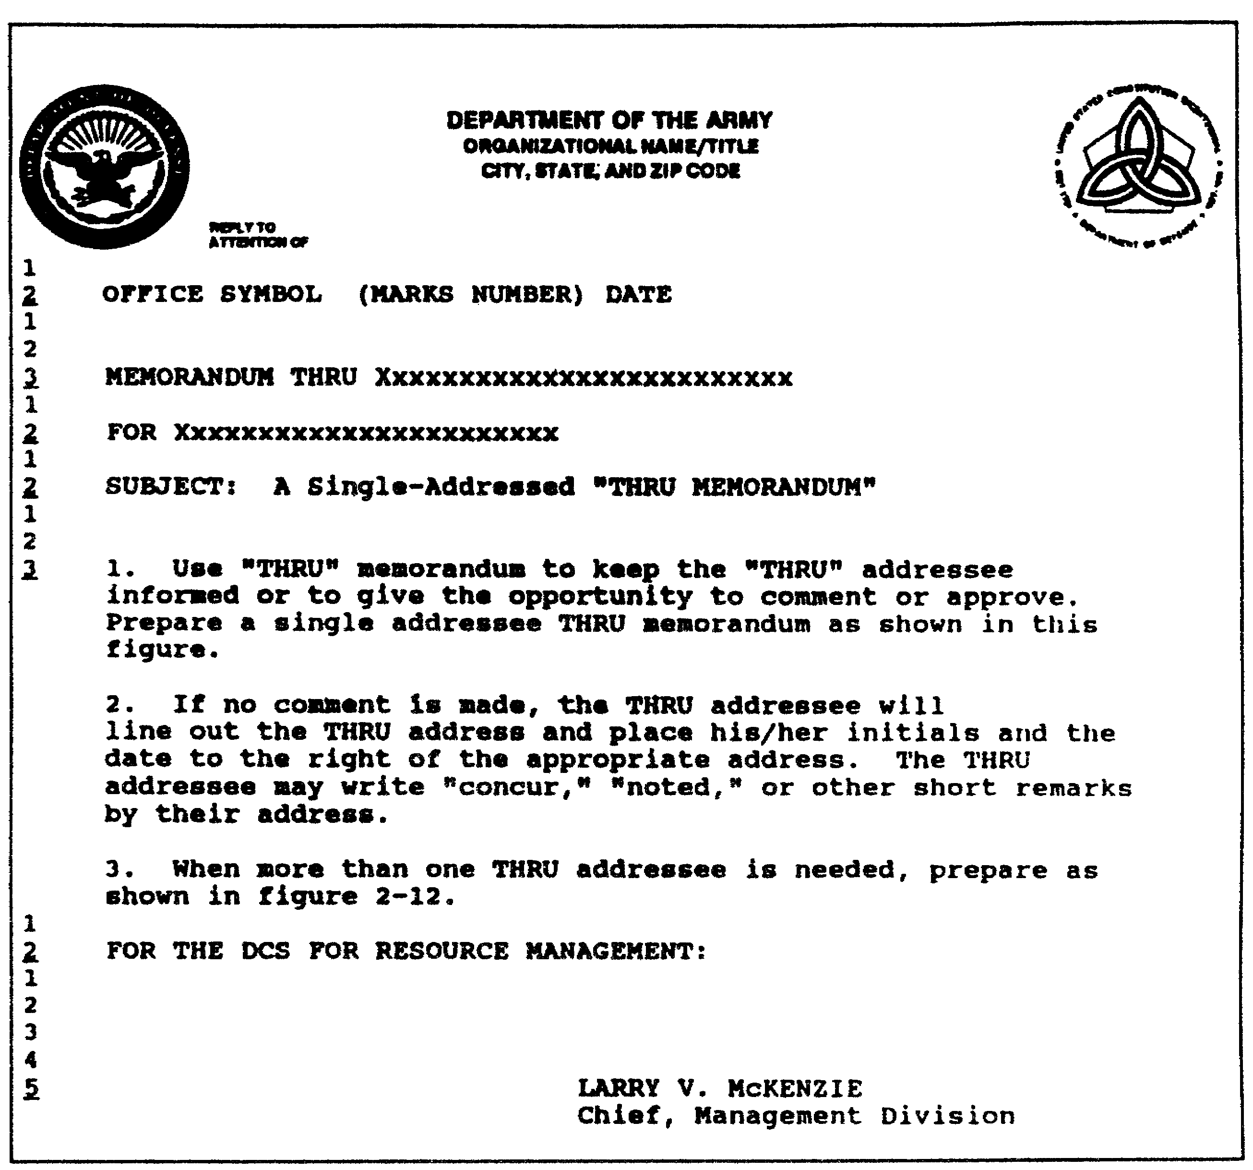

Figure 1-23. A single addressed THRU memorandum.

1-27 QM3517

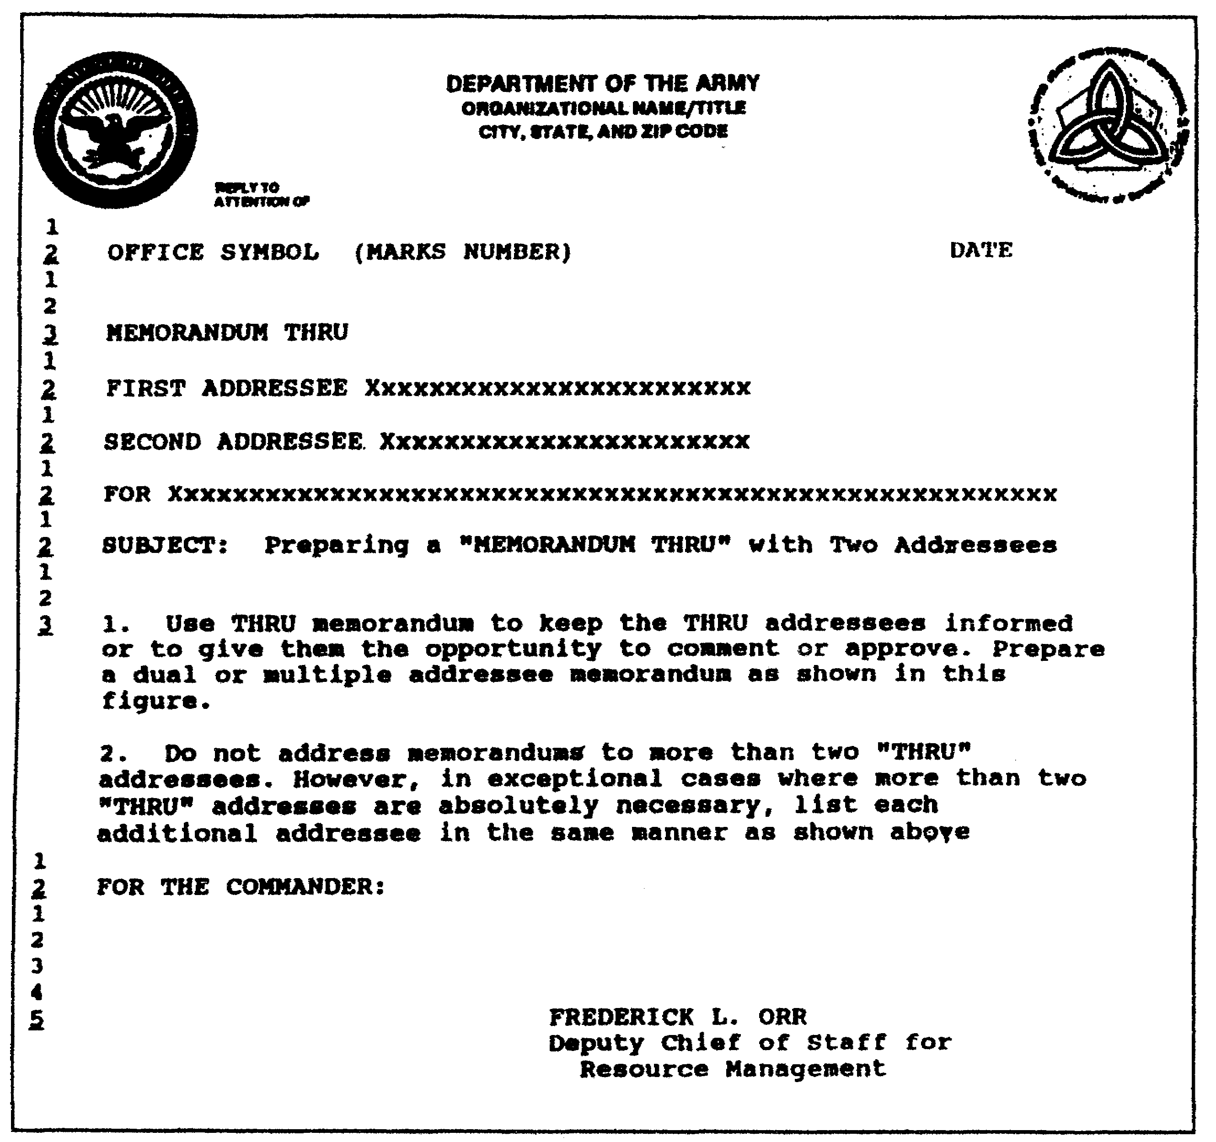

Figure 1-24. Preparing a THRU memorandum
with two or more addresses.

(2) Text. The following subparagraphs provide guidance concerning the text of your memorandum. Refer to these subparagraphs for specific details.

(a) Beginning. For the beginning of the text of your memorandum, use the following guidelines:

o Begin the text on the third line below the last subject line.

QM3517 1-28

o Open with your purpose sentence. Make sure that this is a short, clear sentence.

o Put your recommendation, your conclusion, or your most important information (the main point) next. (In some writing, you can combine your purpose and your main point.)

o Separate each major section clearly. Use paragraphs, headings, or sections.

o When required, provide a point of contact (POC) line as the last line of the body of your correspondence.

(b) Spacing. Single-space your text. Double-space between your paragraphs and your subparagraphs. Single space one-paragraph memorandums. On occasion, you may have to use subparagraphing in one-paragraph correspondence. Use the same spacing as that which you use for the basic memorandum.

(c) Indenting. Indent your subparagraphs four spaces. Begin typing on the fifth space.

(d) Numbering Paragraphs. Number your paragraphs as follows:

o DO NOT number a one-paragraph memorandum.

o If the memorandum has more than one paragraph, number the paragraphs consecutively. Use Arabic numerals--for example: 1, 2, 3, and so on.

o If the paragraphs have subparagraphs, use the lowercase letters of the alphabet to identify them. For example:

1.
a.
b.

2.
a.
b.

1-29 QM3517

o If the subparagraphs are further divided, use Arabic numerals in parentheses. For example:

1.
a.
(1)
(2)

b.
(1)
(2)

o If a third subdivision is necessary, use lowercase letters in parentheses. However, do not indent any further. For example:

1.
a.
b.
(1)
(2)
(a)
(b)

o Do not subdivide further.

NOTE: Use the same numbering system to prepare your draft outlines.

(3) Closing. Major elements are the authority line, the signature block, and the enclosure listing. Supplements are the "DISTRIBUTION" listing (if one is needed) and "Copies Furnished" (CF).

(a) AUTHORITY Line (Use, Placement, and Omissions). Individuals who are designated properly as having the authority to sign for the commander or the head of an office use the authority line to--

o sign. A person other than the commander who signs military correspondence uses an authority line to indicate that the correspondence expresses the will of the commander. An authorized individual uses an authority line and signs for the commander or the head of an agency for correspondence that contains policy matters, command decisions, official recommendations, and tasking orders.

QM3517 1-30

NOTE: An authorized individual is one who has the proper authority to sign for the commander or the agency head.

o Place. Type an authority line at the left margin in UPPERCASE LETTERS on the second line below the last line of your text.

o omit. If you are unsure about which authority line to use, omit it. Type or stamp it later--after the head of the command, the agency, or the office signs the letter.

(b) Signature. Use the regulation or the directive that governs the action that is involved to decide on the appropriate signature. Your signature is your name, signed in black or dark-blue ink. If a signature is not prescribed, then write the signature as you desire. Normally, your signature includes your full name. You may use your initial or initials in place of your first and middle names. However, your typed name must match your signature. Once you decide on your official signature, use the same signature for official actions throughout your employment or service with the DA.

The person whose name is typed may not sign personally. In this case, the individual who is authorized to sign must sign his own name. He adds the word "for" in front of the typed name in the signature block. If an individual in the military signs for another individual, then the signer shows his rank following the signature. If a civilian signs for an individual in the military, then the signer includes his title (for example, "Mr.").

In addition to signing the original correspondence, the signer initials the record copy of the correspondence. If appropriate, stamp courtesy copies or information copies "SIGNED" or handprint "/s/" to avoid having to sign manifold tissue copies.

On THRU or IN TURN correspondence, when you make no comment, the signer lines out the appropriate address and initials and dates the line out.

1-31 QM3517

(c) Signature Blocks (Placement and Omission). Subparagraph 2b(11) of this lesson discusses the general rules for signature blocks. In regards to the signature block, consider the following:

o Placement. Begin the signature block in the center of the page on the fifth line below the authority line. If there is no authority line, then begin it on the fifth line below the last line of the text.

o Omission. If the identity of the signer is not known, then omit the signature block. You may add it by typing or rubber stamping it on the military correspondence at the time of signature.

See Figure 1-25 through Figure 1-29. These figures show examples of signature blocks.



Figure 1-25. Office of the commander signed
by an authorized subordinate.



Figure 1-26. Signed by the commanding officer of a
unit, headquarters, or installation.

QM3517 1-32

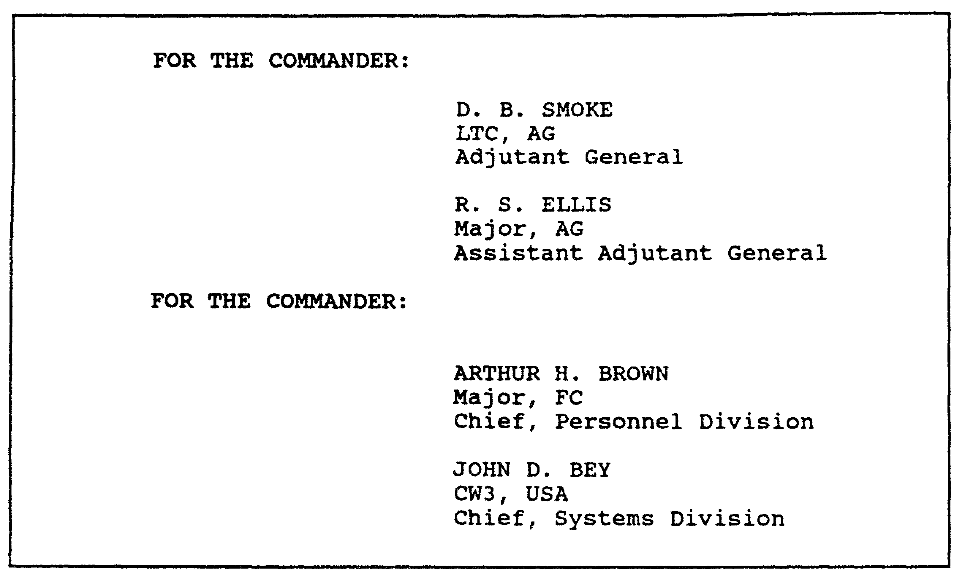

Figure 1-27. Signed by an authorized representative of the
commander of a unit, headquarters, or installation.



Figure 1-28. Signature of an officer writing as an individual.

For the signature of an officer who writes as an individual, show his name, SSN, grade, branch, and organization, as shown in Figure 1-28.

1-33 QM3517

(d) Signature Block--Personnel on Active Duty. Personnel on active duty use the following procedures for entries in the signature block. Enter the following information:

o Name. Sign your name plainly and legibly. Ensure that your signature is identical to your typewritten, stamped, or printed name.

o SSN. Use your SSN according to the guidelines of the Privacy Act of 1974 or as otherwise directed by AR 25-50.

o Rank. Enter your rank. Your rank is that in which you serve (for example, colonel [COL], lieutenant colonel [LTC], major [MAJ], or captain [CPT]). Chaplains put their ranks in parentheses and precede them with the word "Chaplain." For example:

J. JONES
Chaplain (CPT) USA

(e) Signature Block--Officers. When you prepare general officer signature blocks, spell out the rank. When you use abbreviations in any signature block for other than general officers, use only the abbreviations (for example, COL, LTC, MAJ, or CPT). You may use optional rank abbreviations on military correspondence. You also may use abbreviations in the text of all military correspondence when you refer to an individual by rank.

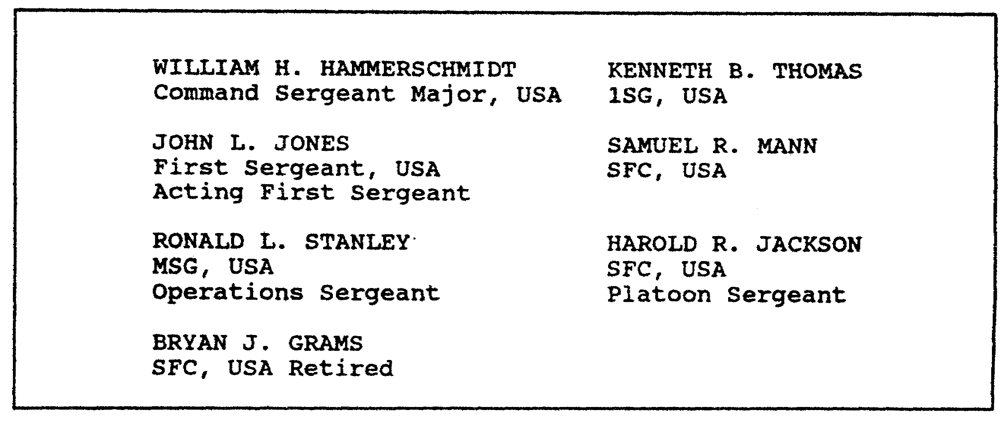

Figure 1-29. NCO signature blocks.

QM3517 1-34

(f) Signature Block--Warrant Officers. If you are a warrant officer (WO), use the designation "USA" except for an authorized branch title. If you are an Army Reserve WO on active duty, use the designation "USAR." If you are an Army National Guard (ANG) WO, use the designation "ARNGUS".

(g) Signature Block--Chaplains. If you are a chaplain, use the designation "USA" after your rank. For example, Chaplain (MAJ) USA.

(h) Signature Block--Branch Designations. Use your branch designation on letters only when doing so is necessary for credibility. Examples are "Medical Corps" or "Chaplain" on matters that require the attention of the medical profession or the clergy.

(i) Signature Block--Army National Guard. If you are an ANG member who is not on active duty, use the two-letter state or territory abbreviation of your unit, followed by "ARNG." An example is "KSARNG" (Kansas Army National Guard personnel).

(j) Signature Block--Organization. In some cases, you show the organization in the signature block. This often is the case when you do not include the signer's organization in the letterhead or elsewhere in the correspondence. Show the organization as the final element of the signature block.

(k) Signature Block--Title. Use the following guidelines when you enter your title:

o When you serve in an acting capacity, use a title that reflects your acting status. Examples are "Acting Commander," "Acting Adjutant General", "Acting Transportation Officer", and "Acting Post Engineer".

o When you occupy more than one position, sign messages with the most appropriate title. Examples are "E. D. White, Colonel, AG; Secretary, Retirement Board".

o When you write about yourself, DO NOT use a title.

NOTE: The same rules govern Army Reserve personnel who are not on' active duty. As an exception, add the identification "USAR" after the grade of enlisted personnel or the branch

1-35 QM3517

assignment of commissioned officers. General officers, chaplains, and WOs use "USAR".

(l) Enclosures. Number and attach enclosures in the same order in which they appear in the memorandum. When there is only one enclosure, do not precede "Encl" with the number "1". Use only "Encl". Begin the enclosure listing on the same line as the signature block.

(m) DISTRIBUTION Listing. The next item in the closing of your memorandum is the DISTRIBUTION listing (if it is needed). Refer to Figure 1-21 and Figure 1-22.

(n) COPIES FURNISHED (CF)Line. Use the "Copies Furnished" (CF) line to inform others of the subject only if they have a need to know or an interest in the subject. Type "CF" on the second line below the last line of the signature block, the enclosure listing, or the distribution listing, whichever is lower.

(o) Number of Pages. Your subject determines the number of the pages in your memorandum. However, try to limit the number to two pages. Use enclosures for additional information. If a memorandum is longer than one page, then see Figure 1-19 and Figure 1-20 and follow these rules:

o Type the office symbol or the reference symbol at the left margin on the eighth line from the top edge of the paper. It is not necessary to repeat the MARKS number or the date on the continuation pages.

o Type the subject of the memorandum at the left margin on the next line below the office symbol or the reference symbol.

o Begin the continuation of the text at the left margin on the third line below the subject phrase. When you continue a memorandum on another page DO NOT divide a paragraph of three or fewer lines between pages. At least two lines of the divided paragraph must appear on each page. Include at least two words on each page of any sentence that is divided between pages. DO NOT hyphenate a word between pages. DO NOT type the authority line and the signature block on the continuation page without including at least two lines of the last paragraph. However, if a paragraph or a

QM3517 1-36

subparagraph has only one line, then place it alone on the continuation page with the authority line and the signature block.

o Center the page number approximately 1 to 1 1/2 inches from the bottom of the page.

d. Endorsements. An endorsement is a reply or a forwarding statement that you add to a memorandum. Number endorsements sequentially (1st, 2d, 3d, and so forth). Do not use endorsements for letters or for readers outside the Department of Defense (DOD). However, you may forward letters as enclosures to memorandums. See Figure 1-30 through Figure 1-36. The format rules for endorsements are as follows:

o Prepare the endorsement in the modified block-style format.

o Margins, paragraph numbering, indentations, and subparagraphing for the endorsement are the same as for the memorandum.

o Type the symbol of the office or the action officer who prepares the endorsement at the left margin on the eighth line from the top of the page. Two spaces after this, type the office symbol and the date of the basic correspondence in parentheses. Space twice. Type the MARKS number in parentheses. Type the endorsement number two spaces after the MARKS number.

o Place the writer's name, the initials of the typist, and the telephone number of the action officer on the same line as the endorsement number, ending at the right margin. Space may not be available to type the writer's entire identification on the same line. If this is the case, then it is permissible to break the line after one of the slash (/) marks and to continue on the next line below. Begin typing at the left margin.

o If there is a suspense date, then type or stamp it on the sixth line from the top of the page, ending at the right margin. You may place the suspense date in the body, preferably in the last paragraph of the correspondence.

o Type the subject on the first line below the office symbol and the endorsement line. If the subject cannot be typed on a single line, then begin the second line flush with the left margin.

1-37 QM3517

o The address of the endorsing office serves as a return address. Type it at the left margin on the second line below the subject. Stamp or type the date of the endorsement three spaces after the zip code of the endorsing office.

o Type the "FOR" address beginning on the second line below the address of the endorsing office, starting at the left margin. When endorsements are for a single addressee, use the full address. Addresses may be either in all UPPERCASE TYPE or in lowercase type. Be consistent. DO NOT mix the two type cases. For example, do not type one address in uppercase letters and the second or subsequent addresses in both uppercase and lowercase type.

o Place the authority line, the signature block, the enclosure listing, the information copy, and the furnished copy the same as you place them in the memorandum.

o DO NOT type endorsements on the signature page of a multipage memorandum or a multipage preceding endorsement. Use a separate-page endorsement.

o If an entire endorsement (to include the signature block, the enclosure listing, and so forth) cannot be prepared on the signature page of a one-page memorandum, use a separate-page endorsement. See Figure 1-30 and Figure 1-31.

o Endorsements may be longer than one page, as shown in Figure 1-32. Endorsements are an integral part of the basic memorandum. Therefore, number the pages of the memorandum and its endorsement consecutively throughout the entire package. For example, a separate-page endorsement to a one-page memorandum shows the endorsement page as page number 2. An endorsement to a three-page memorandum shows the endorsement page as page number 4. Position the page number in the center of the page, 1 to 1 1/2 inches from the bottom.

o Figure 1-33 is an example of a second endorsement that is prepared at the Major Army Command (MACOM) level and that is addressed to an ARSTAF element.

o Figure 1-34 is an example of a first endorsement that is prepared at the field level and that is addressed to a field organization.

QM3517 1-38

o When an endorsement must be routed through a command, a subordinate command, an agency, or an office to keep the THRU addressee informed or to provide the opportunity to comment or to approve, then prepare the THRU endorsement as Figure 1-35 shows.

See Figure 1-36 for an example of how to prepare a multiple THRU endorsement.

e. Letters. Use the letter for official business with non-DOD and DOD civilians and military members whom you address by name. Use the letter when you correspond with a civilian agency official or other government agency officials, including state and local officials. Use letters for official personal correspondence by military and civilian personnel, for letters of welcome, and for letters of appreciation or commendation.

o Use the same type of style rules that were discussed in subparagraph 2b(6) of this lesson ("General Rules for Memorandums").

o DO NOT use phrases such as the following: "The Secretary has requested that I reply"; "The secretary desires that I reply"; or "On (or In) behalf of the (name)" unless the secretary of the Army has specifically directed such a phrase.

o Avoid the use of abbreviations, brevity codes, acronyms, and military jargon that may not be familiar to the reader. When it is absolutely necessary to use an abbreviation, spell it out the first time that you use it. Follow its identification with the abbreviation in parentheses, as discussed previously.

o Use a letter to reply to other letters unless the originator requests otherwise. DO NOT endorse letters. Forward a letter (for example, a letter of appreciation) through proper channels by attaching a brief memorandum to it.

1-39 QM3517

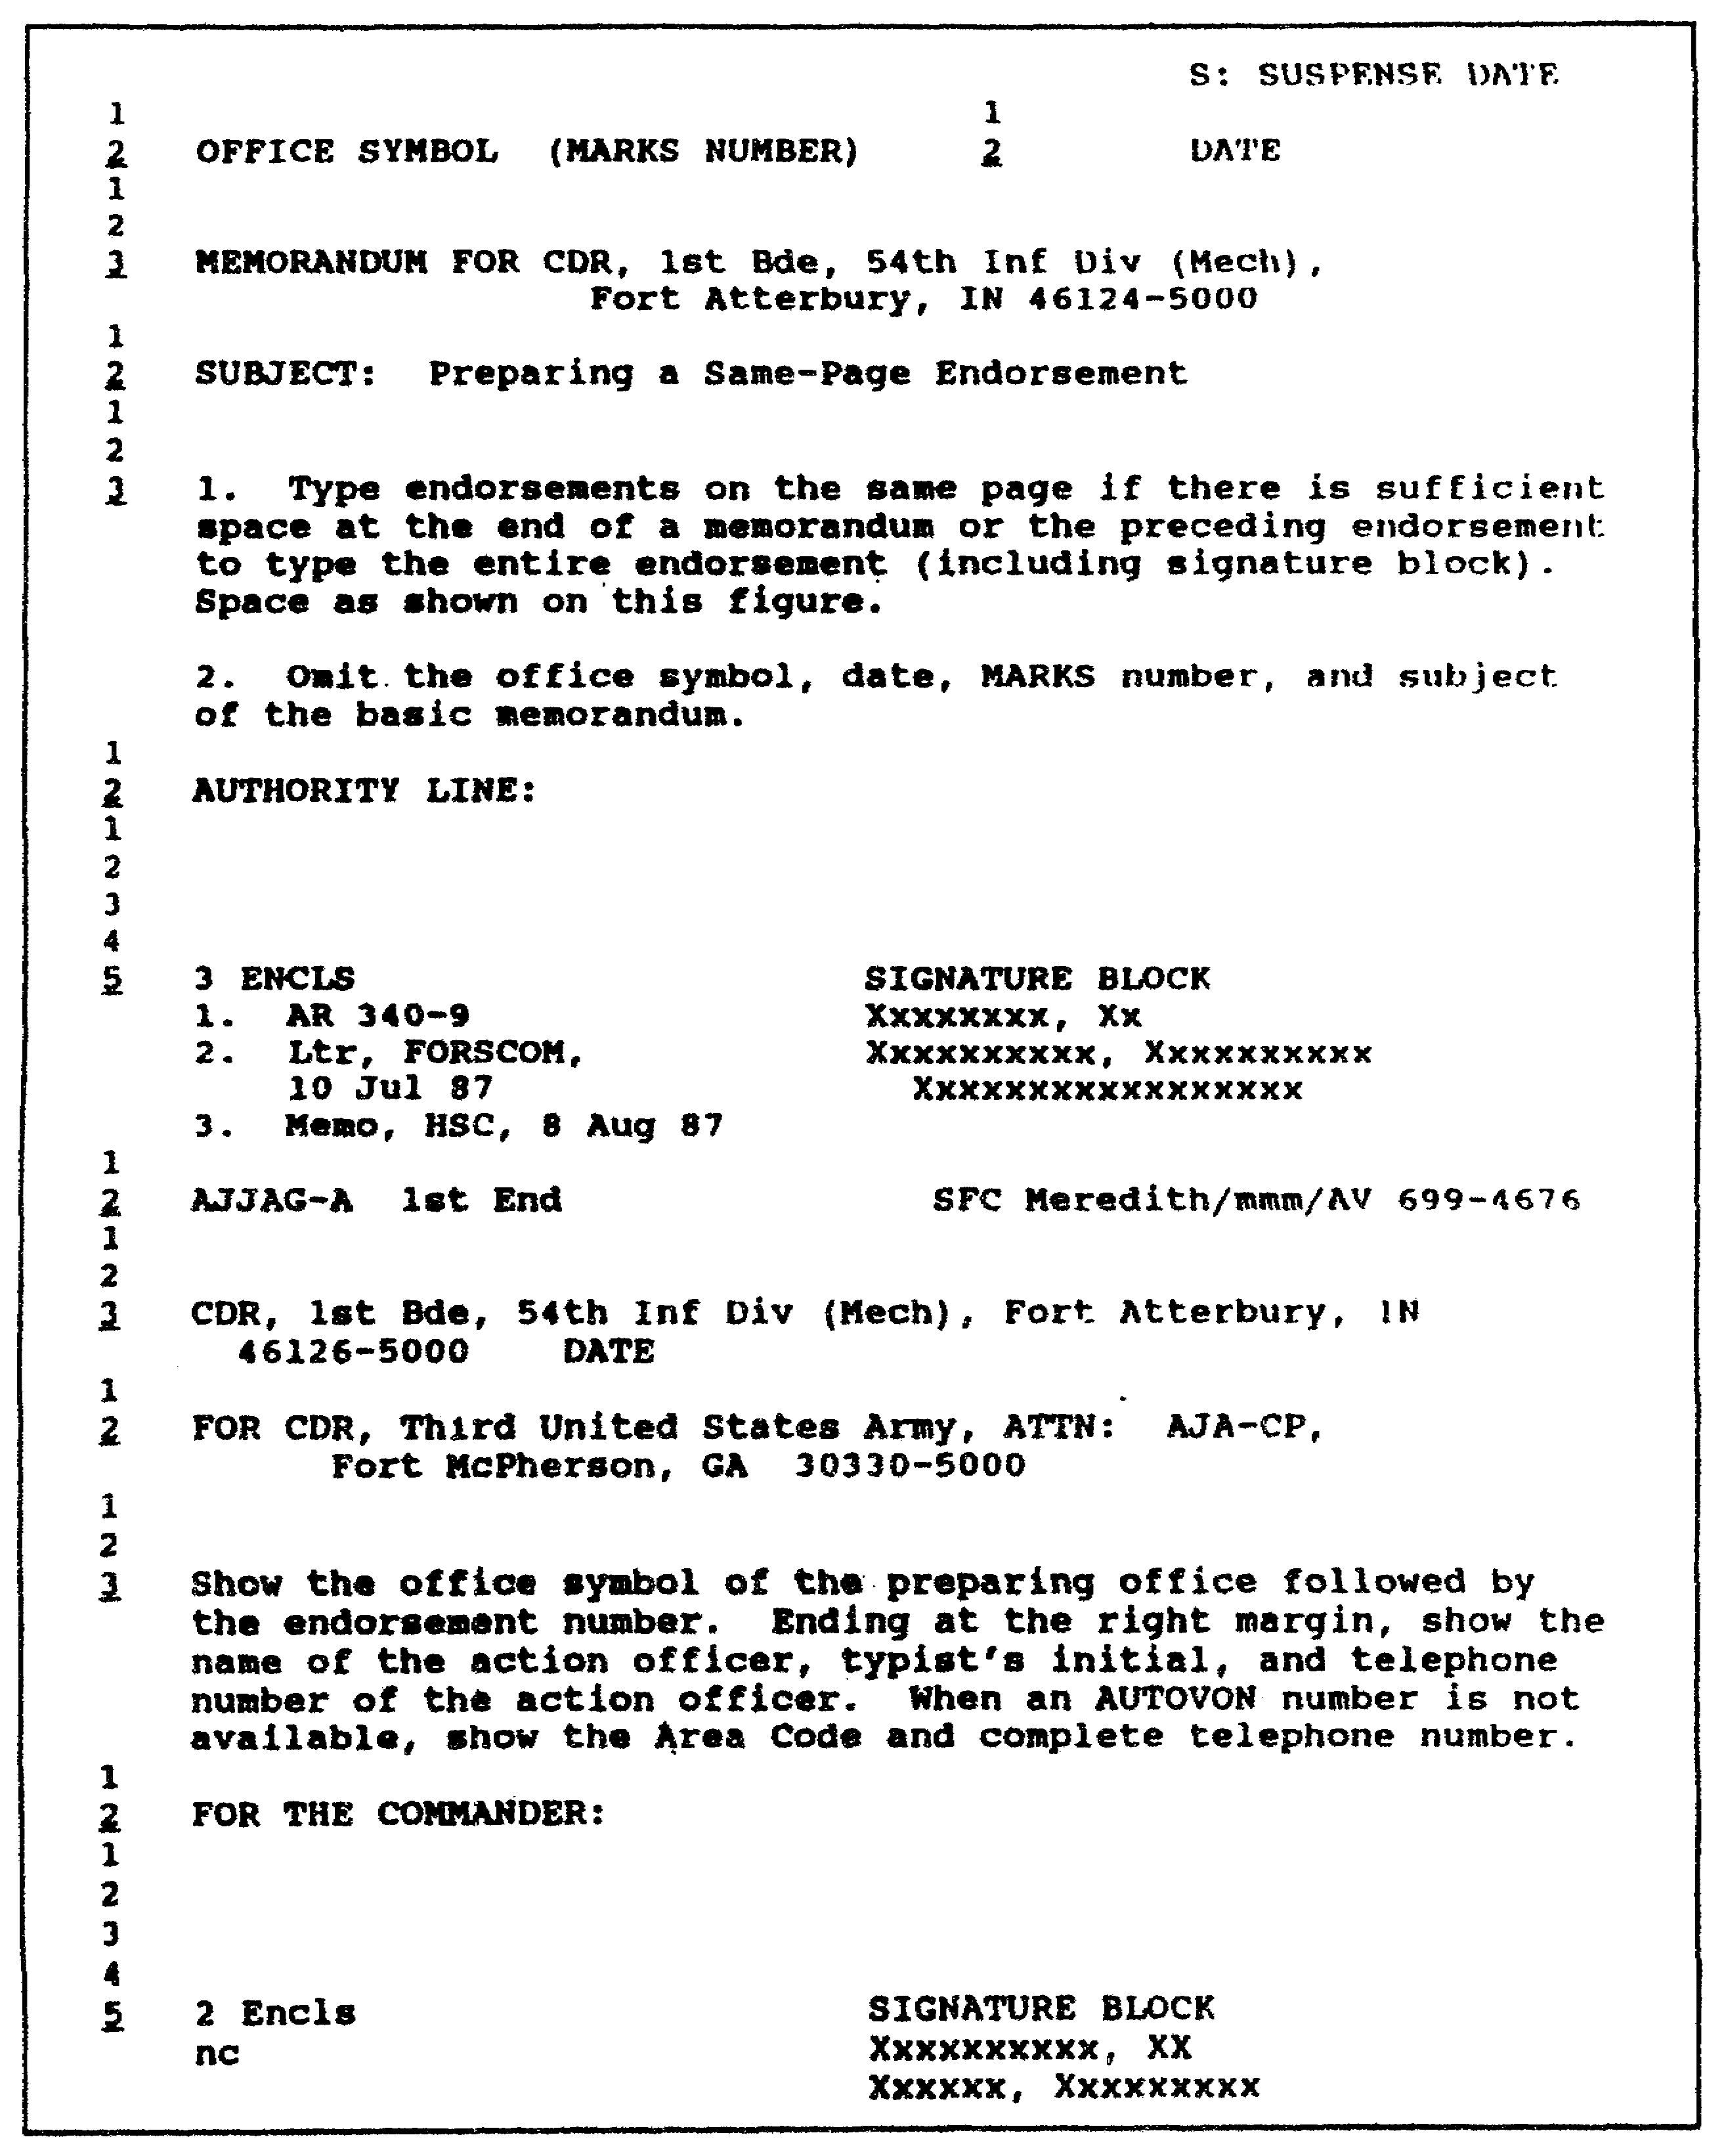

Figure 1-30. Preparing a same-page endorsement.

QM3517 1-40

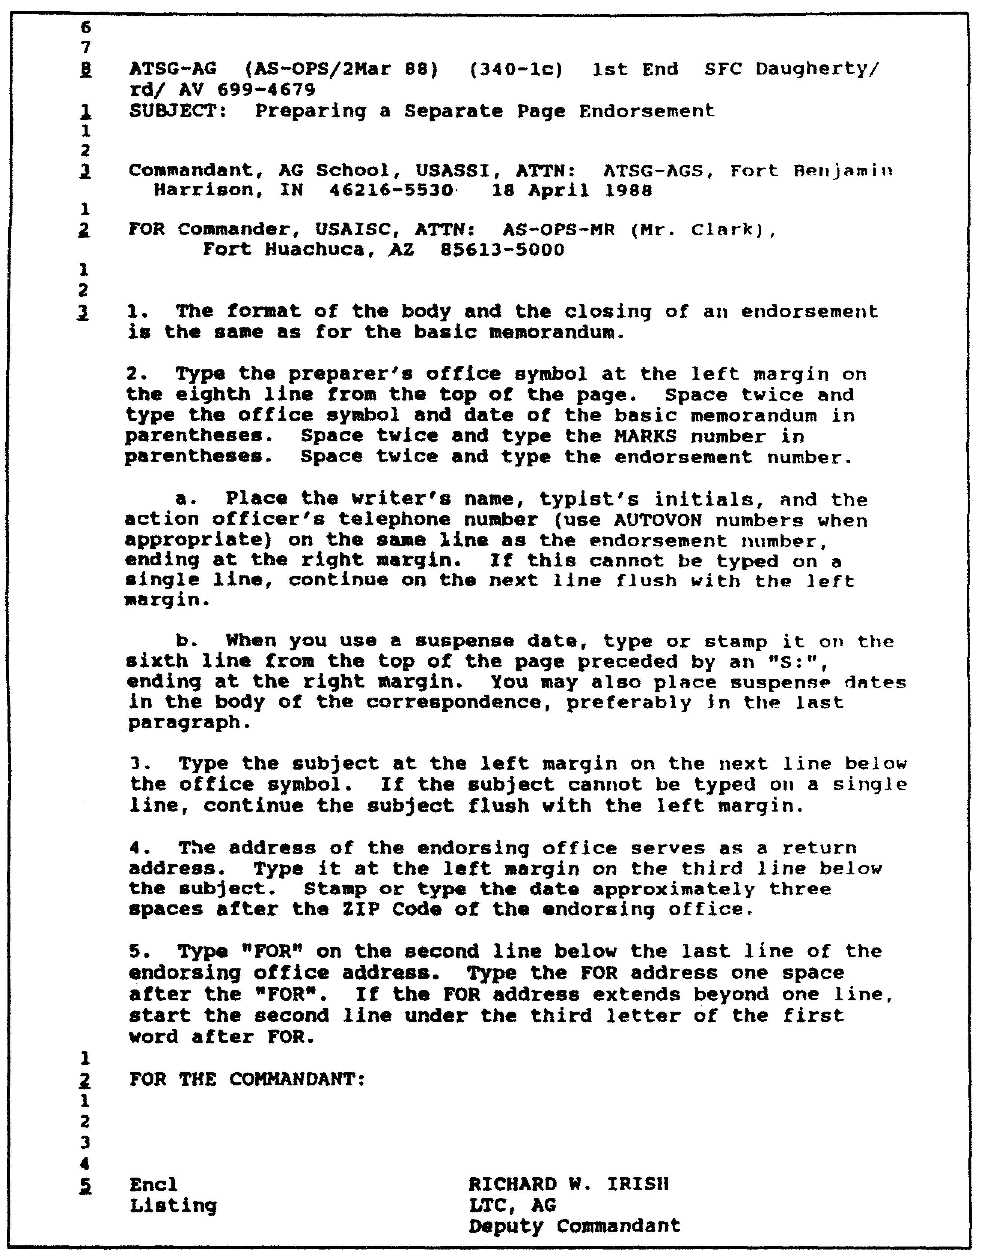

Figure 1-31. Preparing a separate-page endorsement.

1-41 QM3517

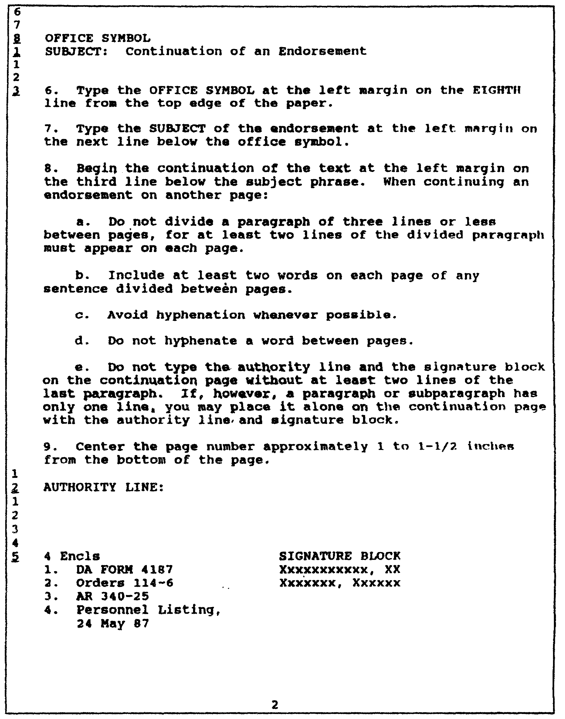

Figure 1-32. Continuation of an endorsement.

QM3517 1-42

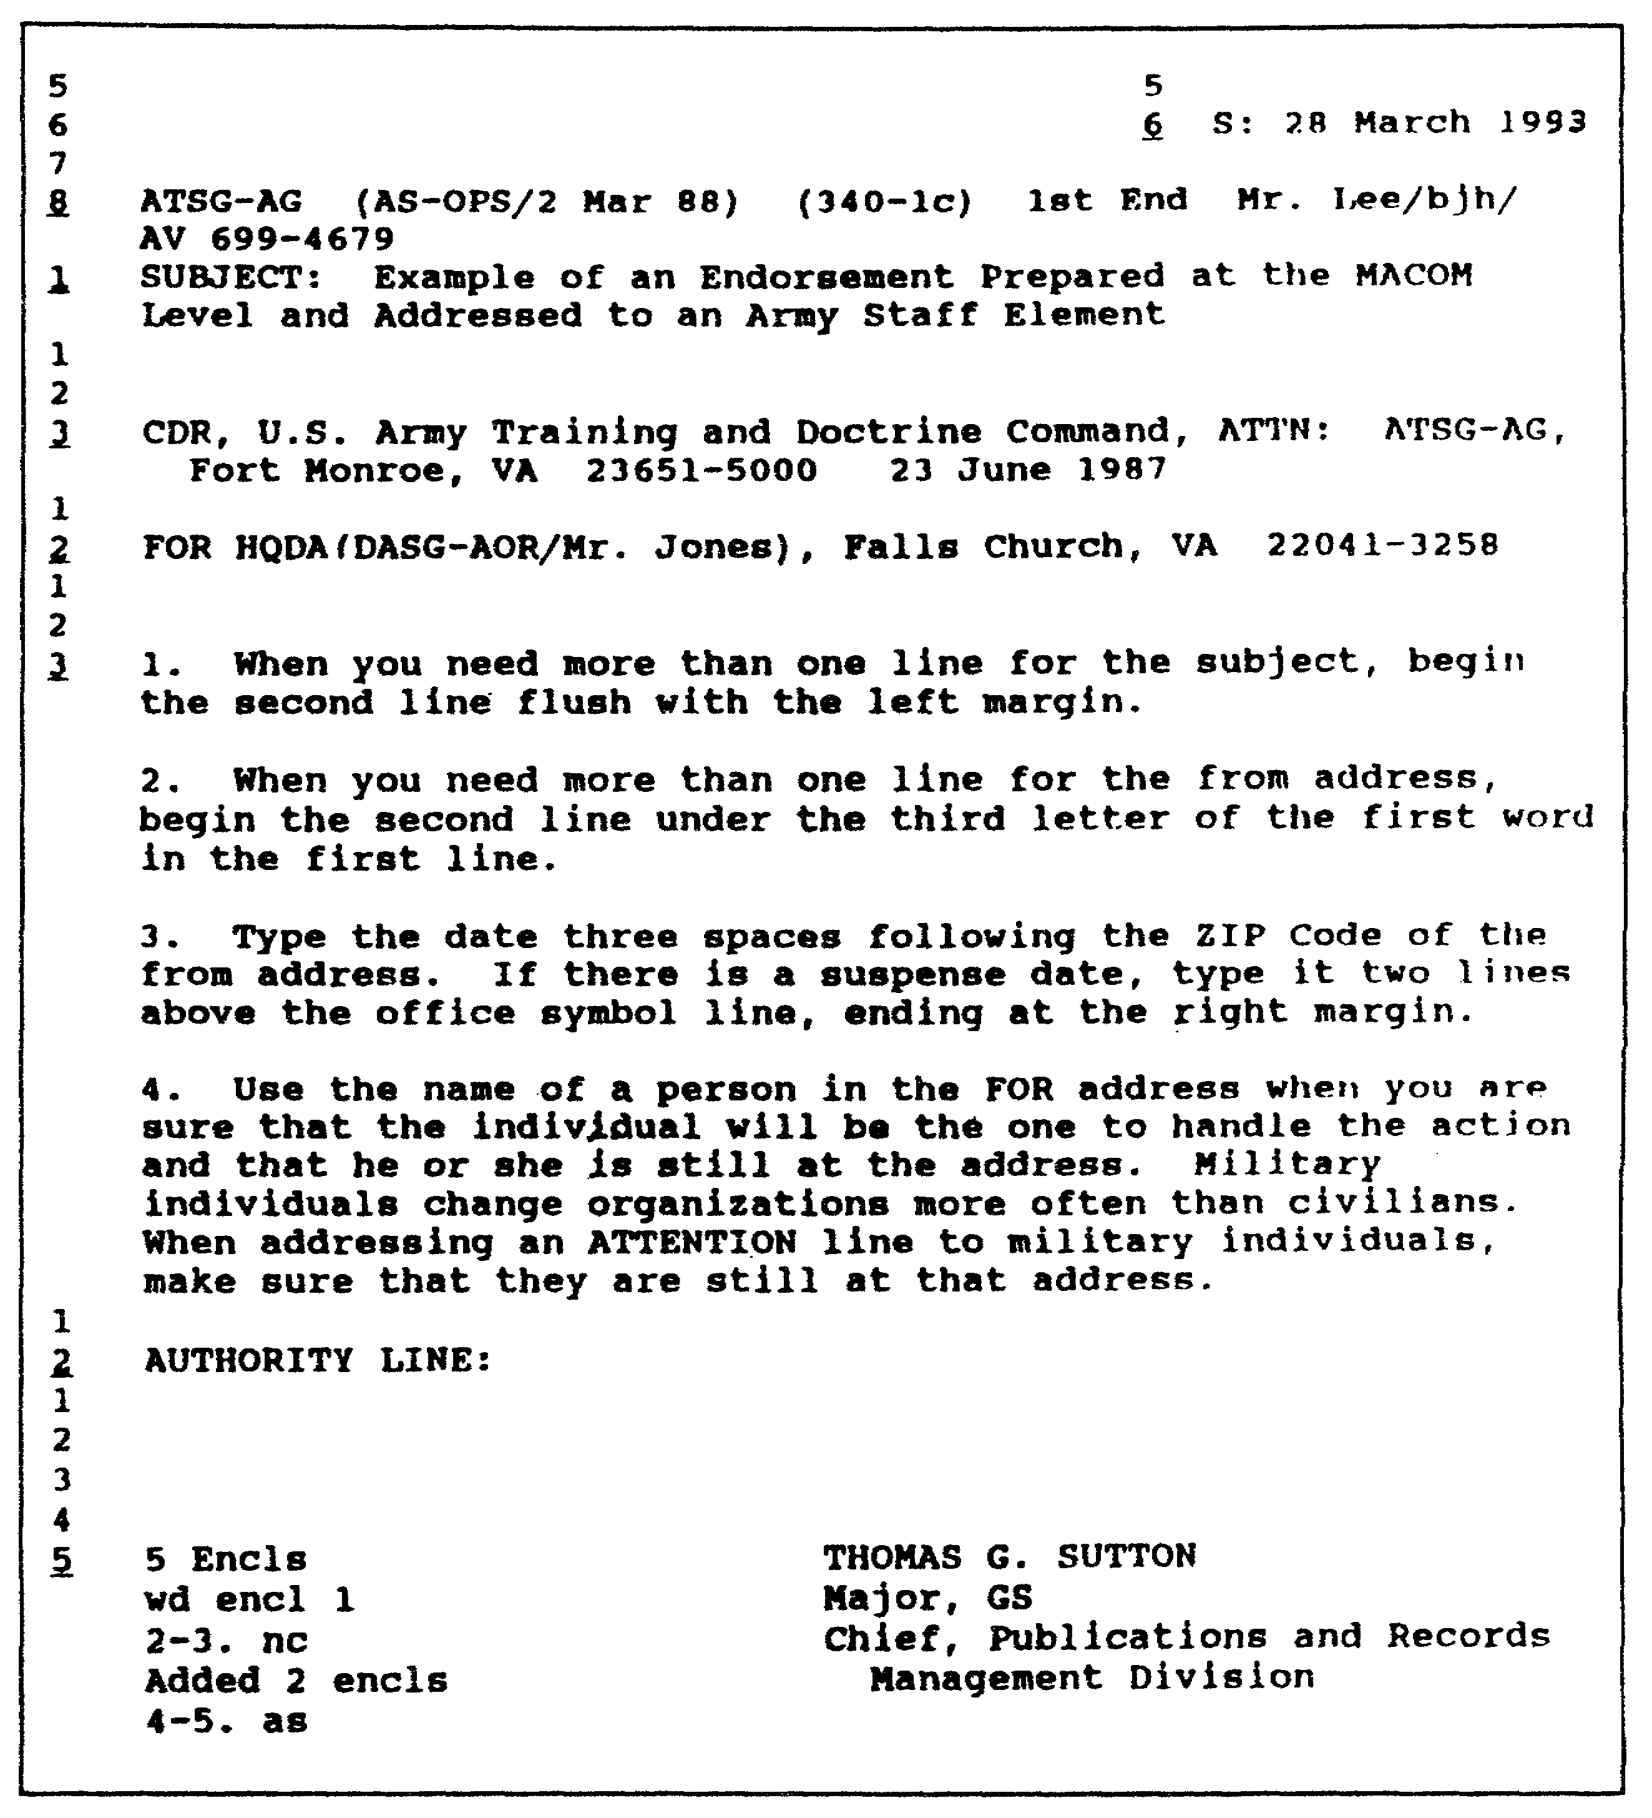

Figure 1-33. Example of an endorsement prepared at the
MACOM level and addressed to an ARSTAF element.

1-43 QM3517

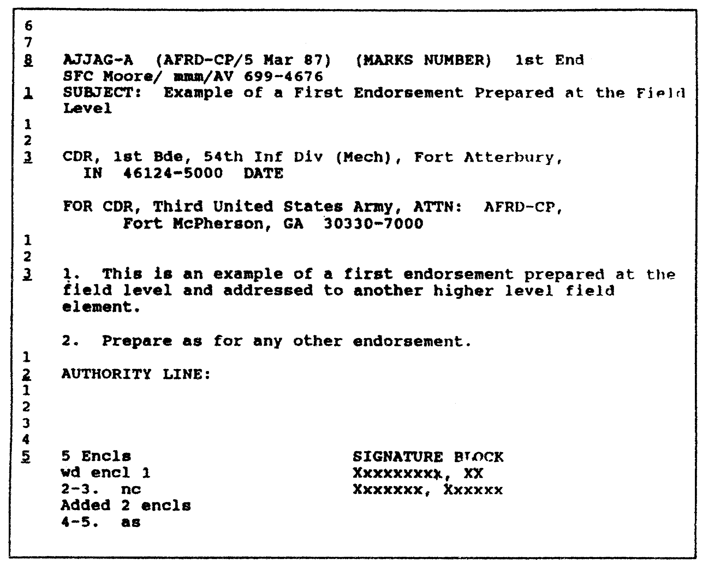

Figure 1-34. Example of a first endorsement prepared at
the field level and addressed to a field operation.

QM3517 1-44

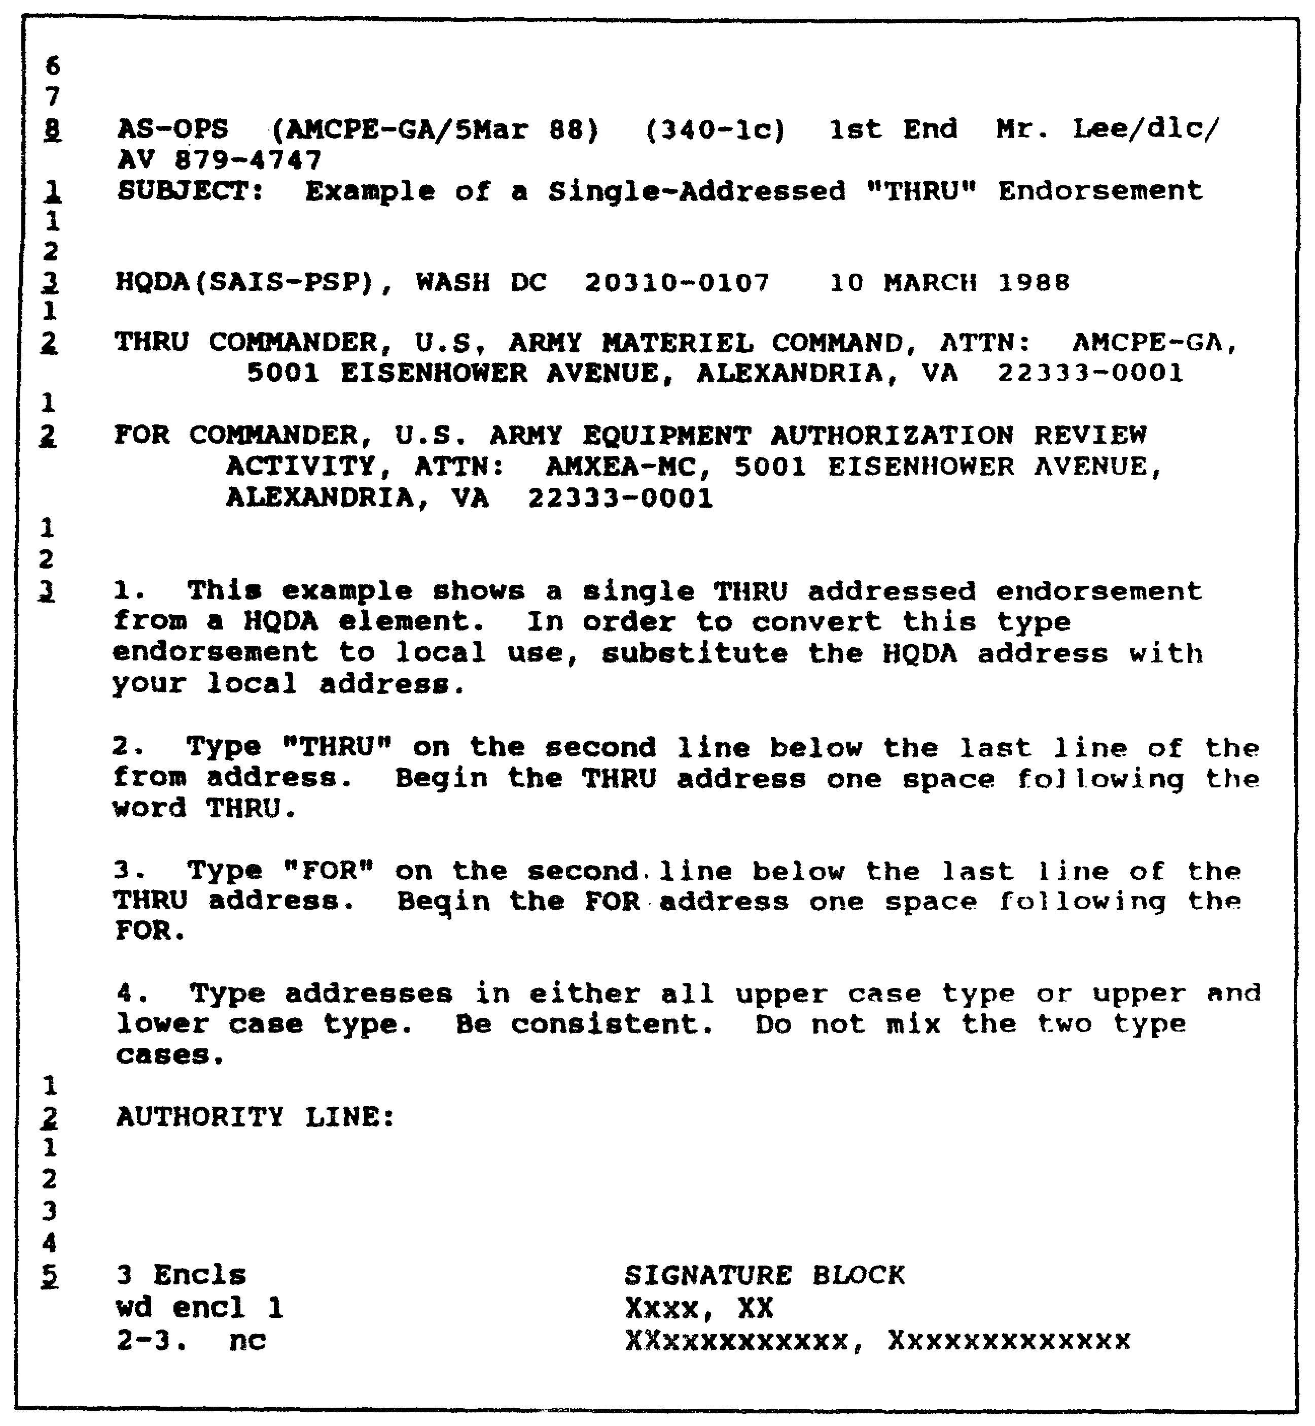

Figure 1-35. Example of a single addressed THRU endorsement.

1-45 QM3517

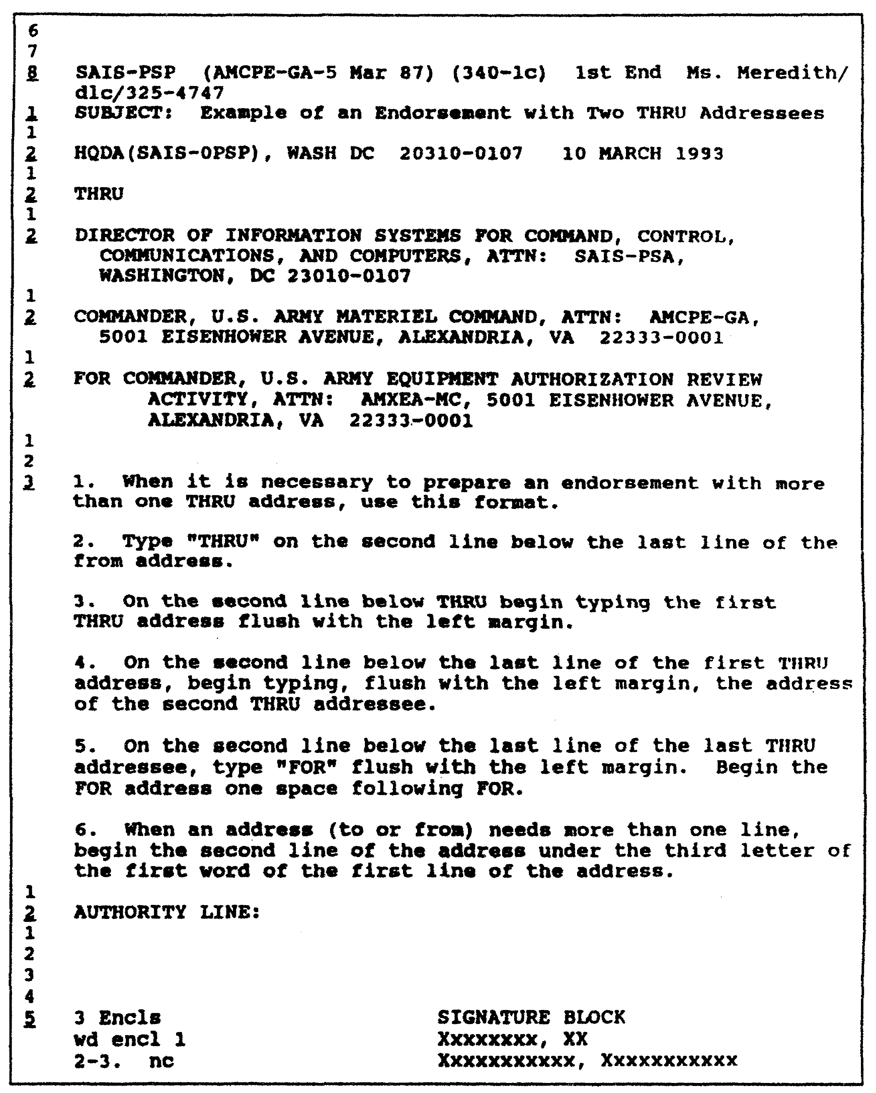

Figure 1-36. Preparing a multiaddressed THRU endorsement.

QM3517 1-46

f. General Rules for Letters. Certain general rules apply to letters. These rules are discussed in the following subparagraphs:

(1) Paper. Use standard 8 1/2- by 11-inch paper. Use the standard-size paper unless there is a good reason to use a larger size.

(2) Original Pages. Use white letterhead stationery for the first page. Use plain bond paper for all continuing pages.

(3) Copies. Use manifold carbon sets, when they are available. When these are not available, make copies on a copy machine.

(4) Margins. Adjust the margins on the page, centering the body of the letter as if it were going to be placed in a picture frame. Generally, set the left and the right margins 1 to 1 1/2 inches or more. DO NOT justify right margins. When you prepare two or more pages, leave at least a 1-inch margin at the bottom of the page.

(5) Addresses. AR 25-50, Appendix C, provides addressing, salutations, and complimentary closes for letters for a large number of personnel and activities, including all military personnel. Refer to this publication when you address letters.

(6) Point of Contact. When you write any type of correspondence, identify the writer by his military rank or by his civilian prefix, his last name, and his telephone number. When it serves a useful purpose to do so, use this sequence for the identification of the writer or the POC in the last paragraph. If necessary, add an address in the last paragraph as well. When you write to someone at another military installation, also include the writer's or the POC's telephone number. If an AUTOVON number is not used, list the area code with the commercial telephone number.

g. Format for Letters. The letter consists of three major parts:

o Heading.
o Body (text).
o Closing.

Refer to the following subparagraphs and to Figure 1-37 through Figure 1-42 for a discussion of these parts and subelements.

1-47 QM3517

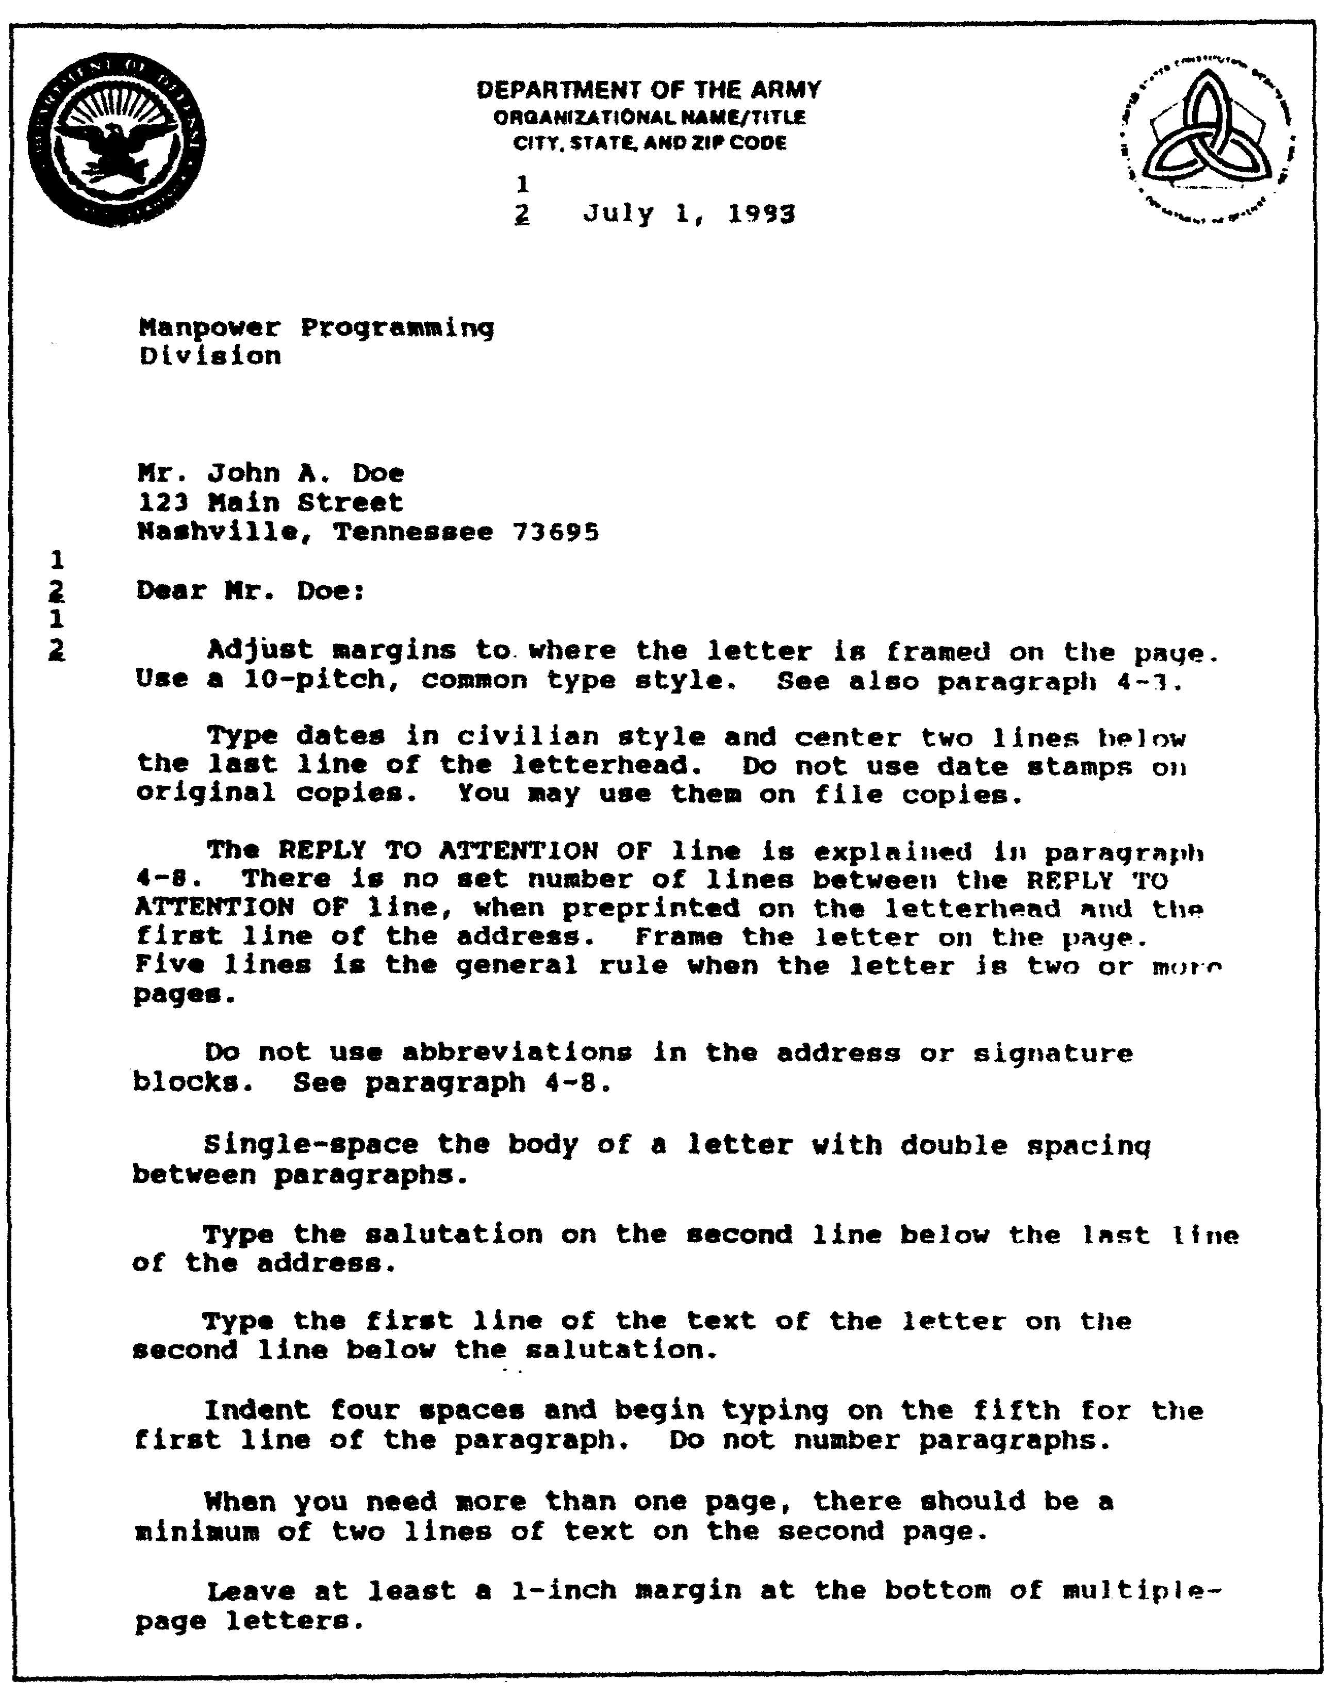

Figure 1-37. Basic letter format.

QM3517 1-48

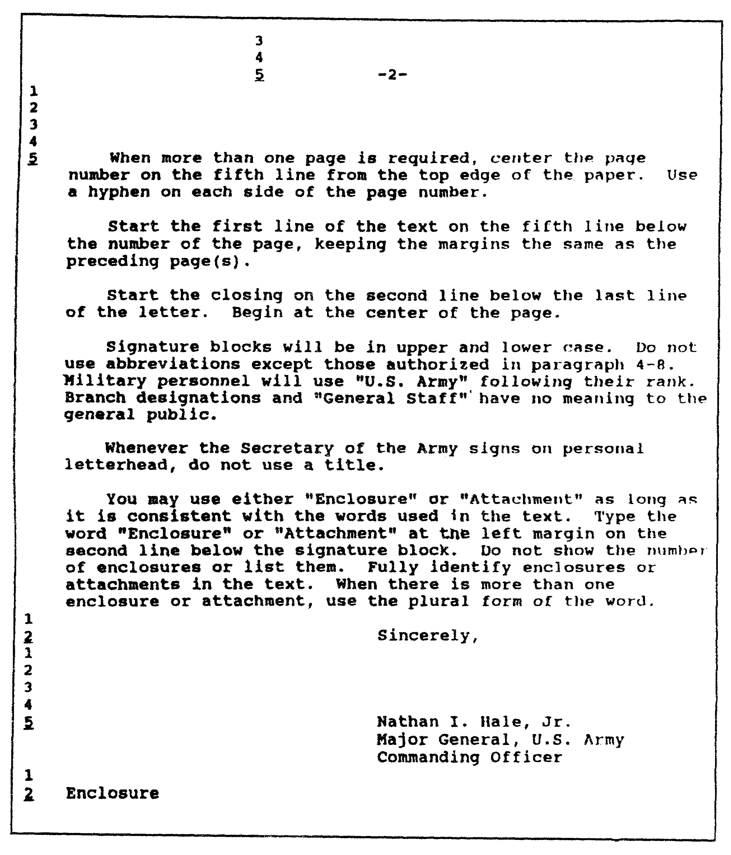

Figure 1-38. Continuation of a letter.

1-49 QM3517

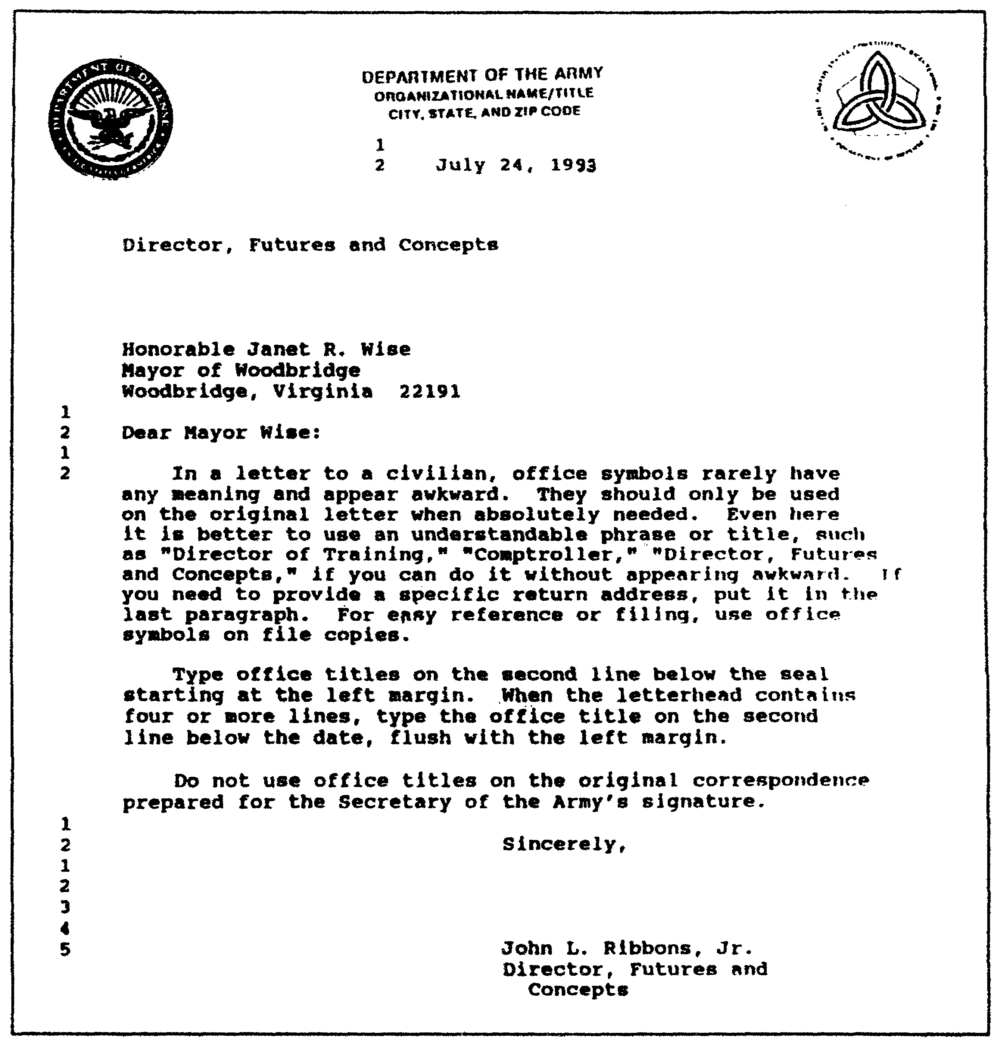
Figure 1-39. Use of office symbols and titles.

QM3517 1-50

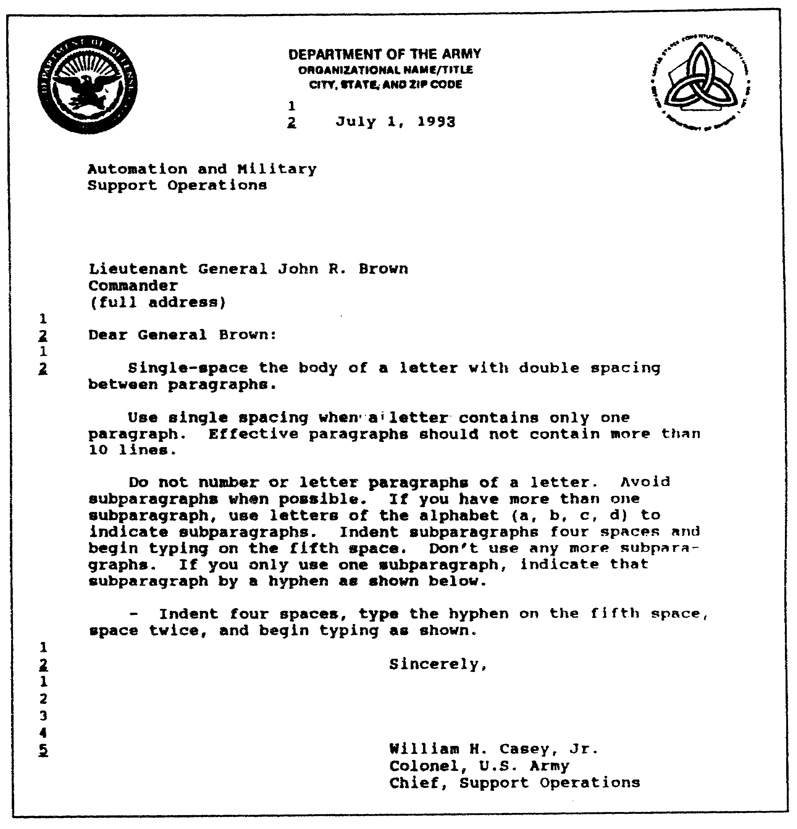

Figure 1-40. Spacing and letter with one subparagraph.

1-51 QM3517

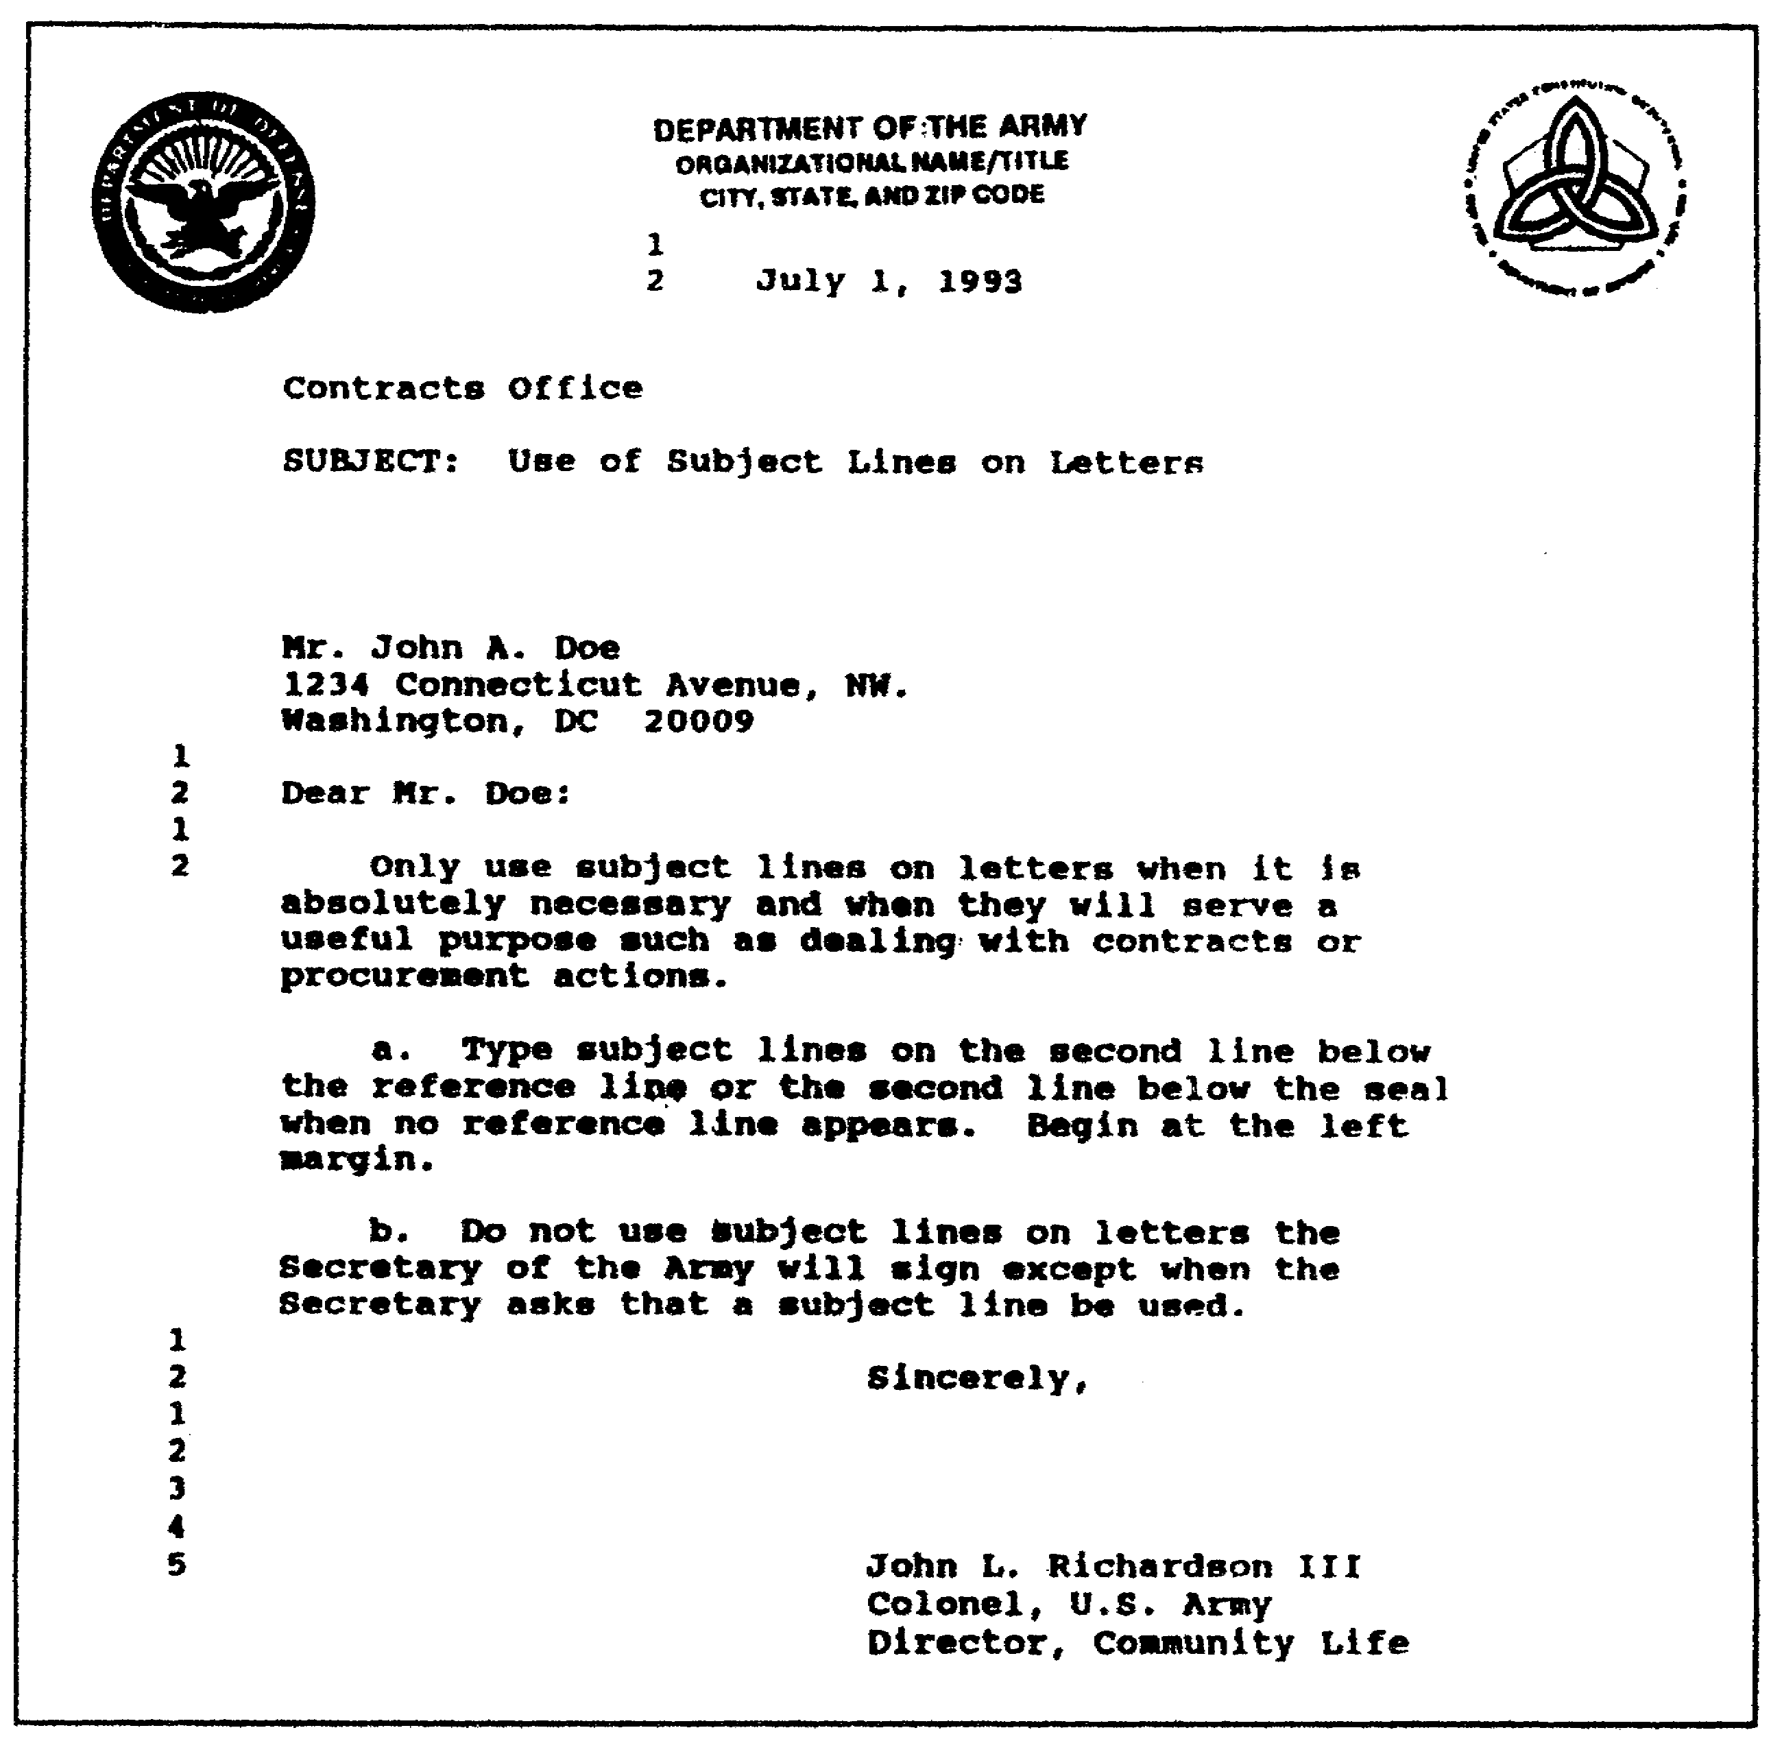

Figure 1-41. Letter with two subparagraphs and a subject line.

QM3517 1-52

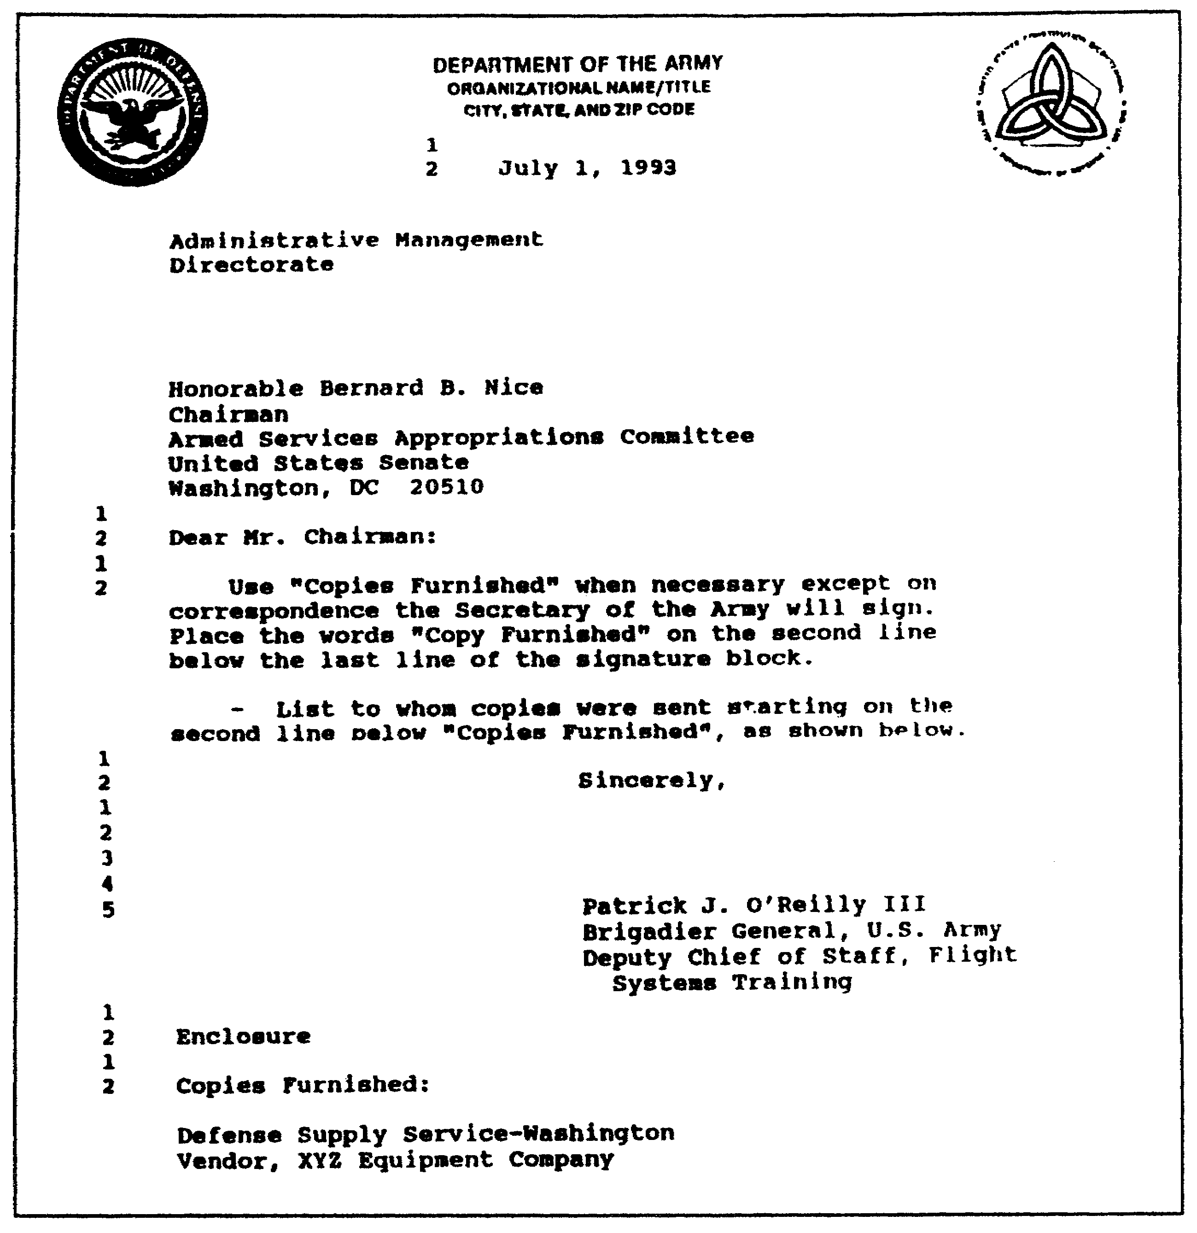

Figure 1-42. One paragraph and one subparagraph
and copies furnished.

(1) Heading. The heading consists of five elements:

o Date.
o "Reply to Attention Of" line.
o "Subject" line.
o Address.
o Salutation.

1-53 QM3517

The elements of the heading are shown in Figure 1-37.

(a) Date. Type the date in the civilian style (for example, January 4, 1988). Center it on the letterhead page, two lines below the heading. DO NOT use date stamps on original copies. Normally, date letters after they are signed.

(b) REPLY TO ATTENTION Of Line. Office symbols (Figure 1-37 and Figure 1-39) rarely have any meaning. They appear awkward to civilian recipients of a letter. DO NOT use them on the original letter. It is better to use an understandable phrase or title such as "Comptroller," "Directorate of Training", "Director", or "Futures and Concepts". If a more specific return address is required, you may include it in the text of the letter. Use office symbols on file copies for easy reference or for filing.

Type the office titles on the second line below the seal, starting at the left margin. The letterhead address may contain more than three lines, thereby bringing it near the bottom of the seal. If this is the case, then type the date as usual, two lines below the last line of the letterhead address. Type the office title on the second line below the date, starting at the left margin.

DO NOT use office titles on the originals of correspondence that is prepared for the signature of the Secretary of the Army.

There is no set number of lines between the "Reply to Attention Of" line and the first line of the address. Try to frame the letter on the page. Five lines is the general rule when the letter is two or more pages.

(c) SUBJECT Line. A subject line is shown in Figure 1-41. Use subject lines in the Army-style letter only when it is absolutely necessary to do so or when they serve a useful purpose. For example, use subject lines when you deal with contracts or procurement actions.

Type subject lines on the second space below the reference line or on the second line below the seal when no reference line appears, beginning at the left margin.

DO NOT use subject lines on letters to be signed by the Secretary of the Army except when the Secretary of the Army specifically requires this.

QM3517 1-54

(d) Addresses. DO NOT use abbreviations in the address. The only exceptions to this rule are the following abbreviations:

o DC.
o US.
o PO Box.
o Mr.
o Mrs.
o Dr.
o Jr.
o Sr.
o 2d.
o II.
o III.
o Ret.
o Compass points (NE, NW, SE, and SW).

NOTE: Always spell out state names.

There is no set number of lines between the "Reply to Attention Of" or the "Subject" lines and the address. Evenly space the letter on the page.

(e) Salutation. Type the salutation on the second line below the last line of the address.

(2) Body (Text). The following subparagraphs discuss information that pertains to the body (text) of the letter.

(a) First Line. Type the first line of the body of the letter on the second line below the salutation.

(b) Indents. Indent four spaces. Begin typing on the fifth space.

(c) Bottom Margin. Leave at least a 1-inch margin at the bottom of multiple-page letters.

(d) More Than One Page. If more than one page is needed (see Figure 1-38), then type a minimum of two lines on the continued page. Center the page number on the fifth line from the top edge of the paper. Use a dash on each side of the page number.

(e) Continuing Page. Start the first line of the text on the fifth line below the number of the page. Keep the margins the same as those of the preceding page or pages.

1-55 QM3517

(f) Paragraphs and Subparagraphs. DO NOT number or letter the paragraphs of a letter. Avoid subparagraphs when possible. When you use only one subparagraph, indent four spaces, type the dash on the fifth space, space twice, and begin typing as shown in Figure 1-40. When you need more than one subparagraph, use letters of the alphabet ("a", "b", "c", "d") to indicate subparagraphs (Figure 1-41). Never use further subparagraphs. Indent subparagraphs four spaces. Begin typing on the fifth space. Use single spacing even when a letter contains only one paragraph. For effective paragraphs, do not use more than 10 lines.

(3) Closing. See Figure 1-38. The closing has three subelements:

o Complimentary close.
o Signature block.
o Enclosure or copy furnished.

(a) Complimentary Close. Start the closing on the second line below the last line of the letter. Begin at the center of the page.

(b) Signature block. Type the signature block on the fifth line below the closing. Begin at the center of the page. Type the signature block in uppercase and lowercase letters. DO NOT use abbreviations in the signature block except for the following:

o "US Army."
o "Jr."
o "Sr."
o "II."
o "III."

When you use "US Army", use proper punctuation and correct spacing. Use the title "Jr." and the individual's full title to improve clarity. Whenever the Secretary of the Army signs on personal letterhead, DO NOT use a title.

(c) Enclosure or Attachment. Use either the term "Enclosure" or the term "Attachment" as long as it is consistent with the words that you used in the text. Type "Enclosure" or "Attachment" at the left margin on the second line below the signature block. DO NOT show the number of the enclosures or list them. If there is more than one enclosure, then show the plural form (for, example, "Enclosures [Encls]" or "Attachments [Atchs]"). Be sure that your enclosures or attachments are identified fully in the text. Do not use the words "As Stated".

QM3517 1-56

(d) Copy Furnished. Never use the term "Copy Furnished" on letters that are signed by the Secretary of the Army. If it is necessary for other signers to furnish a copy or copies to anyone other than the addressee, then place a statement in the body of the letter, preferably in the last paragraph, indicating that a copy or copies are being furnished and to whom. For example, you might state that "I am forwarding a copy (or copies) of this letter to (name and address)." (See Figure 1-42.)

Place the annotation for "Copy Furnished" or "Copies Furnished (CF) " at the left margin on the second line below the last line of the signature block or the enclosure listing, whichever is lower. List to whom the copy or copies was or were furnished, beginning on the second line below the "Copy Furnished" annotation, as shown in Figure 1-42.

If you list the enclosures, then place the copies furnished listing two lines below the enclosure listing and flush with the left margin.

3. Prepare Your Outline.

Prepare an outline using the same format that you use to prepare memorandums, endorsements, and letters. This gives you a pattern by which you can develop your ideas in a logical sequence. It also helps you to prepare your draft in a logical manner.

4. Prepare Your Draft.

Prepare your draft using the same format that you use to prepare memorandums, endorsements, and letters. When correspondence must be prepared for the approval or the concurrence of another office, submit it in draft form (unless you know that it will not be changed). The approving or the reviewing official signs and returns the draft. Prepare the final correspondence for signature. Attach the draft to the record copy.

5. Read Your Draft.

Read your draft. Use the criteria in the following subparagraphs to finalize your draft:

o Use the quick-screen edit that was discussed in subparagraph lc(1). Remember to check your grammar and spelling. Also, remember to avoid jargon, excessive and unnecessary words, and unfamiliar acronyms.

o Use the clarity index that was discussed in subparagraph lc(2) to help eliminate confusion, misreadings, ambiguities, and distracting aspects of your draft.

1-57 QM3517

Remember to use the active voice and the first person. Use familiar, plain, and accurate words. Review and revise your test as necessary for clarity and compactness.

o Share your draft. Have someone read your draft or listen to you as you read your draft. Have this person provide you with feedback.

o State your purpose or controlling idea up front, as previously discussed.

o Separate your supporting text.

o Proofread your final draft.

QM3517 1-58

LESSON 1

PRACTICE EXERCISE

The following items will test your grasp of the material covered in this lesson. There is only one correct answer for each item. When you complete the exercise, check your answers with the answer key that follows. If you answer any item incorrectly, study again that part of the lesson which contains the portion involved.

1. You are writing a two-paragraph memorandum. You ensure that you write the "bottom line" first. What is the bottom line?

A. The last line of the text.
B. The least important information.
C. The last paragraph of instruction or information.
D. The recommendation, the conclusion, or the reason for writing.

2. You make a single, rapid reading of your memorandum, looking for, and highlighting, major violations of the Army's standard of writing. You are using the

A. clarity index.
B. clarity-screen index.
C. quick-screen edit.
D. quick-clarity edit.

3. You use the formal memorandum for correspondence that is

A. internal to the headquarters or the command.
B. external to the headquarters or the command.
C. subject to revision or rejection.
D. used only by Army Agencies.

4. You send correspondence to a civilian agency to state your appreciation for some work that the agency's personnel performed at your facility. Which type of correspondence do you send?

A. Memorandum.
B. Letter.
C. Endorsement.
D. Note.

1-59 QM3517

5. The heading in a memorandum has how many elements?

A. Three.
B. Four.
C. Five.
D. Six.

6. Where do you place the action officer's telephone number on an endorsement?

A. On the same line as the endorsement number.
B. Above the office symbol.
C. Below the subject line.
D. On the second line below the address of the endorsing office.

7. The framework of the Army's new writing style is called

A. structuring.
B. active voice.
C. packaging.
D. condensing.

8. Where do you type the signature block on a letter?

A. On the fifth line below the closing, beginning at the center of the page.
B. On the fourth line below the closing, beginning at the right margin.
C. On the third line below the closing, beginning at the left margin.
D. On the second line below the closing, beginning at the center.

QM3517 1-60

LESSON 1

PRACTICE EXERCISE

ANSWER KEY AND FEEDBACK

Item Correct Answer and Feedback

1. D. The recommendation, the conclusion, or the reason for writing.

Put the recommendation, the conclusion, or the reason for writing (the "bottom line") in the first or the second paragraph, not at the end. (page 1-2, para la(1))

2. C. quick-screen edit.

The quick-screen edit is a tool that identifies major violations of the Army standard for writing. To use the quick-screen edit, use a highlighter, a pencil, or pen and, in a single, rapid reading, underline the purpose of the writing; passive voice constructions; unnecessary long words or jargon; and spelling, punctuation, or grammar mistakes.
(page 1-7, para lc(1))

3. B. external to the headquarters or command.

Use the formal memorandum for correspondence that is sent outside the headquarters, the command, the installation, or similar identifiable organizational elements.
(page 1-16, para 2a(1))

4. B. Letter.

Use the letter for official business with non-DOD and DOD civilians and military members whom you address by name. Use the letter when you correspond with a civilian agency official or other government agency officials, including state and local officials. Use letters for official personal correspondence by military and civilian personnel, for letters of welcome, and for letters of appreciation or commendation. (page 1-39, para 2e)

1-61 QM3517

5. D. Six.

The heading has six elements. They are as follows:

o Office symbol or reference symbol.
o MARKS number.
o Date.
o Suspense date.
o "MEMORANDUM FOR" line.
o "Subject" line.

(page 1-19, para 2c(l))

6. A. On the same line as the endorsement number.

Place the writer's name, the initials of the typist, and the telephone number of the action officer on the same line as the endorsement number, ending at the right margin.
(page 1-37, para 2d)

7. C. packaging.

Require all staff writing to be packaged specifically. Focus first on the main point. Doing so changes the overall construction of Army writing. This restructuring, called packaging, is the framework of the new writing style.
(page 1-5, para 1b(2))

8. A. On the fifth line below the closing, beginning at the center of the page.

Type the signature block on the fifth line below the closing, beginning at the center of the page. Type the signature block in uppercase and lowercase letters. DO NOT use abbreviations in the signature block except for the following:

o "US Army."
o "Jr."
o "Sr."
o "II."
o "III."

When you use "US Army," use proper punctuation and correct spacing. Use the title "Jr." and the individual's full title to improve clarity. (page 1-56, para 2g(3)(b))

QM3517 1-62

LESSON 2

PROFESSIONAL BRIEFING TECHNIQUES

Critical Task: 01-9007.01-0250

OVERVIEW

LESSON DESCRIPTION:

In this lesson, you will learn how to conduct an information briefing, a decision briefing, and an action briefing. You also will learn the following briefing requirements:

o Determine your purpose for the briefing.

o Identify your audience and its level of understanding.

o Determine when and where to give your briefing and how much time it should take.

o Determine how much preparation time is available.

o Research, outline, and draft your briefing text using the same process that you use in the Army style of writing.

o Add cues to your briefing text to support your briefing.

o Rehearse, simulating the audience and the location.

o Conduct your briefing.

o Respond to questions.

TERMINAL LEARNING OBJECTIVE:

ACTION: Conduct an information briefing, a decision briefing, a mission briefing, and a staff briefing.

CONDITION: You will be given information from AR 25-50 and DA Pamphlet 600-67.

STANDARD: Conducting an information briefing, a decision briefing, a mission briefing, and a staff briefing will be in accordance with AR 25-50 and DA Pamphlet 600-67.

2-1 QM3517

REFERENCES: The material contained in this lesson was derived from the following publication: FM 101-5.

INTRODUCTION

Your communication skills either help or hinder workmanship. You must employ effective communication to accomplish the following job-related functions:

o Teaching.
o Coaching.
o Briefing.
o Counseling.
o Supervising.
o Coordinating.
o Evaluating.

The communication process is complex. For example, how many times have you heard someone say, "Well, I told Jones to do it" only to find that Jones misunderstood the message? Unless you encode and transmit your message skillfully, your listener may misinterpret it.

Methods of communication include written and telephonic messages. However, the Army prefers face-to-face communication. Face-to face communication contains both content and context. Content consists of the actual words or symbols that you use. Context includes both verbal and nonverbal cues. For you, the military briefing is a very important face-to-face form of communication. The military briefing is a specialized type of speech. Use it to present selected information to staffs, commanders, or other designated audiences. Base your briefing technique on the following considerations:

o Purpose of the briefing.
o Required response.
o Your role as the briefer.

PART A - BRIEFINGS

1. Types of Briefing.

The term "briefing" is applied loosely to almost any oral presentation that is given in connection with military activities. However, the purpose of this lesson is to discuss only the following three basic types of briefings:

o Information briefing.
o Decision briefing.
o Briefing to take action.

QM3517 2-2

Refer to the paragraphs 2 through 4 of this lesson for a discussion of each of these respective types of briefing.

2. Information Briefing.

The information briefing is designed to inform the listener. It deals primarily with facts and does not include a conclusion or a recommendation. Use it to present the following:

o High-priority information that requires immediate attention.

o Complex information that involves complicated plans, charts, systems, or statistics.

o Controversial information that requires elaboration and explanation.

a. Purpose. The purpose of the information briefing is to keep listeners abreast of current situations. You can use it to supply specific information.

b. Characteristics. As mentioned previously, the information briefing deals with facts. It does not include recommendations or conclusions.

c. Format. The format consists of the following three elements:

o Introduction.
o Body.
o Closing.

Refer to the following subparagraphs for details.

(1) Introduction. The introduction is divided into the following four parts:

o Greeting.
o Identification and classification.
o Purpose.
o Procedure.

(a) Greeting. In your greeting, address the persons whom you are briefing. Use military courtesy.

(b) Identification and Classification. Identify both yourself and the organization for which you work. Announce the classification of your briefing.

2-3 QM3517

(c) Purpose. Explain the purpose of your briefing. Identify your main topic and its relevancy to your audience.

(d) Procedure. Give a brief outline of your material. Give the sources that you used for your information. The following is an example of an introduction for an information briefing.

General Smith, General Jones, and gentlemen, I am Captain Black, S3 of the 1st Battalion. I am going to explain the concept, the objectives, and the key features of the battalion's new physical fitness program. Then, I will escort you to our proficiency course where you can observe Company A taking the test.

(2) Body. Use the following guidelines when you organize the body of your information briefing:

o Focus on your topic.
o DO NOT allow side issues to distract your focus.
o Arrange your main point in a logical sequence.
o Support your points with factual information.
o Use visual aids correctly.
o Prepare to answer questions at any time.

(3) Closing. The last part of a briefing is the closing. The closing portion of the briefing is very simple. For example, if you present an information briefing on your battalion's new physical fitness program to a group of visiting officers, you might close with the following example:

Sir, I have covered the concept, the objectives, and the key features of this battalion's new physical fitness program. This concludes my briefing. Do you have any questions?

As the example shows, your briefing should accomplish the following:

o Summarize the main points.

o Make a concluding statement and ask for questions.

In addition, in your closing, you may introduce the next briefing, if there is one.

QM3517 2-4

3. Decision Briefing.

Formats vary from one organization to another. The format that is suggested in this lesson provides a structure which results in a formal presentation that often is used in higher echelons. Combine or omit parts of this structure depending on how you need to brief your subject matter and on whether the audience already knows some of the facts.

a. Purpose. The purpose of a decision briefing is to produce an answer to a question. Also use a decision briefing to obtain a decision concerning a specific problem.

b. Characteristics. A decision briefing is used at high command levels. It often is called an oral staff study.

c. Format. Like the information briefing format, the format for the decision briefing consists of the following three elements:

o Introduction.
o Body.
o Closing.

The following subparagraphs discuss these elements of the format.

(1) Introduction. Using military courtesy, address the persons whom you are briefing. Identify yourself and the organization for which you work. For a team presentation, introduce all the members of the team and provide information concerning the team's years of experience and current and future assignments. Address the following key points of the introduction:

o State the type and the purpose of your briefing.

o State the subject and the classification of your briefing.

o State the reason for your briefing. For example, state that "This briefing results from _______________".

o Establish the cause of the problem (or a concise background).

o State the sources of your information, the points of coordination, or both. Establish your research expertise.

o State the order in which you will cover the points in your presentation.

2-5 QM3517

Study the following two examples of the introductory parts of a decision briefing:

o "Sir, this is a decision briefing. The purpose of this briefing is to obtain your signature on the memorandum that is to be used to transmit our staff study for concurrence and implementation."

o "General Smith, Colonel Jones, and gentlemen, I am Captain Black, the S3 action officer for the implementation of this new mobilization alert plan. Portions of this briefing are classified SECRET. Captain White, the S2, has cleared all of you for access to the material. The purpose of this briefing is to present you with this unit's recommendations to the plan and consequently to obtain your approval. I have coordinated with the interested staff sections of your headquarters."

(2) Body. Arrange your main ideas in a logical sequence. Support your points with factual information. Follow the staff study format which dictates the following sequence:

o Subject and the names of the presenters.

o Statement of the problem.

o Facts that bear on the problem.

o Assumptions, if there are any.

o Options, advantages, and disadvantages of each option.

o Conclusions.

o Recommendations. Word the recommendation so that it requires only approval or disapproval.

NOTE: Create visual aids for each element as appropriate.

State any follow-on actions that will be necessary to complete the research or to complete the implementation of the steps to be used to solve the problem.

(3) Closing. Make a concluding statement and ask for questions. For example, you might state, "Ladies and gentlemen, this concludes the briefing. Do you have any questions"?

QM3517 2-6

Give the reason for the need of an immediate decision. For example, you might state, "Sir, we need a decision now because_________ ". If no decision is given, then ask for the decision. For example, you might ask, "Sir, what is your decision"?

4. Direct Action Briefing.

There are two types of briefings that direct action. They are the staff briefing and the mission briefing.

a. Staff Briefing. The staff briefing is the most widely used briefing. Use it to keep commanders and their staffs abreast of situations. It may involve the following:

o A change of information.
o An announcement of a decision.
o An issuance of directives.
o The presentation of guidance.

However, its main purpose is to secure a coordinated or a unified effort.

At the battalion level and below, the staff briefing normally is conducted by the commander. At higher levels, the chief of staff usually presides over the staff briefing. He calls on staff representatives to present matters that interest those who are present or matters that require a coordinated staff action. Each staff officer briefs his area of responsibility. In field or combat operations, tactical matters predominate when staff briefings are held on a regularly scheduled basis. The substance of each staff officer's presentation may be an update of material that was presented previously.

(1) Purpose. The purpose of the staff briefing is to rapidly disseminate information orally, to aid group decision making, and to secure a unified effort.

(2) Characteristics. The staff briefing's chief characteristic is that it is the most flexible type of briefing. It is used at all levels of command and ensures the unity of command.

(3) Format. Local standing operating procedures (SOPs) determine form and format, which vary from unit to unit.

b. Mission Briefing. Use the mission briefing to do the following:

o Elaborate on an order.
o Give specific instructions.

2-7 QM3517

o Instill a general appreciation of a mission.

The intended result of the mission briefing is to impart a thorough understanding or appreciation for the unique aspects that a mission involves.

(1) Purpose. The purpose of the mission briefing is to impart information, to give specific instructions concerning a mission, or to instill appreciation for a mission.

(2) Characteristics. The mission briefing does the following:

o Reinforces orders.

o Provides more detailed requirements and instructions for individuals.

o Provides an explanation of the significance of the roles of the individuals who participate in the mission.

You must present the briefing with care to ensure that it does not cause confusion or conflict with orders.

(3) Format. This format also uses an introduction, a body, and a closing, as discussed in the previous briefings. However, the body includes the following:

o Situation.
o Mission.
o Execution.
o Service support.
o Command and signal.

5. Military Briefings--General.

You must know how to plan, how to organize, how to prepare, and how to conduct military briefings. The following subparagraphs discuss military briefings in general.

a. Nature of the Briefing. The briefing is so common that giving one is a routine staff function at all echelons of command. Officers should know the format of the briefing, how to prepare the briefing, and how to deliver the briefing. The purpose of the military briefing is to inform, to obtain a decision, or to direct action.

The audience for the military briefing differs from the audience for oral instruction. In most cases, the audience for a military briefing consists of your superiors or very important guests of

QM3517 2-8

the military. With regard to the military briefing, address your remarks as is appropriate to the rank of your audience.

Unlike students, each person at a military briefing has his own reason for attending. DO NOT include in the introduction of an oral briefing a statement as to why it is important for the audience to learn the subject. Keep in mind that the audience of the briefing wants to be informed in a limited amount of time. Make a concise presentation of the facts.

When you consider that the purpose, the audience, and the content of the oral military briefing differ from those for oral instruction, it is logical to conclude that your delivery techniques also will differ. When you give an oral military briefing, your delivery technique must be formal.

b. Types of Briefings. There are no official Army-wide classifications for the briefing. This lesson has discussed the information briefing, the decision briefing, the mission briefing, and the staff briefing. You can use these types of briefings to conduct briefings for specific audiences and purposes. For example, you would use the information briefing to brief a group of local civilian officials concerning the organization, the missions, and the operations of your unit.

c. Briefing Plans. Use the following five steps to plan a briefing:

o Make an estimate.
o Select and organize the content or the body.
o Write an outline or a manuscript.
o Rehearse.
o Make a final check.

(1) Make an Estimate. Your first step in planning a briefing is to make an estimate. Your estimate of the briefing involves the consideration and the evaluation of all the factors that may guide and influence your preparation for, and presentation of, the briefing. You also must consider the following principal factors of your estimate:

o Purpose and scope.
o Audience.
o Time and schedule.
o Facilities and equipment.
o SOP.

NOTE: Ensure that your SOP includes the preparation for, and the approval of, the manuscript. It also includes the rehearsal.

2-9 QM3517

(a) Purpose and Scope. When your commander tells you to prepare and to present a briefing for the division commander, begin immediately. Ask the following questions:

o Will I be speaking to the division commander only or will there be others with him?

o When and where will the briefing take place?

o How much time will I have to prepare for, and to conduct, the briefing?

o Am I responsible for the facilities and the equipment?

o Should I follow the regular SOP?

o What is the purpose of my briefing?

o What is the scope of the briefing?

(b) Audience. Once you know the purpose and the scope of your briefing, you need to know the following information concerning the principal members of your audience:

o Names.
o Grades.
o Official positions.
o Backgrounds.

Remember that the composition of the audience may influence the subsequent planning and the actual content of your briefing.

(c) Time and Schedule. How much time you have to prepare and how much time you have on the schedule are also important considerations in your briefing estimate. Plan to present your briefing within the time that is allotted, but also plan to be flexible. For example, you may conclude your briefing of the division commander on schedule and invite your audience to ask questions. The general may ask you to explain your use of self-tutor texts (a subject that you did not mention in your briefing). In this case, answer the question. You planned to be flexible and that includes being flexible in time and subject matter.

(d) Facilities and Equipment. You must ensure that the facilities and the equipment that you require for your presentation are ready. If you do not do so, you may encounter problems or failure. For example, a few minutes before your briefing, you discover that your briefing room is too small for the audience and that one of your visual aids is too large to fit

QM3517 2-10

through the door. You may have lost the opportunity for a successful briefing.

(e) Standing Operating Procedures. Most major headquarters have an SOP for oral briefings. The SOP reflects the desires of the commanding officer. Expect the SOP to vary from one unit to the next. Generally, the SOP covers the following matters:

o Approval of outlines or manuscripts.
o Responsibility for facilities.
o Style and the type of visual aids.
o Rehearsals.
o Presentation techniques.

Read the unit SOP on briefings.

(2) Select and Organize the Content. Your second step in planning a briefing is to select and to organize the content. Select only the material that meets these criteria. For example, you may be tasked to brief the division commander concerning the battalion plan for a field exercise that you will conduct in 30 days. For this briefing, you would select the following:

o Training objectives.
o Logistical support plan.
o Status of the personnel and the training.

Your first concern in selecting material is its pertinence. Also, make sure that the material is accurate and factual.

(3) Prepare the Outline or the Manuscript. The third step in planning your briefing is to prepare an outline or a manuscript. Check your unit's SOP on briefings for format, review, and approval requirements. A good outline or manuscript is essential to an effective briefing.

(4) Rehearse. Effective oral instruction and effective military briefings require rehearsing. This is the fourth step in your planning process. Use the following guidelines for rehearsing:

o Ask someone to listen to your rehearsal. Make sure that he has the expertise to critique both the content and the delivery techniques.

o Practice using the training aids and the assistants that you will use in the actual briefing.

2-11 QM3517

o Rehearse until you can present the material fluently, clearly, and without using your notes.

Even if you are required to present a briefing from a manuscript rather than extemporaneously, you still need to rehearse.

(5) Make a Final Check. The last step in preparing an oral briefing is to make a final check of the following:

o Facilities.
o Equipment.
o Assistants.
o Yourself.

DO NOT wait until the very last minute to make this check. If you do, you could encounter problems. For example, you may have to fumble through a presentation without the benefit of an overhead projector when one is required. Even worse, you may have to cancel a briefing, which could interfere with future schedules.

6. Briefing Pointers.

There are a number of briefing pointers with which you should be familiar. The following list discusses these briefing pointers:

o Practice! Practice! Practice! Use a tape recorder during your practice to show yourself the areas in which you need to improvement your performance, such as pronunciation, appropriate pausing, and the use of too many "ands", "er-as", and "you knows".

o Have all your aids ready before the briefing.

o Arrive early. If you need an electrical outlet, check the room for access to one. Determine whether the outlet works. Have an extension cord available in case the outlet is not close enough to your projector. Take an extra bulb for the projector with you. It may come in handy at the last minute.

o Use visual aids. They can help you to develop and to clarify statistics and main points.

o Place only one major point or idea on a visual aid. Do not mix major points or ideas. Doing so breaks your audience's concentration, lessens your audience's comprehension, and decreases your clarity of purpose.

QM3517 2-12

o Keep the total number of the steps or the subtopics for a major point on a visual aid to a minimum. Never exceed 20 words on a chart, a slide, or an overhead transparency.

o Limit the number of your visual aids to the number of your major points. Never use a visual aid that does not relate to the teaching point or the main idea. DO NOT provide communication concerning a major point without a visual aid.

o Use CAPITAL LETTERS to maintain consistency and sustained visual acuity for the audience.

o Use color changes for lettering to indicate the difference in headings and subheadings or to emphasize points to remember.

o Limit all visual aids to no more than three advancing colors (red, black, blue) for lettering and to no more than three receding colors (light yellow, clear, light green) for the background.

o Center the lettering. Maintain equal margins at the sides, the top, and the bottom.

o Use lettering on a visual aid or project lettering on the screen. The lettering must be at least 1 inch in height for each 20 feet of audience viewing distance.

o Maintain eye contact with the audience. Do not keep your eye on the visual aid.

o DO NOT walk between the briefing aid and the audience.

o DO NOT turn your back on the audience while you discuss a point on the visual aid.

o DO NOT shuffle, sway, or lean on the lectern.

PART B - DELIVERY AIDS

1. Delivery Techniques.

There are both nonverbal and verbal delivery techniques. The following subparagraphs discuss these two delivery techniques.

a. Nonverbal. Nonverbal delivery techniques consist of the following three components:

o Confidence.
o Enthusiasm.

2-13 QM3517

o Body language.

The following subparagraphs discuss these three components.

(1) Confidence. Know the subject. Rehearse before each presentation. Memorize the first two sentences to avoid nervousness. Speak distinctly and loudly to overcome weakness in your delivery style.

(2) Enthusiasm. Demonstrate excitement concerning the topic. Energy conveys more to the audience than any other nonverbal technique. This element can carry you through your presentation.

(3) Body language. Face-to-face oral communication requires effective body language. The following elements of body language represent approximately 60 percent of the delivery process:

(a) Facial Expression. Use facial expressions as if you are engaged in normal conversation. Avoid overdoing them by frowning or smiling excessively.

(b) Gestures. Use hand gestures so that they are meaningful to the speech. Keep one hand free and above your waist at all times. It is permissible to place one hand in your pocket to appear natural, but DO NOT play with keys or loose change. Avoid pointing. Good gestures complement voice inflection.

NOTE: Any hand-held object distracts your audience.

(c) Posture. Stand erect. Face your audience. Use excellent posture to transmit confidence to your audience. Adhere to the following guidelines:

o DO NOT turn sideways or turn your back to the audience while you speak.

o DO NOT lean on objects such as lecterns or tables.

o DO NOT rock back and forth on the balls of your feet or slouch on one leg or the other.

(d) Movement. Keep your body movements fluid and smooth. Avoid jerky motions and pacing back and forth. Move laterally, stop, and square with your audience. Make each movement and each stop a squaring action. Movement provides

QM3517 2-14

transition to the next point and cues the audience that the point is over or that a new point is about to begin.

(e) Eye Contact. Survey the audience, take a deep breath to relax. Immediately establish eye contact with a member of the audience. Speak to specific faces to avoid nervousness. This action provides feedback in the form of nods of agreement, signs of disagreement, indications of interest in the topic, or puzzled expressions. Visual attention to the audience channels any nervous energy into a positive force.

b. Verbal. There are four components of verbal delivery techniques:

o Articulation.
o Volume and rate.
o Inflection.
o Pauses.

The following subparagraphs discuss these four components.

(1) Articulation. Speak clearly, make good word choices, and pronounce words distinctly. Place accents on the correct syllables by modeling those sounds that are worthy of imitation. Model the sounds of words by practicing the associated lip positions.

(2) Volume and Rate. Project your voice to the back of the room. Vary the speed of your presentation. A faster and a louder voice denotes excitement or sudden action. A slower and a less powerful voice denotes calm. Practice aloud (preferably into a tape recorder). Rate and volume increase or decrease according to the audience or your state of mind. The average voice speed ranges from 125 to 135 words per minute.

(3) Inflection. Vary the pitch and the tone of your voice to avoid a monotone and to gain the attention of the audience. A downward pitch and tone at the end of sentences show certainty. An upward pitch and tone indicate a degree of uncertainty. Demonstrating enthusiasm for the topic aids inflection more than any other verbal quality.

(4) Pauses. By using pauses (the cessation or interruption of speech), you can emphasize your main points. They serve the same function as punctuation does in writing. Pauses also provide you a moment to catch your breath or to collect your thoughts. A pause also gives the audience time to reflect on what they have heard.

2-15 QM3517

2. Visual Aids.

Visual aids are concerned with the following:

o Image.
o Speaking and thinking rates.
o Visual sense.
o Devices.

The following subparagraphs discuss these four components.

a. Images. People think in images rather than in words. Words may evoke different mental pictures in different people. For example, if you say "old crow," then some individuals may picture an aged bird or a bottle of bourbon. Others may see a woman who is not very understanding.

b. Speaking and Thinking Rates. Speakers speak between 125 and 135 words per minute. Thus, a completely verbal presentation limits the experience to the audio mode only. Limited experience equals limited understanding. Individuals think between 800 and 1 ,000 words per minute. By using visual aids, you help to close the gap between the speaking rate and the thinking rate. Therefore, by using visual aids, you allow your audience to experience more of your topic.

c. Visual Sense. From 75 to 95 percent of learning and understanding occurs through the visual sense. Visual aids appeal to the sense of sight and enhance a verbal presentation. They help you to present information so that your audience has a clear understanding of what you say. Your audience maintains interest in your subject matter when you use visual aids effectively.

d. Devices. The characteristics of an effective visual aid include the following:

o Simplicity.
o Legibility.
o Accuracy.
o Applicability to the topic.

The following four devices are used most commonly:

o Flip chart.
o Overhead transparencies.
o 35-millimeter (mm) slides.
o Chalkboard.

The advantages and the disadvantages of each are shown in Figure 2-1 and are discussed in the following subparagraphs.

QM3517 2-16

(1) Flip Chart. To use the flip chart, you need to make a lettering guide. Use the following procedures:

o Using one of the sheets, mark a 5-inch top and bottom margin and 3-inch side margins.

o Next, draw the guide lines using a yardstick and a black felt-tip pen. Now, your guide is ready to place under the flip chart sheet upon which you will write.

o Draw your letters (minimum height 1 inch per every 20 feet) in pencil first. Fill them in with a wide, felt-tip pen or a grease pencil.

o Use a maximum of three colors. Prefer blue, black, and red. Skip every other line.

o Use common English. Keep your lettering plain. Prefer simple block lettering. DO NOT use ornate, complex, or difficult-to-read types.

o Be sure to leave a blank sheet between each written page to prevent the marker ink from bleeding through. You also can use this blank page for added information during your presentation.

Use a long pointer (in the hand that is closer to the chart) to target the information. Stand beside the easel so that both the chart and the audience are in view. DO NOT cross your body with the pointer.

(2) Transparencies. You can use two methods to make transparencies.

You can photocopy the information to be converted into transparencies. Then take the photocopies to the self-service area of your training and audiovisual support division where you will find film, frames, and transparency machines at your disposal.

Alternatively, print the information on lined paper to use as a draft guide. Then, place the draft guide under the transparency paper or tear a document protector in half, discard the black paper, and use each half as a transparency.

NOTE: You also can use a zip-lock bag in an emergency.

2-17 QM3517

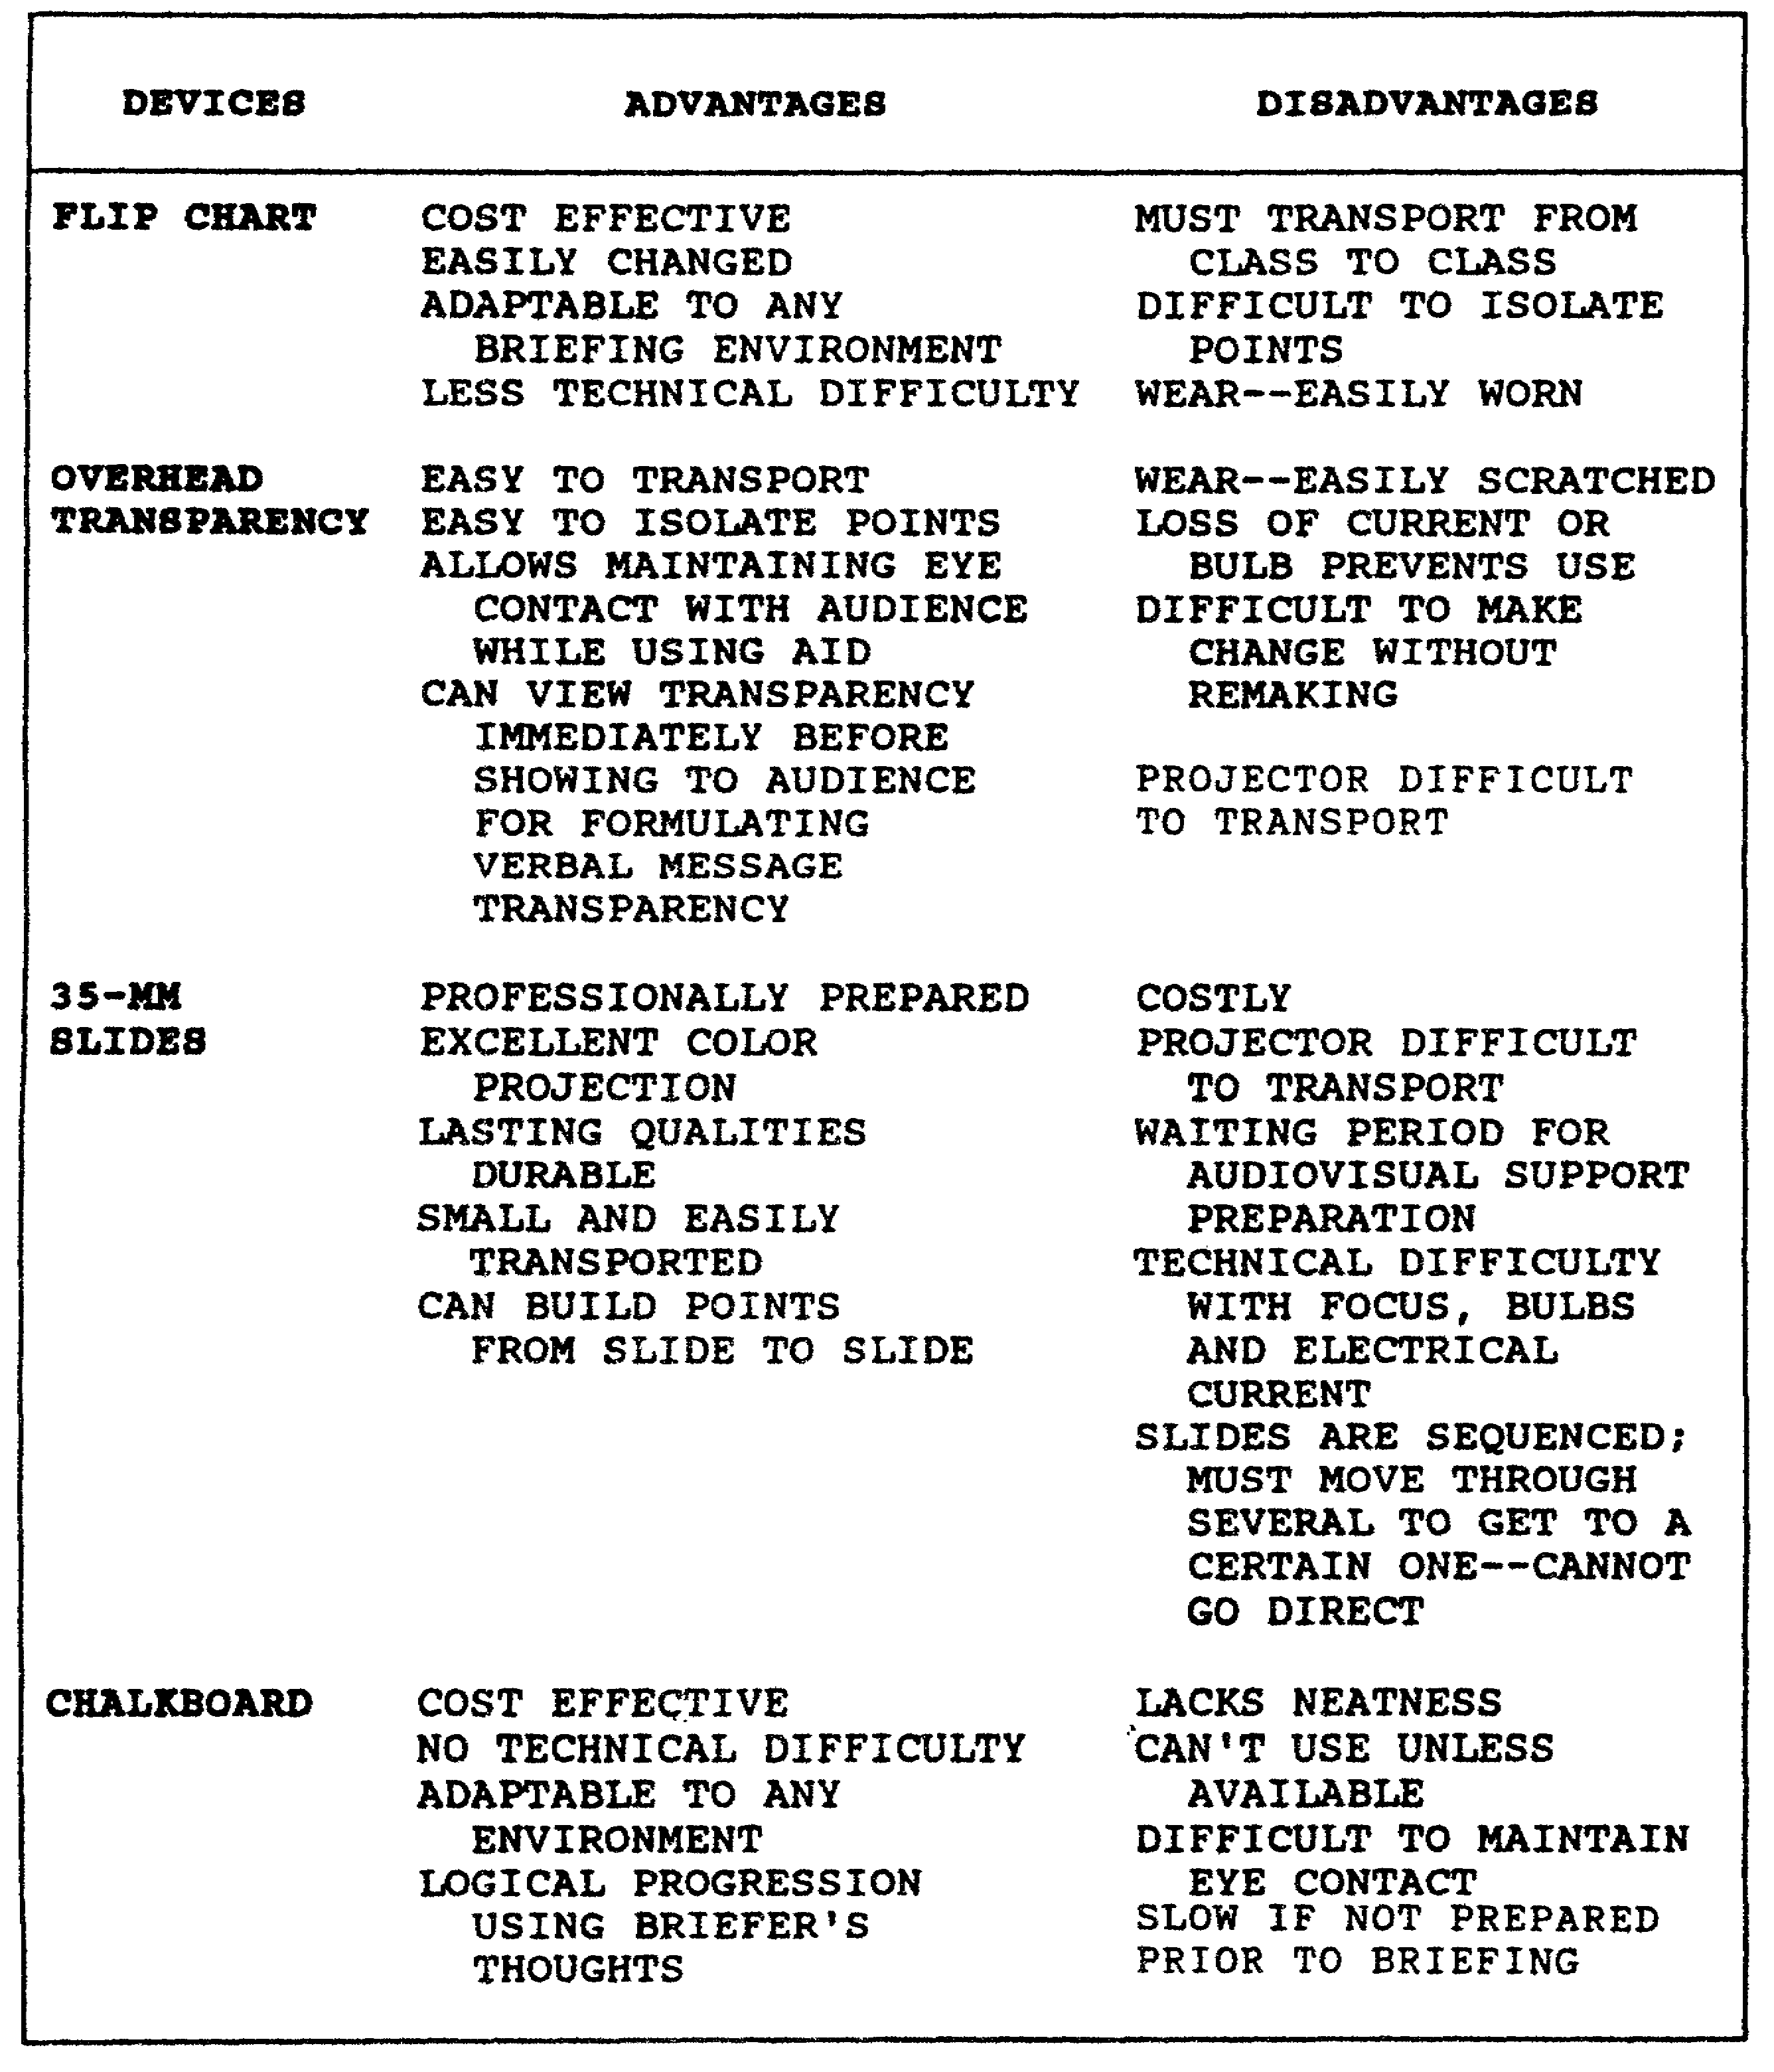

Figure 2-1. Visual aids.

QM3517 2-18

Trace the information onto the transparency using a vis-a-vis, water soluble, film pen or a china marker (grease pencil). Ensure that your transparencies are in sequence. Number them ahead of time to allow quick sequencing if you drop them.

NOTE: You can write notes in the outer margin of the frame around your transparency to prompt yourself toward the next frame or to jog your memory for additional information.

Check the transparencies before the briefing to be sure they can be read from the back of the room. When you use the overhead projector to display your transparencies, DO NOT stand between your audience and the screen. Doing so obstructs your audience's view of the screen. Use a pen or a pencil on the transparency to target the information that you are discussing rather than walk back and forth between the projector and the screen to point to the information.

(3) 35-mm Slide Projector. Your training and audiovisual support division provides production services for slides. Rehearse with the projector or the podium controls before the actual briefing. Doing so aids you in giving a fluid presentation. Use a long pointer to point out specific areas on the screen as you would with a flip chart.

(4) Chalkboard. It is your decision whether to prepare the chalkboard before or during your presentation. Most often, briefers do so before their presentations. Ensure that you have an eraser and sufficient chalk or, better yet, always have some chalk with you. Remember that you can use colored chalk to add emphasis. You can keep a 1-foot-square piece of flannel folded and ready in your pocket if you need it as an eraser. If it is possible to do so, have most of your information written on the chalkboard beforehand. Have at least the first topic or point written out in advance.

If you choose to write on the chalkboard during the briefing, DO NOT speak to the audience while you write. Your back will be to the audience, and your voice will be muffled.

PART C - BRIEFING STRUCTURE

1. Four-Step Briefing Process.

When you prepare a briefing assignment, you follow four steps:

o Analyze the situation.
o Construct the briefing.
o Deliver the briefing.

2-19 QM3517

o Conduct a follow-up.

This part of this subcourse discusses each of these steps in detail.

a. Step One: Analyze the Situation. Your first step in the process of preparing a briefing is to analyze the situation. This step includes analyzing the audience and the occasion by determining the answers to the following questions:

o Whom do I brief and why?

o How much knowledge of my subject does my audience have?

o What does my audience expect of me?

Before you brief an individual for the first time, inquire as to
the particular official's desires. Make sure that you understand
the purpose of the briefing. Are you to present facts or to make
a recommendation? Your purpose determines the nature of your
briefing. The time that you are allocated for a briefing
dictates your style, the physical facilities available to you,
and the preparatory effort that you must make. You must consider
the availability of physical facilities, visual aids, and
draftsmen. Prepare a detailed presentation plan. Coordinate
with your assistants, if you use any. Use care as you schedule
the preparatory effort. Formulate a briefing outline. Make an
initial estimate of the deadlines for each task. Schedule
facilities for practice. Request critiques.

b. Step Two: Construct the Briefing. Your construction of the briefing varies with the type and the purpose of the briefing. Your analysis provides the basis for this determination. Employ the following major steps as you prepare your briefing:

o Collect your material.

o Know your subject thoroughly.

o Isolate your key points.

o Arrange your key points in a logical order.

o Provide supporting data to substantiate the validity of your key points.

o Select your visual aids.

o Establish your wording.

QM3517 2-20

o Rehearse before a knowledgeable person who can critique your briefing.

c. Step Three: Deliver the Briefing. The success of your briefing depends on how you present it. If your delivery is confident, relaxed, forceful, enunciated clearly, and obviously based on a full knowledge of the subject, then you help to convince your audience. Maintain a relaxed, but military, bearing. Use natural gestures and movements, but avoid distracting mannerisms. Make sure that your delivery is concise, objective, and accurate. Be aware of the following:

o Accomplish your basic purpose, which is to present the subject as you are directed and to ensure that your audience understands it.

o Keep your introduction and your summary brief.

o Use logic in arriving at conclusions and recommendations.

o Realize that interruptions and questions may occur at any point. If these occur, answer each question before you proceed or indicate that you will answer questions later in your briefing. At the same time, do not permit questions to distract you from a planned briefing. If you will answer the question later in your briefing, then make specific reference to the earlier question when you introduce the material. Be prepared to support any part of your briefing. Anticipate possible questions. Be prepared to answer them.

d. Step Four: Follow-Up. When your briefing is over, prepare a memorandum for record (MFR). In your MFR, record the following information:

o Subject of your briefing.
o Date of your briefing.
o Time of your briefing.
o Place of your briefing.
o Ranks, names, and positions of those present.

Record the substance of your briefing in a concise form. Record recommendations and their approval, disapproval, or approval with modification. Also record any instruction or directed action and who is to act.

Distribute the MFR to staff sections or agencies that must take actions on the decisions or the instructions that your MFR contains or whose operations or plans may be influenced.

2-21 QM3517

2. Briefing Outline.

To deliver an effective briefing, you must prepare an effective outline of your briefing. Refer to the following subparagraphs for details concerning how to prepare an outline of your briefing.

a. Situation Analysis. Base the outline of your briefing on the situation. With regard to the situation, your outline must address the elements that are discussed in the following subparagraphs.

(1) Audience. Determine how many members of your audience there are and the nature of your audience. To do so, address the following questions:

o Who comprises my audience? Is my audience comprised of a single service or a multiservice group? Are the members of my audience civilians? Are they foreign nationals? Who are the ranking members? What are their official positions? Where are they assigned?

o How much professional knowledge of the subject do the members of my audience have?

o Are the members of my audience generalists or specialists?

o What are the interests of the members of my audience?

o What are the personal preferences of the members of my audience?

o What reaction do I expect from my audience?

(2) Purpose and Type. You also must consider the purpose and the type of your briefing. To do so, consider which of the following briefings you need to prepare:

o Information briefing (to inform).
o Decision briefing (to obtain a decision).
o Mission briefing (to review important details).
o Staff briefing (to exchange information).

(3) Subject. You must consider the subject of your briefing. Ask yourself the following questions:

o What is my specific subject?
o What is the desired coverage?

QM3517 2-22

o How much time has been allocated to me?

(4) Physical Facilities. You also must ask yourself about the physical facilities that you will use. Ask yourself the following questions:

o Where will I present my briefing?

o What arrangements do I require?

o What visual aid facilities are available to me?

o What are the deficiencies?

o What actions do I need to take to overcome deficiencies?

b. Schedule of Preparatory Effort. You must schedule your preparatory effort. Make sure that you accomplish the following:

o Complete the analysis of the situation.

o Prepare a preliminary outline.

o Determine the requirements for training aids, assistants, and recorders.

o Edit or redraft.

o Schedule rehearsals (facilities, critiques).

o Arrange for the final review by the responsible authority.

c. Briefing Construction. You perform a number of steps to construct your briefing. Refer to the following subparagraphs for details concerning these steps.

(1) Collect Material. Your first step in constructing your briefing is to collect your material. You do this by conducting research, becoming familiar with the subject, and collecting authoritative opinions and facts.

(2) Prepare the First Draft. Next, prepare your first draft. Take the following steps:

o State the problem (if necessary).

o Isolate your key points (facts).

o Identify the courses of action.

2-23 QM3517

o Analyze and compare the courses of action. State the advantages and the disadvantages of each.

o Determine your conclusions and your recommendations.

o Prepare your draft outline.

o Include visual aids.

o Fill in the appropriate material.

o Review your first draft with the appropriate authority.

(3) Revise, and Edit the First Draft. Next, revise and edit your first draft. Take the following steps:

o Make sure that your facts are important and necessary.

o Include all the necessary facts.

o Include your answers to anticipated questions.

o Polish your material.

(4) Plan the Use of Visual Aids. As mentioned previously, by using visual aids, you often can make the delivery of your briefing more effective. In planning your use of visual aids, do the following:

o Check for simplicity and readability.

o Develop the method for your use of the visual aids.

(5) Practice. Practice the delivery of your briefing. Use the following guidelines:

o Rehearse -(with assistants and visual aids).
o Polish.
o Isolate your key points.
o Commit your outline to memory.
o Develop transitions.
o Use definitive words.

d. Follow-Up. Follow-up is an important part of constructing your briefing. Follow these steps:

o Ensure your audience's understanding.

QM3517 2-24

o Record your audience's decision.
o Inform the proper authorities.

3. Parts of an Oral Presentation.

This paragraph discusses the parts of an oral presentation. An effective oral presentation has the following three parts:

o Introduction.
o Explanation.
o Summary or review.

Remember the adage: "Tell them what you are going to tell them, tell them, then tell them what you told them".

NOTE: The following discussion of the introduction, the explanation, and the summary or the review of the oral presentation involves a teaching-learning situation. However, the principles that are explained in the discussion pertain to briefings in general rather than to the briefing to instruct in particular.

a. Introduction Part of Oral Presentation. The first part of an oral presentation is the introduction. By means of the introduction, you set the stage for your presentation. The introduction varies in length, depending on the nature of the subject and the teaching situation. The introduction must accomplish the following three essential actions:

o Establish contact between you and your audience.
o Arouse your audience's interest in your subject.
o Disclose the scope and the objectives of your subject.

(1) Establish Attention. To establish contact, arouse interest, and obtain attention, use one or more of the following:

o A reference to previous instruction, when applicable, and any reference of special interest to the class.

o A startling statement.

o A story, an example, or an appropriate nonoffensive joke

o A rhetorical question.

o A quotation o r an historical illustration.

o A skit or a demonstration.

2-25 QM3517

The method that you choose is not as important as the information. It must relate to the subject and accomplish the goals of gaining attention, establishing contact, and arousing interest. A discussion of three attention-getting methods follows.

(a) Startling Statement. DO NOT say anything important until you have the attention of your students. For example, an instructor once startled his class to attention with the statement:

Thirty seconds! Just thirty seconds! That is how long you will live on the battlefield if you do not use cover and concealment.

(b) Rhetorical Question. Another method that you can use to gain attention is the rhetorical question. A rhetorical question is one that you intend to answer yourself or a question for which you are not seeking an answer. When you ask this type of question and someone volunteers an answer, let him. You have accomplished your goals of gaining attention and of arousing interest. For example, you may begin a leadership class by asking a rhetorical question such as, "What are the qualities that make a soldier respect an officer as a leader"? Several students may raise their hands. If this is the case, then call on several students to answer.

(c) Skit or Demonstration. If you choose to use a skit or a demonstration as a starting point for a period of instruction, then give the students the idea that they are observing an actual situation. All participants should strive for realism. DO NOT use a skit or a demonstration strictly for humor. Make sure that the teaching points are not lost in the act. For example, a scene in a division headquarters with the staff demonstrating coordination, staff action, and command action is an excellent way to start a class on organization and functions of-the staff.

(2) Elements of Introduction. With a bit of imagination and thought you can make any introduction stimulating. Once you have gained attention, however, you are not finished with the introduction. Remember the part of the adage that states, "Tell them what you are going to tell them". Tell your student the objectives, the reasons and, in some cases, the procedure for your instruction or a review of previous instruction. It does not matter whether you give objectives or reasons first in your instruction. Just remember to include them both.

QM3517 2-26

(a) Objectives. In the introduction you must tell the student the objectives of the lesson. For example, having gained the attention of the students by an opening statement, you might say:

During this period, you will learn to use the marginal information on a map. You will need this information for all your future classes in map reading.

Your students must understand fully what they must accomplish in the period of instruction. Therefore, you must give the students clear, concise lesson objectives in the introduction. DO NOT do as the instructor did who started a one-hour class in map reading by saying, "During this period, you are going to learn all about map reading".

Such a statement is too broad and unrealistic. Give objectives that the student can expect to accomplish in the time that is specified. When he states the objectives, the instructor lets the students know what they must learn. Remember that you must state the objectives in your introduction.

(b) Statement of Reasons. Every introduction must include a statement of the reasons for the briefing. If you were a student, then you would like to know the importance of the lesson or the reasons that you should learn it. If you were giving a lesson on grid coordinates, then you might state the reasons by saying, "You use grid coordinates to locate your position on a map. You also use grid coordinates to locate other friendly units, terrain features, logistical facilities, enemy positions, and targets. You use grid coordinates when you call for indirect fires. If you cannot rapidly and accurately plot grid coordinates, then you endanger other friendly units and possibly your unit's overall mission".

Remember that you must state the reasons in your introduction.

(c) Procedure. In some cases, you may include a statement of the procedure for the lesson. For example, the following is an example of such a statement:

During the first hour of this instruction, you will learn how to determine grid coordinates. In the second hour, you will have practical work in which you will use grid coordinates to locate specific areas on a map. Then, you will take a written quiz to determine how much you have learned.

2-27 QM3517

(d) Review of Previous Instruction. Another element that you may include in your introduction is a review of previous instruction. You can review main points to show the relationship of past instruction to the subject that you are about to present or you can simply use it to provide a refresher to better understand the subject.

(3) Evaluation. See whether you can identify the element in each of the following three portions of a typical introduction:

As members of a tank platoon, you must know the formations that we use to maneuver the platoon against the enemy. Platoon combat formations are essential to maintain control, security, mobility, and firepower. If you do not understand the techniques of maneuver, the formation to use in different situations, and your position and function in each formation, then you have virtually no chance of survival. More importantly, you jeopardize the lives and equipment that are needed to accomplish the mission. You cannot depend on learning combat formations on the battlefield--then, it is too late.

You must know the basic platoon formations, the method of moving from one formation to another, and the security responsibilities of each tank commander. You must know how to employ each formation. As a result of this information, you will be able to maneuver and to function correctly with your tank crew as well as with the other tank crews in the formation.

The first hour of instruction is in the classroom. You will see a tank platoon employing the formations in a tactical situation. During the second hour, we will have a practice exercise (PE), and you will select the correct formation for various tactical situations. During the last two hours of this four-hour period, we will have a tactical exercise during which you will put these techniques into practice.

The first part of the introduction addresses the reasons for the instruction. The second portion addresses the objectives of the instruction. The third portion addresses the procedure for the instruction.

QM3517 2-28

b. Explanation Part of an Oral Presentation. In order to explain or teach the subject to your students, you may need to give them plenty of information. If this information is not organized, you will confuse them. There are many ways to organize your information. One way is to organize the bits of information under main headings or logical groupings. Another way to organize your material is by using chronological order. This method works well with historical data or with data that you can categorize by dates or times. If you were teaching a class on the four lifesaving steps, then you might organize your information according to functional or logical sequences.

How do you know which method of organization to use? The nature of your subject (or sometimes the background of your students) dictates the method by which you organize your information.

(1) Organization. You may choose to organize your information on the basis of functional or logical sequences. If so, then you must consider how something works or its procedure.

(a) Functional Sequence. Follow a functional sequence with an explanation as to how an item works. For example, a tracked-vehicle repairer must know how the engine in the vehicle operates in order to troubleshoot it and to repair it. It might be easier to present the information if it were categorized by functional sequence.

(b) Logical Sequence. If you choose to organize your information in a logical sequence, then start at a beginning point, follow a logical sequence, and end up with a conclusion. You may choose that your logical sequence follow a sequence of tasks from easy to difficult or a sequence of facts from unknown to known. Alternatively, you may choose that your sequence allow your audience to reason out a problem using cause-to-effect or effect-to-cause.

NOTE: Whatever your subject and its organization, you must use techniques that help your students to follow your order of presentation. How do you make the student aware of your organization? You might list the main points on a chalkboard as you develop them or show each point on a slide or a chart as you discuss it. Help the student to follow the organization and the sequence of the main point by using training aids such as

2-29 QM3517

chalkboards, charts, or transparencies.

(c) SEW Up Procedure. Another way of keeping your students aware of the organization of your explanation is to SEW up each main point before moving on to the next one. You SEW up a main point by doing the following:

o Stating the point or the idea.

o Expanding the point so that it is more meaningful.

o Wrapping up the main point.

The following example SEWs up a main point:

Alaska is our largest state.

It has an area of 586,000 square miles. It is big enough to hold Arizona, New Mexico, Texas, and Louisiana with enough room left over for Maine and Rhode Island.

Alaska is so large that its citizens suffer claustrophobia when they visit Texas.

(2) Transitional Techniques. Keep the points of your explanation connected. Use transitional words or statements that provide the relationship between your points. You probably have heard the overuse of transitions such as the following:

o "Now, we will go into. . . .”
o "Next. . . . "
o "OKAY . . . .”
o "All right. . . .”I

Some instructors begin each new idea with one of these words or phrases. DO NOT fall into such a habit. Use a variety of meaningful transitions and statements in your oral presentations.

(a) Transitional Word. The transitional word in the following statement is "another": "Another principle of war that we must apply in every tactical situation is the principle of security".

(b) Main Topic. Another transitional technique that you can use to make students aware of the connection between points or between changes from one point to the next is to refer

QM3517 2-30

to the main topic as you introduce the new supporting point. For example, if you are teaching Indications of Leadership and you have concluded your first point, then you might introduce the next point by saying: "An additional indication of leadership in a unit is the state of morale".

(c) Summary. You also may use a summary as a transitional technique because it reemphasizes your main points. For example, if you are teaching the first-aid lifesaving steps, then you can make a transition by saying, "So far, you have learned how to stop the bleeding by applying direct pressure, elevating the injured member, and using the tourniquet. You also have learned that clearing the airway is the first step. Remember that the patient's breathing passages must be clear of any obstructions. The third, step is to protect the wound . . .".

The summary serves as an excellent transitional device.

(d) Rhetorical Question. Another transition that you can use is the rhetorical question. For example, if you were teaching the four lifesaving steps, you might say, "We have emphasized the importance of clearing the airway and have learned the various methods of stopping bleeding. In order to prevent further injury, what is the next lifesaving step? Logically, the next step is to protect the wound from contamination".

(e) Enumeration. You also can use enumeration to make a transition. This method is particularly effective when developing the subject requires a standard sequence. For example, you may say, "First, we learned to clear the airway. Second, we discussed the ways that we can stop the bleeding. Third, we must protect the wound".

(3) Interest Maintenance. A major problem that you will face as an instructor is that of keeping students interested. The following subparagraphs discuss ways to maintain interest.

(a) Use Stories, Experiences, and Quotations. One excellent way of maintaining interest is by using stories, real-life experiences, or quotations. Look through service journals for interesting attention-getters. A biography or an autobiography of a famous military leader may prove to be a valuable source. Whatever you do, DO NOT use one of these attention-getters without relating it to the subject. Tie it in.

(b) Use Specifics, Real-Life People, Places, and Things. Another way to be interesting is to talk about specifics--real-life people, places, and things. In other words, DO NOT talk in generalities. When you explain characteristics and principles, start with the definition. Then, work down to specific ways of acquiring the characteristic or of applying the

2-31 QM3517

term. Use situations in which the students can identify themselves. Remember NOT to deal in abstractions or general statements. Use specific or real-life situations.

(c) Use Analogies and Examples. Another way to keep your explanation interesting is to expand your points with analogies as the instructor did when he explained the correct sight picture as looking like a pumpkin on a fence post. You also can use examples, such as combat examples, to maintain interest.

(d) Stress the Need to Know. Your students probably will want to know why they are learning a subject and how the information may affect them. You can maintain student interest by emphasizing throughout the instruction how the student will use the information. For example, if you are teaching scales and distances as part of map reading instruction, show the students how they apply this information in the field. Set up a situation in which they can lead their soldiers from point A to point B and determine the distance between the two points. If you are teaching a communication class and have told the students that they must not touch a radio antenna while they transmit, then you can emphasize the point by touching a pencil to the antenna to show the high-frequency arc. They will understand why they are learning this information when they see the pencil burst into flame. Another way that the instructor can maintain class attention is by constantly emphasizing to the students why they must learn this information.

(e) Use Student or Class Participation. Some instructors think that their students are sponges--all they have to do is to pass out the information and the students will soak it up. It will never happen. Get your students to participate in class. Ask question to keep them mentally alert. Give them problems to solve so that they can apply the information that you have taught them. Ask the students for opinions and ideas concerning the point that you teach.

(f) Use Visual (Training) Aids. To teach a student, you must stimulate one or more of his five senses. The more senses that you stimulate, the more interesting and effective will be your instruction. Oral instruction stimulates the sense of hearing first. You can appeal to their sense of sight by using training aids.

(4) Key Point Statements. Another important item in the explanation is giving emphasis to teaching points. The following subparagraphs discuss these important points.

QM3517 2-32

(a) Attention-Getting Statement. If you have a key point that you want the students to note, then you can use an attention-getting statement to alert the student. For example you might say, "Here is a point that you should never forget," "Get this point", or "Now, get this".

These are statements that alert the student to the importance of
a key point.

(b) Summaries. Another way to alert your students to an important point is by using summaries. A summary is a way to make a transition. You also can use a summary to emphasize the ideas that you have taught up to that point. For example, you might state, "We have discussed the principle of the objective and the principle of mobility. Now, we will examine another principle, which is particularly important to the commander--the principle of security".

(c) Training Aids. You must consider the use of training aids to hold interest. You may also employ training aids to provide emphasis to a point. For example, if, in teaching the Principles of War, you not only explain the principles, but also illustrate them using training aids, then your instruction has a greater impact on your students.

(d) Speech Techniques. Another way to emphasize a point in your explanation is to speak it forcefully. Make it sound important. Sound as if you believe it. In other words, use good speech techniques.

(e) Repetition. Consider using repetition to emphasize an important point. If you want to teach the importance of clearing a weapon, then do not mention this point once and then forget about it. Stress the point several times. In all classes on weapons, stress the precaution of clearing the weapon until the soldier becomes aware of its importance and it becomes an automatic procedure for him. You may add to the effectiveness of your repetition by using an example, a story, or a demonstration. For example, you could demonstrate your point of how important it is to clear the weapon by having a blank cartridge in the chamber of an unloaded weapon and firing it after an inspection. This demonstration definitely would get their attention and help them to understand why they must always ensure that their weapons are cleared.

(f) Questions. The last technique is to ask questions. You can use oral questions to perk up the interest of the class. Oral questions also emphasize a point. For example, in teaching the second step of the Lifesaving Measures of First Aid, which is to stop the bleeding, you can ask a question to emphasize the use of the tourniquet by saying, "Now, I have told

2-33 QM3517

you that we never loosen the tourniquet once we have applied it to the patient. I said that we leave it to competent medical personnel to decide whether the tourniquet is to be loosened. Why do you not loosen the tourniquet periodically, SGT Smith?"

c. Summary Part of Oral Presentation. Remember the adage that was mentioned previously: "Tell them what you are going to tell them, tell them, and tell them what you told them". This lesson has discussed the first two "tell thems"--the introduction and the explanation. The next phase of the oral presentation is "Tell them what you have told them." This final part of the oral presentation is called the summary.

(1) Elements of a Summary. To summarize a period of instruction, use the following three elements:

o Answer any questions that your students have concerning the lesson.

o Summarize the key points of the lesson.

o Close with a statement that reaffirms the importance of the subject to your students.

Notice that answering students' questions is the first element of the summary. DO NOT ask for questions at the very end of the lesson after the summary of the main points and the closing statement. The reasons for not asking questions at this time are:

o The period is over for most of the students, and the students will ask few questions.

o Numerous questions may cause the period to run overtime.

o Clarification of questions at the beginning of the summary may affect your summary of the main points.

(2) Questions. An excellent way of summarizing and of emphasizing key points in the final summary is to ask questions. In other words, give your students an oral examination or a quiz.

QM3517 2-34

LESSON 2

PRACTICE EXERCISE

The following items will test your grasp of the material covered in this lesson. There is only one correct answer for each item. When you complete the exercise, check your answers with the answer key that follows. If you answer any item incorrectly, study again that part of the lesson which contains the portion involved.

Situation: You are a staff officer. You are developing briefings. For some briefings, you will employ delivery aids. Use this situation to answer questions 1 through 3.

1. You are directed to prepare a briefing to direct action. You plan to prepare which of the following types of briefings?

A. Information.
B. Decision.
C. Situation.
D. Staff or mission.

2. Within the body of a mission briefing, you include which of the following sections?

A. Execution.
B. Alternatives.
C. Command support.
D. Facts that bear on the problem.

3. You are developing a decision briefing. You plan to include a statement of the problem that is the reason for the briefing. In which of the following parts of your briefing do you include this statement?

A. Introduction.
B. Body.
C. Closing.
D. Conclusion.

4. You can count on the individuals in your audience to think at a rate of between how many words per minute?

A. 500 and 900.
B. 800 and 1,000.
C. 1,200 and 1,400.
D. 1,500 and 1,700.

2-35 QM3517

5. In regard to gesturing, which of the following statements is true?

A. Do not put your hand in your pocket.
B. Keep both hands above your waist at all times.
C. Do not hold an object in your hand if you do not want to distract your audience.
D. Gesture to reduce your volume of speech.

6. One of the disadvantages that you face when you use a chalkboard is that

A. it is difficulty in isolating points.
B. the chalkboard is easily worn or scratched.
C. chalkboards are costly.
D. it is difficult to maintain eye contact when you use a chalkboard.

7. When you use a flip chart, you ensure that the minimum lettering size for the flip chart in relation to viewing distance is 1 inch per every

A. 10 feet.
B. 20 feet.
C. 30 feet.
D. 40 feet.

8. You limit all visual aids to how many colors for letters?

A. One.
B. Two.
C. Three.
D. Four.

QM3517 2-36

LESSON 2

PRACTICE EXERCISE

ANSWER KEY AND FEEDBACK

Item Correct Answer and Feedback

1. D. Staff or mission.

Among the briefings that you most likely will prepare are the information briefing, the decision briefing, and the briefing to direct. There are two types of briefings that direct action: the staff briefing and the mission briefing.
(page 2-7, para 4)

2. A. Execution.

Facts that bear on the problem and alternatives are parts of the decision briefing. The sections of the body of a mission briefing are the situation, the mission, the execution, service support, and command and signal.
(page 2-8, para 4b(3))

3. A. Introduction.

Using military courtesy, address the persons whom you are briefing. Identify yourself and the organization for which you work. For a team presentation, introduce all members of the team and provide information concerning the team's years of experience and current and future assignments. Address the following key points in your introduction:

o State the type and the purpose of your briefing.

o State the subject and the classification of your briefing.

o State the reason for your briefing.

o Establish the cause of the problem (concise background).

o State the sources of the information, the points of coordination, or both. Establish your research expertise.

o State the order of the points that you will cover in your presentation.

(page 2-5, para 3c(1))

2-37 QM3517

4. B. 800 and 1,000.

You speak much slower than your audience is apt to think. Speakers speak between 125 and 135 words per minute. Thus, a completely verbal presentation limits the experience to the audio mode only. Limited experience equals limited understanding. Individuals think between 800 and 1,000 words per minute. Visual aids assist in closing the gap between the speaking rate and the thinking rate. Visual aids, therefore, allow the audience to experience more of the topic.
(page 2-16, para 2b)

5. C. Do not hold an object in your hand if you do not want to distract your student.

Keep one hand above your waist at all times. You may place the other hand in your pocket to appear natural. Gesturing complements voice inflection. However, it does not allow you to reduce your volume. A hand-held object does distract your audience. (page 2-14, para 1a(3)(b))

6. D. it is difficult to maintain eye contact when you use a chalkboard.

According to Figure 2-1, which lists both the advantages and the disadvantages of using various delivery aids, one of the disadvantages is that it is difficult to maintain eye contact when you use a chalkboard. (page 2-18, Figure 2-1)

7. B. 1 inch per 20 feet.

If the lettering height for the flip chart is any less than 1 inch at a viewing distance of 20 feet, then your audience will not be able to read the information. Draw your letters (minimum height 1 inch per every 20 feet) in pencil first. Then, fill them in with a wide, felt-tip marker or a grease pencil. (page 2-17, para 2d(1))

8. C. Three.

Limit all visual aids to no more than three colors-red, black, and blue-for lettering. (page 2-17, para 2d(1))

QM3517 2-38

LESSON 3

COMMAND PHILOSOPHY DEVELOPMENT

OVERVIEW

LESSON DESCRIPTION:

In this lesson, you will learn how to develop a command philosophy paper using the new standard of Army writing.

TERMINAL LEARNING OBJECTIVE:

ACTION: Develop a command philosophy paper using the new standard of Army writing.

CONDITION: You will be given information from the Quartermaster Officer Advanced Course, Philosophy of Command Notebook.

STANDARD: Developing a command philosophy paper will be in accordance with the Quartermaster Officer Advanced Course, Philosophy of Command Notebook.

REFERENCES: The material contained in this lesson was derived from the following publication: Quartermaster Officer Advanced Course, Philosophy of Command Notebook.

INTRODUCTION

In carrying out your military duties, you frequently write to inform or to direct. An example of this kind of writing is the command philosophy paper, which is written in memorandum format.

1. Determine Your Goals.

Your goal as a leader is to develop a general company-level command philosophy. As a successful company commander, you must know how to do the following:

o Develop your thought processes toward how you would like to command instead of toward where or what type of unit you would like to command.

o Write a comprehensive, two-page command philosophy paper according to the new Army writing standard and in memorandum format.

3-1 QM3517

As a commander, your command philosophy affects your subordinate leaders and soldiers. Ultimately, it affects the degree to which your mission and command succeed. Therefore, you must think carefully about each area of responsibility before you formulate your philosophy. Your command philosophy is the basis for strong, effective organizational leadership.

a. Prepare for Command. After you write a general, yet comprehensive, command philosophy paper, you will be better prepared to go to your next duty assignment. You also will be prepared to refine your paper for commanding a specific unit. You then may expand your command philosophy to include specifics about your mission and the problem areas for your unit.

Successful commanders are those who have a well-developed command philosophy and a vision of what they want their units to be. As a result of their philosophy, they can focus their energy and their unit's energy. This may sound easy. However, the following incidents can result when a new commander fails to communicate a command philosophy, fails to establish a future vision, or fails to think through a system to measure progress toward that vision:

o Second-guessing by subordinates as they feel out the commander.

o Piecemeal revision and initiation of policy as the commander's intent is discovered.

o Redirection of energy and focus as subordinates mimic the commander's changing direction of march.

o Inappropriate use of resources as priorities change.

o Delays in building subordinates' trust and confidence.

In short, you waste energy that could be spent molding a better unit. You do not want to cause such waste, but it could happen. However, you can avoid this. Before you assume command, develop your command philosophy so that you can communicate it to your subordinates. Some of the key ingredients that you should state are as follows:

o These are my values, starting with the four Cs (courage, candor, commitment, and competence).

o This is my plan for exercising command.

o These are my most important objectives.

o This is how and what I will evaluate.

QM3517 3-2

o This is how and what I will reward and punish.

Then, ask yourself these questions on the day that you assume command:

o How do I want this unit to look two years from now, and how do I make it happen?

o How do I measure progress?

o How am I to know that my subordinates understand my vision and my strategies for getting there?

O What are my priorities for the year and for the long term, and what is important to me on a daily basis?

Seek guidance from your boss. This guidance and your command philosophy can help you to answer these questions. As you spend more time in command, you will refine your answers and change some ideas. Nevertheless, to ease yourself into the next step, answer these questions before you assume command.

Next, distribute the following items to your subordinates:

o Your written command philosophy.

o A draft DA Form 67-8-1 (Officer Evaluation Report Support Form) that is based on your philosophy.

o Your vision and your answers to the preceding questions.

Since your support form should be the basis for those of your subordinates, you now can make a matrix of them and fill in any voids that you may discover. In this way, you will know whether your unit is focusing on your vision and working on the objectives.

Finally, evaluate progress toward your vision and fine-tune as you go, using the support form as a basis for periodic counseling sessions. Doing so allows you to set priorities on resources and to change time lines and objectives so that you lead your unit toward your vision.

b. Understand Your Command Philosophy. The best way to develop organizational leadership is to develop and to communicate your command philosophy. Your command philosophy provides you vision and support when you become psychologically lost, afraid, or confused. It is a statement that allows you to say, "These are the things in which I believe and for which I stand" and "These are the things for which I will not stand".

3-3 QM3517

What does a command philosophy look like? Command philosophies are as different as commanders. However, some commonalities exist. A good command philosophy--

o is short. Use only one page, front and back.

o is understandable. The paper speaks to privates as well as to field-grade officers.

o takes a whole-organization perspective. Understand that a system does not consist of A + B + C. Rather, a whole system is synergistic and consists of A + B + C + AB + BC + ABC. Reciprocal interdependence enters at the unit level. A unit consists of soldiers, leaders, equipment, structure, and doctrine. Each influences the others.

o specifies goals and objectives. State your command philosophy in terms of desired end-states (that is, what you want your unit to look like in its ideal state). Do not use verbs such as "improve" or "enhance". Use nouns to name goals and objectives. Commonly understood and shared goals and objectives focus your organization's energy.

o specifies priorities. Everything cannot be "priority number 1". If you say that training is priority number 1, but criticize your subordinates because they have not provided efficient area police, then you have shown that your number 1 priority is area police. You also have sent confusing signals to your troops.

o relieves pressure on the system. With a good command philosophy, you get higher headquarters off the backs of your subordinate leaders. You must release and channel the energy in the unit and buffer the organization from outside sponges that sap away its vital energy.

o optimizes the flow of information. As a good leader, you know that leadership in a complex system is dispersed throughout the system. Information allows distributed control to work. The key is to wire together the flow of information both up and down the command levels and from one adjacent level of command to another. The latter is harder.

o gives responsibility. It places the authority in the hands of those who have the responsibility. When you decentralize authority, make your overall philosophy, concept, intent, priorities, and standards absolutely

QM3517 3-4

clear to all. Decentralization, as required by AirLand Battle doctrine, demands high discipline. Be careful. Your staff can do more to upset decentralization than you realize.

o is specific. Your philosophy specifies what and how you measure and inspect matters. What you measure and how you inspect comprises a de facto priority list. Be rational and careful about how you do this.

o creates multiple feedback. Use the chain of command to command. Communicate any way that you can.

o rewards performance. Use the following rules: Do not accept unsatisfactory performance. Instead, coach, teach, and train. If, ultimately, you must, fire. Accept satisfactory performance. It is all right. Reward outstanding performance. Reinforce the behaviors that you are rewarding, and simultaneously create role models.

o demands initiative. Initiative is the cornerstone of tactical doctrine. Teach your people to "ask forgiveness, not permission". It is better to err at 1 00 miles per hour (mph) than to err doing nothing.

o understands that "the best" is the enemy of "the good". It is better to have a dozen good battalions than two "best" ones and 10 ineffective ones. Engineer competition against standards, not among individual units, and never compare one unit to another.

o communicates. A good command philosophy communicates that everything that is done in peace must directly relate to the wartime mission.

c. Answer Questions for Command. Many officers say, "I would do anything to get a command". If you are one of these, do you really mean it? Are you suited for command? Have you really considered what having a command entails? General Clarke challenged commanders to answer the following questions:

o Are you willing to devote all hours of the day and night, seven days a week, to your command?

o If it is necessary, is your spouse willing to do likewise in order to make a happy Army community in your unit's area?

3-5 QM3517

o Is your family willing to be secondary, if necessary, to your company, battalion, group, regiment, combat command, brigade, or division?

o Are you willing to learn, to teach, to stress, and to live with the fundamentals that are necessary to make your unit good and still believe that your great talents for bigger things are not wasted?

o Do you like to be with young people? Can you live with their energy, their points of view, and the problems that they create?

o Are you willing to take the criticism that comes from carrying the responsibility for the failure of your subordinates?

o Can you juggle training, maintenance, tests, administration, inspections, communications, messes, supply, athletics, marksmanship, discipline, and public relations at the same time, without dropping any of them?

o Are you able to do many things concurrently, or are you a consecutive doer? Can you manage a complex job?

o Can you receive and carry out orders? Are you a good follower as well as a good leader?

o Can you stand tough competition from like units in your command and still keep a spirit of cooperation and teamwork with them?

o Are you physically and emotionally fit to carry the load of responsibility?

o Do you have the courage to make, and to stand by, tough decisions?

o Are you and your family willing to live in a goldfish bowl in which your subordinates and superiors closely observe your actions?

o Are you enthusiastic and cheerful when you are confronted with seemingly impossible tasks that you must perform with inadequate means?

o Are you willing to take responsibility when events go wrong in your unit and to correct a bad situation rather than to blame it on a subordinate, the staff, or higher headquarters?

QM3517 3-6

o When you are tasked to perform with inadequate means, are you willing to do your best with what you have?

o Are you confident that you can produce a superior unit with an ordinary run of manpower? Can you inspire personnel to produce outstanding accomplishments?

o Are you willing to take a chance on being relieved for attaining only mediocre results?

o Do you really want a command or do you just want to have your record show that you have had command responsibilities?

According to General Bruce C. Clarke, "If your answers to these questions are 'yes', you should fight to get a command. And, if you hear an officer say 'I want a command', you should confront him with these questions. If his answers are 'yes', he is undoubtedly sincere and you should make every effort to see that he gets a command. No assignment will ever give greater satisfaction or enable an officer to contribute more to the Army and our country".

2. Determine the Concept.

Refer to the following subparagraphs for a discussion of the concept of command philosophy. These subparagraphs discuss the key ingredients of your command philosophy, functional areas to address, and enduring principles to employ.

a. Know the Key Command Philosophy Ingredients. Your command philosophy is the primary tool that you use to convey to your unit how you plan to command. Focus your thought pattern on the following questions and key ingredients of a command philosophy:

o Values, including candor, courage, commitment, and competence.

o How you plan to exercise command.

o Important objectives.

o How and what you evaluate.

o How and what you reward and punish.

b. Address the Command Philosophy Functional Areas. Write a comprehensive command philosophy that addresses functional areas that are common to all commands. Address these functional areas

3-7 QM3517

in your written command philosophy. These functional areas include:

o Leadership.
o Values and ethics.
o Training.
o Caring for soldiers and family support.
o Property accountability.
o Maintenance and readiness.
o Physical fitness.
o Rewards and punishments.
o Safety.

The quotations that follow address the functional areas for which good commanders assume responsibility.

(1) Leadership. Leadership is one of the functional areas for which you assume responsibility. Many leaders have commented upon the importance of leadership.

Leadership in a democratic Army means firmness, not harshness; understanding, not weakness; justice, not license; humaneness, not intolerance; generosity, not selfishness; pride, not egotism.

- -General Omar Bradley

Of a Great Leader. . . when his work is done. . . they will all say, "We did this ourselves".

-Lao-Tzu (6th century BC)

Wars may be fought by weapons, but they are won by men. It is the spirit of the men who follow and the man who leads that gains victory.

- -General George S. Patton

(2) Values and Ethics. You must assume responsibility for values and ethics. Leaders have written or spoken of the importance of both.

"Duty". . ."Honor". . . "Country". Those three hallowed words reverently dictate what you ought to be, what you can be, what you will be. They are your rallying points: to build courage when courage seems to fail; to regain faith when there seems to be little cause for faith; to create hope when hope becomes forlorn.

--General Douglas MacArthur

QM3517 3-8

I hope I shall always possess firmness and virtue enough to maintain what I consider the most enviable of all titles, the character of an "Honest Man".

--G. Washington

The commander stands for the virtues of wisdom, sincerity, benevolence, courage, and strictness.

--Sun Tzu

Even with the gifts of human understanding and of professional competence arising from careful training, our military leader will not be complete without the third attribute of greatness: namely character--character which reflects inner strength and justified confidence in oneself.

--General Maxwell Taylor

(3) Training. You must assume responsibility for training your subordinates. Refer to the following quotations for examples of what leaders have said or written about this important functional area.

Individual training is the foundation on which unit effectiveness is built. It is the source of a soldier's confidence and trust in the Army.

--Lieutenant General Arthur S. Collins, Jr.

Training is not done in a sterile environment of cold, calculating management. Training has to be rooted in deep ideals and beliefs-something worth dying for. The warmth of service to those beliefs--love of country, pride and belief in each other--yes, duty, honor, country--that's the warrior ethic.

--General (Retired) Richard E. Cavazos

Quality is better than quantity. A small force of well-chosen, trained, and steady men is better than a semi-trained, uncertain mass.

--Gideon

Practice those things in peacetime that you intend to do in war.

--General George S. Patton

3-9 QM3517

(4) Soldiers and Family Support. You must assume responsibility for caring for soldiers and for providing family support. Many leaders consider these functional areas to be important for good leadership.

The commander should appear friendly to his soldiers, speak to them on the march, visit them while they are cooking, ask them if they are well cared for, and alleviate their needs if they have any.

--Frederick the Great

A subtle approach to the affection of our men is an interest in their families. Ask any soldier about his wife and children; he is delighted to tell his story and is greatly flattered by the interest which his commander shows. An occasional letter from an officer to a member of a soldier's family--describing the good work which the son is doing in the Army--will reverberate through the entire command, and the officer will make a lifelong friend of the soldier in question.

--General Maxwell Taylor

Far from being a handicap to command, compassion is the measure of it. For unless one values the lives of his soldiers and is tormented by their ordeals, he is unfit to command.

--General Omar Bradley

A reflective reading of history will show that no man ever rose to military greatness who could not convince his troops that he put them first, above all else.

--General Maxwell Taylor

(5) Property Accountability. Ensure that you assume responsibility for property accountability. This also is an important functional area, as the following quotations indicate:

A little neglect may breed mischief. . . . For want of a nail, the shoe was lost; for want of a shoe, the horse was lost; and for want of a horse, the rider was lost.

--Benjamin Franklin

QM3517 3-10

We may take it then that an Army without its baggage train is lost; without provisions, it is lost; without bases of supply, it is lost.

--Sun Tzu

(6) Maintenance and Readiness. It is important that you assume responsibility for maintenance and readiness. The following quotations show why this functional area is important and how to achieve it.

The key to winning the first battle, as well as the second and the last battle, is an adequate sustaining capability. Maintenance. . . gives us this needed dimension. . . .

--General Edward C. Meyer

The cornerstone of good maintenance is well-trained, motivated, supervised equipment operators who know how to perform before, during, and after operational checks.

--General John A. Wickham, Jr.

It appalls me to think how many failures occur in this very last link of the logistic chain. Equipment is manufactured at great expense. It is shipped 5,000 miles by train, ship, and truck. It is issued to the troops and eventually, with great labor, carried to the top of a mountain in Korea. How many times, at that last point, has this whole enormous effort been thrown away, as carelessly as a burnt match, by the happy-go-lucky negligence of the very people whose lives depend on keeping the stuff in shape?

--Lieutenant General W. B. Palmer

(7) Physical Fitness. As the following quotations indicate, physical fitness is important. Make sure that you assume responsibility for this functional area.

Healthy lifestyles accomplish objectives crucially important to the military vocation: better physical fitness, improved mental efficiency, heightened individual productivity and a sense of personal well-being--these are important components of individual readiness.

--General John A. Wickham, Jr.

3-11 QM3517

Development of stamina, heart, and muscle builds men's bodies, improves their physical well-being, and develops the physical strength and mental alertness needed to perform the strenuous and demanding duties of a soldier.

--Lieutenant General Arthur S. Collins, Jr.

The readiness of the United States Army begins with the physical fitness of the individual soldier and the noncommissioned officers and officers who lead them. We are heirs of high standards that our predecessors established and sustained in peace and war.

--Honorable John 0. Marsh, Jr.

(8) Rewards and Punishment. Be sure to assume responsibility for rewards and punishment. The following quotations show the importance of such incentives:

Give me enough ribbon and I'll conquer the world.

--Napoleon

Awards that motivate only the top men are of little value in raising the ability of a unit. It takes awards to motivate the lower third to do that. A unit is measured by the ability of its lower third personnel to carry their part of the load.

--General Bruce Clarke

Military crimes should be judged with promptitude and severity.

--Napoleon

The vigorous rules of military discipline are necessary to guarantee the Army from defeat, slaughter, and especially dishonor.

--Napoleon

Too many courts-martial in any command are evidence of poor discipline and inefficient officers.

--General William T. Sherman

QM3517 3-12

(9) Safety. As the following quotations indicate, safety is still another important functional area. Ensure that you assume responsibility for safety.

Good training concentrates on wartime missions and the way units are going to fight, but at the same time assures that the training is safe. Training can be tough and demanding without being reckless or careless about the lives and limbs of our precious human resource.

--General John A. Wickham, Jr.

To accomplish our missions, the nation entrusts to our care its youth and its resources. There can be no greater responsibility. As stewards of the Army's assets, we must be alert for ways to improve the efficiency, effectiveness, and safety of our operations.

--General John A. Wickham, Jr.

c. Follow Enduring Principles. Certain enduring principles exist regarding command philosophy. Use the following principles to guide you in developing your command philosophy:

(1) Lead by Example. One enduring principle of command philosophy is to lead by example. When you lead by example, you perform the following actions:

o Perform consistently well-above established professional standards.

o Demonstrate high moral and ethical standards.

o Demonstrate loyalty to superiors, peers, and subordinates.

o Take an active interest in soldiers' duties.

o Display a positive "can do" attitude.

o Care about how the job gets done.

o Treat subordinates as you would want to be treated.

3-13 QM3517

(2) Train to Standard. Another enduring principle of command philosophy is to train to standard. In order to train to standard, you must perform the following actions:

o Ensure that everyone knows the task and the standard.

o Continue to train until you meet the standard.

o Refuse to accept substandard performance.

o Explain what caused failure.

o Do not take shortcuts.

o Confirm that you achieved success properly.

(3) Train as You Expect to Fight. A third enduring principle of command philosophy is to train as you expect to fight. When you train as you expect to fight, you must perform the following actions:

o Drill on critical tasks until you master them under difficult conditions.

o Establish realistic scenarios with unexpected situations.

o Tolerate honest mistakes as the price for the mastery of difficult tasks.

o Prepare to fight in worst-case conditions and to expect hardship.

(4) Lead with Dignity and Respect. Another enduring principle of command philosophy is to lead with dignity and respect. In order to lead with dignity and respect, you must perform the following actions:

o Treat each soldier as an individual.

o Be attentive to soldiers' needs,

o Correct subordinate leaders in private.

o Remember that anyone can make an honest mistake.

o Listen hard to a soldier's request for assistance.

o Emphasize the reward, not the punishment.

QM3517 3-14

o Establish an attitude of trust.

o Seek opportunities to reward good performance.

(5) Evaluate Against Objective Duties and Related Standards. A fifth enduring principle of command philosophy is to evaluate against objective duties and related standards. When you evaluate against objective duties and related standards, you perform the following actions:

o Establish specific, realistic, and attainable goals.

o Clarify objectives face to face.

o Consider factors that may deter or delay mission accomplishment.

(6) Insist and Assist. To insist and assist is another enduring principle of command philosophy. When you insist and assist, you perform the following actions:

o Provide the necessary resources for accomplishing the mission.

o Seek and remove hidden training distractors that hinder performance.

o Break difficult tasks into fundamental subtasks.

o Provide guidance and encouragement before attempting new tasks.

(7) Establish Moral Authority and Responsibility. A seventh enduring principle of command philosophy is to establish moral authority and responsibility. When you establish moral authority and responsibility, you perform the following actions:

o Be honest in all things.

o Stifle gossip and rumors.

o Confront offenders.

o Go straight to the source of a perceived problem.

o Live by the same priorities that you establish for subordinates.

o Admit mistakes.

3-15 QM3517

o Keep superiors and subordinates informed. Bad news does not get better with age.

(8) Solve Problems at the Lowest Level. An eighth enduring principle of command philosophy is to solve problems at the lowest level. For using the principle of solving problems at the lowest level, you must perform the following actions:

o Compromise.

o Seek practical alternatives and commonsense solutions.

o Coordinate at the worker level.

o Focus on understanding the objective before looking for solutions.

o Do what is right for the Army.

o Employ the "keep it short and simple" (KISS principle).

(9) Be All You That you, Can Be. A final enduring principle of command philosophy is to be all that you can be. To be all that you can be, perform the following actions:

o Strive for excellence in all endeavors, however great or small they may appear to be.

o Establish personal and professional goals.

o Dedicate yourself to accomplishing your personal and professional goals.

o Reward yourself for accomplishing goals.

o Be enthusiastic about your duties and military service.

d. Use Command Philosophy Notes. Command philosophy notes can help you to develop your command philosophy. Use the following list to guide you in developing your command philosophy:

o Be a professional in every way. You owe it to your country.

o Realize that no one can take your integrity. You must give it away. Do not give away your integrity. It is your most-prized possession.

QM3517 3-16

o Remember that you measure integrity by what you do when no one watches you. Do not compromise.

o Realize that the first two words in "US Army" is "us". The Army is a team--a family.

o Remember that great leaders are great teachers.

o Remember that your mark on your profession is the quality of junior leaders who follow you to lead the Army of the 1990s. Junior leaders are your legacy.

o Do not rationalize failure. Maintain a "can do" attitude.

o Remember that bad news does not improve with age. Be open and honest. Solve problems as a team.

o Be creative. There always is a better way to build a mousetrap. Resistance to change retards growth.

o Be ready to go to war--at any time.

o Set high standards and demand compliance. Basic soldier skills win wars.

o Have a winning attitude. Such an attitude is infectious.

o Ask for clarification if you do not understand an order.

o Remember that disagreement is not disrespect.

o Realize that discipline is the core of an outstanding unit.

o Take charge. Whenever two or more soldiers are together, someone must be in charge.

o Remember that maintenance is hard work, but that it has a high payoff.

o Ensure that good soldiers in your command get the recognition that they deserve.

o Remember that the Army is not a social service and has no room for nonprofessionals.

o Remember that enthusiasm is like a rumor--it spreads fast.

3-17 QM3517

o Allow mistakes. They help soldiers to learn. Never allow failure.

o Never pass a mistake--if you do, you set a new standard.

o Realize that you spend 10 percent of the time that is required to do a job telling people how to do it. Ninety percent of the time is spent in follow-up.

e. Use Available Resources. You have resources available to help you to develop your command philosophy. Rely on these resources.

(1) Review Publications. Contact your installation library for references that contain additional information on developing your command philosophy. These references include the following publications:

o AR 600-20 (Army Command Policy).

o AR 600-50 (Standards of Conduct for Department of the Army Personnel).

o DA Pamphlet 600-2 (The Armed Forces Officer).

o The Army Officer's Guide.

o FM 22-100 (Military Leadership).

o FM 22-103 (Leadership and Command at Senior Levels).

o FM 21-20 (Physical Fitness Training).

o FM 25-100 (Training the Force).

o QMS 3.1 WB1 (QMOAC Leadership for AirLand Battle).

o Military Review, October 1988 (magazine).

o Military Review, November 1988 (magazine).

o "Guideposts for a Proud and Ready Army" (pamphlet) by General (Ret) John A. Wickham, Jr.

o US Army professional bulletins, such as Quartermaster Professional Bulletin, Infantry, Army Trainer.

QM3517 3-18

o Common Sense Training by Lieutenant General Arthur S. Collins, Jr., USA (Ret).

o Small Unit Leadership: A Commonsense Approach by Colonel Dandridge M. Malone, USA (Ret).

o Company Command: The Bottom Line by Colonel John G. Meyer, Jr.

(2) Review Other Resources. Take notes at professional development seminars, commandants' receptions, leadership blocks of instruction, and during oral presentations by guest speakers.

3. Outline Your Command Philosophy Paper.

Prepare an outline of your command philosophy paper. Refer to Lesson 1 (Writing Procedures) and Lesson 2 (Personnel Briefing Techniques) as guides for outline development. Figure 3-1 and Figure 3-2 show an example of how you might outline the command philosophy paper that is shown in Figure 3-3 and Figure 3-4.

4. Develop Your Command Philosophy Paper.

Develop your command philosophy paper using the writing and briefing techniques that were discussed in Lesson 1 and Lesson 2 of this subcourse. The following subparagraphs discuss the development of your command philosophy paper.

a. Purpose. Identify your writing purpose. In this case, your purpose is to write to inform. More specifically, your purpose is to present your command philosophy. You may state your purpose as the SUBJECT of your memorandum or partly as your SUBJECT and partly as your controlling idea or main point. For example, in the sample command philosophy paper that is shown in Figure 3-3, you state your writing purpose as your "SUBJECT: Command Obligations and Philosophy."

b. Audience. Next, identify your audience. For a command philosophy paper, identify all your subordinate leaders--officers and NCOs--as the members of your audience. In addition, identify your own commander as a recipient of your command philosophy paper. List the recipients in the "DISTRIBUTION" section of your paper.

Determine the level of understanding that the members of your audience have concerning your subject. Also determine what level of understanding you want them to have after they have read your paper. Although subordinate leaders in your command have a fairly thorough understanding of the Army, they will know only about that of which you inform them in regard to your command

3-19 QM3517

philosophy. Therefore, you must determine what, specifically, you want them to understand about your command philosophy.

c. Form of Correspondence. The most appropriate form of correspondence for you to use for your command philosophy paper is the memorandum. Therefore, use this form to communicate your philosophy.

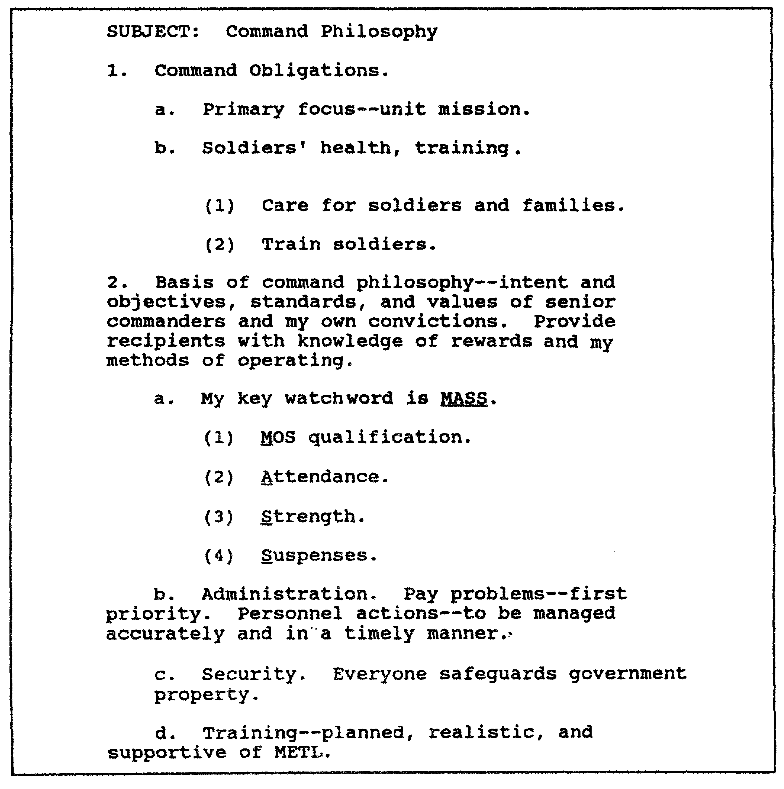

Figure 3-1. Outline of a command philosophy paper.

QM3517 3-20

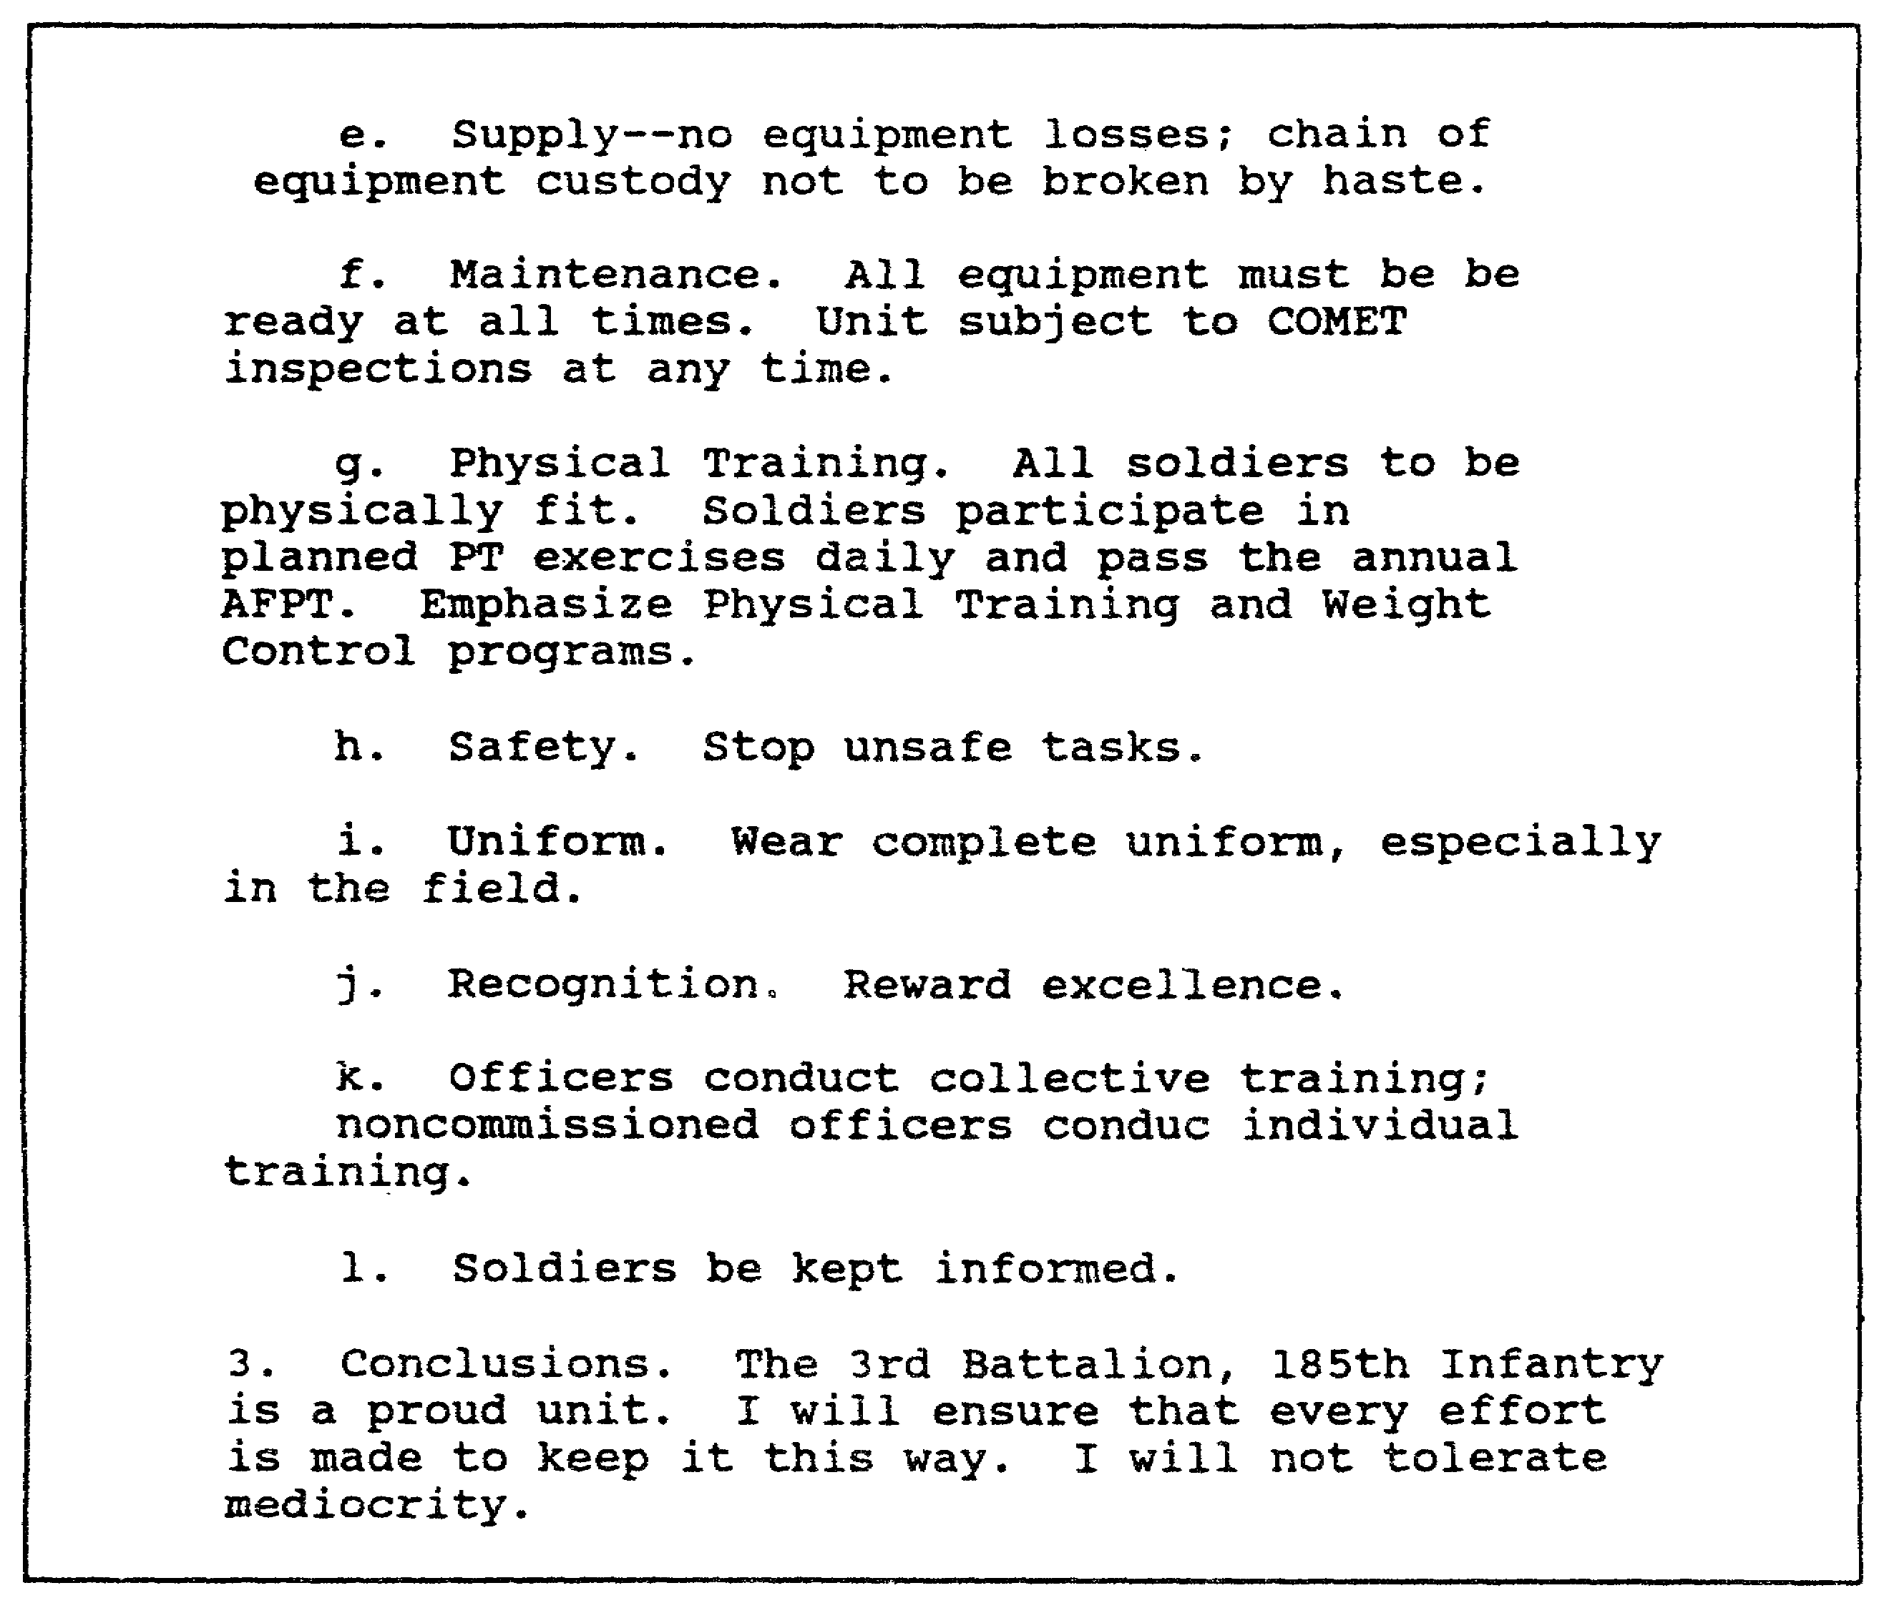

Figure 3-2. Outline of a command philosophy paper (continued).

d. Draft Preparation. Refer to Lesson 1 and Lesson 2 for detailed discussions of draft preparation. Included in the discussion is guidance on the following elements of draft preparation:

o Controlling idea.
o Body paragraphs and supporting ideas.
o Packaging.
o Transitions.

e. Review and Revision. Review and revise your command philosophy paper, as needed, to keep it current. As situations change, so may your command philosophy.

3-21 QM3517

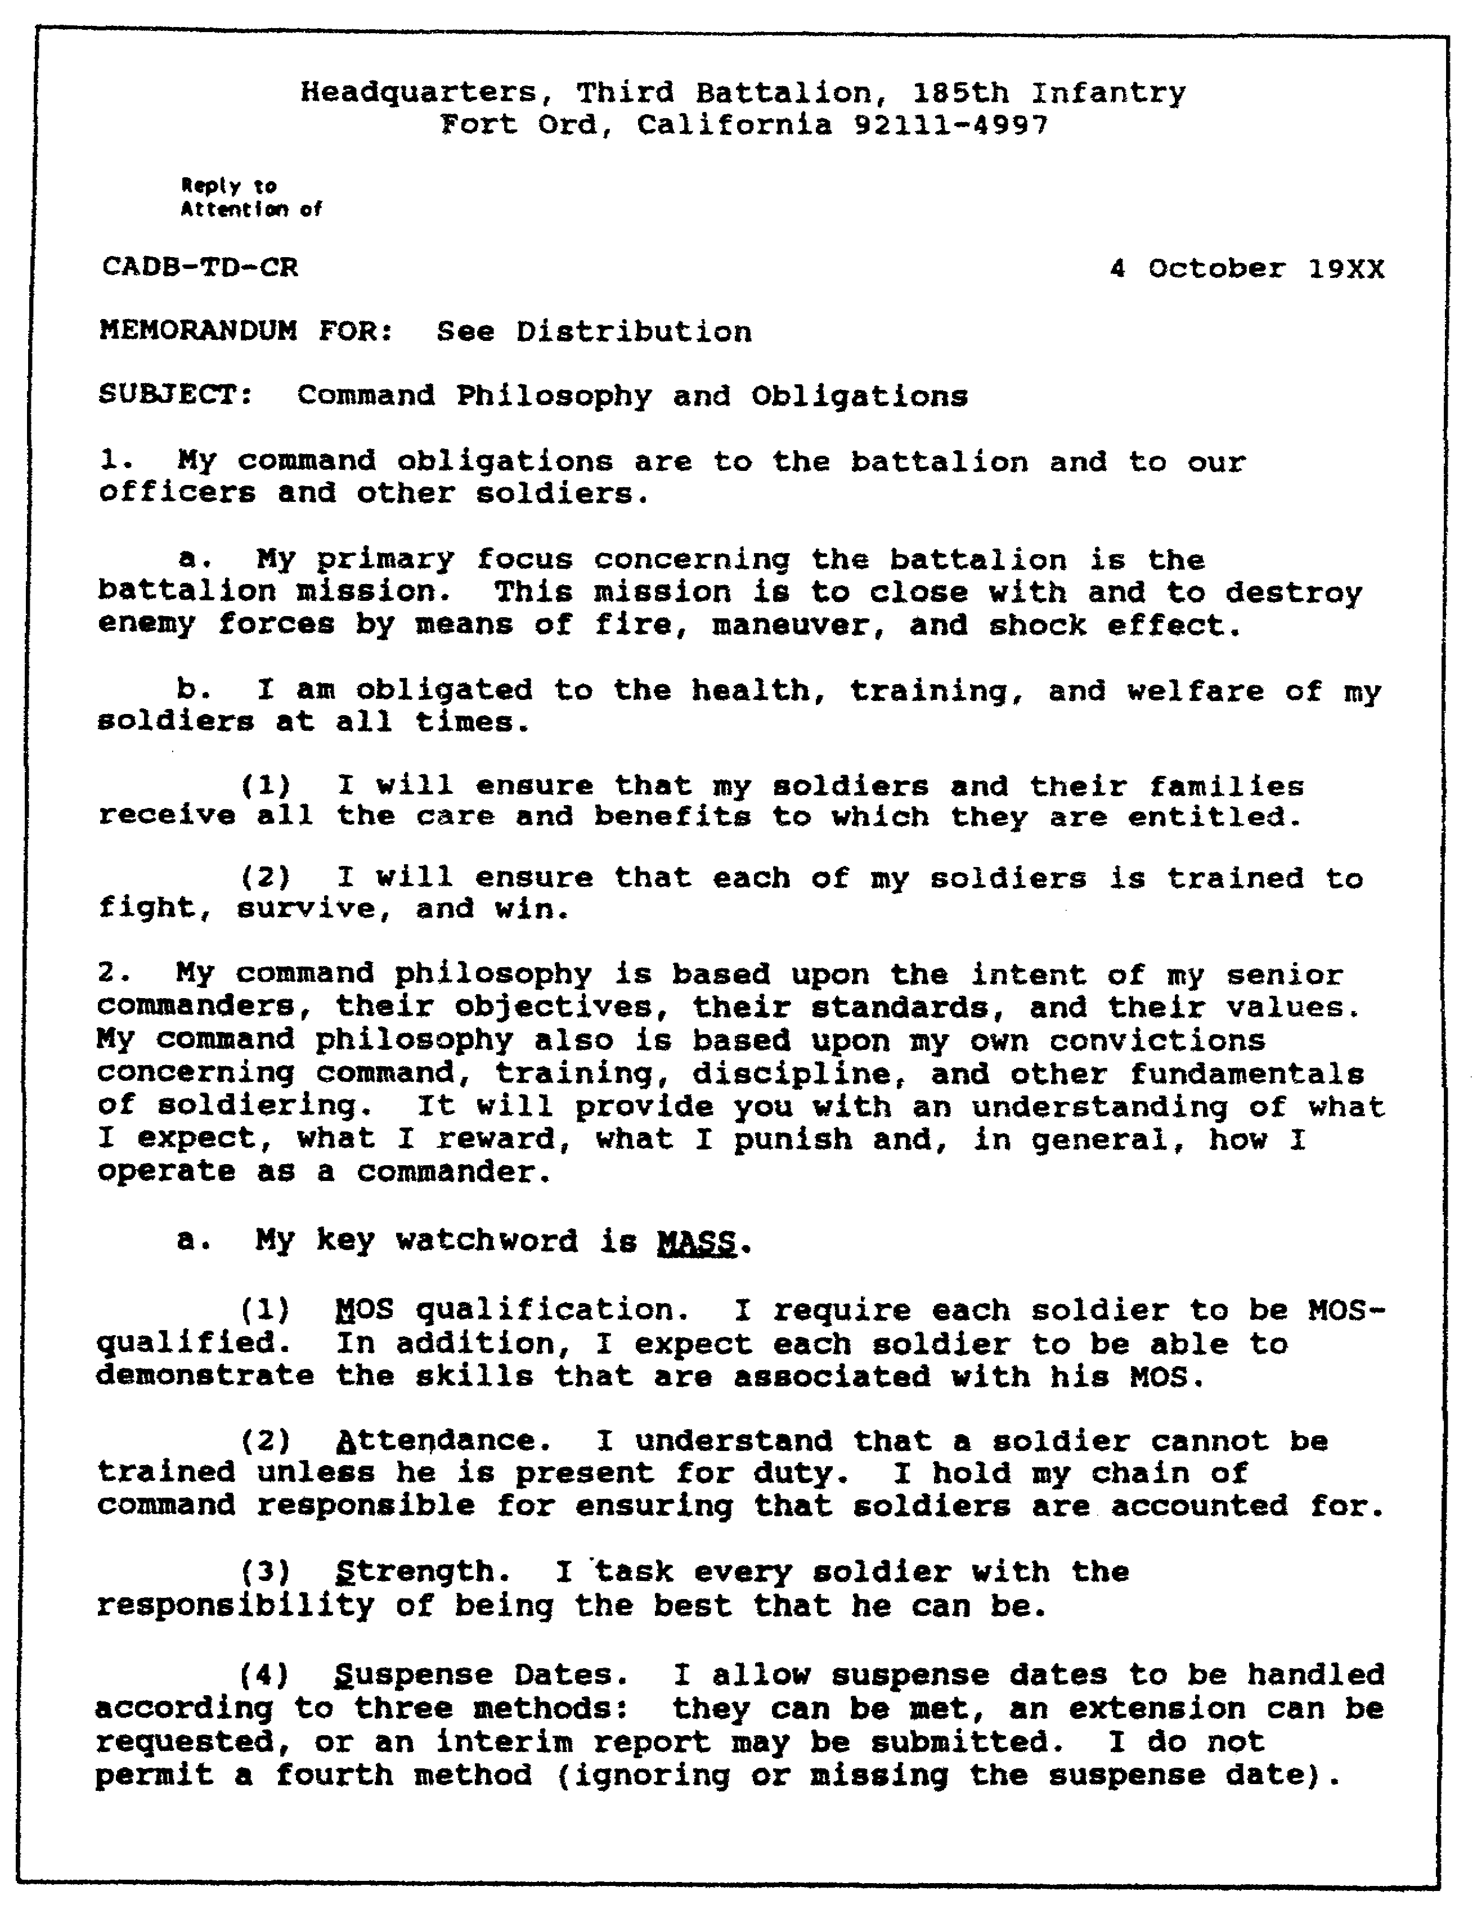

Figure 3-3. Sample of a command philosophy paper.

QM3517 3-22

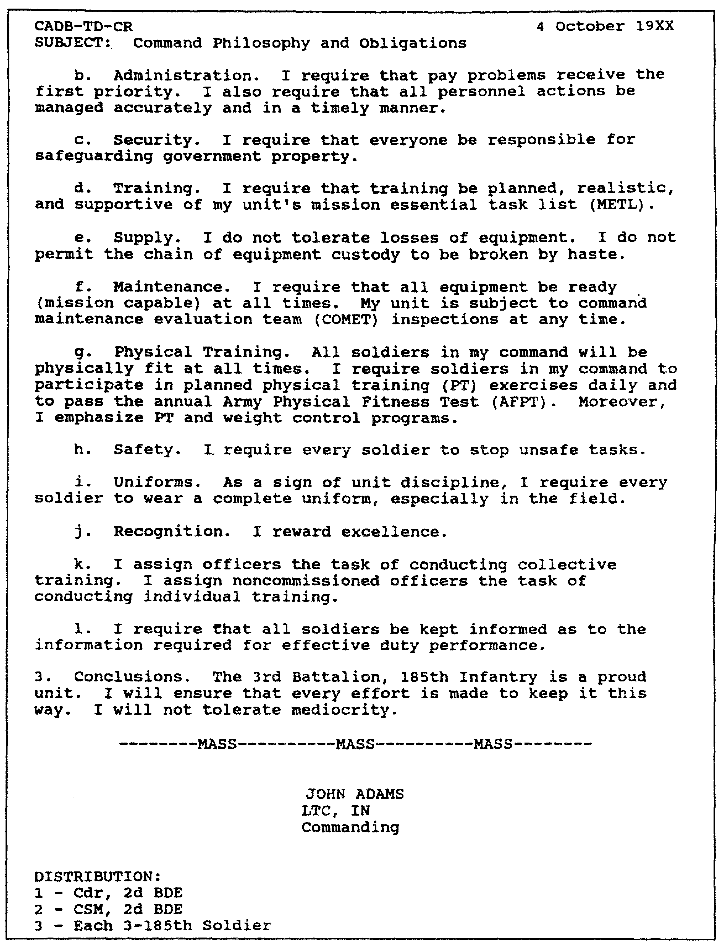

Figure 3-4. Sample of a command philosophy paper (continued).

3-23 QM3517

LESSON 3

PRACTICE EXERCISE

The following items will test your grasp of the material covered in this lesson. There is only one correct answer for each item. When you complete the exercise, check your answers with the answer key that follows. If you answer any item incorrectly, study again that part of the lesson which contains the portion involved.

1. You are preparing for command. You have written your command philosophy and are preparing to have copies of it passed to your subordinates. You also pass your subordinates a

A. DA Form 67-8.
B. DA Form 67-8-1.
C. DA Form 2166-7.
D. DA Form 2166-7-1.

2. As a commander, you want to develop your thought processes toward

A. where you want to command.
B. what type of unit you want to command.
C. when you want to command.
D. how you would like to command.

3. The most appropriate form of correspondence for you to use for your command philosophy paper is the

A. endorsement.
B. letter.
C. memorandum.
D. outline.

4. Your command philosophy paper is an example of writing to

A. inform.
B. direct.
C. persuade.
D. brief.

QM3517 3-24

LESSON 3

PRACTICE EXERCISE

ANSWER KEY AND FEEDBACK

Item Correct Answer and Feedback

1. B. DA Form 67-8-1.

As part of your preparation for command, you distribute your written command philosophy and a DA Form 67-8-1 (Officer Evaluation Report Support Form), that is based on your command philosophy, to your subordinates. (page 3-3, para 1a)

2. D. how you would like to command.

Your goal as a leader is to develop a general company-level command philosophy. As a successful company commander, you must know how to develop your thought processes toward how you would like to command instead of toward where or what type of unit you would like to command. (page 3-1, para 1)

3. C. memorandum.

The most appropriate form of correspondence to use for your command philosophy paper is the memorandum.
(page 3-22, Figure 3-3 and page 3-20, para 4c)

4. A. inform.

Your writing purpose is to inform. More specifically, your writing purpose is to present your command philosophy.
(page 3-19, para 4a)

3-25 QM3517

LESSON 4

NONCOMMISSIONED OFFICER EVALUATION REPORT DEVELOPMENT

Critical Task: S3-0170.00-1006

OVERVIEW

LESSON DESCRIPTION:

In this lesson, you will learn how to identify the purpose and the proper use of DA Form 2166-7 (Noncommissioned Officer Evaluation Report [NCO-ER]) and DA Form 2166-7-1 (US Army Noncommissioned Officer Counseling Checklist/Record). You also will learn the procedures to use to complete these forms; the times at which you render the reports; the rating scheme; the importance of each rater's evaluation or comments; your responsibility for providing accurate information and unbiased appraisals; and the responsibilities for resolving major disagreements. You will learn how to identify the qualifications and the responsibilities of the rater, the immediate rater, the reviewer, and the rated individual. Additionally, you will learn how to use bullet comments (narrative) to support numerical ratings for your NCOs. Moreover, you will learn the roles and the responsibilities of the Personnel Service Center (PSC) and the Personnel Administration Center (PAC).

TERMINAL LEARNING OBJECTIVE:

ACTION: Identify the purpose and the proper use of the DA Fort 2166-7 and DA Form 2166-7-1. Learn the procedures to use to complete these forms, the times at which you render the reports; the rating scheme; the importance of each rater's evaluation or comments; your responsibility for providing accurate information and unbiased appraisals; and the responsibilities for resolving major disagreements. Learn how to identify the qualifications and the responsibilities of the rater, the immediate rater, the reviewer, and the rated individual. Additionally, learn how to use bullet comments (narrative) to support numerical ratings for your NCOs. Moreover, learn the roles and responsibilities of the PSC and the PAC.

CONDITION: You will be given information from AR 623-205 and DA Pamphlet 623-105.

4-1 QM3517

STANDARD: Performing the following actions will be in accordance with AR 623-205 and DA Pamphlet 623-105:

o Identify the purpose and the proper use of DA Form 2166-7 and DA Form 2166-7-1.

o Complete DA Form 2166-7 and DA Form 2166-7-1.

o Identify the times at which you render the reports, the rating scheme, the importance of each rater's evaluation or comments, your responsibility for providing accurate information and unbiased appraisals, and the responsibilities for resolving major disagreements.

o Identify the qualifications and the responsibilities of the rater, the immediate rater, the reviewer, and the rated individual.

o Use bullet comments (narrative) to support numerical ratings for your NCOs.

o Identify the roles and the responsibilities of the PSC and the PAC.

REFERENCES: The material contained in this lesson was derived from the following publications: AR 623-205 and DA Pamphlet 623-105.

INTRODUCTION

Career progression is important to all soldiers. As opportunities diminish, the competition for selection becomes keener. Competition for selection is tough enough without handicapping NCOs with improperly prepared or poorly written evaluation reports.

As a rating official, you must fulfill your responsibilities of evaluating NCO performance and potential accurately on DA Form 2166-7. In addition, you must complete DA Form 2166-7-1 properly. Although no single report can wholly determine an NCO's career, each one can have an effect.

The evaluation system examines the performance and the potential of its leaders. It is the basis for informed personnel management decisions as to promotions, assignments, advanced training, and retention. Special reports document either

QM3517 4-2

exceptional or abysmal performance which cannot wait until the next reporting period.

PART A - RESPONSIBILITIES OF NONCOMMISSIONED OFFICER
RATERS, REVIEWER, AND RATED INDIVIDUAL

1. Background Philosophy and Functions.

As a result of a recent study, the Army revised the NCO-ERS. Refer to the following subparagraphs for a discussion of the study and the revisions which resulted from it.

a. Study. The idea for a new DA Form 1266-7 began with the work of the NCO Professional Development Study Group in 1985. The group discussed NCO professional development with NCOs and officers throughout the Army. It became obvious that the Army needed a better report. The group also found that there was not enough communication between NCO raters and the rated NCOs. However, the most important contribution was the group's list of what the Army requires its NCOs to be and to know. This list was a real breakthrough.

b. New System. The Army now had a list that focused on the NCO. It became obvious that a new NCO evaluation system should emphasize, teach, and evaluate what the Army now calls "NCO responsibilities". The development process included the usual considerations such as examining other systems, past and present; obtaining input from selection boards; and listening to senior officers and NCOs. Beyond this, the NCO corps provided its input.

The single strongest message was that more counseling was needed and that assistance was required to accomplish the counseling. The Army approved the forms and major policy changes on 1 6 June 1987.

c. Functions. This subparagraph discusses the functions of the DA Form 2166-7. The Army designed DA Form 2166-7 to accomplish the following:

o Strengthen the ability of the NCO corps to meet the professional challenges of the future through the inculcation of values and basic NCO responsibilities.

o Ensure the selection of the best NCOs to serve in positions of increasing responsibility by providing a rating-chain view of performance and potential for use in centralized selection, assignment, and other Enlisted Personnel Management System (EPMS) decisions.

4-3 QM3517

o Contribute to Armywide improved performance and professional development by increased emphasis on performance counseling.

2. The Noncommissioned Officer Evaluation Reporting System.

The following subparagraphs discuss the NCO-ERS. Refer to these paragraphs for information concerning its characteristics, functions, and uses.

a. Evaluation of Army Values and NCO Responsibilities. The Army designated the NCO-ERS to strengthen the ability of the NCO corps to meet the professional challenges of the future by inculcating Army values and basic NCO responsibilities. Use the rating chain to ensure that these values and responsibilities remain evaluation criteria and reinforce a professional focus for reviewing NCO performance. Over time, NCOs accept these values and NCO responsibilities. Then, you obtain better performance and a stronger NCO corps.

b. Selection Based on Rating Chain. Your use of the NCO-ERS ensures that the best-qualified NCOs serve in positions of increasing responsibility. The NCO-ERS provides a rating-chain review of NCO performance and potential. Use this review in centralized selection, assignment, and other EPMS decisions.

The Army uses the information in evaluation reports, its own needs, and the individual NCO's qualifications as the bases for such personnel actions as the following:

o School selection.
o Promotion.
o Assignment.
o MOS classification.
o CSM designation.
o Qualitative management.

The NCO-ERS also contributes to Armywide improved performance and professional development by increasing the emphasis on performance counseling. Your evaluation reports provide formal recognition of the NCO's performance of duty. Your evaluation reports also measure his professional values and his personal traits. Use DA Form 2166-7-1 and your evaluation reports as your bases for performance counseling. You need communication between seniors and subordinates to maintain high professional standards and an effective evaluation system.

c. Accuracy and Completion of Reports. You want to ensure that the Army can make sound personnel management decisions and that a soldier can fully develop his potential. To do so, you must ensure that your evaluation reports are accurate and

QM3517 4-4

complete. Make sure that each report is a thoughtful, fair appraisal of the NCO's abilities, weaknesses, and potential. If your report is incomplete or fails to provide a realistic and objective evaluation, then you will find it difficult to make personnel management decisions.

d. Appraisal Philosophy. Do not allow any single report to determine a soldier's career. You best serve both the Army and the NCO when your appraisal philosophy recognizes continuous professional development and growth, rather than demanding immediate, uncompromising perfection.

3. Types of Reports and Codes.

Submit only those reports that AR 623-205 authorizes. The following are mandatory reports; they take precedence over optional complete-the-record reports:

o Annual reports.
o Change-or-rater reports.
o Relief-for-cause reports.

Report codes refer to block "g" of Part I of DA Form 2166-7. Refer to Part C of this lesson for a discussion of block "g" of Part I of the report.

a. First Report--Report Code 1. A variety of events can require the submission of an evaluation report. The date of the event for which the report is required determines the first report that an active Army (AA), an ARNG, or a USAR NCO receives. This event may be a change of rater or the requirement for an annual report. When you submit the first report, select one of the following as the beginning month:

o The month of the effective date of promotion to sergeant.

o The month during which reversion to NCO status occurs after the soldier has served as a commissioned or warrant officer (WO) for 12 months or more.

o The month of reentry on active duty after the soldier has had a break in service.

o The date of the Army Board of Correction of Military Records (ABCMR) memorandum which approves reinstatement in an NCO rank.

4-5 QM3517

(1) Army National Guard First Reports. Submit the first NCO-ER reports for ARNG NCOs for whichever of the following events, situations, or conditions occurs first:

o Immediate reenlistment or extension.

o Transfer to the Inactive Regular Reserve (IRR).

o Transfer to another ARNG unit.

o Transfer to another reserve component (RC).

o Board selection which requires that a report be submitted.

o Change of rater.

o Annual reporting month.

(2) United States Amy Reserve First Reports. Prepare first reports for USAR NCOs for whichever of the following events, situations, or conditions occurs first:

o Board action which requires that a report be submitted.

o Change of rater.

o Annual reporting month.

b. Annual Report--Report Code 2. Submit an annual report 12 months after the most recent of the following events, situations, or conditions occurs:

o Ending month of the last report.

o Effective date of promotion to sergeant.

o Reversion to NCO status after the soldier serves as a commissioned officer or a WO for 12 months or more.

o Reentry on active duty of a soldier in the rank of an NCO after a break in enlisted service of 12 months or more.

Twelve months may elapse and an annual report may be due. However, the rater may not have met the required 90-day minimum rating period qualification criterion. If this is the case, then the annual report period may be extended until the rater meets the minimum requirements. The rater does NOT sign an annual

QM3517 4-6

report before the first day of the month following the ending month of the report.

The report period may cover from 12 months to 2 years because of breaks in service, temporary disability retirement list (TDRL) assignment, or other reasons. However, DO NOT allow the rating period to exceed 12 rated months. Providing an annual rating that covers more than the authorized 12 months can be detrimental to the rated NCO. Also, he could appeal an annual DA Form 2166-7 successfully, thereby negating the entire rating period. Additional months that are included in such a report period then could be counted as nonrated time.

A rater may die, be relieved, be reduced in rank, be absent without leave (AWOL), or be declared missing. He may be incapacitated to such an extent that the reviewer, on the advice of medical authorities, believes that the rater cannot submit an accurate evaluation. This may happen after the report period but before the report is signed. If so, the senior rater completes the rater and the senior rater portions of the report, provided that the senior rater meets minimum rater qualifications.

For ARNG and USAR, prepare annual reports as of the last day of the month as follows:

o August for MSG or 1SG and sergeant major (SGM) or CSM.
o September for platoon sergeant (PSG) and SFC.
o October for staff sergeant (SSG).
o November for SGT.

NOTE: For specifics on reports for IRR, Individual Mobilization Augmentee (IMA), and Inactive National Guard (ING) NCOs, see AR 623-205, paragraphs 5-10 and 5-11.

NOTE: Ensure that the regular reports which are submitted annually meet the three-rated-month minimum rating period and rater qualifications. Extend the report period until these requirements are met, if necessary. Do not prepare a regular report if another report has been submitted during the three-month period preceding the end of the regular reporting month.

c. Change-of-Rater Report--Report Code 3. Submit a report whenever your unit changes the designated rater (provided that

4-7 QM3517

you meet minimum rater qualifications and have submitted no other reports in the preceding three months). You need a report when any of the following conditions occur:

o The rater or the rated NCO is reassigned.

o The rater or the rated NCO departs on extended temporary duty (TDY) or special duty (SD).

o The rater or the rated NCO is released from active duty early per AR 635-200 or normal expiration term of service (ETS). Allow exceptions for discharge and immediate reenlistment.

o The rated NCO is reduced to corporal (CPL), specialist (SPC), or below. Reduction to another NCO grade does not require a report unless the actual rater changes.

o The rater dies, is relieved or reduced, becomes AWOL, or is declared missing. Alternatively, he may become incapacitated to such an extent that the reviewer, on the advice of medical authorities, believes that the rater is unable to submit an accurate evaluation.

NOTE: The senior rater completes both the rater's and his own portions of the reports on each of the rater's subordinates. To do so, he must meet minimum rater qualifications. Also, he enters in Part Ve a brief explanation such as "rater deceased" or "rater relieved". Neither the rater nor the senior rater may be able to evaluate because of any combination of these factors. If this is the case, then your unit does not submit a report. On the next report, this period will be shown as nonrated. Use code "Q" to explain nonrated periods.

o The rater submits a change-of-rater report upon approved retirement. The ending month is the month that the transition leave begins or the month that retirement is effective if transition leave is not taken.

A change-of-rater report may not be signed before the date that the change occurs. However, in the event of a permanent change of station (PCS), the report may be completed and signed up to 10 days before the date of departure in order to facilitate orderly outprocessing.

QM3517 4-8

(1) Temporary Duty, Special Duty, or Compassionate Reassignment. Change-of-rater reports for both the NCO and his eligible subordinates must be submitted before the NCO departs on TDY or SD under these conditions (provided that the rater meets rater qualifications):

o To attend a service school resident course or training scheduled for 90 calendar days or more.

o To attend a civilian academic or training institution on a full-time basis for 90 calendar days or more.

o To perform duties that are not related to his primary functions in his parent unit under a different immediate supervisor for three rated months or more. You are not authorized to submit a report if the NCO is still responsible to, or receiving instructions from, rating officials in the parent organization.

The TDY or the SD supervisor rates an NCO on TDY or SD (other than as stated in the preceding first two bullets) for the TDY or the SD period when the NCO is not responsible to rating officials in his parent organization. The supervisor rates the NCO in accordance with Figure 4-1. The TDY or the SD supervisor ensures that a rating scheme is published in accordance with AR 623-205 (Responsibilities of Commanders), paragraph 1-4b.

The NCO's normal rating officials continue to rate him when he is on TDY or SD and remains responsible to ratings officials in his parent organization for the period during which is on TDY or SD. This is the case regardless of the length of the period. Memorandum input from the supervising officials of the attached organization is mandatory. (Note 1 of Figure 4-1 applies.)

An NCO who is attached to an organization remains responsible to his parent unit when he is awaiting compassionate reassignment. The attached organization does not evaluate him. Again, memorandum input from the supervising officials of the attached organization is mandatory. (Note 1 of Figure 4-1 applies.)

4-9 QM3517

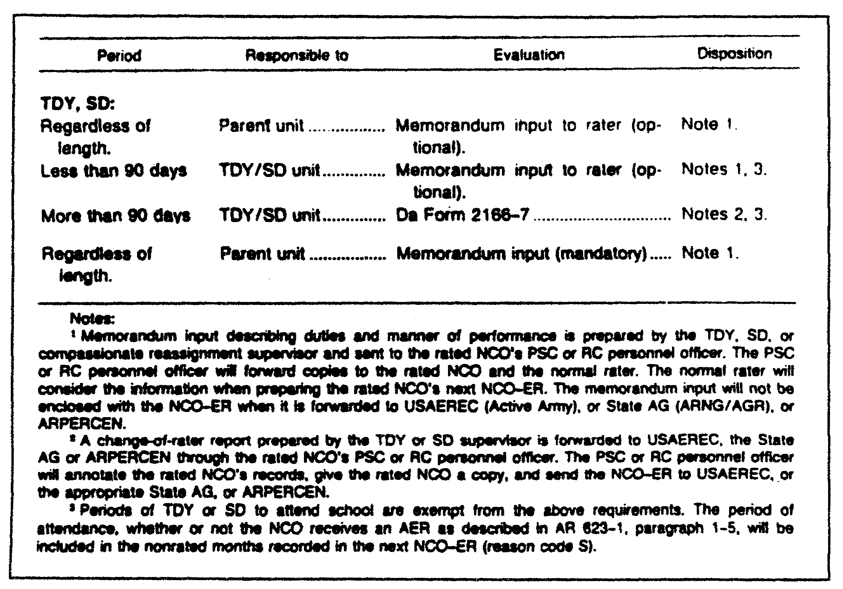

Figure 4-1. TDY, SD, or compassionate attachment supervisor's
reports (other than TDY or SD to attend school).

(2) USAR Change-of-Rater Reports. A report on USAR NCOs is submitted whenever the designated rater is changed, as long as the minimum 90-day rater qualifications are met. Ensure that a report is submitted when any of the following conditions occur:

o The rater or the rated NCO is reassigned. The rater or the rated NCO is transferred to another unit. The rater or the rated NCO is transferred to the IRR, IMA, or ING. The rater or the rated NCO is transferred to another RC.

o The rater or the rated NCO is discharged or the normal ETS occurs, except for discharge and immediate reenlistment.

o The NCO is reduced to CPL, SPC, or below. Reduction to another NCO grade (for example, from SFC to SGT) does not require a report, unless the actual rater changes.

QM3517 4-10

o The rater dies, is relieved, is reduced, is AWOL, or is declared missing. Alternatively, the rater may become incapacitated to such an extent that the reviewer, on the advice of medical authorities, believes that the rater is unable to submit an accurate evaluation.

NOTE: The senior completes both the rater and the senior rater portions of the reports on each of the rater's subordinates. (The senior rater must meet minimum rater qualifications.) He enters a brief explanation of the reason for the report in Part Ve (for example, "rater deceased" or "rater relieved"). Both the rater and the senior rater may be unable to evaluate because of any combination of these factors. If this is the case, then a report is not submitted. The period will be shown as nonrated on the next report. Code "Q" will be used to explain nonrated periods.

o The rater or the rated NCO requests it upon approved retirement.

A change-of-rater report may not be signed before the date that the change occurs. However, in the event of a PCS, the report may be completed and signed up to 10 days before the date of departure in order to facilitate orderly outprocessing.

(3) ARNG Change-of-Rater Reports. Change-of-rater reports are optional for an ARNG NCO when his duties change significantly with the change-of-rater and the NCO remains in the same unit. They are also optional for an ARNG NCO whose rater transfers within the unit. A change-of-rater report is required when an ARNG NCO or the rater transfers to another unit or to the IRR or another component. A change-of-rater report also is required when directed by the chain of command in conjunction with a change-of-rater or a change-of-duty assignment.

d. Complete-the-Record Report--Report Code 4. This report may be submitted at the option of the rater when a DA-centralized board is about to consider the NCO for any of the following:

o Promotion.
o School.
o CSM selection.

4-11 QM3517

This also applies to ARNG and USAR CSM programs and to ARNG and USAR promotion boards that are centralized at state or major United States Army Reserve Command (MUSARC) headquarters and the Army Personnel Center (ARPERCEN). However, the rated NCO must meet the following conditions:

o He must be in the primary or the secondary zone of consideration for a centralized promotion board or in the zone of consideration for a school or CSM selection board.

o He must have been in his current duty assignment position under the same rater for at least six rated months.

o He must not have received a previous report from the same rater for the current duty position.

This is an optional report. Therefore, a request for standby reconsideration cannot be made if such a report is not in the Official Military Personnel File (OMPF) at the time of the board's review.

Complete-the-record reports may not be signed prior to the first day of the month following the ending month.

The complete-the-record report must be completed accurately. If the wrong ending date is used, then the DA Form 1266-7 will be returned for correction. It also will be returned for correction if the complete-the-record report is signed before the end date of the report. Complete-the-record reports must be submitted within a few days before the selection board convenes. Therefore, there may not be enough time to correct the report and to return it for the selection board's consideration.

e. Relief for Cause Report--Report Code 5. AR 600-20 (Army Command Policy and Procedures), paragraph 3-23, defines "relief for cause" as the removal of an NCO from a ratable assignment. This is based on a decision by a member of the NCO's chain of command or supervisory chain. In effect, the member says that the NCO's personal or professional characteristics, conduct, behavior, or performance of duty warrant removal in the best interest of the US Army. If relief for cause action is contemplated on the basis of an informal AR 15-6 (Procedures for Investigating Officers and Board of Officers) investigation, then ensure that the referral procedures in that regulation are met before the relief is initiated or directed. This requirement does not preclude directing a temporary suspension of an NCO from assigned duties pending the application of the procedural safeguards contained in AR 15-6.

QM3517 4-12

The rating official who directs the relief must explain clearly the reason for the relief in Part IVf if he is the rater. If the relieving official is the senior rater, he explains the reason for the relief in Part Ve. The relieving official must state that he has notified the NCO of the reason for the NCO's relief.

The individual who directs the relief may be an official other than the rater or the senior rater. In this case, he must describe the reasons for the relief in an enclosure (not to exceed one page) to the report. Additionally, he must have the rater (or, in the absence of a rater, the senior rater) indicate that he (the relieving official) has notified the NCO of the reason for the relief.

The minimum rating period and the rater and senior rater qualification period for this report is 30 days. This restriction allows the rated NCO a sufficient period in which to react to performance counseling during each rating period. The authority to waive this 30-day minimum period in clear-cut cases of misconduct is granted to a general officer in the chain of command or to an officer who has general courts-martial jurisdiction over the relieved NCO. The waiver approval, in memorandum format, is attached as an enclosure to the report.

The date of relief determines the "through" date of the report. A cause-of-relief report may be signed at any time during the closing or the following month of the report.

When the rater is relieved or both the rater and the rated NCO are relieved concurrently, the senior rater completes both (rater and senior rater) portions on each of the rater's subordinates. He enters "rater relieved" in Part Ve. The relieved rater is not identified in Part IIa.

When the computation of the rated months results in zero (0) rated months, DA Form 2166-7, Part I, item "i" (as an exception to normal policy), reflects one rated month.

f. Reports for IRR and IMA NCOs--Report Code 6. The NCO-ER is prepared in triplicate. The original and a copy are sent to Cdr., ARPERCEN, ATTN: DARP-PRE-E, 9700 Page Boulevard, St Louis, MO 63132-5200. The rated NCO receives the other copy. Reports must be forwarded not later than 90 days after the ending date of the report.

Reports that are submitted according to subparagraph 3b of this lesson will be completed for IRR and IMA NCOs, SGT or above. These NCOs are attached or assigned to active or RC commands of the US Armed Forces for indefinite periods. They perform inactive duty for training (IDT) or active duty for training (ADT) for pay or points. An example of such an NCO is an IRR

4-13 QM3517

soldier who is attached for training to the US Air Force Reserve or the Air National Guard.

Submit an NCO-ER when an IRR or an IMA NCO (except as stated in the preceding paragraph), SGT or above, completes more than 11 consecutive days of any of the following:

o Annual training (AT).
o ADT.
o Active duty for special work (ADSW).
o Full-time training duty (FTTD).
o Temporary tour of active duty (TTAD).

These reports are coded with the report code "6". They are processed as follows:

o The command to which the NCO is to be attached or assigned for the tour of duty contacts the NCO within 14 days of the reporting date. The NCO is informed of the impending duties, responsibilities, reporting requirements, and appropriate sponsorship information.

o Performance counseling is conducted.

o Prior to departure from the tour of duty, the NCO should receive a copy of his completed NCO-ER. As a minimum, the NCO receives the rater's portion of the NCO-ER.

o The duty station ensures that the NCO's completed NCO-ER is forwarded to Cdr, ARPERCEN, ATTN: DARP-PRE-E, 9700 Page Boulevard, St. Louis, MO 63132-5200. The NCO-ER must be forwarded not later that 90 days after the ending date of the report.

g. Relief from Annual Training, Active Duty Training, Active Duty Special Work, Full-Time Training Duty, and Temporary Tour of Active Duty-Report Code 6. For DA Forms 1266-7 that you submit per paragraph 3b of this part of this lesson, refer to AR 623-205, paragraphs 5-10 and 5-11. These paragraphs provide instructions as to how and when to submit DA Forms 1266-7 for relief from AT, ADT, ADSW, FTTD, and TTAD.

4. Professional Evaluation.

This paragraph discusses professional evaluations. Refer to the following subparagraphs for a discussion of commander's responsibilities; commander inquiry into suspected, illegal, or unjust evaluations; and evaluation principles.

QM3517 4-14

a. Commander's Responsibilities. The commander establishes controls to ensure compliance with the following requirements:

o The unit publishes official rating schemes by name. The unit posts them so that each NCO knows his rater, his senior rater, and his reviewer. The rating scheme reflects the effective dates of each rating official.

o For ARNG (not on ARG or Full Time National Guard Duty [FTNGDJ]) official rating schemes are published by duty position and are posted in the unit so that all NCOs know their raters, their senior raters, and their reviewers. The schemes include the effective dates of the rating schemes.

o Each rating official has the full qualifications to meet his responsibilities as outlined in paragraph 5 of this part of this lesson. Each rating official also ensures that he knows whom he must counsel, coach, and rate.

o Rating officials give timely counseling to subordinates on professionalism and job performance.

o Rating officials, designated in the published rating scheme, prepare the reports.

o Each rated NCO receives a copy of his completed evaluation report, including any authorized enclosures.

o NCOs get help, if they request it, in preparing and submitting appeals.

o Unit leaders prepare reports fairly and carefully and submit them in time. They must reach the United States Army Enlisted Records and Evaluation Center (USAEREC) not later than 60 days after the "through" date of the report for the active duty NCOs. For reservists, they must reach the US Army Reserve Personnel Center (ARPERCEN) not later than 90 days after the ending month of the report for ARNG or USAR NCOs.

b. Commander Inquiry Into Suspected, Illegal, or Unjust Evaluations. The commander must look into allegations that a report rendered by one of his subordinates or a member of a subordinate command may be illegal, unjust, or otherwise in violation of AR 623-205.

4-15 QM3517

(1) Commander's Inquiry. Ensure that a commander (major or higher) makes an inquiry in the chain of command above the designated rating officials. The rated NCO or anyone who has knowledge of the alleged illegality, injustice, or violation may bring these matters to the commander's attention.

The commander confines the inquiry to matters relating to the
following:

o Clarity of the report.
o Facts contained in the report.
o Compliance of the report with AR 623-205.
o Conduct of the rated NCO and rating officials.

The commander may use formal or informal procedures for this inquiry, as he deems appropriate, to include telephone and personal discussions. He also may appoint an officer who is senior to the designated rating officials who are involved in the allegations to make the inquiry.

(a) Purposes of Inquiry. The primary purpose of the commander's inquiry is to ensure that the command prevents obvious injustices to the rated NCO. The commander's inquiry also ensures that such errors are corrected before they become a matter of permanent record. A secondary purpose is to provide a greater degree of command involvement in clarifying injustices after the evaluation report is accepted at USAEREC, a state AG office, or the ARPERCEN. However, in these after-the-fact cases, the commander's inquiry is not intended as a substitute for the appeals process. The appeals process is the primary means of addressing errors and injustices after they have become a matter of permanent record.

(b) Restrictions. Regulations prohibit anyone from using the commander's inquiry procedures to document differences of opinion between rating officials about an NCO's performance and potential. Regulations also prohibit the use of the commander's inquiry to document differences between the commander and rating officials. Basically, the evaluation system established rating chains. Normally, it relies on the opinions of the rating officials. Rating officials should evaluate and have their opinions. Their evaluations and opinions constitute the organization's view of the rated NCO. However, the commander may determine through the inquiry that the report has serious irregularities or errors. Examples include, but are not limited to the following:

o Improperly designated or unqualified rating officials (such as rating officials who have

QM3517 4-16

had substantiated findings against them from an official investigation).

o Inaccurate or untrue statements.

o Lack of objectivity or fairness by rating officials.

(c) Prohibitions. The Army prohibits the commander from the following:

o Pressuring or forcing rating officials to change their evaluations.

o Evaluating the rated NCO, either as a substitute for, or in addition to, the designated rating officials' evaluations.

o Using the commander's inquiry provisions to forward derogatory information to the rated NCO.

(2) Current or Subsequent Commander's Inquiry. To ensure the availability of pertinent data and the timely completion of an inquiry that is conducted after the USAEREC, the state AG's office or the ARPERCEN receives the evaluation in question, Army regulations require that one of the following individuals conducts the inquiry:

o The individual who was commander at the time that the report was rendered and who is still in the command position.

o A subsequent commander in the position.

Not later than 120 days after the "through" date, the inquiry must be forwarded to one of the following addresses:

o Cdr, USTAPA, ATTN: AAPC-MSE (Active Army and ARNG AGR title 10 NCOs) or to the appropriate State Adjutant General (ARNG, including ARNG AGR title 32 soldiers).

o Cdr, ARPERCEN, ATTN: DARP-PRE-A (all USAR).

(3) Processing Procedures. The commander uses the following procedures to process commander inquiries.

(a) No Illegality, Injustice, or Violation of Regulation. If the inquiry reveals that no illegality, injustice, or violation of AR 623-205 has occurred, then the

4-17 QM3517

commander so advises the individual who requests the inquiry. No further action is taken in regard to DA Form 1266-7 except to forward the report to USAEREC, the appropriate state AG, or the ARPERCEN. The commander may retain a written record of the inquiry, such as a memorandum.

(b) Error or Wrongdoing. The inquiry may reveal that an error, an illegality, an injustice, or a violation of AR 623-205 has occurred. The report may not have been forwarded to USAEREC, the appropriate state AG, or the ARPERCEN. If this is the case, then the commander returns the DA Form 1266-7 with the inquiry results to the reviewer. The commander asks the reviewer to correct the report to account for the matters that were revealed in the inquiry. This is done with regard to the restrictions against the commander pressuring or forcing rating officials to change their evaluations. After the report is corrected, it is forwarded to USAEREC, the appropriate state AG, or the ARPERCEN with no reference to the commander's action.

The report may not have been forwarded yet to the USAEREC, the appropriate state AG, or the ARPERCEN. In addition, the commander and the rating chain members may not be able to agree on the need for change in the report. In this case, the commander forwards the report and the results of the inquiry to whichever of the addresses that are shown in subparagraph 4b(2) of this part of this lesson is appropriate.

The commander may find that a report that has been forwarded to the USAEREC, the appropriate state AG, or the ARPERCEN violates AR 623-205. If so, then he forwards the results of his inquiry to whichever of the addresses that are shown in subparagraph 4b(2) of this part of this lesson is appropriate. If the results of the inquiry reflect only administrative errors, then it need not be forwarded to Cdr, USTAPA.

NOTE: If the inquiry reveals an error or wrongdoing, then rating officials cannot lower their evaluations as a result of the inquiry.

(4) Format. The results of the commander's inquiry must include findings, conclusions, and recommendations in a format for clarification purposes. These results are to be filed with the report in the NCO's OMPF. The results--

o must include the commander's signature.

o should stand alone without reference to the other documentation.

QM3517 4-18

o should be limited, as a matter of preference, to one page.

The commander also attaches sufficient documentation, such as reports and statements, to justify his conclusion.

c. Evaluation Principles. Rating officials directly affect a rated NCO's performance and professional development. Therefore, ensure that rating officials consider the following requirements:

(1) Ensure Understanding. Ensure that the rated NCO thoroughly understands the following:

o The organization.

o The mission.

o His role in support of the mission.

o All the standards, values, and NCO responsibilities that are used to judge his performance.

(2) Observe Rated NCO. To render objective evaluation, the rating official uses all opportunities to observe and to gather information on the rated NCO's performance.

(3) Cover Failures and Achievements. Ensure that evaluation reports are complete, accurate, and fully considered. This is vital to the long-range success of the Army's missions. Ensure that reports cover failures as well as achievements. However, do not base evaluations on isolated, minor incidents. Maintain due regard for the NCO’s current grade, experience, and military schooling.

(4) Balance Obligations. Balance your obligations to the rated NCO with your obligations to the Army. Ensure that the NCOs under your supervision receive accurate, fair evaluations. Make sure that full credit is given to the rated NCO for his achievements and potential. However, ensure that the rating official is honest in his evaluations. Selection boards and career managers need balanced evaluations to make intelligent decisions.

(5) Evaluate Performance. Performance evaluations are judgments as to how well the rated NCO meets duty requirements and adheres to the professional standards of the NCO corps. That is, rating officials evaluate by observing the rated NCO's actions and his demonstrated behavior. In addition, rating officials evaluate by observing the results that the rated NCO

4-19 QM3517

obtains from the point of view of the values and the NCO responsibilities that are contained in DA Form 1266-7 and in DA Form 2166-7-1. Make sure that the rating official gives due regard to the NCO's relative experience and efforts and to the results can reasonably be expected given the time and the resources that are available.

(6) Evaluate Potential. Evaluations of the rated NCO's potential are assessments of his ability, compared with that of NCOs of the same grade, to perform in positions of greater responsibility or a higher grade.

(7) Use Army Wide Areas of Special Emphasis. Ensure that items of Armywide special interest are used when a counseling session is scheduled and when overall NCO performance is assessed on the DA Form 1266-7. The rating official may establish his own special interest items. Areas of Armywide emphasis are addressed by the following Army publications. The titles of the publications refer to the Armywide areas of special interest which each publication addresses. These publications and interests include:

o AR 10-20 (Personnel Management Responsibility for Army Civilian Employees).

o AR 11-2 (Internal Management Control).

o AR 36-7 (Audits).

o AR 380-5 (Information Security Program).

o AR 385-10 (Safety).

o AR 690-500 (Civilian Position Management).

o DA Pamphlet 600-19 (Quality of Life).

o DOD Directive 5000.52-M (Contracting and Acquisition).

o Unit Supply Update Handbook (Property Accountability).

5. Qualifications and Responsibilities of Rating Officials.

Raters, senior raters, and reviewers act as rating officials. Refer to the following subparagraphs for a discussion of the qualifications and the responsibilities of each type of official.

QM3517 4-20

a. Rater Qualifications and Responsibilities. The following subparagraphs outline the qualifications of the rater. They also outline his responsibilities.

(1) Rater Qualifications. Ensure that each rater has the following qualifications:

o He must be the immediate supervisor of the rated NCO and designated as the rater for a minimum period of 90 days. An exception to this requirement occurs when the minimum rater and the senior rater qualification and the minimum rating period are 30 days. The fundamental purpose of this restriction is to allow the rated NCO a sufficient period in which to react to performance counseling during each rating period. Authority to waive this 30-day minimum period in clear-cut cases of misconduct is granted to a general officer who has general courts-martial jurisdiction over the relieved NCO. The waiver approval must be in the memorandum format and must be attached as an enclosure to the report.

o He must be senior to the rated NCO by either pay grade or date of rank. In cases in which the grade of rank is the same, the date of rank is used to determine seniority. The rater may be on an HQDA-recommended list for promotion to one of the top three enlisted grades. In addition, he may be serving in an authorized position for the new grade. If this is the case, then he may rate any soldier whom he supervises provided that, after he is promoted, he will be senior in pay grade or date of rank to the rated NCO. An NCO may be frocked to the rank of 1SG or CSM and may be serving in an authorized 1SG or CSM position. If so, then he may rate any NCO whom he supervises provided that, after promotion, he will be senior to the rated NCO by either pay grade or date of grade of rank.

o A US civilian may be employed as a rater if a first-line military supervisor is not available and the civilian rater is in the best position to evaluate the NCO's performance. The uniqueness of other pay scales (Wage Grade [WG], wage labor [WL], and wage service [WS]) precludes the establishment of an Armywide policy. Therefore, local commanders determine the minimum grade for civilian raters who hold other than government service general schedule pay grades. The

4-21 QM3517

published rating scheme must designate the civilian rater officially, and he/she must have a general schedule-6 grade or above.

o Ensure that members of other US military services (for example, members of the Navy or the Air Force [AF]) meet the requirements that are outlined in the preceding bullets if you use them as raters. You are not authorized to use members of allied forces as raters.

NOTE: Commanders of table of organization and equipment (TOE) and table of distribution and allowances (TDA) units rate their CSMs. An exception to this policy is the military community CSM. He may be rated by the deputy community commander. Another exception to this policy is the CSM who is the commandant of an NCO Academy. He may be rated by the assistant division commander and the deputy installation commander or the division and installation CSM, provided that rater qualifications are met. A third exception to this policy is the USAR NCO Academy CSM. The continental United States (CONUS) Army CSM rates him.

(2) Rater Responsibilities. The rater's primary role is to evaluate performance. His responsibilities include such matters as the following:

o Counseling the rated NCO on his duty performance and his professional development during the rating period. Leaders must counsel all NCOs within the first 30 days of each rating period. Count the 30-day period as one of three months for the first quarter of the rating period. NCOs must receive counseling at least once during each quarter (three-month period), CPLs and SGTs must be counseled within 30 days after the effective dates of their lateral appointments to CPL or their promotions to SGT, and quarterly thereafter. Raters must use DA Form 2166-7-1 for counseling all NCOs, CPL through PSG and SFC. Senior rater comments must explain why there may be no counseling dates listed (paragraph IIIf, DA Form 2166-7).

QM3517 4-22

o Preparing a separate DA Form 2166-7-1 for each rated NCO. These checklists are maintained until after the checklists receive approval. For CPLs, maintain the checklists for one year. DA Forms 2166-7-1 do not have to be kept beyond this. However, in some cases, it is appropriate to keep them longer to support personnel actions.

o Assessing the performance of the rated NCO using all reasonable means.

o Preparing a fair, correct report evaluating the NCO's duty performance, values, responsibilities, and potential.

o Verifying Part I and Part II and entering the APFT and height and weight entries in Part IVc of the DA Form 2166-7-1. Raters verify Part III with the rated NCO. Raters enter APFT numerical scores to justify excellence or need-for improvement ratings based solely on the APFT. Rating officials stress the importance of APFT, height, and weight entries. They also stress the fact that this information is critical to selection boards.

b. Senior Rater Qualifications and Responsibilities. Refer to the first of the following subparagraphs for a discussion of the qualifications of senior raters. Refer to the second of the following subparagraphs for a discussion of the responsibilities of senior raters.

(1) Senior Rater Qualifications. A senior rater must have the following qualifications:

o He must be in the direct line of supervision of the rated NCO. The unit must have designated him as the senior rater for a minimum of two rated months (a minimum of 30 days on relief for cause reports). The senior rater may not meet the minimum qualifications. If he does not, then he enters "Does not meet minimum qualifications" in Part Ve. For exceptions to this requirement, refer to subparagraphs 3c and 3f of this part of this lesson.

o He must be senior to the rater in pay grade or date of rank. The senior rater may be on an HQDA-recommended list for promotion to one of the top three enlisted grades. He may be an NCO who was frocked to the rank of 1SG or CSM and who is

4-23 QM3517

serving in an authorized position for the new grade. If this is the case, then he may rate any soldier whom he supervises provided that, after he is promoted, he will be senior in pay grade or date of rank to the rated NCO.

o He may be a US civilian when a military supervisor is not available and when the civilian supervisor is in the best position to evaluate accurately the NCO's performance. A US civilian must have a general schedule-6 rating or above and the unit must designate him officially on the published rating scheme. The uniqueness of other pay scales (WG, WL, and WS) precludes the establishment of an Armywide policy. Therefore, local commanders determine the minimum grade for civilian senior raters who hold other than general schedule pay grades.

o He may be another US military service member (for example, a member of the Navy or the AF) who meets the qualifications of senior raters. The use of members of allied forces as senior raters is not authorized.

(2) Senior Rater Responsibilities. The senior rater has the primary roles of evaluation, focusing on potential, overwatching the performance evaluation; and mentoring. The senior rater does the following:

o Uses all reasonable means to become familiar with the rated NCO's performance throughout the rating period.

o Prepares a fair, correct report which evaluates the NCO's duty performance, professionalism, and potential.

o Enters a statement in Part Ve explaining why the unit did not accomplish counseling if counseling dates are not shown.

o Obtains the rated soldier's signature in Part II of DA Form 2166-7. The senior rater ensures that the rated NCO knows that his signature does not indicate agreement or disagreement with the evaluations by the rater or the senior rater. Rather, his signature means that the rated NCO has seen the completed report; that the administrative data (Part I) are correct; that the rating officials are proper (Part II); and

QM3517 4-24

that the duty description is accurate (Part III), including the counseling dates. When counseling dates are omitted, the senior rater enters a statement in Part Ve, explaining why the counseling was not accomplished and ensures that the APFT and height and weight entries are correct (Part IVc). The rated NCO's signature also shows his awareness of the appeals process. If the NCO refuses, or is not available, to sign the report, then the senior rater enters an appropriate statement explaining that this is the case.

o Ensures that bullet examples support appropriate ratings.

o Ensures that the statement "Senior rater does not meet minimum qualifications" is entered in Part Ve when he does not meet the minimum requirements.

o Does NOT render an evaluation in Part Vc or Part Vd when the minimum time requirement is not met.

o Signs Part IIc when he also serves as the reviewer.

o Does NOT direct that the rater change an evaluation that he believes to be honest.

c. Reviewer Qualifications and Responsibilities. The following subparagraphs outline the qualifications and the responsibilities of the reviewer. Refer to the first of the following two subparagraphs for a discussion of the reviewer's qualifications. Refer to the second of the following two subparagraphs for a discussion of the reviewer's responsibilities.

(1) Reviewer's Qualifications. There is no requirement for a minimum time period or a specific set of qualifications for the reviewer. However, the reviewer must be a commissioned officer, a WO, a CSM, or a sergeant major (SGM MAJ) in the direct line of supervision. He must be senior in pay grade or date of rank to the senior rater. If the reviewer is a civilian, then he must have a general schedule-9 rating or above. An officer of other US services or a US civilian, general schedule-9 rating or above, may serve as the reviewer. However, he must meet the grade and line-of-supervision requirements. In addition, either the rater or the senior rater must be a uniformed Army official. A member of allied forces may not be the reviewer. Neither the

4-25 QM3517

rater nor the senior rater may be other than uniformed Army rating officials. Moreover, no uniformed Army reviewer may be available. If this is the case, then an officer in the rated NCO's PSC or unit administrative office must review the report.

(2) Reviewer's Responsibilities. The reviewer is responsible for rating safeguard over watch. He may comment only when he is in disagreement with the rater or the senior rater. The reviewer performs the following actions:

o Ensures that the proper rater and senior rater complete the report.

o Examines the evaluations rendered by rating officials to ensure that, in accordance with known facts, they are clear, consistent, and just. The reviewer ensures that bullet examples support the excellence, success, or needs-improvement rating.

o When the reviewer judges that the rater or the senior rater has not evaluated in a clear, consistent, or just manner, the reviewer approaches one or both of these rating officials to determine the basis of the discrepancy. The rater or the senior rater may acknowledge a discrepancy and revise DA Form 2166-7 accordingly. In this case, the reviewer no longer disagrees with the evaluation. The reviewer checks the "concur" box in Part II. On the other hand, the rater and the senior rater may not acknowledge a discrepancy indicating that the evaluation is their honest opinion. In this case, have the reviewer check the "nonconcur" box in Part II of the DA Form 2166-7 and add an enclosure. In his enclosure, he clarifies the situation. He also renders an opinion as to the proper manner of performance and potential.

NOTE: The reviewer cannot direct the rater or the senior rater to change an evaluation which either believes to be honest.

o In cases in which neither the rater nor the senior rater is an NCO, the reviewer may find it useful to get additional informal input from the senior NCO subordinate to the reviewer.

o The reviewer must limit the enclosure to one page. He cannot use it as a third, reworded

QM3517 4-26

agreement with evaluations by the rater and senior rater.

o Completes Part IId and sends the report to the PSC AA or to the appropriate ARNG or USAR unit personnel officer.

NOTE: The reviewer dates and enters his signature in Part IId. He forwards the report to the PSC for AA, ARNG AGR title 10, and USAR-AGR NCOs. He forwards the report to the appropriate ARNG personnel officer for ARNG AGR title 32 NCOs. He forwards the report to the USAR unit personnel officer for USAR unit NCOs. He may forward the report to the address that is shown in B-lc of the report for IMA and IRR NCOs.

d. Rating Periods of Reports. The minimum authorized period for a DA Form 2166-7 is three rated months, except for relief-for-cause reports.

Once the first report is submitted, the DA Forms 2166-7 must show a continuous record of each month and year. However, an exception to this requirement occurs when there is a break in NCO status, such as in a reduction below SGT for more than 12 months. In such a case, the month that the NCO returns to active duty, reverts to NCO status, or regains NCO rank is used as the beginning month of the next DA Form 2166-7. A break in NCO status of 12 or fewer months is included as nonrated months (Code B). The month following the ending month of the last DA Form 2166-7 is used as the beginning month for DA Form 2166-7.

Unless an annual report is due, or the rater or the ratee requests one, DA Forms 2166-7 are not normally prepared for the following individuals:

o Those who are within four months of an approved voluntary retirement date.

o Those who have requested retirement in lieu of accepting a permanent PCS assignment or reassignment.

e. Loss of Rating Chain Official. Special rules are followed when a rating chain official is unable to render an evaluation of the rated NCO. These situations occur when a rating official dies, is relieved, is reduced, is AWOL, or is declared missing. Such a situation also occurs when a rating official becomes incapacitated to such an extent that the reviewer, on the advice of medical authorities, believes that he

4-27 QM3517

is unable to submit an accurate evaluation. The Army does not permit the evaluation of subordinates by relieved, reduced, AWOL, or incapacitated raters. Employ the following rules in these situations:

(1) Senior Rater. The removal of the senior rater or the reviewer is treated as a routine change. A new rating official is designated who may participate in evaluation after completing the required minimum time in position.

(2) Rater. The rater may be removed from the rating chain, and the new rater may not have met the minimum rating period requirement yet. In this case, the period becomes nonrated, and a new rater can be designated. If the rater is past the minimum rating period, then the senior rater performs both the rater's and the senior rater's functions. When the senior rater performs the rater's functions, the rated period becomes the period during which the senior rater has been in the chain.

6. Rating Scheme.

Rating schemes must correspond as closely as possible to the chain of command and the supervision within an organization. Refer to Figure 4-2 for an example of a rating scheme. Commanders must ensure that the following requirements are met:

o Units publish official rating schemes by name and post them so that all NCOs know their raters, their senior raters, and their reviewers. Schemes also must include the effective dates of each rating official.

o Designated rating officials prepare reports.

o Units provide rated NCOs a copy of their completed evaluation reports.

QM3517 4-28

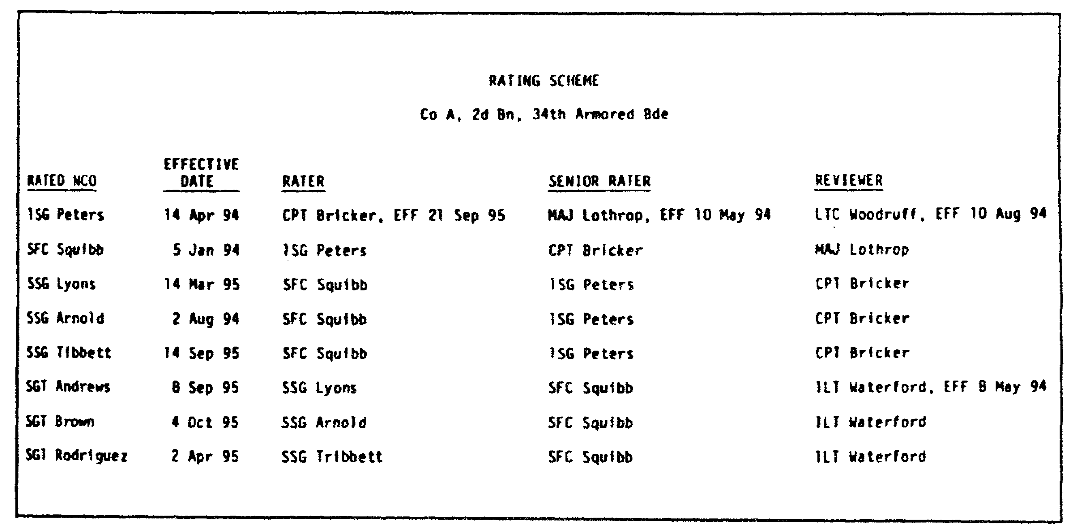

Figure 4-2. Sample rating scheme.

PART B - DA FORM 2166-7-1

The rater uses DA Form 2166-7-1 as a guide to prepare, to conduct, and to record performance counseling sessions with the rated NCO. Its use is mandatory for counseling all NCOs, CPL through SFC and PSG. However, its use is optional for counseling other senior NCOs. The checklist provides structure and discipline to the performance counseling process.

1. Purpose of Counseling.

The objective in performance counseling and coaching is to help an individual improve his performance in his present position. This enables the military supervisor to perform the mission. Performance counseling and coaching are NOT just terms for faultfinding. Performance counseling is an exercise in human relations by which the following values, attitudes, and characteristics are instilled in the subordinate:

o Enthusiasm for his work.

o Confidence in himself and his fellow workers.

o Satisfaction in the knowledge that he contributes to the accomplishment of the mission.

4-29 QM3517

a. Authoritarian Structure. Performance counseling and coaching tasks are difficult because the Army is authoritarian in structure. However, American society is democratic in structure. Each person in the Army is aware of his basic rights as an individual who lives in a democratic society. A military supervisor must recognize a subordinate's basic rights. Moreover, a military supervisor should encourage his subordinates to use their own initiative. Furthermore, a military supervisor must understand that his subordinates have accepted (in almost every case) the Army's authoritarian structure as a necessity. There is no need to keep reminding them of its presence.

b. Leadership Principles. Every Army NCO knows such tried-and-true leadership principles as "know yourself", "know your soldiers", and "know your work". Each has tried to list, in his own mind at least, the order of merit of such leadership traits as the following:

o Integrity.
o Judgment.
o Initiative.
o Tact.

These principles and traits must be applied to counseling and coaching situations. Supervisors, ever conscious of their role as leaders, tend to concentrate all their efforts in leading the way; showing the way; and guiding, directing, and advising their subordinates.

In so doing, they consider that they have performed largely the function of counseling and coaching.

c. Counseling Goal. During performance counseling, supervisors inform soldiers about their jobs and expected performance standards. Supervisors provide feedback on actual performance. The goals of every supervisor should include the following:

o Promote success. The counseling goal is to get all NCOs to be successful and meet standards.

o Look forward. The best counseling is always forward-looking. It does not dwell on the past and what was done. Rather, it focuses on the future and what can be done better.

o Perform counseling early. Counseling at the end of the rating period is too late since there is no time to improve before evaluation.

QM3517 4-30

d. DA Form 2166-7-1 Document. For detailed information on counseling, refer to Figure 4-3. The Army designed DA Form 2166-7-1 for use with DA Form 2166-7 as a sole-source counseling support document. DA Form 2166-7-1 contains just about all the information that is needed to prepare and to conduct a counseling session. It also provides a place to record the results. The Army requires its use for counseling all NCOs, CPL through CSM. Note the reference to nine leadership competencies.

One checklist for each rated NCO is maintained until after the end of the rating period. At first glance, the checklist may appear long. However, most of it is reference material concerns the "what" of counseling, Army values, and NCO responsibilities.

DA Form 2166-7-1 contains good information, but it must be read.

Many NCOs have said that once they sat down and read the checklist, they liked what they read. For the first time, in one place, they are able to read what the Army expects of them.

e. Performance Counseling. There are many kinds of counseling situations. Each one has a specific purpose. This lesson pertains to performance counseling and coaching in relation to NCO evaluation reporting. Evaluation reports provide assessments of individuals in the form of standard records that are designed to meet the requirements of a centralized personnel management system. Performance counseling and coaching are acts of leadership that are designed to help the evaluated individual to improve his performance in his present position. Often, it is proper to include counseling of a broader scope--such as guidance in career development and professional development--in a performance counseling situation. However, doing so is not a major purpose. Bear in mind that DA Form 2166-7 "bullets" can be developed before or during each counseling session.

2. Counseling Session.

Refer to the following subparagraphs for a discussion of counseling sessions. In particular, these subparagraphs discuss the following:

o Mandatory counseling.
o First counseling session.
o Later counseling sessions.
o Counseling times.
o Counseling and coaching session.
o Counseling techniques.
o Performance counseling philosophy and standards.

4-31 QM3517

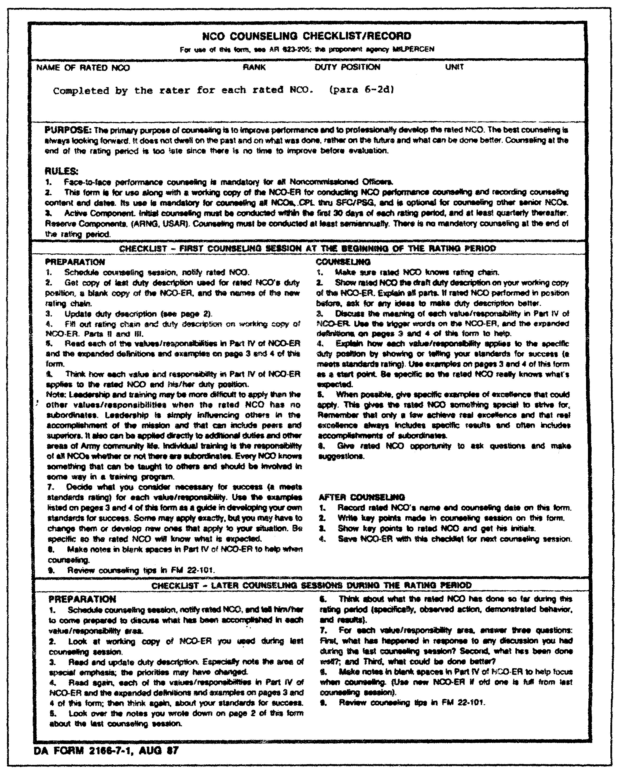

Figure 4-3. DA Form 2166-7-1.

QM3517 4-32

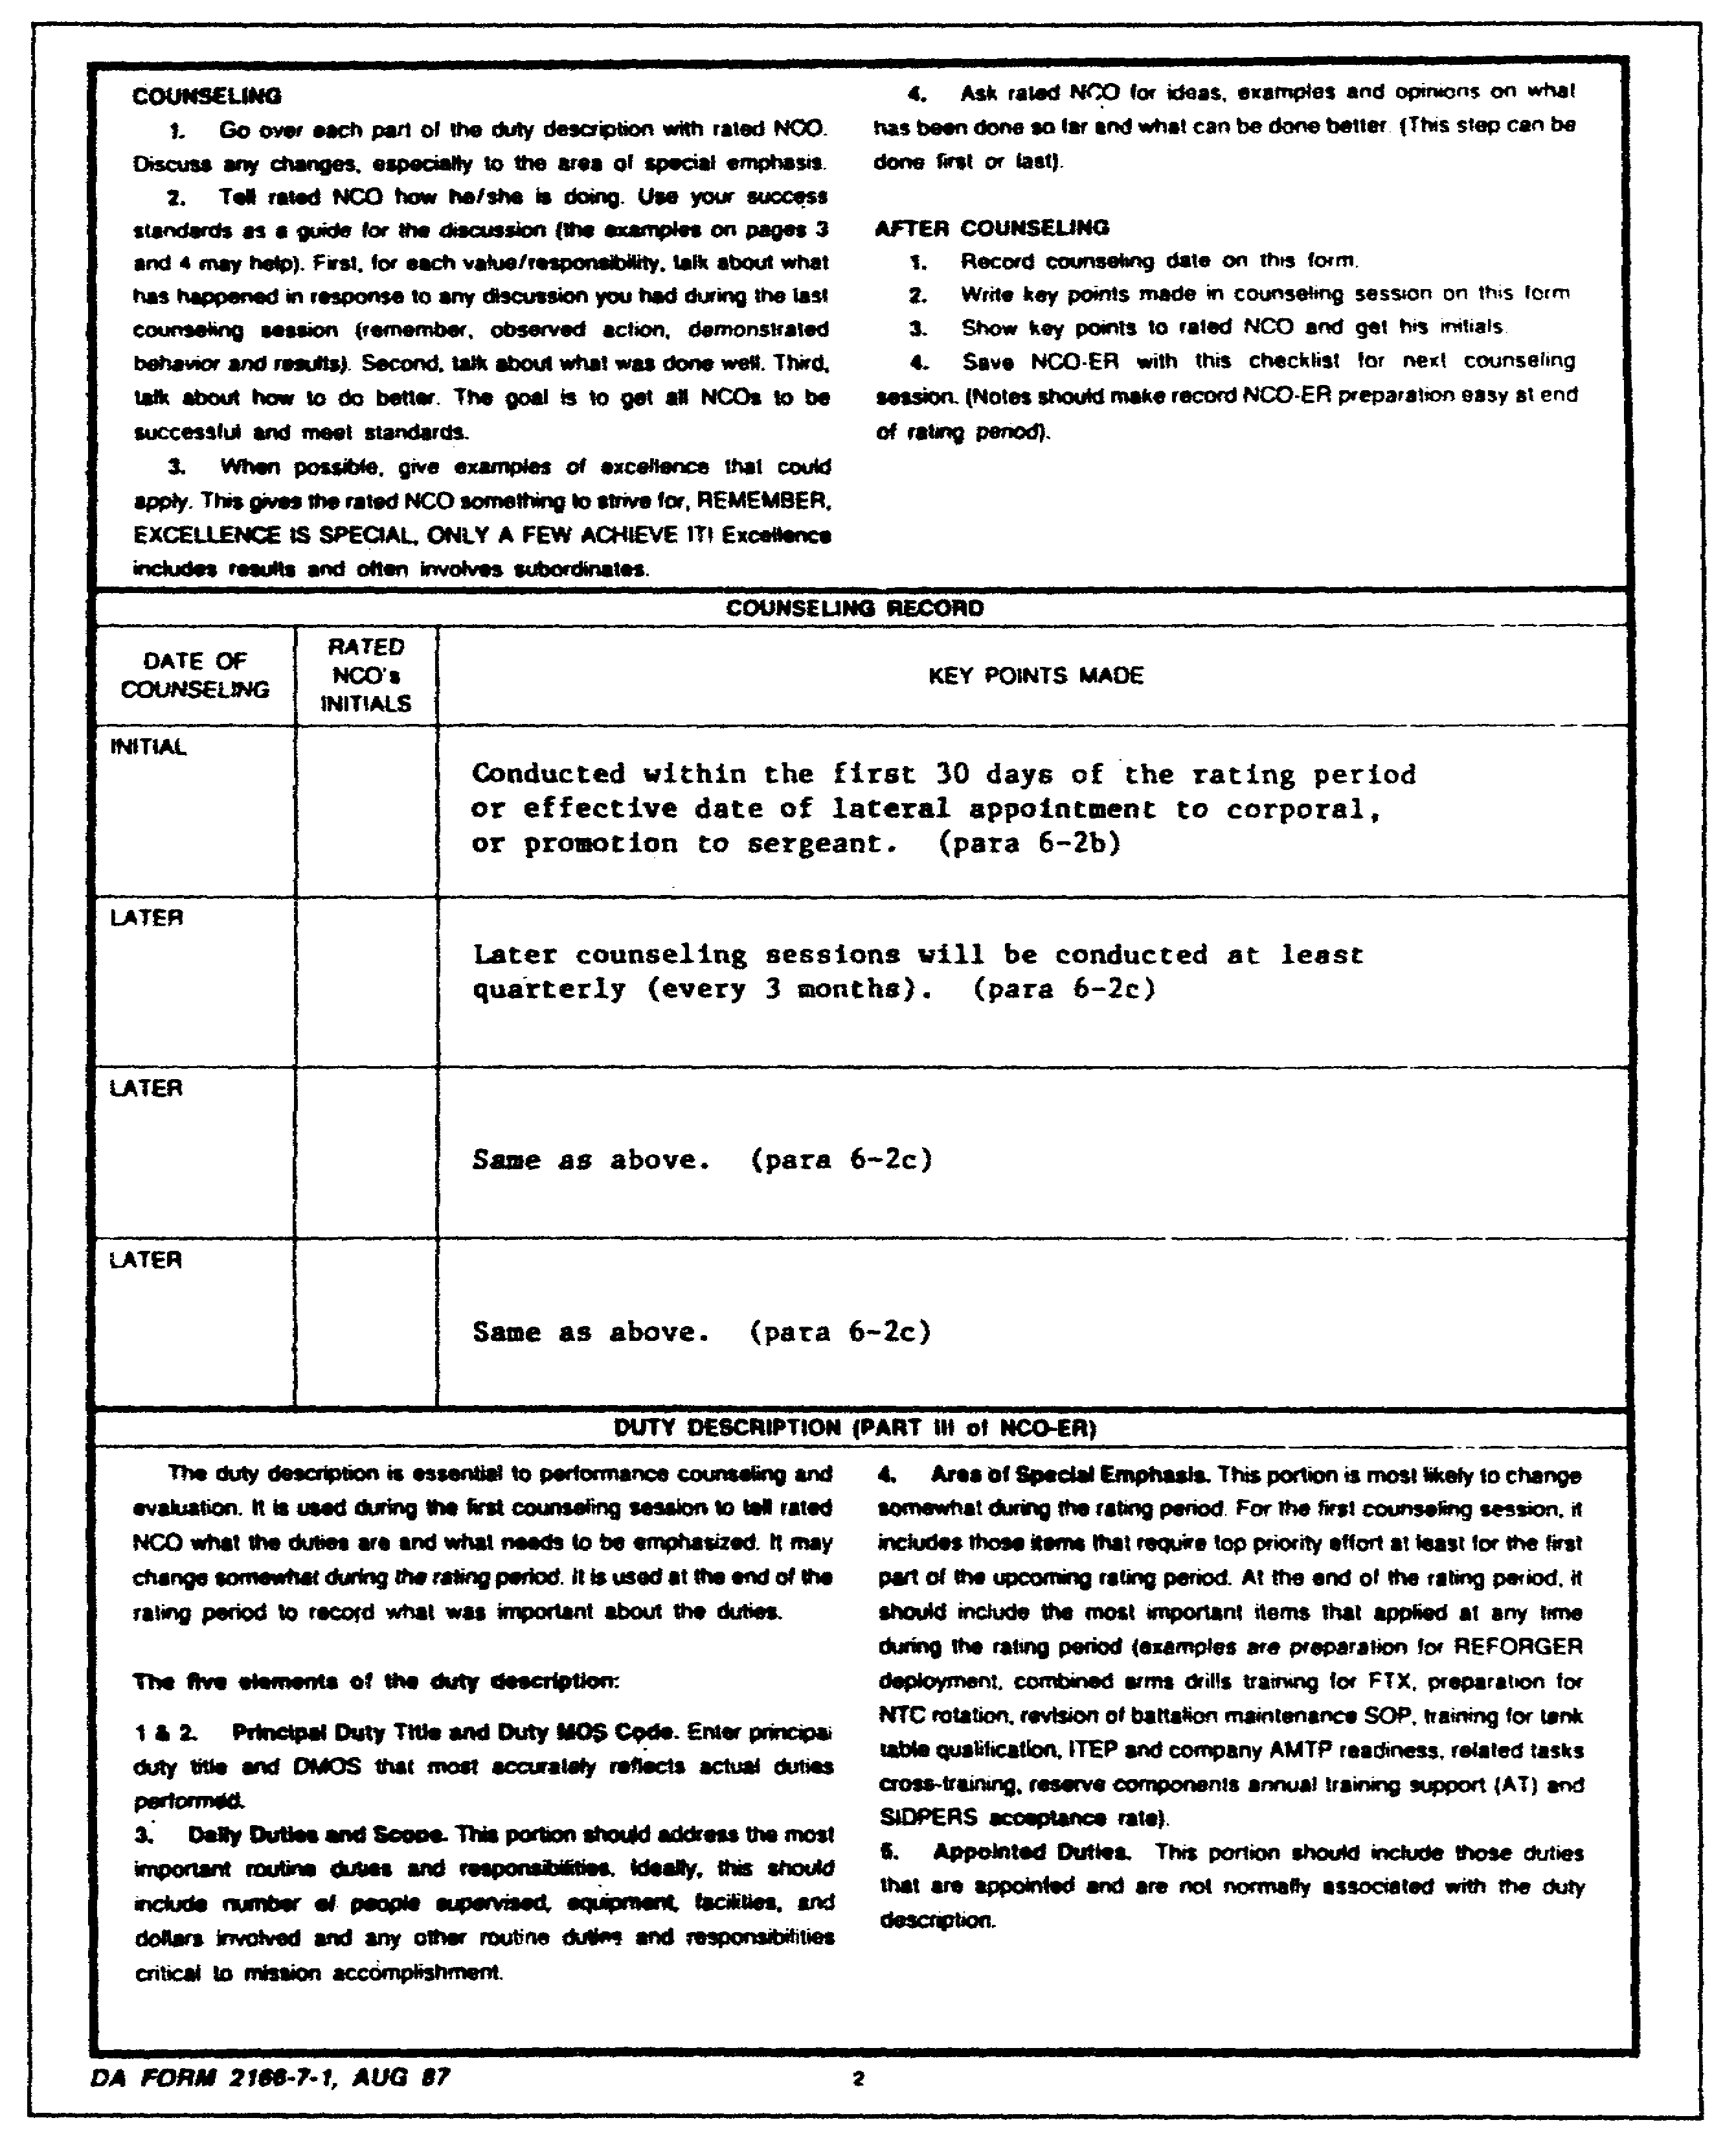

Figure 4-3. DA Form 2166-7-1 (continued).

4-33 QM3517

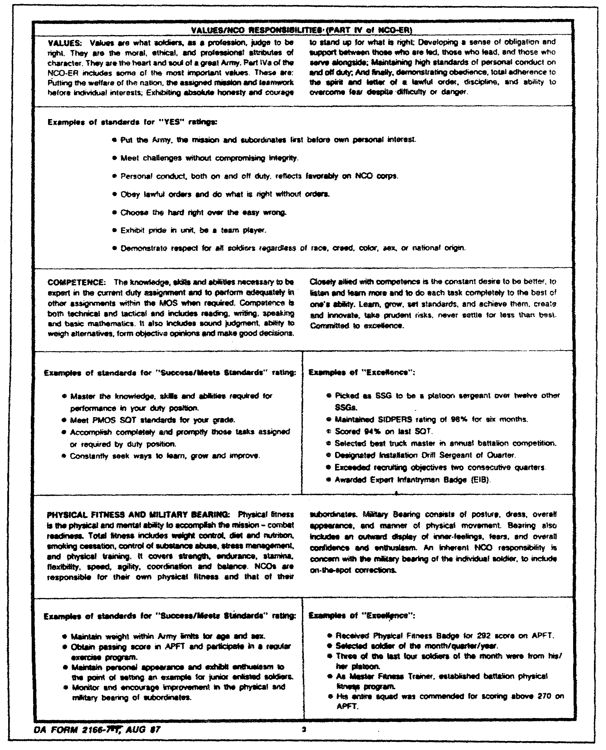

Figure 4-3. DA Form 2166-7-1 (continued).

QM3517 4-34

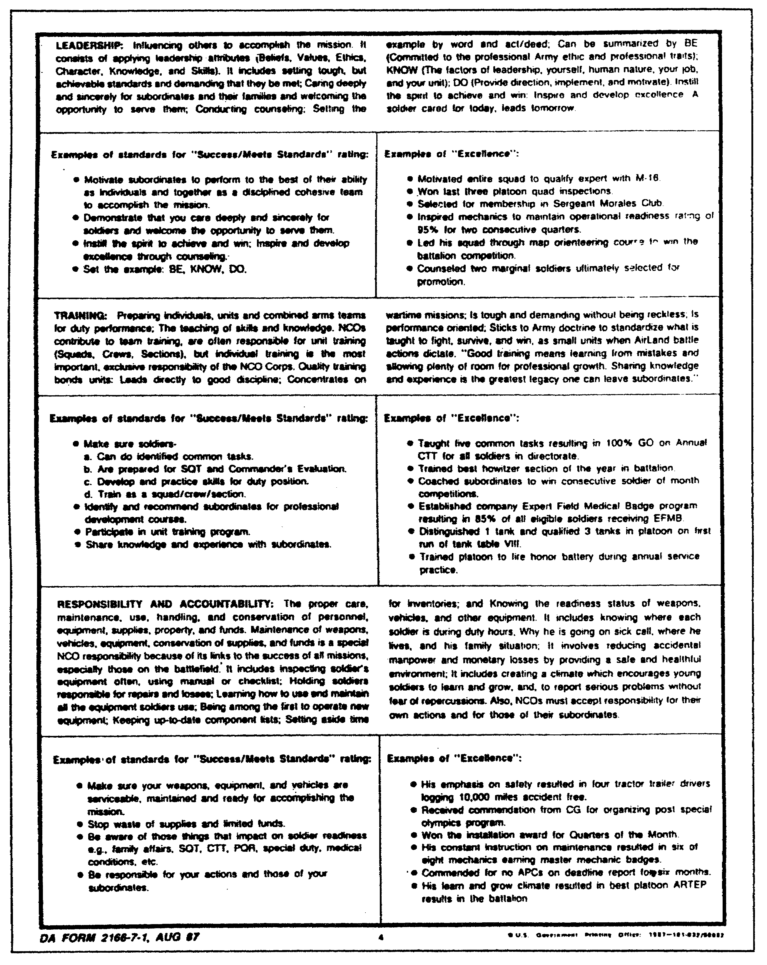

Figure 4-3. DA Form 2166-7-1 (continued.)

4-35 QM3517

a. Mandatory Counseling. Face-to-face performance counseling between all rated NCOs and their supervisors is mandatory. The goal is to improve performance and to develop the rated NCO professionally. Performance standards are developed and communicated to the rated NCO at the beginning of the rating period. Periodically, the NCO's progress toward meeting these standards is discussed.

The best counseling is forward-looking. Counselors do not dwell on the past. Initial counseling must be accomplished within the first 30 days of the rating period and quarterly thereafter. ARNG and USAR NCOs in IDT status must be counseled at least twice a year. IRR and IMA NCOs who serve on tours of duty must be counseled not later than 1200 of the NCO's first duty day. The NCO must understand his duty requirements and responsibilities during the tour of duty for which he is to be evaluated. The NCO is to receive the opportunity to express his expectations of achievements during the tour of duty. Another session is to be scheduled midway during the NCO's tour.

b. First Session. The first counseling session is conducted within the first 30 days of the rating period or the effective date of lateral appointment of CPL or promotion to SGT. An exception occurs when IRR and IMA NCOs who are completing more than 11 consecutive days on AT, ADT, ADSW, or TTAD are counseled. The first counseling session is somewhat different from later counseling sessions in that the primary focus is on communicating performance standards to the rated NCO. In other words, it lets the rated NCO know what is expected of him during the rating period. The DA Form 2166-7-1 provides examples, definitions, and step-by-step assistance for preparing and communicating performance standards and direction to the rated NCO. Specifically, the following procedures are to be employed:

o Show the rated NCO the rating chain and a complete duty description.

o Discuss the meaning of the values and responsibilities that are contained on the DA Form 2166-7.

o Explain the standards for success.

After counseling, key points of discussion are recorded, and the rated NCO's initials are obtained on the DA Form 2166-7-1.

c. Later Sessions. Later counseling sessions are conducted at least quarterly for AA and AGR NCOs. Later counseling sessions are conducted at least semiannually for ARNG and USAR NCOs performing IDT.

QM3517 4-36

These counseling sessions differ from the first counseling session in that the primary focus is on telling the rated NCO how well he is doing. Specifically, the following procedures are to be used:

o Update the duty description.

o Discuss what was done and what could be done better, based on observed action and demonstrated behavior and results.

The guide for this discussion is the success standards that were established in the previous counseling session. After counseling, key points that were discussed are recorded and the rated NCO's initials are recorded on page 2 of DA Form 2166-7-1.

d. Counseling Phases. Although performance counseling and coaching are continuous functions of leadership, their practical applications usually involve two distinct phases over time.

(1) New Assignment. First, when the NCO reports to duty for a new assignment, he is counseled regarding the following items:

o Organizational goals.

o Expectations concerning his performance.

o His responsibilities.

o Standards by which his performance will be judged.

In effect, performance counseling and coaching are thus provided before the fact. Doing this is a highly important part of the counseling picture.

(2) Quarterly Counseling. Second, ensure that leaders counsel the NCO at least quarterly. The specific counseling or coaching session is the most likely means of informing an NCO of any failure to meet required standards. However, the fact that there is no fault to find in an NCO's performance should not preclude the requirement of periodic counseling.

Hopefully, this early dialogue between the rated NCO and his rater within the first 30 days of each rating period will open the lines of communication and keep them open.

Through the years, raters have seemed to resist or to be unaware of their responsibilities toward their subordinates. They have not readily accepted their roles as trainers (or coaches). It is

4-37 QM3517

this simple: HQDA expects to develop its NCOs on the job and in school. No one would expect a service school instructor to avoid talking to his students. One should not expect a supervisor to manage his subordinates without communicating with them or providing them proper goals and guidance for job performance. The wisdom and the experience that a senior NCO passes to a junior NCO really is what counseling or coaching is all about.

e. The Counseling and Coaching Session. To help the NCO improve his performance in his present position, counseling and coaching are to be performed. The NCO must be counseled concerning his future career.

(1) Planning the Session. The scope and the content of each counseling and coaching session are important planning considerations. If four NCOs are to be counseled, then there must be four distinct areas of discussion. However, several points may deserve emphasis in all four sessions. Preparation must be made for each counseling and coaching session. The NCO's duties, in order of importance, and the standards or criteria for judging his performance of them must be reviewed.

Each session must be scheduled, and the NCO must be informed of the exact time and place well in advance. In the notice to him, the NCO is to be advised of the following:

o His jobs in order of importance.

o His accomplishments.

In addition he should be asked to state what he is doing to improve himself professionally and to include any other matter that he may wish to discuss.

(2) Preparing for the session. Prior to the actual meeting, the following preparations must be made:

o The rated NCO is to be given a few days of advance notification concerning the time and the place of the meeting so that he, too, can prepare for it.

o Enough time (about an hour) must be set aside for the meeting.

o A site for the session must be selected which gives you some privacy and minimizes distractions or interruptions.

QM3517 4-38

f. Techniques for the Counselor. The atmosphere of the counseling and coaching session is largely a reflection of the counselor's personality and way of doing things. Privacy is the one essential element in all counseling and coaching. The fact that a session is formal does not necessarily mean that the discussion should be conducted in an atmosphere of military formality. A person-to-person approach may be desired. The experience and the grade of the NCO who is being counseled should be considered when such matters are decided Beyond this, there are no hard and fast rules for effective counseling and coaching. Techniques that are effective for one counselor are not necessarily the best for another. However, several common elements apply, regardless of the manner that is chosen. These are some common elements:

(1) Accuracy. Criticism (or praise) of the NCO's performance must be based upon facts and upon a clearly conceived set of high standards. The individual may enter the session with a different viewpoint concerning these facts. However, there must be no doubt at the conclusion that you know the facts. If the individual interprets your criticism as being based upon a misunderstanding or a misinterpretation of the facts, then your counseling and coaching session accomplishes nothing.

(2) Firmness. The session can (and usually should) involve friendly conversation, even when facts that are, in themselves, unpleasant are discussed. Straightforward, honest criticism of the individual's performance is essential. Criticism achieves its purpose of pointing out the way to improve performance only when the individual is aware that this is the purpose of the criticism.

(3) Consistency and Clarity of Standards. Usually, the counselor will make the NCO aware of the standards by which he judges the NCO's performance. These standards should be reviewed to show how the NCO's performance has failed to meet them. It is extremely important that the standards that are discussed at the formal counseling do not contradict any previous standards that have been given to the NCO.

(4) Balanced Appraisal. Very few coaching sessions involve an individual whose performance has been a failure in every respect. During preparation, facts that deserve praise as well as those that deserve criticism should be considered. However, the primary purpose of coaching is improvement. Praise should not be regarded as merely a device to soften the pain of sharp criticism. The person who is coached can recognize this device quite easily, and it does nothing for the counselor's prestige.

4-39 QM3517

3. Philosophy and Standard of Performance Counseling.

To counsel effectively, a counseling and coaching philosophy and a standard of performance that address the job requirements of the NCO who is being counseling must be developed. Then, job performance and job standards may be compared and counseling and coaching may take place as necessary.

a. Leadership Philosophy. Counseling and coaching philosophy is not new. DA Message 182150Z, February 1972, (Subject: Performance Coaching and Career Counseling) is quoted as follows:

"1. The Army War College study 'Leadership for the 1970s' identifies a correlation between current leadership problems and adequate interpersonal communications at various organizational levels. Supporting this observation, officers and noncommissioned officers conferring with the Chief of Staff in the climate of the Army consistently express the opinion that they are not counseled frequently enough. Leadership for the 1970s, as well as other studies conducted in recent years, point out that counseling offers a meaningful contribution to improved effectiveness--especially among junior officers and noncommissioned officers.

"2. By nature, counseling has two perspectives: career counseling and performance coaching.

"3. Performance coaching is vital to mission accomplishment and job satisfaction. Moreover, performance coaching is as necessary for successful and experienced subordinates doing excellent jobs as it is for inexperienced individuals who may be performing less satisfactorily. Coaching is a continuous process whereby each superior aims to enhance team success through the development of the individual members. When applied as a normal and frequent feature of superior-subordinate relations, performance coaching produces improved two-way interlevel communications which will define mutual expectations and the degree to which such expectations are being met.

"a. Upon assignment to a new position, each subordinate must be advised, face to face, by his immediate superior concerning the scope of his duties, objectives to be attained, expectations related to job performance and conduct, and routine operating procedures. Every effort must be made to

QM3517 4-40

eliminate misunderstanding regarding job requirements and superior-subordinate expectations.

"b. Continuously thereafter, throughout their association, the superior must coach the subordinate--recognizing positive accomplishments as well as areas requiring further improvement and suggesting procedures for resolving shortfalls, whenever appropriate.

"4. All commanders and supervisors have a responsibility and duty to career counsel subordinates by accurately providing information on the many opportunities, challenges, and benefits inherent to any Army career. In this regard, the experienced advice of senior officers can be particularly helpful to junior officers and younger enlisted personnel."

Note: The message refers to performance coaching rather than performance counseling.

b. Standard of Performance Judgment. To counsel a subordinate effectively, there must be a precise standard against which his performance can be judged. This does not require a searching examination of the person in the job, but of the job itself. The device of making the job fit the person is well known. Aggressive individuals, who had little ability for anything other than empire-building, have built up jobs. In reverse, there are cases in which organizations have reduced job scopes, either because the incumbent had limited ability or because someone suspected that he had limited ability. Once a standard is determined, job performance can be compared against it: Did the NCO exceed those standards? If so, specifically, how? In addition, an EXCELLENCE rating may be determined. A description such as "a superb NCO" must not be a basis for an "EXCELLENCE." Refer to checklists on the third page of DA Form 2166-7-1 for guidance on rating an NCO on Leadership and Training.

(1) Start Analysis with Table of Organization and Equipment. The appropriate TDAs or TOEs prescribe the unit mission, personnel, and general organization. The logical place to start an analysis is with the TOE. The rater must determine the following:

o The specific role assigned to an activity.

o What portion of the overall mission it must perform.

o Specifically, what functions it must accomplish.

4-41 QM3517

The rater traces the chain of command, responsibility, and decision-making authority from the top level of the organization down to his own activity, and from his activity down to its lowest component element.

(2) Analyze Organizational Chart. The organizational and functional chart can be used to depict this information. In analyzing a chart, the rater pays particular attention to such principles as the following:

o Unity of command.
o Span of control.
o Delegation of authority and responsibility.

However, an officer or an NCO cannot triumph over organizational faults even if he is extremely competent. He cannot, for instance, function effectively when two or more superiors divide the authority to command his labor. He must know to whom he should report and to whom he should look for direction.

c. Job Requirements Consideration. For any successful counseling and coaching session, the requirements of the job that the NCO performs must be considered.

When the soundness of the organizational structure has been established, the various duty positions within the structure are reviewed.

The rater may begin this review with the following series of questions:

o What does each position contribute to the accomplishment of the activity's mission?

o What major functions are involved in its contribution?

o What activities or subfunctions are involved in these major functions?

The specifications of the duty positions that are under consideration will be of some value at this stage of the review. Since specifications are fairly broad in scope, it is unlikely that any duty position will encompass the entire scope of a particular MOS. However, the MOS descriptions in AR 611-201 (Enlisted Career Management Fields and Military Occupational Specialties) is of value for three reasons. First, they help to avoid overlooking a phase of the duty that might otherwise not be considered. Second, they provide a way of checking the organizational table to ensure that the MOS that is called for in the table is actually the one that is required. Third, they help

QM3517 4-42

the rater to fulfill his training responsibility to the NCOs under his supervision.

Since this kind of activity is not usually the principal duty, the system that is used to evolve the standards must be so simple that it will not become unwieldy. Instead, it must permit information to be kept current. One way of doing this is to look for major factors, key results, and principal measures, evaluating them in terms of the primary objective of the position. In attempting to establish relative priorities for the various activities of the position, the following question may be asked: "What duty (or duties), if left undone, would result in the failure of this position to accomplish its primary objective"? The following question also might be asked: "What duties have great, some, or little effect upon the accomplishment of the primary objective"?

Answers to these questions constitute the beginning of a performance yardstick. From these fundamental duties and responsibilities, detailed position descriptions can be developed. At the outset, the type and the grade of the duty position that is involved determines the specificity with which these descriptions can be written. The higher a position, the wider the range of the activities for which it is responsible. Likewise, the person in charge of the position usually is farther away from doing things and closer to the planning and judging areas.

The closer a position is to actual operations, the more specific technical knowledge must be provided. For example, a senior personnel NCO might be expected to be aware generally of the kind of information that is recorded on a specific personnel record. A personnel specialist might be expected to know precisely where to find an item on the record and to be able to recognize incorrect entries immediately.

It is comparatively simple to establish tangible end results as performance standards for some elements of some jobs. For example, in administrative units of various types the following quantitative standards might be established:

o Reply to all correspondence within three days of receipt.

o Do not have a typing backlog in excess of a particular number of pages.

o Schedule the instructor training load so as to provide a particular number of hours of preparation time for each instructor each week.

4-43 QM3517

o Ensure that personnel management teams visit each unit that is served at least once every so many days.

o Operate the unit dining facility so as not to exceed a specified percent of breakage or spoilage in a particular period of time.

o Have monthly financial and operation reports available by the 15th of the following month.

o Process all requisitions that are received within so many days.

o Reproduce and distribute all headquarters publications within so many days of receipt.

For performance that cannot be measured by quantitative results, a different kind of standard must be established. The degree of detail that is provided depends, again, upon the level of the position. However, the following requirements might be considered typical of the type of standards that are used:

o Supply ready and definite answers to questions about overall capacity of facilities.

o Base plans on sound organizational principles.

o Plan with awareness of personnel limitations.

o Be able to distinguish between the important and unimportant.

o Be able to keep several diverse projects going at the same time.

o Be able to provide in-depth training for subordinate positions.

o Be able to handle emergency situations.

o Be able to delegate authority and to assign responsibility to subordinate positions whenever possible.

o Be able to give simple, clear, written, and oral instructions.

o Be able to handle all routine procedures on definitely established time schedules.

QM3517 4-44

One last point to mention in connection with establishing a job standard is the effect that supervisors can have on it. Supervisors should take a close look at their own actions to ensure that they are not artificially limiting the scope, or otherwise hampering the operations, of the position. They might be required to ask themselves the following:

o Have I delegated adequate authority to accomplish all the responsibilities that I have assigned to this position?

o Have I prepared a simple job description of this position with specific statements that portray accurately what I expect from the job?

o Have I delegated authority and assigned responsibility to the extent that I might have?

One useful tool that supervisors can use in answering the last question is a simple diagram of three columns drawn on a sheet of paper as follows:

Supervisory Operative
Activity Task Task

Then for two or more weeks, the supervisor jots down in the "Activity" column each task that he performs. At the end of the period, he has a fairly complete list of his activities. Next, he goes over the list, item by item, checking the appropriate column to indicate whether the task is supervisory or operative. After this coding, he carefully scrutinizes the list of operative tasks and eliminates those that he can delegate to subordinate positions. Then he goes through the same procedure with the list of supervisory tasks. He may find that he is performing many tasks that he should assign to one of his subordinates. By conducting such an analysis, the supervisor may produce a by-product of more time for the duties that are essential to his position.

d. Comparison of Job Performance to Standards. When the standards of efficiency are established clearly, a method must be devised for comparing performance with these efficiency standards. Different criteria must be used for tasks that have tangible results and for those which have intangible results. In addition, other considerations must be applied in comparing performance to efficiency standards, as the following subparagraphs point out.

(1) When Results are Tangible. The relative degrees of success or failure can be shown in numerical terms when there are tangible results. For example, such results could be responding

4-45 QM3517

to correspondence within a specified time or operating within an allowed backlog of typing pages. The end result is "EXCELLENCE", "SUCCESS", or "NEEDS IMPROVEMENT".

(2) Questions T o Ask for Evaluating. In areas in which this cannot be done, performance can be compared with the standard by answering questions regarding key factors of the position. For example:

o Are there frequent crises in this NCO's operations?

o Are there complaints about bottlenecks in his activity?

o How well does his section operate while he is away?

o Have his subordinates received adequate training to handle routine affairs without seeking help outside his activity?

o Has he met prescribed objectives?

o Does he report figures and situations accurately?

o Is he thorough or does he leave loose ends dangling?

o Does he handle a heavy work load satisfactorily?

o Is his performance consistently reliable?

o Does he anticipate needs and start the ball rolling in time?

o Has he assumed responsibility and gone ahead satisfactorily in our absence?

(3) Special Problems in Evaluating. An infantry or a tank company commander or a platoon leader' faces special problems in evaluating performances. He is concerned with the most important elements. These elements are those that are most difficult to measure objectively. Take, for example, the standard, "Must be able to deploy his squad in a way that takes full advantage of cover and concealment". How does the platoon leader judge his subordinate's ability to meet it? First, he must be there to watch the squad leader deploy his troops. Second, the proper solution depends upon a consideration of the specific set of circumstances that are involved in that

QM3517 4-46

particular situation--that is, the specific mission, enemy, terrain, and troops. An effective action in one instance may be the one thing that should NOT be done in another. This puts the platoon leader in a most difficult position.

A music teacher who cannot sing can teach others the skills that they need to become great singers. However, a squad leader who is not skilled in taking full advantage of cover and concealment in deploying his troops can neither teach his subordinates these skills nor recognize them when he sees them. He can teach from books the ground rules, such as "keep a distance of five paces between soldiers". However, he may not understand the principles that are discussed in the book and may be unable to apply these principles in various circumstances. Thus he cannot know why (or whether) it is better to put the second soldier behind a pile of rocks to the right or in a little hollow behind the bushes. In this case, it is clearly impossible to separate the evaluation of performance from the caliber of the officer or the NCO who is making the evaluation.

e. Private Records. Supervising subordinates implies a day-to-day relationship. Any subject that is dealt with in the formal performance coaching session should have been the subject of some previous exchange during this day-to-day contact. However, if a leader is to have knowledge of the trends in performance and be able to counsel in specific rather than general terms, then he must have some private written record of the NCO's performance. This might be in addition to DA Form 2166-7-1. This is not a record for office files. It is not meant to open an era of "little black books". The written record has the following purposes:

o Record items that are significant in terms of job performance.

o Ensure that formal performance coaching sessions do not depend solely on the hazy recollection of the rater.

o Keep all events, both the most distant and the most recent, in proper perspective in the overall performance picture.

In addition, this informal record can be used in the descriptive portion of an evaluation report. For example, recommendations and letters of appreciation may be cited.

The DA specifically prohibits the retention of extracts of evaluation reports. Any performance records that raters keep must be destroyed upon the expiration of the period to which these reports apply. Each new evaluation reporting period

4-47 QM3517

constitutes a new slate to the NCO who is concerned. Matters that are covered in coaching sessions must be based on the events of that period.

f. The Positive Side. The record is not solely for the negative side of performance. It is also for the positive side, as measured against the established standard. For instance, how critical or emergency situations--the so-called critical incidents--are handled by the NCO may be recorded. Then, during performance coaching, both the NCO's strong and weak performances may be discussed. Some NCOs may find the idea of a written record of performance distasteful. For those with photographic memories, an aid of this type may be unnecessary. For most, however, the events of today may become blurred in their memories six months or a year from now. By then, occurrences may have lost their significance, but they may indicate the beginning of a trend.

Evaluations are not to be based upon a few minor incidents. An injustice is done when the rater enters the coaching sessions with generalities, platitudes, or criticisms to "advise and assist" the rated NCO. No constructive results can be expected from such an ill approach. The rater should look at the situation through the eyes of the rated NCO (as he, in turn, must do). A slipshod or a casual approach to this responsibility cannot satisfy its purpose. There may be those who can achieve the desired ends without benefit of written record. These individuals are fortunate. Most raters, and especially the inexperienced, find written records a necessity.

There is a difference between evaluation reporting and coaching. These two performance appraisal functions are to be performed separately, although they are to be coordinated. The NCO's evaluation report is an appraisal of his performance. It is designed to determine his potential to discharge assigned duties and to aid in the selection of assignments that are necessary for his career.

The most challenging aspect of coaching is to present to an individual the analysis of his performance in such a way as to encourage maximum self-improvement and development. If responsibilities for coaching are accomplished fully, then it is easier to understand the NCO report.

4. Rated Noncommissioned Officer's Role in Performance Counseling.

The rated NCO also plays a role in the performance counseling session. In order to conduct an effective performance counseling session, he must understand this role.

QM3517 4-48

All raters, whether an officer or an NCO, become the rated sometime during their assignments. If the role of the rated is understood, then perhaps the raters' roles might be better-understood as well.

Although the newly assigned NCO is required to counsel and to coach within 30 days (new rating period), it may be advisable to delay his counseling until he has been counseled by his rater. The communication process is a two-way street. The performance coaching session gives the rated NCO the opportunity to give information as well as receive it. For example, he may have discovered that additional resources are required to meet a performance objective or that there are unforeseen obstacles which hinder his effectiveness. These are the types of information that he needs but of which he may not be aware. In addition, the rated NCO may have identified objectives that need to be deleted from, modified, or added to the list on the NCO Counseling Checklist/Record. The performance coaching session provides the perfect forum for surfacing these proposed changes.

The following assumptions are being made:

o A set of performance objectives has been established already, and these objectives are clearly stated on a DA Form 2166-7-1 and the working copy of the DA Form 2166-7.

o The rater has some idea of the NCO's progress and problems.

o A coaching session date and time have been set.

The procedure that is discussed in this subparagraph represent one way of participating in a coaching session. It is a procedure that has been shown to work. However, it is not the only way to get the job done. A modification may be needed to fit an actual situation.

The rated NCO should be positive and not be defensive. If he has a problem or is experiencing some unforeseen difficulties, he should say so honestly and directly. He should get advice or assistance from his rater in areas in which the rater thinks that he needs improvement. This is supposed to be a discussion, not a pitched battle.

After the coaching session, the rated NCO takes the following steps:

o Makes out a list of the comments made by his rater. Outlines how he plans to implement the rater's suggestions and directives.

4-49 QM3517

o Follows up on the plans that he outlined. Keeps his rater informed of his progress and problems. The only way that the rater and the rated NCO can work together to meet organizational goals is to keep the lines of communication open.

PART C - DA FORM 2166-7

1. Basis of Evaluation for DA Form 2166-7.

DA Form 2166-7 is the official document for the NCO-ERS. Refer to the sample that is shown in Figure 4-4. Information which must be stored, handled, and transmitted as sensitive, personal information is included on DA Form 2166-7. Each report must be a thoughtful, fair appraisal of the NCO's abilities, weaknesses, and potential. DA Form 2166-7 also is used as a source of guidance during counseling. There is an increased emphasis on face-to-face counseling on the part of the rater.

Every opportunity is to be used to observe and to gather information concerning the rated NCO's performance. An accurate evaluation that is relative to the rated NCO's current grade, experience, and military schooling is to be prepared and completed. The evaluations covers failures as well as achievements. However, evaluations are not to be based upon isolated minor incidents.

QM3517 4-50

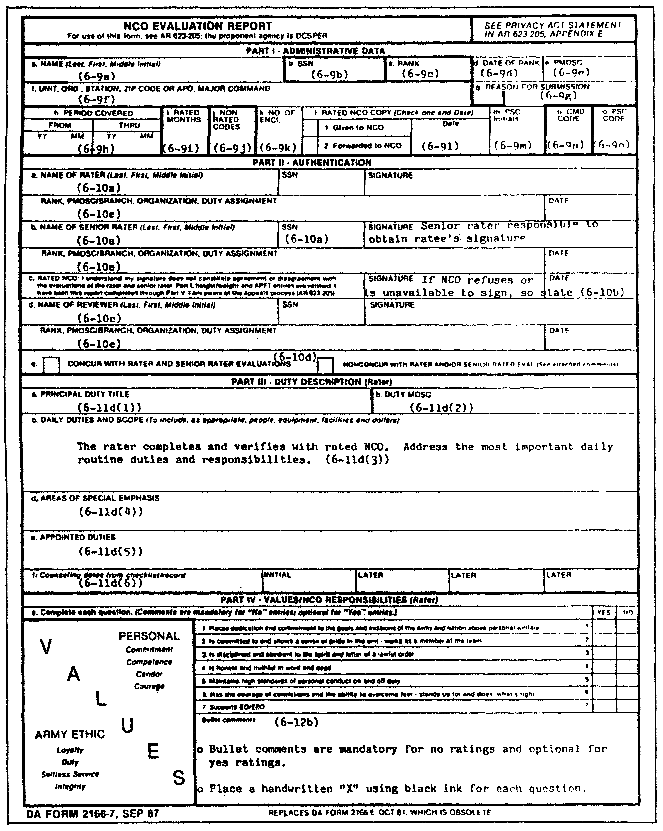

Figure 4-4. DA Form 2166-7 (Parts I, II, III, and IVa).

4-51 QM3517

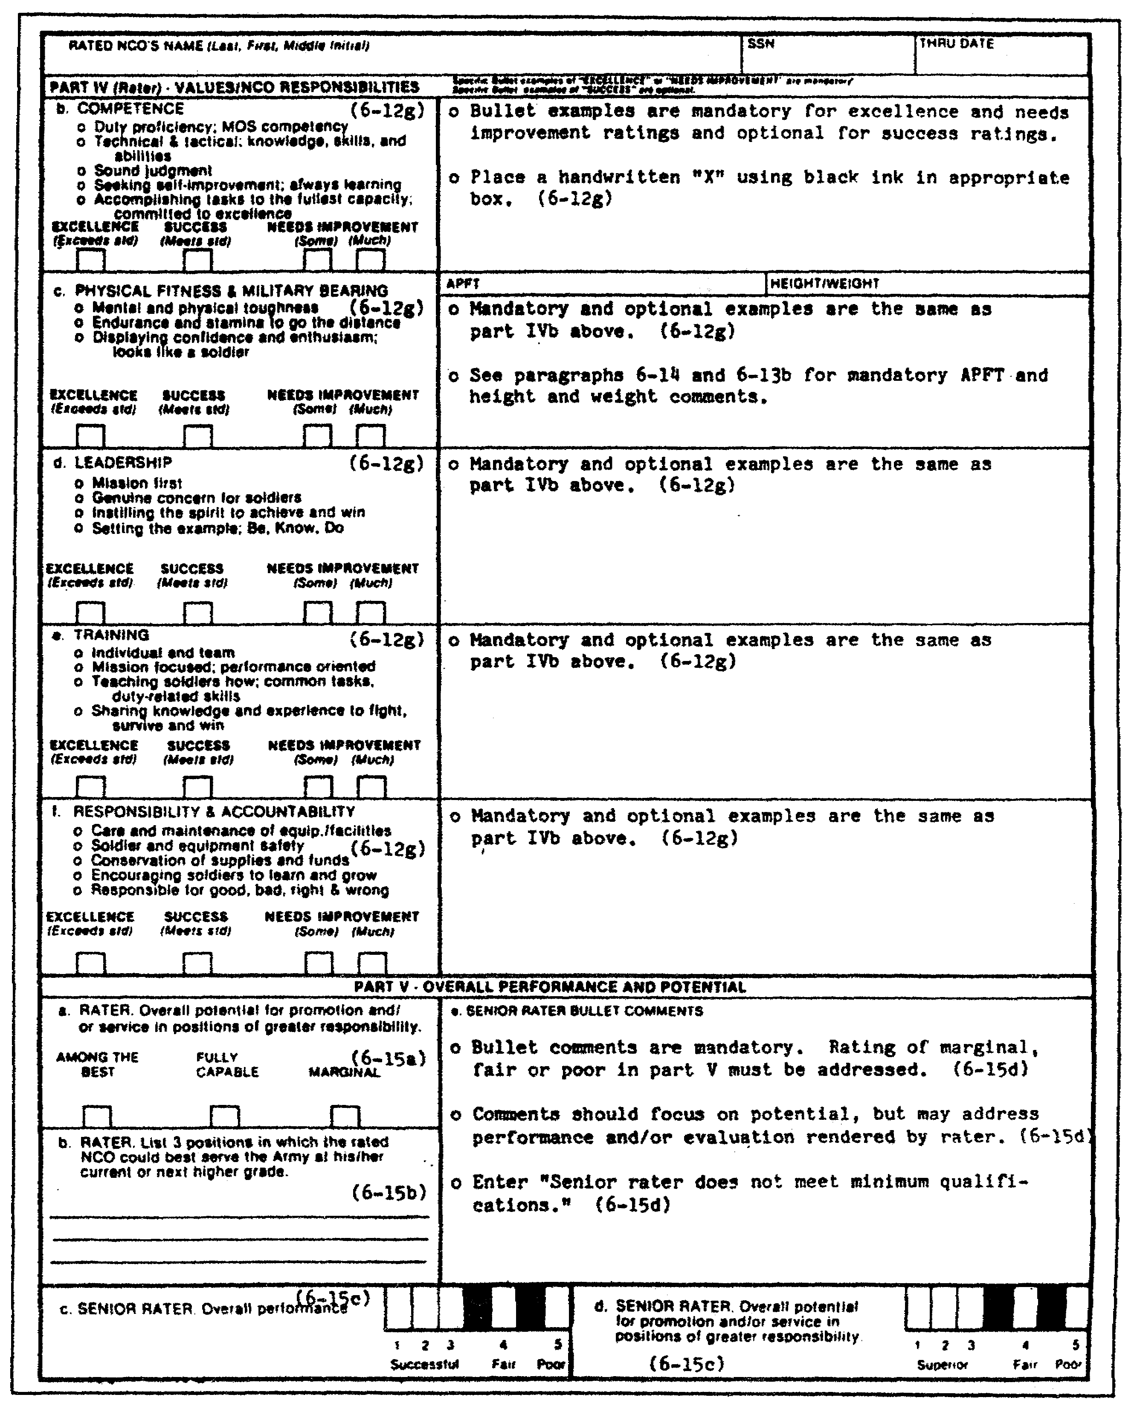

Figure 4-4. DA Form 2166-7 (Parts IVb, c, d, e, and f
and Part V)(continued).

QM3517 4-52

a. Prohibited Comments. Evaluations must be fair and honest. Rating officials are prohibited from using inappropriate or arbitrary remarks related to any of the following:

o Race.
o Color.
o Religion.
o Sex.
o National origin.

Subjective evaluations must not reflect personal bias or prejudice. Rating officials are prohibited from using narrative gimmicks, including the following techniques:

o Brief, unqualified superlatives or phrases, particularly if they may be considered trite.

o Comments (bullets) that are so brief that they may be interpreted incorrectly by selection boards or career managers.

o Any technique that is aimed at making specific words, phrases, or sentences stand out from the rest of the narrative, including, but not limited to, handwritten comments, more than one bullet per line, single spacing between bullets; an excessive use of capital letters, italics or similar printing, and exaggerated margins.

o Evaluation comments based upon the NCO's marital status or the employment, education, or volunteer activities of the NCO's spouse. For example, rating officials are not permitted to make such comments as "MSG Doe and his wife make a fine team" or "As a bachelor, SFC Doe can react quickly to this unit's contingency mission". DA Forms 2166-7 that are prepared in violation of this policy will be returned through the PSC to the appropriate rating officials for correction.

o Any punitive or administrative actions that are taken (or planned) against a rated NCO. However, rating officials may mention the NCO's misconduct which served as the basis for the action. For example, when an Article 15 is imposed, regardless of the final decision, the rating officials may comment on the fact that the NCO received an Article 15. However, no mention of the underlying misconduct which served as the basis for the Article 15 may be made.

4-53 QM3517

o Any unverified derogatory information concerning the NCO. Rating officials may refer to such information only when it has been verified through thorough investigations before the report is forwarded to the USAEREC. If the NCO is absolved, comments pertaining to the incident may not be made in the rating official's reports. This restriction is intended to prevent the inclusion of unverified derogatory information in evaluation reports.

b. Finality of Submitted DA Form 2166-7. Once an evaluation report is forwarded to the USAEREC and the report is accepted for inclusion in the NCO's official record, the report is assumed to be administratively correct and to have been prepared by the proper rating officials. It also is considered to represent the considered opinion and the objective judgment of the rating officials at the time of preparation. If any rating official claims second thoughts, administrative oversight, or typographical errors, then his appeal will not be accepted unless substantive evidence accompanies it.

NOTE: Refer to paragraph 10 at the end of this lesson for further information concerning the appeals process and sample formats of substantive, administrative, and combined appeals. Paragraph 10 also discusses the formats for a letter that requests third-party support and a third-party memorandum of support.

c. Access to Reports. Only individuals who are responsible for maintaining the file or who are authorized to use for personnel management purposes have access to the reports at HQDA. Only those persons who have command, administrative, or rating official responsibility for the report have access at the local level.

2. Completion of the Report.

Evaluation information is to be stored, handled, and transmitted as sensitive, personal information. All administrative and bullet comment portions of the form are prepared by typing or machine printing in either pica (10 pitch) or elite (12 pitch) type. Compressed-type face or spacing may not be used. A clear original is required so that legible copies of the report can be given to the rated NCO and filed in the OMPF. A photostated copy of DA Form 2166-7 may have to be provided to USAEREC because someone did not previously forward the original to the PSC. If so, then the PSC enters the statement "True Copy" or "Corrected Copy" in Part Ve of the DA Form 2166-7 and marks the signature block of the PSC officer. The PSC officer signs above the signature block and forwards the report to USAEREC for filing.

QM3517 4-54

The box is marked with a handwritten "X" in black ink, and the signature block in Part II is completed. The use of facsimile signatures is not authorized. Authorized abbreviations may be used. However, acronyms are to be avoided.

3. Part I--Administrative Data.

Part I items are self-explanatory. Nonrated time is no longer recorded. Although many NCOs have worried about nonrated time in the past, it happens to everyone at one time or another and is normally not important.

The PSC or the RC personnel officer completes Part I. The rater verifies Part I data with the rated NCO and notifies the PSC or the RC personnel officer of any errors.

a. Blocks A and B--Name and Social Security Number. This is self-explanatory.

b. Block C--Rank. The three-letter abbreviation for the NCO's military rank, not his pay grade, is entered--for example, "SSG" or '"SFC".

c. Block D--Date of Rank. The six-digit date of rank in year-month-day sequence is entered-for example, "790613".

d. Block E--Primary Military Occupational Specialty Code. The nine-place PMOSC is entered--for example, "19E300000", "75Z5PA300", or "18B5SLAW9".

e. Block F--Unit, Organization, Station, Zip Code or Army Post Office, Major Command. Data are entered in the order that is listed on the form--for example, "Co B, 3d Bn, 67th Armor, 2AD, Ft Hood, TX 76546-5000". In addition, the entry of the following information is verified:

o For ARNG, the three-character Standard Installation/Division Personnel System (SIDPERS) state unit code (SUC).

o For ARNG and USAR, the unit identification code (UIC) of the unit by which the NCO is evaluated.

o For USAR, the NCO's status code--for example, troop program unit (TPU), active guard/reserve (AGR), IRR, or IMA.

4-55 QM3517

f. Block G--Reason for Submission. The appropriate report code is entered in the left-hand portion of the block. (See Part A, paragraph 3, of this lesson.) For example, one of the following numbers should be entered:

o 1 for "First".
o 2 for "Annual".
o 3 for "Change of Rater".
o 4 for "Complete the Record".
o 5 for "Relief for Cause".
o 6 for "Relief from AT, ADT, ADSW, FTTD, or TTAD".

g. Block H--Period Covered. The following subparagraphs provide instructions for completing block "h" of DA Form 2166-7. Refer to these subparagraphs for details.

(1) FROM Date. The entry of the beginning date is entered in the "FROM" boxes. Two-digit numerical identifiers for the year and the month should be entered--for example, "8707". The beginning month is always the month that follows the ending month of the last report, except for reports that are rendered in the following situations:

o For AA personnel, refer to paragraph 3a of Part A of this lesson for details as to when an NCO's first report period is prepared.

o For USAR-AGR personnel, ensure that a USAR-AGR NCO's first report period begins on the effective date of promotion to SGT or the effective month ordered to AGR status, whichever occurs later.

o For USAR-TPU personnel, make sure that a USAR-TPU NCO's first report period begins on the effective date of promotion to SGT or the effective month that is assigned or attached to a TPU, whichever occurs later.

o For IRR, IMA or ING personnel, verify that the report periods begin with the month in which the IRR, the IMA, or the ING NCO performs AT, ADT, or active duty support (ADS), ADSW, FTTD, or TTAD.

o For ARNG personnel, ensure that the initial report period begins on the effective month of promotion to SGT or the effective month they are assigned or attached to a unit, whichever occurs later.

QM3517 4-56

(2) THRU Date. The ending date is entered in the same manner as the beginning date--for example, "8804". The ending month is always the month of the event which generates the report, regardless of when the event occurs during that month--for example, "1st day", "10th day", or "28th day".

h. Block I--Rated Months (Active Army and AGR). The number of rated months is computed as follows:

o The number of calendar months in the rating period from the beginning month through the ending month are totaled.

o The number of nonrated months are totaled. (See AR 623-205, paragraph 2-3f and Appendix C.)

o The nonrated months, if any, are subtracted from total calendar months.

o The remainder--the number of rated months in block I--is entered.

i. Block J--Non-Rated Codes (Active Army and AGR). The appropriate reason codes are entered. (For specific details, see AR 623-205, paragraph 2-3.) The codes are:

o "A" for "AWOL" or "desertion".

o "B" for "break in active enlisted service of 12 or fewer months".

o "C" for "confinement in a military or civilian detention facility", "assignment to a military personnel control facility", or "assignment to a correctional training facility".

o "D" for "TDRL status".

o "I" for "in transit between duty stations", including leave, and TDY.

o "M" for "missing in action".

o "P" for "patient" (including convalescent leave).

o "Q" for "lack of rater qualification".

o "S" for "student at a military service or civilian school".

4-57 QM3517

o "T" for "TDY” or "SD other than to attend school or compassionate reassignment".

o "W" for "prisoner of war".

o "Z" for "none of the above". This code also is used when there is a nonrated period of fewer than 12 months resulting from reduction to a rank below CPL or when a previous command did not render a DA Form 2166-7.

NOTE: The following bullets refer to periods during which the NCO or the rating official is in a nonrated status. These periods are not counted toward a rating period or rater or senior rater qualification.

In addition to the codes listed in the preceding bullets, the following codes must be used correctly:

o Periods of attendance at military or civilian school which represent a PCS, TDY, or SD are nonrated. The period of attendance, regardless of whether the NCO receives an Academic Evaluation Report (AER), are to be included in the nonrated months recorded on the next DA Form 2166-7 (reason code "S").

o A break in NCO status (to include a reduction below the rank of SGT) of 12 or fewer months is included as nonrated months (Code "B") recorded on the next DA Form 2166-7 (provided that a previous DA Form 2166-7 was completed). For a break in NCO status (to include a reduction below the rank of SGT) of more than 12 months, the beginning month of the next DA Form 2166-7 is the month that the NCO returns to active duty, reverts to NCO status, or the effective date upon which the NCO regains the rank of SGT or above.

o Periods of TDRL status are included on the next DA Form 2166-7. The beginning month is the month which follows the ending month of the last DA Form 2166-7.

o Periods of leave are rated, except as indicated in reason codes "I" and "P".

QM3517 4-58

The number of nonrated months during a report period are computed as follows:

o Determine the total days in the report period during which the NCO was in a nonrated status (refer to the preceding bullets which relate to nonrated periods).

o Convert the total nonrated days to nonrated months by using Figure 4-5.

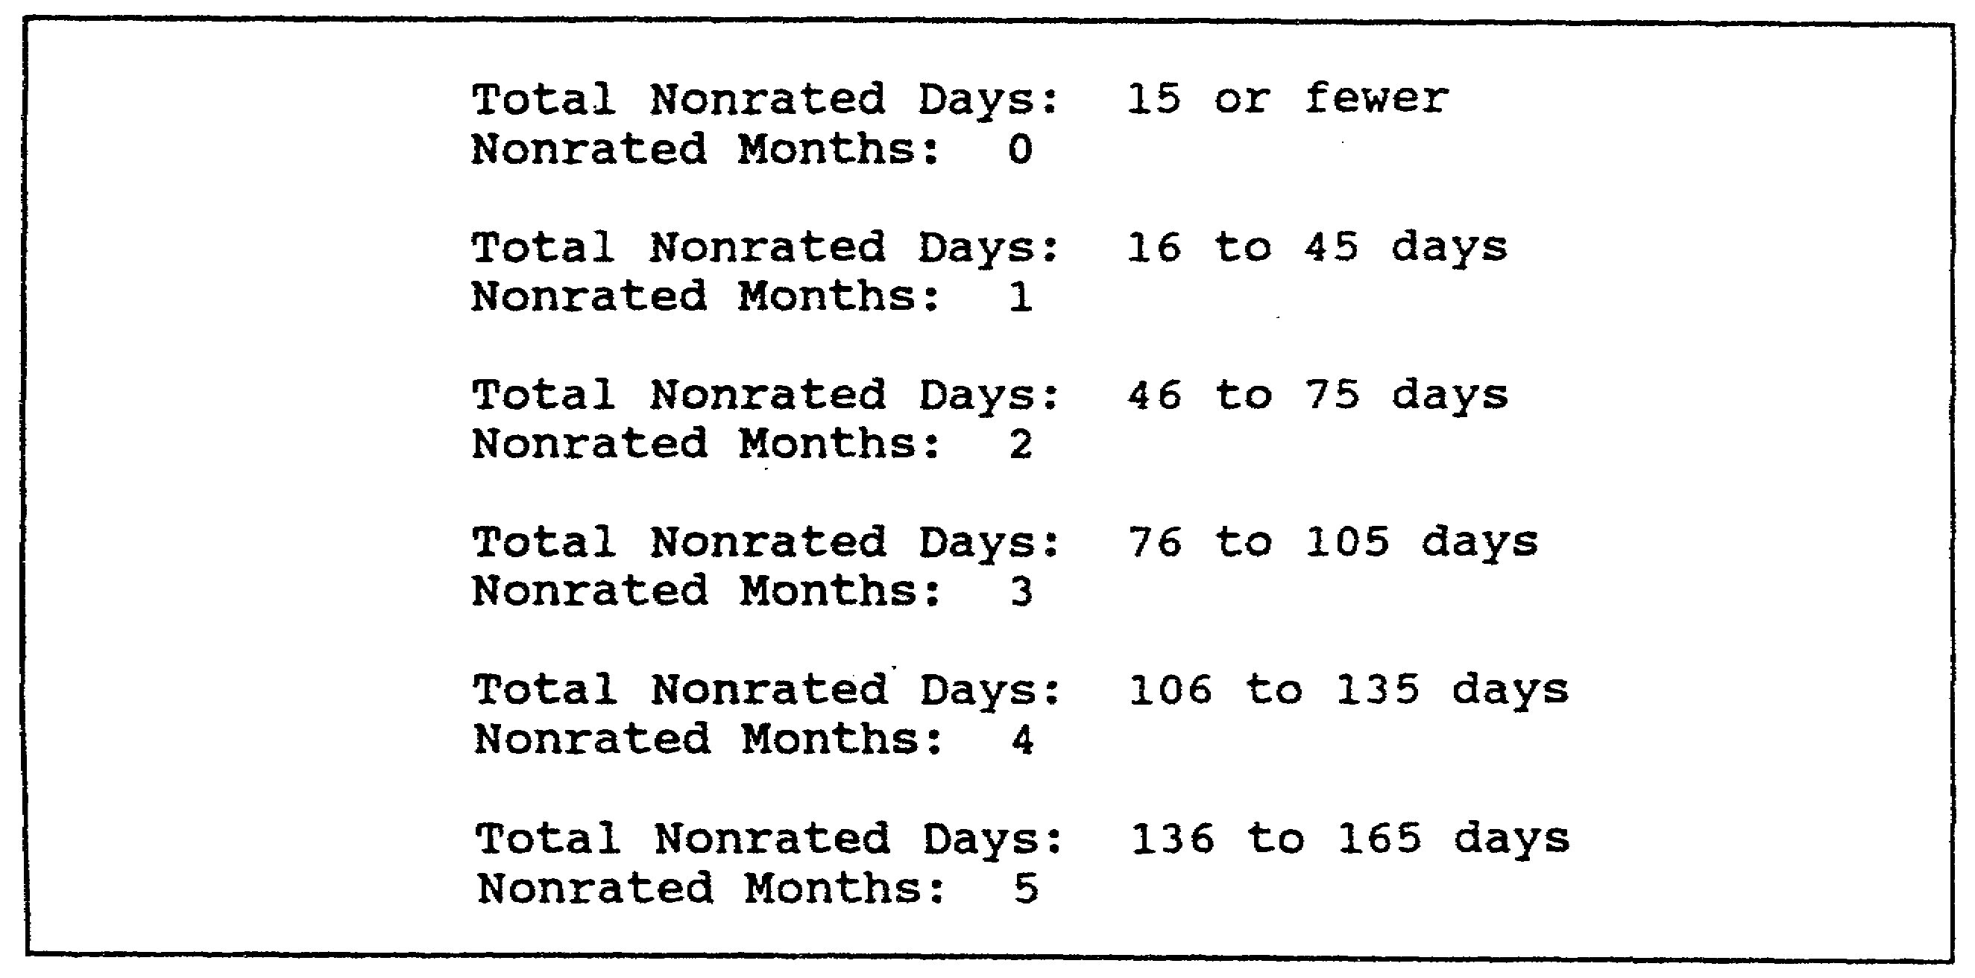

Figure 4-5. Computation of rated and nonrated months.

j. Block K--Number of Enclosures. The number of authorized enclosures, if any, that are being attached and forwarded with the completed DA Form 2166-7 are entered.

k. Block L--Rated NCO Copy. The handwritten "X" and the six-digit date are entered in black ink--for example, "870429". For ARNG AGR on Title 10-the parent state to which the NCO is assigned is entered to ensure that the copy will be forwarded--for example, "NHARNG".

l. Block M--PSC Initials. The PSC or RC representative enters his initials in black ink.

m. Block N--CMD Code. The rated NCO's MACOM is identified by the two-place command assignment code.

4-59 QM3517

n. Block O--PSC Code. The four-position alphanumeric PSC code is entered. An RC personnel officer leaves this block blank.

4. Part II--Authentication.

The signing sequence is the same as for the old DA Form 2166-6: rater, senior rater, rated NCO, reviewer.

The new DA Form 2166-7 expanded the rated NCO's signature block to include assurance that the form is complete at the time of signature and to remind the rated NCO of his appeal rights.

Part II of the DA Form 2166-7 contains a box that is labeled "CONCUR WITH RATER AND SENIOR RATER EVALUATIONS". It also contains a box that is labeled "NONCONCUR WITH RATER AND/OR SENIOR RATER EVALUATION". If the reviewer disagrees with the rater or the senior rater, he attempts to resolve the disagreement. This attempt may result in the rater and the senior rater changing their ratings. However, the reviewer is prohibited from forcing such changes. If the reviewer is unable to change the minds of the rater and senior rater and the reviewer still disagrees, then he marks the "NONCONCUR WITH RATER AND/OR SENIOR RATER" box with an "X". He must include a nonconcurrence enclosure. A third, differently worded concurrence cannot be attached to the report.

Placing an "X" in one of these blocks also introduces another new feature of this form. All "Xs" must be written in pen and ink (no typewriters).

The rating official and the rated NCO date the reports when they sign them and prior to forwarding them to the PAC or PSC.

a. Blocks A and B--Rater and Senior Rater. These are self-explanatory. The following subparagraphs discuss the other authentication section blocks, blocks C through E.

b. Block C--Rated NCO. The rater verifies Parts I and II. He also verifies the APFT and height and weight entries with the rated NCO. The senior rater obtains the rated NCO's signature or enters the appropriate statement "NCO refuses to sign" or "NCO unavailable for signature". The rated NCO's signature verifies the following:

o Rated NCO has seen the completed report.

o Administrative data (Part I) are correct.

o Rating officials (Part III) are proper.

QM3517 4-60

o Duty description (Part III) is accurate, to include the counseling dates.

o APFT and height and weight entries (Part IVc) are correct.

c. Block D--Reviewer. The reviewer has overall responsibility for ensuring the timely submission of an accurate DA Form 2166-7 per the controls established by the commander.

d. Block E--Concur or Nonconcur. The reviewer places a handwritten "X" in the appropriate block, indicating concurrence or nonconcurrence. As mentioned previously, a nonconcurrence enclosure is mandatory. Once again, enclosures cannot be used to add an additional concurrence to the report.

e. Rank Portion of Blocks A, B, and D. Appropriate three-letter, Army-rank abbreviations are used. If the official is a promotable MSG occupying an SGM position and acting as a reviewer, then "MSG(P)" (master sergeant promotable) is entered. For rating officials who are not US Army officers or NCOs, in addition to their rank, their pay grades and branches of service are entered. For example, a US Navy captain is entered as "CAPT 06 USN". A USMC gunnery sergeant (GYSGT) is entered as "GYSGT E7 USMC". A civil service official is entered as "GS-" or "GM-(6-18)". Members of the Senior Executive Service (SES) are entered as "SES" in lieu of a grade. Additionally, the appropriate PMOS for NCOs and MOS for WOs or branch for commissioned officers is entered.

5. Part III--Duty Description.

The rater completes Part III and verifies the information with the rated NCO. Unnecessary words are not used. The most important words are highlighted.

The rater's duty description is essential to his performance counseling and evaluation. He uses it during the first counseling session to tell the rated NCO his duties and what he needs to emphasize. He may update his duty description somewhat during the rating periods The rater uses it at the end of the rating period to record what was important about the duties.

Selection board experience shows the duty description to be far more critical to centralized selection than is generally assumed.

a. Parts IIIa and IIIb--Principal Duty Title and Duty Military Occupational Specialty Code. The rater enters the principal duty title that most accurately reflects the actual duties that the rated NCO performs. The DMOS must have at least five characters but no more than nine.

4-61 QM3517

b. Part IIIc--Daily Duties and Scope. In this area, the rater includes only the most important routine duties and responsibilities. Ideally, he includes the following:

o Number of the persons whom the rated NCO supervises.

o Equipment, the facilities, and the dollars involved.

o Any other routine duties and responsibilities that are critical to mission accomplishment.

The rater employs the narrative rule of using a series of phrases, starting with action words and separated by semicolons.

c. Part IIId--Areas of Special Emphasis. This is a new concept. When the rater first shows this part to the rated NCO during the first counseling session, he emphasizes those items that need to receive top priority effort at least during the first part of the rating period. This is another way of letting the rated NCO know what is expected. At the end of the rating period, when it is time for the rater to fill out the form, he includes in this area (and therefore highlights to anyone that reads it), the most important items that applied any time during the rating period. The following are examples:

o Preparation for return of forces to Germany (REFORGER) deployment.

o Training for tank table qualification.

o SIDPERS acceptance rate.

This portion is most likely to change somewhat during the rating period. The rater employs the narrative rule of making a list of the tasks or the duties that are separated by semicolons.

d. Part IIIe--Appointed Duties. These are duties which are not normally associated with the duty position. They are what used to be known as "additional duties". These often involve much effort and time. Examples are serving as any of the following:

o Reenlistment NCO.
o NCO in charge (NCOIC) of a rail-loading team.
o Records management NCO.
o Postal supervisor.
o Security manager.
o Safety NCO.
o Energy conservation NCO.

QM3517 4-62

e. Part IIIf--Counseling Dates. The rater supplies the initial and the later counseling dates from the Counseling Checklist/Record. Enter the appropriate six-digit date. The absence of counseling cannot be used as the sole basis for an appeal.

6. Part IV--Values and NCO Responsibilities.

In Part IV, the rater provides his evaluation of the rated NCO's performance. Before completing the evaluation portion of Part IV, he must consider the rated NCO's performance on the commander's evaluation (CE), the skill qualification test (SDT), the common task test (CTT), the APFT, weapons qualifications, and compliance with AR 600-9 (Army Weight Control Program) standards.

The rater marks boxes (using handwritten "Xs") and uses "bullet" comments throughout the evaluation. He ensures that the narrative format adheres to the following rules:

o Use bullets that are short, concise, and to the point.

o Ensure that each bullet is one line, but no more than two lines.

o Do not allow more than one bullet to a line.

o Start each bullet with an action verb or a possessive pronoun (his or her).

o Avoid using the NCO's name or the personal pronoun "he" or "she".

o Double-space bullets.

o Precede each bullet with a small "o".

NOTE: Adherence to these rules is so important to selection boards that the HQDA will not accept reports that are not in compliance with the bullet narrative rules .

a. Part IVa. The rating official reads the checklist before he evaluates just as much as he does before counseling. Part IVa of DA Form 2166-7 requires a "Yes" or a "No" response concerning many of the basic values. Bullet comments explain any area in which the rated NCO is particularly strong or needs improvement. The rater must make comments for all "No" ratings. Place these in the space that is provided at the bottom of the page. Whether the rater makes comments on "Yes" entries is optional. A blank space should not hurt a rated NCO.

4-63 QM3517

AR 623-205, paragraph 6-12, defines NCO values and responsibilities as discussed in the following subparagraphs.

(1) Values. "Values" are what soldiers, as a profession, judge to be right. They are the moral, ethical, and professional attributes of character. They are the heart and the soul of a great Army. Part IVa of DA Form 2166-7 includes some of the most important values. These values are as follows:

o Put the welfare of the nation, the assigned mission, and teamwork before individual interests.

o Exhibit absolute honesty and courage to stand up for what is right.

o Develop a sense of obligation and support between those who are lead, those who lead, and those who serve alongside.

o Maintain high standards of personal conduct on and off duty.

o Demonstrate obedience, total adherence to the spirit and the letter of a lawful order, to discipline, and to the ability to overcome fear despite difficulty or danger.

(2) Competence. "Competence" is the knowledge, the skills, and the abilities that are necessary to be expert in the current duty assignment and to perform adequately in other assignments within the MOS. Competence is both technical and tactical. It includes the following:

o Reading.

o Writing.

o Speaking.

o Basic mathematics.

o Sound judgment.

o Abilities to weigh alternatives, form objective opinions, and make good decisions.

Closely allied with competence is the constant desire to be better, to listen and to learn more, and to do each task completely to the best of one's ability. An NCO must learn, grow, set standards and achieve them, create and innovate, take

QM3517 4-64

prudent risks, never settle for less than the best, and be committed to excellence.

(3) Physical Fitness and Military Bearing. "Physical fitness" is the physical ability and the mental ability to accomplish the mission. Physical fitness is combat readiness. Total fitness includes weight control, diet and nutrition, smoking cessation, the control of substance abuse, stress management, and physical training. It covers the following:

o Strength.
o Endurance.
o Stamina.
o Flexibility.
o Speed.
o Agility.
o Coordination.
o Balance.

NCOs are responsible for their own physical fitness and for that of their subordinates.

Military bearing consists of the following:

o Posture.

o Dress.

o Overall appearance.

o Manner of physical movement.

o Outward display of inner feelings, fears, and overall confidence and enthusiasm.

An inherent NCO responsibility is concern with the military bearing of the individual soldier, to include on-the-spot corrections.

(4) Leadership. Leadership is influencing others to accomplish the mission. It consists of applying leadership attributes such as the following:

o Beliefs.
o Values.
o Ethics.
o Character.
o Knowledge.
o Skills.

4-65 QM3517

Leadership includes the following actions:

o Setting tough, but achievable standards, and demanding that they be met.

o Caring deeply and sincerely for subordinates and their families and welcoming the opportunity to serve them.

o Conducting counseling.

o Setting the example by word and act or deed.

You can use the following memory aid to summarize leadership:

o BE committed to the professional Army ethic and professional traits.

o KNOW the factors of leadership, yourself, human nature, your job, and your unit.

o DO provide direction, implement, and motivate.

Instill the spirit to achieve and win. Inspire and develop excellence. A soldier cared for today leads tomorrow.

(5) Training. Training is preparing individuals, units, and combined-arms teams for duty performance. When you train a soldier, you provide him with skills and knowledge. NCOs contribute to team training and often are responsible for the unit training of squads, crews, or sections. Yet individual training is the most important, exclusive responsibility of the NCO Corps. Quality training accomplishes the following:

o Bonds units.

o Leads directly to good discipline.

o Concentrates on wartime missions.

o Is tough and demanding without being reckless.

o Is performance-oriented.

o Sticks to Army doctrine to standardize what to teach to fight, survive, and win as small units when AirLand battle actions dictate.

(6) Responsibility and Accountability. Responsibility and accountability ensure the proper care, maintenance, use, handling, and conservation of personnel and property. A special

QM3517 4-66
NCO responsibility is the maintenance of weapons, vehicles, equipment, conservation of supplies, and funds. This is because of its links to the success of all missions, especially those on the battlefield. Responsibility and accountability include the following:

o Inspecting soldier's equipment often, using a manual or a checklist.

o Holding soldiers responsible for repairs and losses.

o Learning how to use and how to maintain all the equipment soldiers use.

o Being among the first to operate new equipment.

o Keeping up-to-date component lists.

o Setting aside time for inventories.

o Knowing the readiness status of weapons, vehicles, and other equipment.

o Knowing where each soldier is during duty hours.

o Knowing why each soldier is going on sick call, where he lives, and his family situation.

o Reducing accidental manpower and monetary losses by providing a safe and healthful environment.

o Creating a climate which encourages young soldiers to learn, to grow, and to report serious problems without fear of repercussions.

Also, NCOs must accept responsibility for their own actions and for those of their subordinates.

b. Part IVb-f. In Part IV ("b" through "f"), the rater indicates the level of the rated NCO's performance, on the left, by placing a handwritten "X" in one of the four boxes. The rater indicates the NCO's performance level based on the following criteria:

(1) Excellence. A rating of excellence indicates that the NCO exceeds standards. His excellence in exceeding standards is demonstrated by specific examples and measurable results. Excellence is special and unusual. It is achieved by only a few. This rating clearly is better than most others. When a rated NCO

4-67 QM3517

demonstrates the following actions, he is worthy of being rated as excellent:

o Scored 94 on last SDT.

o Received Physical Fitness Badge for 292 score on the APFT.

o Qualified entire squad as expert with M-16 and the M-60.

o Awarded the Expert Infantryman Badge (EIB).

(2) Success. When the rater rates an NCO as having achieved success, the rater indicates that the NCO meets all standards. This rating accounts for the majority of ratings. It is intended to be the equivalent of "125" score on the old EER. By rating an NCO as having achieved success, the rating official indicates that the NCO is fully competitive for schooling and promotion. The rater's counseling goal is to bring all NCOs to this level. The following are examples of actions that merit a rating of success:

o Shares experiences readily, constantly teaching soldiers.

o Constantly seeks to improve; completed three subcourses during rating period.

o Coached and played on company softball team.

o Established a comprehensive cross training program for his section.

o Had only one tank on deadline report for his entire platoon (for 10 days) during the last 11 months.

(3) Needs Improvement. When the rater indicates that an NCO needs improvement, the rater indicates that the NCO did not meet some standard. An NCO is rated as being in need of improvement when he--

o is often unaware of the whereabouts of his subordinates.

o has the highest deadline rate in the company due to apathy.

QM3517 4-68

o lacks the endurance or stamina to complete company runs.

o is unprepared to conduct formal training on three occasions.

Most NCOs receive a "SUCCESS" rating. A report with all "SUCCESS" ratings is the equivalent of a 125 EER. "EXCELLENCE" is very difficult to achieve. Only a few NCOs do so. Bullet examples of excellence ratings must be provided, and these bullet examples must exceed standards, contain specific evidence or results, and be special. Opinions must be supported with facts. Whether bullet examples of "SUCCESS" ratings are provided is optional. However, these bullets must meet standards, contain what is expected of good NCOs, and must not meet one or more of the requirements of an "EXCELLENCE" rating. The rating official must provide bullet examples of "NEEDS IMPROVEMENT" ratings. These examples must reflect below standard performance and be specific. Bullet examples must reflect the results of performance.

The rated NCO may be a good performer. However, the rater may not have specific examples. If this is the case, then the rater leaves the space blank. The Army considers the NCO to be exactly as rated. This means the following:

o He is successful.

o He is fully proficient in that responsibility.

o He is a solid asset to his organization and to the US Army

o He is fully competitive for schooling and promotion.

The rater uses only a single bullet example once. He must decide which responsibility fits best. The same bullet narrative rules also apply: The rater doublespaces between bullets and ensures that each bullet has no more than two lines (preferably one).

c. Part IVc--Height and Weight Entry. The rated NCO's verified height and weight (in inches and pounds) is entered as of the rater's signature date. "YES" or "NO" is entered to indicate compliance or noncompliance with the provisions of AR 600-9. The rater must type the data in Part IVc. Example entries are "72/180 YES" or "68/205 NO". The rater need not make the "YES" or the "NO" entry for NCOs who exceed the weight for the height screening table of AR 600-9, Appendix A, but who have not completed the body fat examination. However, the rater must explain the absence of this entry in Part IVc.

4-69 QM3517

NOTE: The rater can enter "YES" and "Within body fat standards of AR 600-9" for NCOs who exceed the weight-for-height screening table that is provided in AR 600-9. However, such entries may be made only after the NCO has a body fat measurement and is within the body fat standard for his age group.

The rater must provide specific bullet examples in Part IVc to explain the following:

o Absence of the height and weight data.

o Any entry of "NO", indicating noncompliance with AR 600-9. The rater must state the reason for noncompliance, note any medical waivers to weight standards, and indicate progress or lack of progress in a weight control program.

o Basis for a "Yes" entry when an individual exceeds the weight-for-height screening table limit but, through a body fat determination, is in compliance with the body fat standards of AR 600-9.

o Indication that a pregnant NCO's height and weight data during the period of pregnancy are omitted (left blank). The following explanation is entered in Part IVc: "Exempt from weight control standards of AR 600-9".

NOTE: The word "pregnant" may not be used, and no reference may be made to an NCO's pregnancy in any manner when DA Form 2166-7 is completed.

d. Part IVc--Army Physical Fitness Test Entry. Part IVc of the DA Form 2166-7 pertains to APFT results and data. The rater employs the guidelines in the following subparagraphs when he completes Part IVc of the DA Form 2166-7.

(1) Army Physical Fitness Test Data. The rater enters one of the following APFT entries: "PASS" or "FAIL". He also enters the year and the month of the APFT results or "PROFILE" and the year and the month that the profile was awarded. These entries must reflect the rated NCO's status on the date of the most recent APFT that the unit administered within the 12-month period prior to the last rated day of supervision. "APFT" refers to both the PT Test for NCOs without profiles consisting of push-ups, sit-ups, and the 2-mile run and to the alternate PT test as prescribed by health care personnel for NCOs with permanent

QM3517 4-70

profiles. The APFT entries for both are the same. The following are sample entries:

o "PASS 8601."
o "FAIL 8602."
o "PROFILE 8603."

APFT numerical scores are entered as bullet comments to justify "EXCELLENCE" or "NEEDS IMPROVEMENT" ratings based solely on the APFT. Whether the rater enters the APFT score for success ratings is optional.

(2) Army Physical Fitness Test Bullets. The rater must provide specific bullet examples in Part IVc for the following:

(a) "FAIL" or "PROFILE" Explanation. The rater must explain an APFT entry of "FAIL" or "PROFILE". He ensures that his comments on "FAIL" entries address the reasons for failure. He notes any progress toward meeting the physical fitness standards of AR 350-15. He ensures that his comments on "PROFILE" entries describe the rated NCO's ability to perform assigned duties.

(b) Blank Entry Explanation. If the NCO has not taken the APFT within 12 months of the "THRU" month of the report, the rater leaves the APFT data entry blank. The rater must explain the absence of an APFT entry in Part IVc.

(c) Pregnant Noncommissioned Officer Army Physical Fitness Test Clarification. AR 40-51 exempts pregnant NCOs from the APFT for the duration of the pregnancy as well as the period of convalescent leave following the delivery. The attending physician determines the period of convalescent leave. Pregnant NCOs must receive one of two APFT entries on their DA Form 2166-7: The rater enters "PASS" or "FAIL" and the date that the test was taken if the NCO had completed the APFT prior to the pregnancy and within the last 12 months. The rater leaves this entry blank if, due to pregnancy, the NCO had taken no APFT within the last 12 months. However, in Part IVc, the rater must enter "Exempt from APFT requirements according to AR 40-501 (Standards of Medical Fitness)."

(d) Age 40 and Over With No Cardiovascular Screening. The rater need not make an APFT entry for NCOs who are age 40 and over and who have not taken the APFT within the last 12 months due to the requirement of the cardiovascular screening program. The rater must explain the reason for the absence of the APFT in Part IVc. The most common explanations are:

o "Cardiovascular screen not completed."

4-71 QM3517

o "Cardiovascular screen completed, but no medical clearance for the APFT."

o "Cardiovascular screen completed, medical clearance granted, and NCO awaiting next APFT."

7. Part V--Overall Performance And Potential.

In Part V of DA Form 2166-7, boxes are marked to indicate the following information:

o Rated NCO's overall promotion or service potential.

o Rater's specific positions recommendation.

o Senior rater's overall performance and potential.

o Senior rater's choice of alternatives for future performance.

a. Part Va. In Part Va, a handwritten "X" in black ink is placed in the appropriate box. The following ratings are used:

(1) Among the Best. These are NCOs who have demonstrated success or excellence and a very good, solid performance. They deserve a strong recommendation for promotion or service in positions of greater responsibility.

(2) Fully Capable. These NCOs have demonstrated success and a good performance. Should sufficient slots be available, promotion is to be recommended.

(3) Marginal. These NCOs need improvement in one or more areas. These NCOs should not be promoted at this time.

b. Part Vb. The rating official lists up to three future duty positions (use job titles) in which the rated NCO could best serve the Army at his current or next grade.

c. Parts Vc and d. The senior rater marks a block with one handwritten "X" to indicate the rated NCO's overall performance or potential as follows:

(1) Successful or Superior. Both a "1" and a "2" rating on both scales represent a very good, solid performance and a strong recommendation for promotion, a "1" being a better rating than a "2". A "3" rating also represents a good performance. A "3" should result in a recommendation for promotion if sufficient slots are available. Nonetheless, it is not as good as a "2".

QM3517 4-72

(2) Fair. NCOs who are rated as "fair" need improvement or additional training in one or more areas. They are not to be promoted at this time.

(3) Poor. NCOs who are rated as "poor" need significant improvement or additional training in more than one area. They are not promoted at this time.

The senior rater's box marks are independent of the rater's. There are no specific box mark ratings required of the senior rater based on the box marks made by the rater.

d. Part Ve. When the senior rater does not meet minimum time requirements for evaluating the rated NCO, he must enter the following statement in Part Ve: "Do not meet minimum qualifications". Narrative rules for the senior rater are as follows:

o Bullet comments are mandatory.

o He must address marginal, fair, or poor ratings in Part V.

o Comments should focus on potential, but may address the performance or the evaluation that is rendered by rater.

8. Enclosures.

Any enclosure may be attached to the completed DA Form 2166-7 except the following:

o Comment by the reviewer when he has marked the nonconcurrence box in Part IIe.

o Statement from the person who directed a relief-for-cause, if other than the rating official.

o Relief-for-cause report 30-day-waiver approval.

No enclosure may exceed one page. Enclosures are prepared per AR 34-015 on 8 1/2- by 11-inch bond paper and include the following:

o Rated NCO's full name, SSN, and grade.

o Period of the report.

o Signature of the originator.

4-73 QM3517

o Reason for enclosure, such as reviewer nonconcurrence, 30-day relief waiver, relieving official's statement.

You are not authorized enclosures such as the following:

o Awards.

o Memoranda of relief addressed to the NCO.

o Memoranda of commendation or appreciation.

o Medical documents.

o Publications.

o Statements by persons who are outside the rating chain (other than that required above).

o Any other favorable or unfavorable communications.

9. Tips for Rating Officials.

The following subparagraphs discuss tips for rating officials.
Refer to these subparagraphs for recommendations as to what
actions a rater, a senior rater, or a reviewer takes.

a. Rater. The rater employs the following guidelines:

o Obtains, retains, reads, and uses the checklist.

o Spends a little extra time before counseling, writing or reviewing the duty description. If the rater has a hard time understanding it, then the rated NCO will have trouble. The rater must keep the duty description simple.

o Sets standards for his subordinates. This is the hardest part of counseling. For help, the rater may start with the "Examples of Standards" in the checklist. He can use them as they are or adjust them to fit his situation.

o Spends most of his time talking about the future when he counsels. The rater talks about what the NCO should do or what he should do better. The rater does not dwell on the past. The rater does not forget to get the rated NCO's ideas and to listen.

When the rater rates, he follows these guidelines:

QM3517 4-74

o Follows the rules for bullet comments. The Army must return reports that do not follow the rules.

o Realizes that, if he enters a "No" in Part IVa of DA Form 2166-7, then he has made a serious evaluation since the Army expects all NCOs to adhere to NCO values. The rater does not use a "No" as an attention-getter. When the rater puts a "No" on a DA Form 2166-7, he means it.

o Recognizes that the hardest part of the new report to get used to is the concept of excellence. Excellence is special. Only a few achieve it. Thus a report with all excellence ratings would be very unusual. However, the bullet examples must tell whether it really is excellence. All success ratings in Part IVb-f will not hurt an NCO. He is fully competitive for promotion and schooling. The rater must give specific examples for an "EXCELLENCE" or a "NEEDS IMPROVEMENT" rating. The rater should not worry if he rates all successes and leaves the comment space blank. It will not hurt the rated NCO. On the other hand, if he has something to say about success, he says it with a bullet example.

o Reads definitions for potential rating in Part V. The rater can rate an NCO with all success ratings in Part IV "among the best" in Part V.

b. Senior Rater. The senior rater adheres to the following guidelines when he rates an NCO:

o Understands that the better he knows the rated NCO, the better the senior rater does his duty.

o Checks early to see that the rater is counseling and has a checklist for each rated NCO. This is a matter of command and inspection interest. The senior rater ensures that he does not get caught short.

o Makes sure, when it is time to rate, that the rater's bullets follow the rules. The senior rater especially ensures double spacing and allows no more than two lines per bullet. He also checks that the rater fully justifies an "EXCELLENCE" rating in Part IV with examples. If the rater has not, then the senior rater gets with the rater and offers help.

o Realizes that his primary mission is to evaluate potential so that he make sure that his bullet comments include recommendations for the future. If

4-75 QM3517

the senior rater does not, then he could place the rated NCO at a disadvantage.

o Reads carefully the definitions for box "Xs". Either a "1" or a "2" represents a good, solid performance and a strong recommendation for promotion.

c. Reviewer. The reviewer employs the following guidelines:

o Considers himself in charge. It is the reviewer's responsibility to see that the evaluation on DA Form 2166-7 is accurate and fair and to ensure that it serves the best interests of the Army. Feedback from the NCO Corps indicated a strong desire to have a reviewer to overwatch the evaluation process. The reviewer must ensure that the trust that is placed in him is not lost.

o Steps in as soon as he sees something going wrong. The reviewer tries to correct the problem with the rater and the senior rater before the report goes to the DA. The reviewer cannot force the rater and the senior rater to change an honest evaluation. However, by discussing the matter with them, he often may resolve the issue.

o Expresses his nonconcurrence with the enclosure when he is unable to resolve the problem. The senior rater uses an enclosure only when he has a significant disagreement. Selection boards do not want a third agreement. That wastes everybody's time.

o Remembers to check that performance counseling is happening. Good counseling results in better performance and is essential to leader development. Therefore, counseling is a subject of command and inspection interest.

o Ensures that the rater fully justifies any "EXCELLENCE" ratings with bullet examples when the unit submits a report for his signature.

d. Reviewer, of Command Sergeant Majors or Sergeant Majors and First Sergeants or Master Sergeants. The purpose of counseling is to develop NCOs and to improve performance. The counseling checklist addresses both aspects through the use of values and NCO responsibilities. However, the stronger emphasis is on development. Therefore, its use is mandatory for counseling CPL through SFC and PSG. When counseling the most senior NCOs, the counselor places less emphasis on the senior NCOs' own development and greater emphasis on the importance of

QM3517 4-76

senior NCOs in supporting, emphasizing, and teaching values and NCO responsibilities down through the ranks of the organization. Therefore, while it is optional as to whether DA Form 2166-7-1 is used when E 8s and E 9s are counseled, the checklist does provide important information that must be transmitted through NCO leadership to all NCOs.

10. Appeals.

Certain regulations govern the appeal of a DA Form 2166-7. Refer to the following subparagraphs for a discussion of these regulations.

a. Correctness. A DA Form 2166-7 must be correct once the USAEREC accepts and includes it in the NCO's file. However, an appellant who perceives that an evaluation report is incorrect, inaccurate, or unjust in some way has the right of appeal for redress. The appeals system protects the Army's interests and ensures fairness to the soldier. At the same time, it avoids impugning the integrity or the judgment of the rating officials without sufficient cause. Although the commander's inquiry is not part of the appeals system, rated soldiers may seek an initial means of redress through a commander's inquiry. Do not allow the preparation of an appeal to delay the submission of the original report. You must support an appeal with substantiating evidence. The Army will not consider an appeal that alleges that a report is incorrect, inaccurate, or unjust without usable supporting evidence. The Army normally simply returns--without action--any appeals that are based solely on statements from rating officials who claim administrative oversight or typographical error unless the appeals are accompanied by additional substantiating evidence. The burden of proof rests with the appellant. However, he may request assistance from the PSC.

b. Submission. The following is a listing of some of the points that must be accomplished when an appeal is submitted:

o Make sure that the appeal memorandum is in correct format and signed.

o Ensure that there are certified true copies of personnel qualification records.

o Verify that supporting documents are originals or certified true copies.

o Make sure that there is a certified true copy of the rating scheme.

4-77 QM3517

o Ensure that third-party statements are certified or are provided in affidavit format.

c. Formats. Substantive, administrative, and combined appeals, as well as letters, requesting third-party support and letters providing such support have particular formats. Refer to the following figures for examples of these formats:

o Figure 4-6 (substantive appeal).

o Figure 4-7 (administrative appeal).

o Figure 4-8 (Combined administrative and substantive appeal).

o Figure 4-9 (letter requesting third-party support).

o Figure 4-10 (third-party letter of support).

d. Returns. The Army returns the majority of appeals to the NCO because of incompleteness. Refer to AR 623-205, Chapter 4, for more specific details on the appeal system.

QM3517 4-78

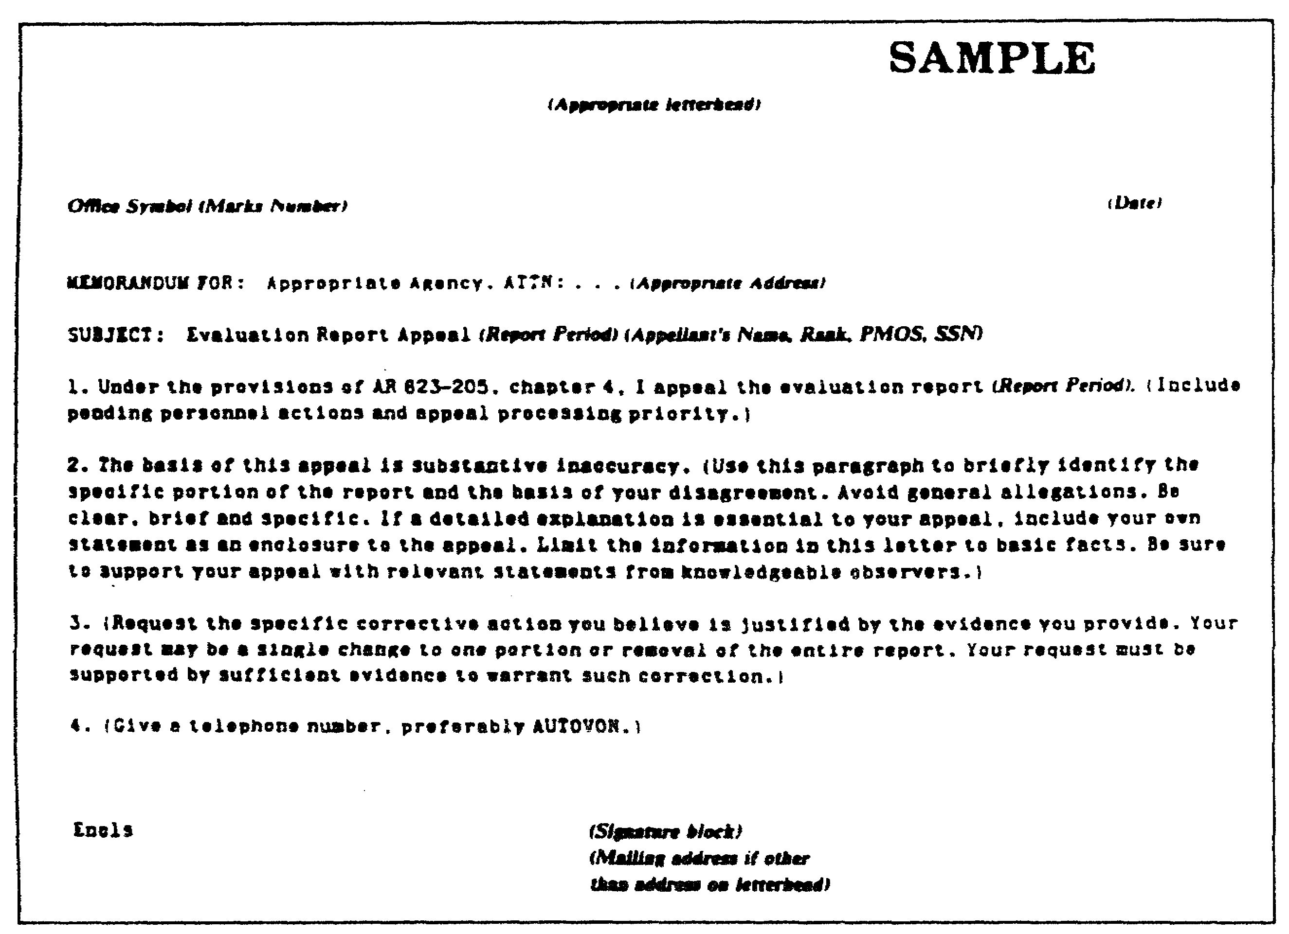

Figure 4-6. Sample format of substantive appeal.

4-79 QM3517

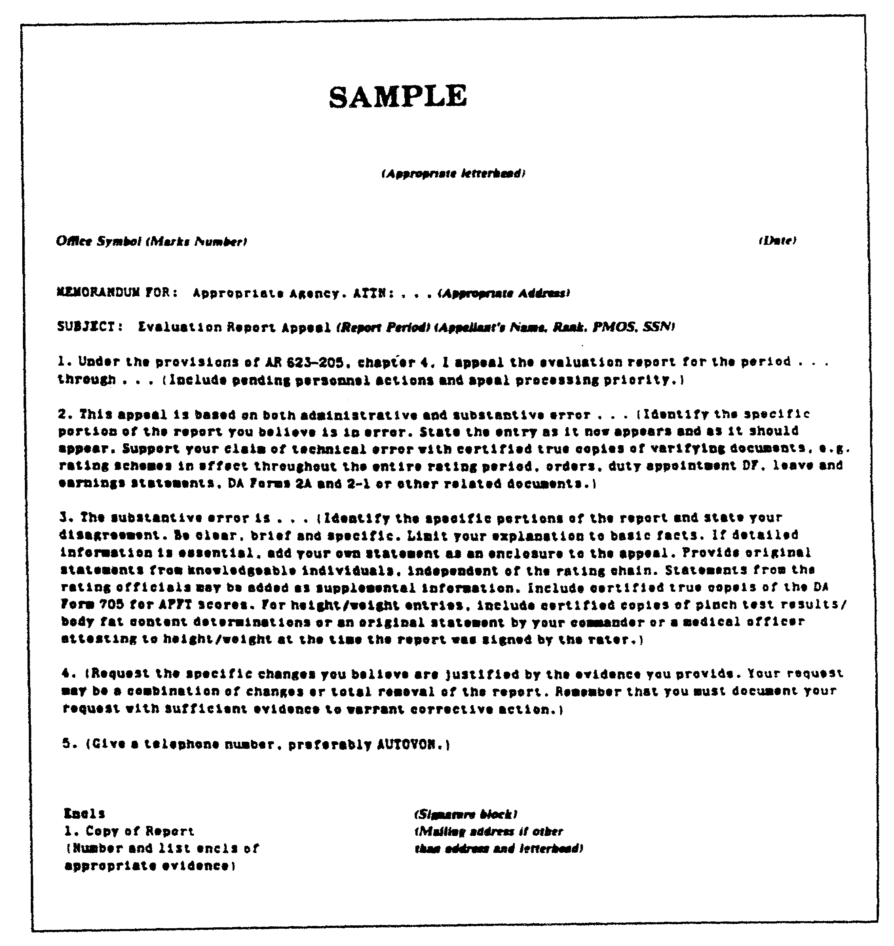

Figure 4-7. Sample format of an administrative appeal.

QM3517 4-80

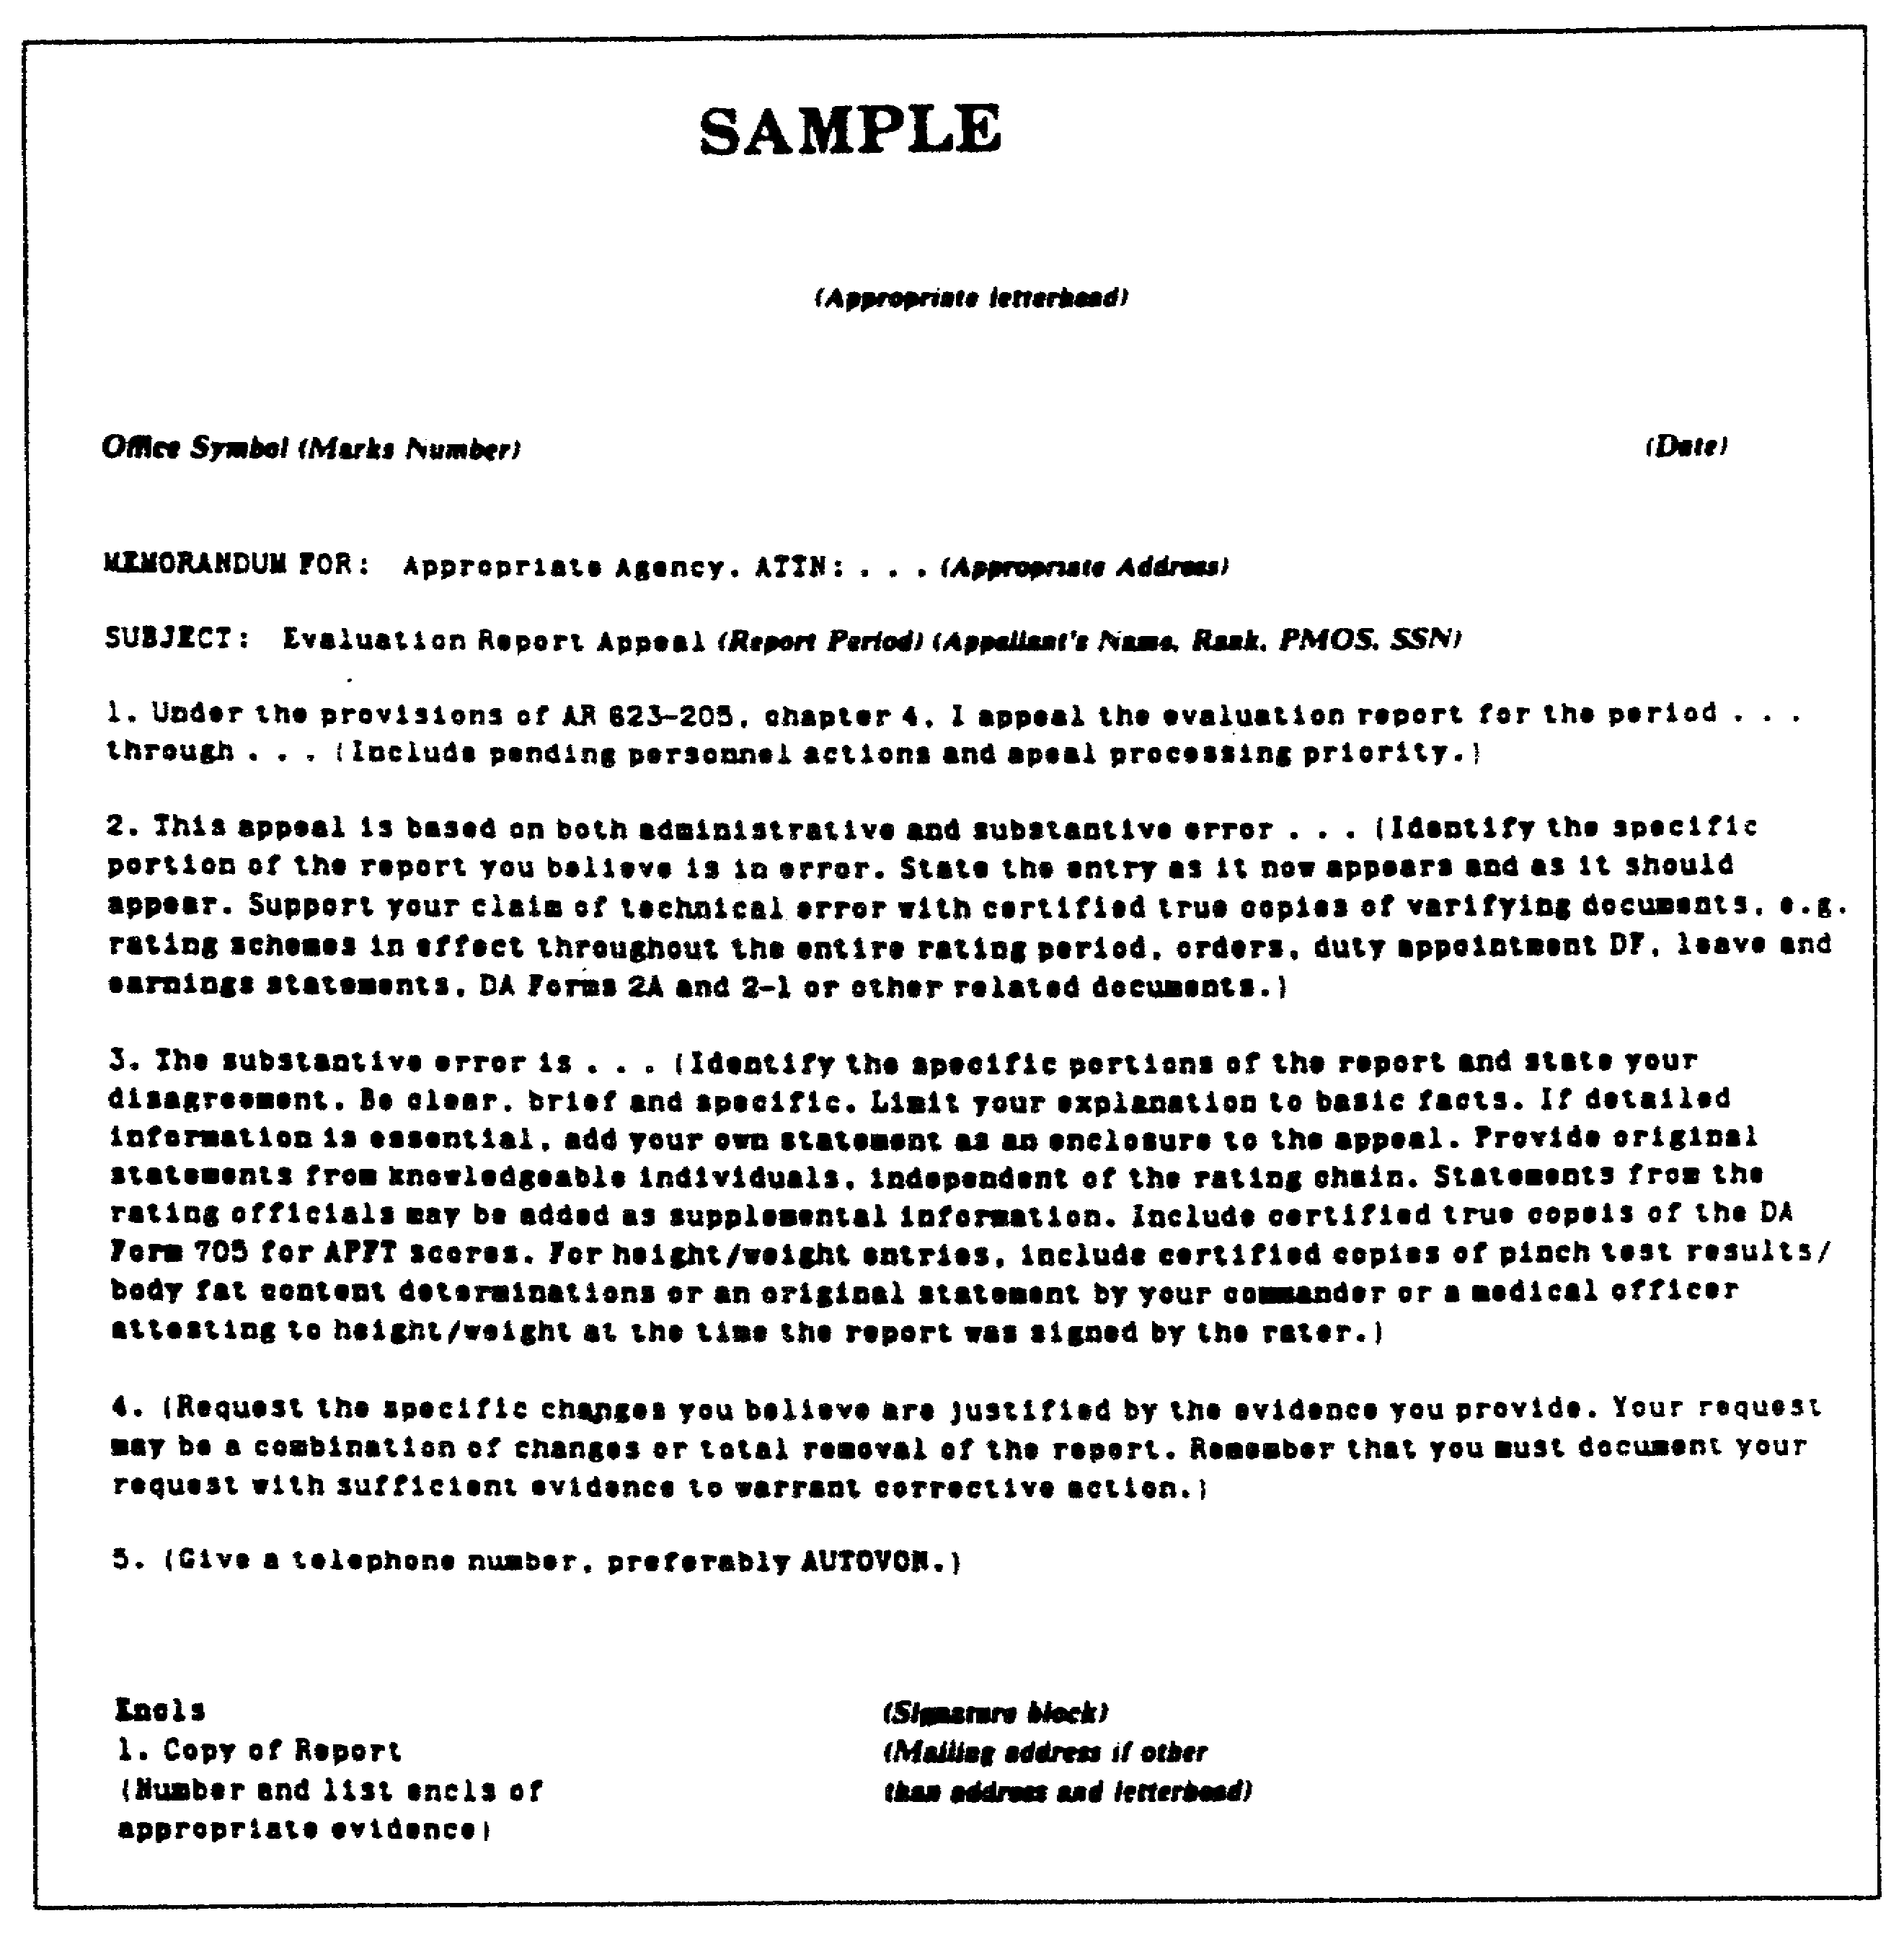

Figure 4-8. Sample format of a combined (administrative
and substantive) appeal.

4-81 QM3517

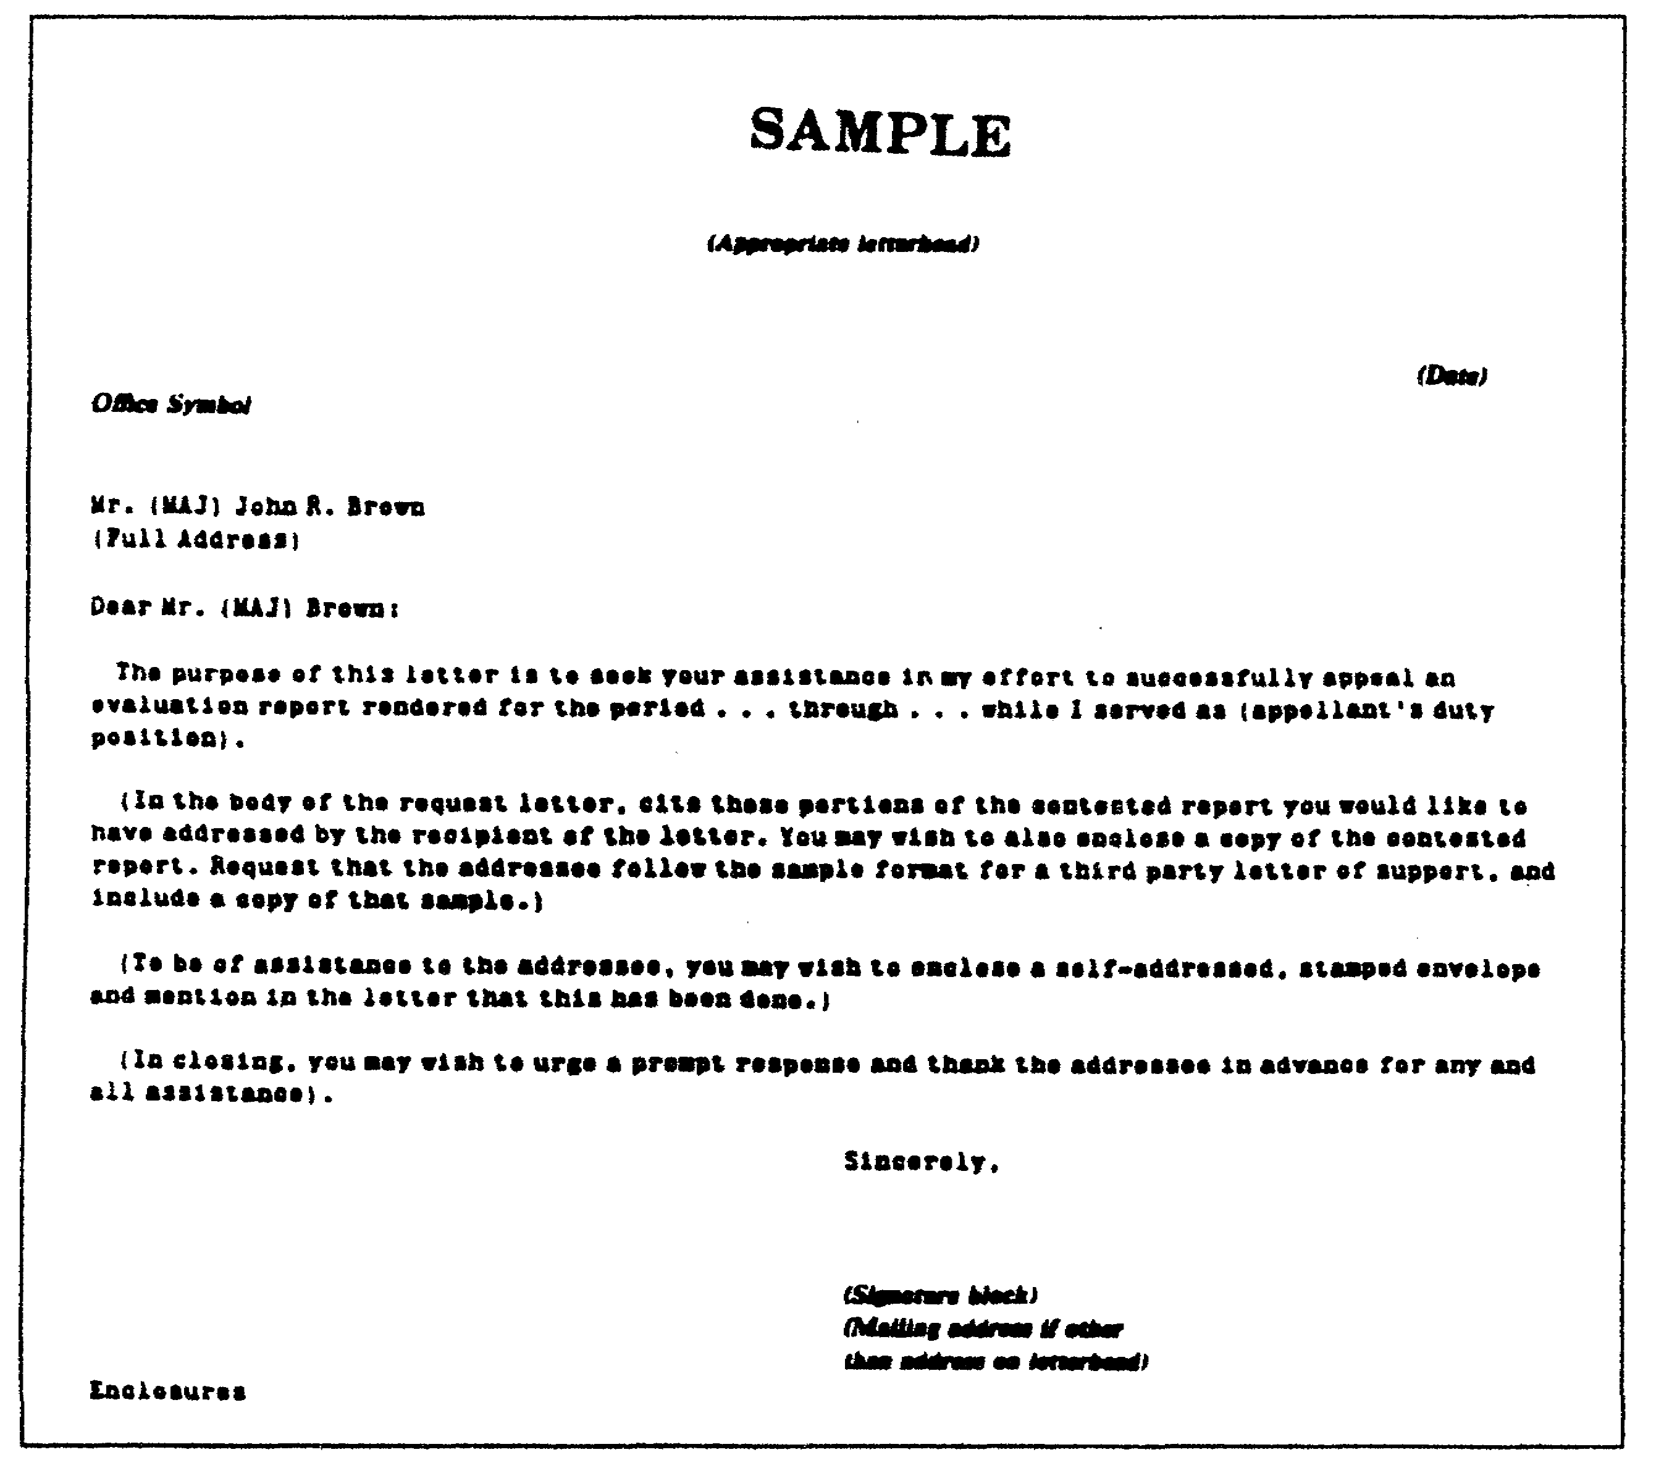

Figure 4-9. Sample format of letter requesting
third-party support.

QM3517 4-82

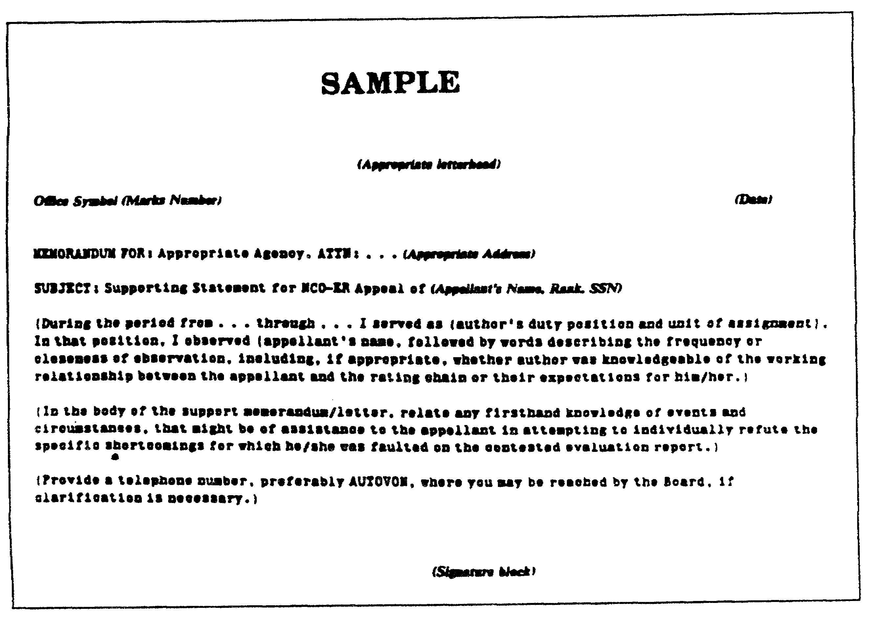

Figure 4-10. Sample format of a third-party
memorandum of support.

4-83 QM3517

LESSON 4

PRACTICE EXERCISE

The following items will test your grasp of the material covered in this lesson. There is only one correct answer for each item. When you complete the exercise, check your answers with the answer key that follows. If you answer any item incorrectly, study again that part of the lesson which contains the portion involved.

Situation: You are evaluating an NCO using the DA Form 2166-7. Use this situation to answer questions I through 8.

1. When you suspect an unjust evaluation, regulations require you

A. to pressure rating officials to change their evaluations.
B. to evaluate the rated NCO as a substitute for the rater.
C. to take no further action regarding a DA Form 2166-7 if an inquiry reveals no error or wrongdoing.
D. to lower the evaluation of the rater and establish a board of investigation.

2. During the performance coaching session, you spend the greatest amount of time on the rated NCO's

A. career development.
B. personal problems.
C. good points.
D. performance of duty.

3. When you must criticize the rated NCO, you do so in such a way that the

A. rated NCO is not aware that he is being criticized.
B. coaching session does not degenerate into an unpleasant atmosphere.
C. rated NCO knows that the purpose of the honest criticism is to improve performance.
D. rated NCO's feelings are not upset.

QM3517 4-84

4. As outlined in the study "Leadership of the 1970s", which of the following do you do when the Army assigns an NCO to a new position?

A Tell the NCO what mistakes his predecessor made and stress that you will not tolerate similar errors.
B. Advise the rated NCO of the scope of his duties, of your objectives for him, and of the routine and job performance that you expect from him.
C. Provide no performance coaching because studies have shown that only inexperienced NCOs need performance coaching.
D. Leave the NCO alone to feel his way into what best fits his talents.

5. You keep a private, written record of the NCO's performance because

A. your unit might later ask you to justify your evaluation.
B. most raters must keep account of their NCO's faults from one evaluation reporting period to another.
C. you can use this informal record for the descriptive portion of an evaluation report.
D. it keeps NCOs on their toes when they see raters walk away making an entry in a little book.

6. Which of the following is a technique for making a thoughtful evaluation in the bullet comments portion of DA Form 2166-7?

A. Use italics and frequent capital letters to highlight key points for the selection board.
B. Single space with exaggerated margins to fit in all the NCO's accomplishments.
C. Ensure that they are not so brief that career managers may interpret them incorrectly.
D. Point out any extracurricular contributions such as volunteer activities of the NCO's spouse.

7. Which of the following statements is a bullet example that truly represents excellence?

A. "Instilled the spirit to achieve and win."
B. "Received annual Best Trainer Award from Bde CDR."
C. "Best NCO in Bn."
D. "Is the most dedicated NCO I know."

4-85 QM3517

8. What problem can an NCO have if you give him all "SUCCESS" ratings in Part IVb-f of DA Form 2166-7?

A. It can devastate his career since everybody knows that raters tend to "inflate" DA Forms 2166-7.
B. If you leave comment spaces blank, it may jeopardize his competition for promotion or schooling.
C. It is hardest to get used to the concept of excellence over success in a new report.
D. An NCO with all "SUCCESS" ratings in Part IV can only be rated "FULLY CAPABLE" in Part V.

QM3517 4-86

LESSON 4

PRACTICE EXERCISE

ANSWER KEY AND FEEDBACK

Item Correct Answer and Feedback

1. C. to take no further action regarding a DA Form 2166-7 if an inquiry reveals no error or wrongdoing.

If the inquiry reveals no error or wrongdoing, then the commander takes no further action. The Army does not allow anyone to pressure or to force raters to change their evaluations. Also, regulations do not allow the commander to rate the NCO as a substitute. The rater cannot ask the reviewer to lower his evaluations as a result of the inquiry. (page 4-17, para 4b(3)
(a))

2. D. performance of duty.

Performance counseling and coaching are acts of leadership that are meant to help to improve an individual's performance in his present position. You may properly include counseling of a broader scope-such as guidance in career development and professional development. (page 4-36, para 2b)

3. C. rated NCO knows that the purpose of the honest criticism is to improve performance.

It is essential to have straightforward and honest criticism of the individual's performance. You achieve performance only when a subordinate is aware that this is the purpose of the criticism, although the facts themselves may be unpleasant. (page 4-39, para 2f(2))

4. B. Advise the rated NCO of the scope of his duties, of your objectives for him, and of the routine and job performance that you expect from him. Make every effort to eliminate misunderstanding regarding job requirements and superior-subordinate expectations. (page 4-40, para 3a(3.a.))

4-87 QM3517

5. C. you can use this informal record for the descriptive portion of your evaluation report.

A private, written record is not for office files or so that the Army can create an era of "little black books". However, a formal performance coaching session should not depend solely on hazy recollections. You can use it for descriptive notes for commendations or letters of appreciation. You should destroy performance records after the expiration of an evaluation period so that evaluation reporting constitutes a new slate to the NCO concerned. (page 4-47, para 3e)

6. C. Ensure that they are not so brief that career managers may interpret them incorrectly. Regulations prohibit narrative gimmicks. You must not use excessive capital letters, italics, single spacing between bullets, or exaggerated margins. You should not base evaluation comments on marital status or a spouse's employment, education, or volunteer activities. (page 4-53, para 1a)

7. B. Received annual Best Trainer Award from Bde CDR.

The criteria for excellence is that the NCO must exceed standards with specific evidence or results that are special or achieved by only a few. (page 4-68, para 6b(3))

8. C. It is hardest to get used to the concept of excellence over success in a new report.

Only a few achieve excellence, and such a report would be special and very unusual. No "SUCCESS" rating or comment space that you leave blank hurts a rated NCO. You can rate "AMONG THE BEST" in Part V for an NCO with all success ratings. (page 4-75, para 9a)

QM3517 4-88

LESSON 5

OFFICER EVALUATION REPORT DEVELOPMENT

Critical Task: S3-0170.00-1006

OVERVIEW

LESSON DESCRIPTION:

In this lesson, you will learn how to identify the purpose and the proper use of DA Form 67-8 (United States Army Officer Evaluation Report) and DA Form 67-8-1 (US Army Officer Evaluation Report Support Form). You will learn the procedures to use to complete these forms; the times at which you render the reports; and the rating scheme. In addition, you will learn the importance of each rater's evaluation or comments; your responsibility for providing accurate information and unbiased appraisals; and the responsibilities for resolving major disagreements. You will learn how to identify the qualifications and the responsibilities of the rater, the reviewers, and the rated individuals. Moreover, you will learn the roles and the responsibilities of the PSC and the PAC.

TERMINAL LEARNING OBJECTIVE:

ACTION: Identify the purpose and the proper use of DA Form 67-8 and DA Form 67-8-1. Learn the procedures to use to complete these forms; the times at which you render the reports; and the rating scheme. Learn the importance of each rater's evaluation or comments; your responsibility for providing accurate information and unbiased appraisals; and the responsibilities for resolving major disagreements. Learn how to identify the qualifications and the responsibilities of the rater, the reviewers, and the rated individuals. Learn the roles and responsibilities of the PSC and the PAC.

CONDITION: You will be given information from Army Regulation (AR) 623-105.

5-1 QM3517

STANDARD: Perform the following actions in accordance with AR 623-105:

o Identify the purpose and the proper use of DA Form 67-8 and DA Form 67-8-1.

o Learn the procedures to use to complete these forms; the times at which you render the reports; and the rating scheme.

o Learn the importance of each rater's evaluation or comments; your responsibility for providing accurate information and unbiased appraisals; and the responsibilities for resolving major disagreements.

o Learn how to identify the qualifications and the responsibilities of the rater, the reviewers, and the rated individuals.

o Learn the roles and the responsibilities of the PSC and the PAC.

REFERENCE: The material contained in this lesson was derived from the following publication: AR 623-105.

INTRODUCTION

There were times in the Army's history during which the officer corps was small enough for most officers to know each other personally or by reputation. Senior officers often could rely upon their memories in making important decisions. If they personally did not know the officers under their commands, chances were that a colleague could furnish them information that was based upon firsthand knowledge. For an officer corps of even a few thousand, such an informal and standardized efficiency reporting system would be a haphazard method of evaluating the performance and the abilities of individual officers. For a corps of nearly 100,000 officers, it would be unworkable.

Today, almost all armies employ some standardized method of reporting and recording duty performance and the personal characteristics of personnel. You must have a thorough knowledge of this officer evaluation system since you must evaluate your subordinates. In turn, you will be evaluated by your superiors.

The evaluation system examines the performance and the potential of its leaders. It is the basis for informed personnel management decisions as to promotions, assignments, advanced

QM3517 5-2

training, and retention. Special reports document either exceptional or abysmal performance which cannot wait until the next reporting period.

PART A - RESPONSIBILITIES OF OFFICER RATERS

1. Purpose of the Officer Evaluation Reporting System.

The purpose of the Officer Evaluation Reporting System (OERS) is the same as that for the NCO-ERS. The OERS allows commanders to make intelligent personnel decisions such as those involved in promoting officers. Refer to the following subparagraphs for a detailed discussion of the OERS:

a. Importance Attached to the Officer Evaluation Report. One of the most difficult tasks that you have to perform as an officer is to evaluate your subordinates. What makes this task even more difficult is the great importance that is attached to this evaluation. The evaluation report directly influences many personnel actions, including promotions. All reports become part of the rated officer's permanent file. Evaluation reporting is a serious business. Each rating official must understand that the success or the failure of the reporting system depends upon his ability to report accurately and objectively.

Evaluation reports provide continuous measurement of the rated officer's professional attributes, duty performance, and potential.

The evaluation report is such an important part of an officer's records that the Army has taken great care to avoid hit-or-miss methods in its development. The Army developed the OERS carefully and scientifically. However, its effectiveness is ultimately in the hands of the people who complete the reports.

b. Design of the Officer Evaluation Reporting System. The Army designed the OERS to provide a continuous measure of an officer's overall value to the service. Individual reports provide specific information as to how an officer has performed in a certain duty position during a specific time. Each report must reflect the officer's qualifications and potential during a specific duty performance. Never include past performance or past qualifications.

5-3 QM3517

When you incorporate the information into the officer's whole record, it becomes a basis for the qualitative management of his career. The Army must account for all service on some type of report. Since officers get training on the job and in schools, the Army uses two basic types of reports:

o DA Form 67-8 (US Army Officer Evaluation Report).

o DA Form 1.059 (Service School Academic Evaluation Report). This report will NOT be discussed in detail in this lesson.

It is important that every officer understand the purpose of the OERS. The Army designed, and intends, each report to provide useful and meaningful information about the officer. It becomes the basis for making personnel management decisions. These decisions involve every aspect of an officer's career. The OERS culminates in actions such as the following:

o Promotion.
o Assignment.
o Selection for military and civilian schools.
o Training.
o Retention on active duty.
o Elimination.

2. Use of the Officer Evaluation System.

This paragraph discusses the use of the Officer Evaluation System (OES). Refer to the following subparagraphs for specific details:

a. Officer Identification. Use the OES to identify officers who are best-qualified for promotion and assignment to positions of higher responsibility. Use it to identify officers whom the Army should keep on active duty, those whom the Army should retain in grade, and those whom the Army should eliminate.

b. Kinds of Evaluations. Use the OES to evaluate an officer on his performance and his potential. The OES uses the following three kinds of evaluations:

(1) Duty Evaluation. One type of evaluation that you can give is the duty evaluation. Use the DA Form 67-8 for this evaluation.

(2) School, Evaluation. Another type of evaluation that you can give is the school evaluation. Use the Academic Evaluation System for this evaluation. The Academic Evaluation System will NOT be discussed in detail in this lesson.

QM3517 5-4

(3) Department of the Army Evaluations. Selection boards and personnel management systems are used for DA evaluations. The duty evaluation and the school evaluation are single time-and-place evaluations. They are used to make DA evaluations. DA evaluations cover an officer's entire career.

DA evaluations focus on an officer's potential. They are judgments of the officer's ability to perform at higher grades. They also judge whether the Army should retain an officer and give him greater responsibility in his present grade. Use the following three factors for making DA evaluations:

(a) Army Requirements for Officers. The needs of the Army for officers frequently change. At times, the Army needs officers with certain backgrounds, experience, and expertise. The law determines the size of the Army officer corps in terms of strength by grade. Army requirements limit the number of the selections and the number of the assignments. Thus, the Army determines an officer's potential partially by how he compares with his peers.

(b) Duty Performance. Performance of duty is extremely important in determining an officer's potential. An officer's duty performance is judged by how well he performs his tasks and how well he meets the officer corp's professional values.

(c) Officer Qualifications. Officer qualifications is the third factor in determining an officer's potential. The Army considers this factor to meet its needs for outstanding leaders of troop and technical units, supporting staff managers, and technical specialists. One consideration in determining officer qualifications is the different skills and backgrounds that different specialties require. Another consideration is the officer's progress through specialist fields to positions of greater responsibility. In addition, the Army considers his length of service and his civil and military schooling.

3. Function of the Officer Evaluation Reporting System.

The following subparagraphs discuss the importance of the OERS as a subsystem of the OES. The following are discussed as well:

o Basic structure of the OERS.
o Primary function of the OERS.
o Secondary functions of the OERS.

5-5 QM3517

a. Subsystem of Officer Evaluation System. The OERS is an important subsystem of the OES. It largely determines the following:

o Quality of the officer corps.
o Selection of future Army leaders.
o Course of each officer's career.

The OERS supports many current Army personnel management programs.

(1) Ensures Consideration of Specialties. DA Form 67-8 ensures that an officer's specialties are considered along with the specialty requirements of his duty position at the time of his evaluation.

(2) Supports "People-Oriented Programs". The emphasis on senior and subordinate communication supports the Army's "people-oriented programs". Ensure that attention is focused on constructive problem-solving and the importance of sound working relationships.

b. Basic Structure of Officer Evaluation Reporting System. Although the OERS is a multifunctional system, its basic structure allows you to do the following:

o Give shape and direction to the rated officer's performance.

o Provide a chain-of-command evaluation of an officer's performance and potential.

o Review the entire evaluation reporting process.

c. Primary Function--Provide DA Information for Personnel Decisions. The primary function of the OERS is to provide information to the DA for use in making personnel management decisions. A rating chain in the officer's assigned organization supplies this information.

(1) Use the DA Form 67-8 for Personnel Actions. The Army uses information that is provided on DA Form 67-8, combined with its needs and individual officer qualifications, as a basis for personnel actions. These personnel actions include the following:

o Promotions.
o Eliminations.
o Retentions in grade.
o Retentions on active duty.
o Reductions in force.

QM3517 5-6

o Command selections.
o School selections.
o Assignments.
o Specialty designations.
o Regular Army (RA) integration.

(2) Ensure that Reports are Comprehensive, Realistic, and Objective. Your evaluation reports must be as accurate and as complete as the situation allows. This helps to ensure sound personnel management decisions and the full development of an officer's potential. Make sure that each report is a comprehensive appraisal of the officer's abilities, weaknesses, and potential. Reports that are either incomplete or that fail to provide a realistic and an objective evaluation make it difficult to determine an officer's true potential.

d. Secondary Functions. Secondary functions of the OERS are to encourage officer professional development and to enhance mission accomplishment. The following subparagraphs discuss these secondary functions:

(1) Sound Relationships. The OERS stresses the importance of sound senior and subordinate relationships. It stresses the importance of setting standards and of giving direction to the performance of subordinate officers. If you use the OERS properly, then it can be a powerful leadership and management tool for the rating chain.

(2) Effective Communication. The key to the system's secondary functions is effective communication. The OERS encourages continual two-way communication between senior officers and subordinate officers.

On one hand, such communication helps the rated officer by accomplishing the following:

o Makes him aware of what his duties are.

o Allows him to take part in the organization's planning.

On the other hand, such communication helps you by accomplishing the following:

o Lets you guide and develop your subordinates.

o Keeps you constantly aware of what the organization is achieving.

o Enables you to plan for mission accomplishment.

5-7 QM3517

(3) Career Development. Senior and subordinate communication makes the following more readily available to the rated officer:

o Career development information.
o Advice.
o Guidance.

This enables him to take advantage of your experience as his superior when he makes decisions that affect his career.

4. Responsibilities of Personnel Service Canter.

The field PSC performs an important advisory and administrative role in the OERS. The PSC has general responsibility for ensuring that you have prepared the DA Form 67-8 correctly. It has specific responsibilities in regard to filling out the form.

The PSC maintains copies of the current rating chains. It initiates DA Form 67-8 by sending the rated officer a partially completed DA Form 67-8 and DA Form 67-8-1. The rated officer is responsible for initiating his support form. (Part B of this lesson further discusses DA Form 67-8-1. Part C discusses DA Form 67-8.) The PSC has specific responsibilities to notify the rating officials of suspense dates for returning corrected reports. The PSC ensures that reports arrive at HQDA within 60 days after the "THRU" date of the report.

The PSC is responsible for providing guidance to any rated officers who plan to submit an evaluation report appeal.

5. Responsibilities of Commander, United States Army Military Personnel Center.

The commander of the US Army Military Personnel Center (MILPERCEN) is responsible for the effective operation of the OERS. He exercises final review authority on all evaluation reports that the Department of the Army receives. He determines the correctness of the report. He may determine that the reports are in error or may find that they violate Army regulations. If so, then he returns the reports to the rating officials. He directs local commanders to investigate those errors and regulation violations.

The commander of the MILPERCEN has additional responsibilities to do the following:

o Clarify policies.
o Grant exceptions to policies.
o Formulate new policies.
o Dispose of commander's inquiries.

QM3517 5-8

6. Responsibilities of Local Commanders.

Each local commander has responsibilities. Each local commander is responsible for the following:

o Establishing a rating chain.
o Designating rating chain members.
o Ensuring that each rating official is fully qualified.
o Publishing and distributing the rating chain.

Information that is published in the rating chain should include the following data for each rating official:

o Name.
o Rank.
o Position.
o Effective assignment date.

Someone may bring to the attention of a local commander that a report may be illegal, unjust, or otherwise in violation of AR 623-105. In this case, the commander is responsible for investigating the matter. Each local commander is responsible for requesting the following data from the commander of the MILPERCEN:

o Clarification of policies.
o Exceptions to policies.
o New policies.

The local commander must bring to the attention of the commander of the MILPERCEN situations which--

o are NOT clearly and adequately covered in AR 623-105.

o would result in an injustice to an individual.

o would be a disservice to the Army if officials did NOT make a new policy or grant an exception.

7. Makeup of Rating Chains for Officer Evaluation Reporting.

Rating chains usually consist of the following individuals:

o Rated officer.
o Rater.
o Senior rater.

For discussions of these officials, refer to subparagraphs 8a, 8b, and 8d of this part of this subcourse.

5-9 QM3517

When a rating chain is established, the rater and the senior rater are the first officials to be designated. Some rating chains include an intermediate rater. An intermediate rater is designated only when a rated officer has a supervisor who is between the rater and the senior rater in his chain of command. Paragraph 8 of this part of this lesson discusses each of these positions.

a. Rating Chain Rules. Figure 5-1 displays rating chain rules. They include the fact that if a promotable CPT, MAJ, LTC, or COL is serving in a position which calls for his promotable grade, then he may serve as a senior rater.

c. Rating Chain. Figure 5-2 depicts a suggested rating chain. The dates in the parentheses reflect the original dates for the designated rating officials. A rating chain must be reissued upon any change.

8. Role of Raters.

Ensure that your rating chain corresponds to the chain of command and supervision within your organization. Your rating chain provides the best specific senior and subordinate relationship. When your rating chain corresponds to the chain of command, it allows access to an evaluation of the rated officer by persons who know how he performs his job. This allows for the proper counseling to develop the rated officer and to accomplish the mission. The evaluation of officers by persons who are NOT involved with their supervision is inappropriate.

Each local commander is responsible for establishing and publishing rating chains which show the following information:

o Names.

o Positions.

o Effective dates of the assignments of the rating officials.

a. The Rated Officer. The rated officer is the subject of the evaluation report. Normally, you rate an officer when he completes 90 days in the same duty position under the same rater.

QM3517 5-10

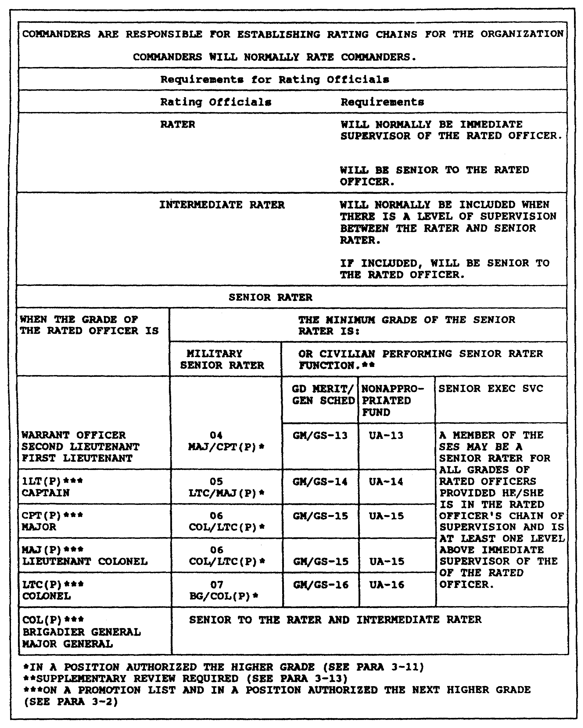

Figure 5-1. Rules for establishing rating chains.

5-11 QM3517

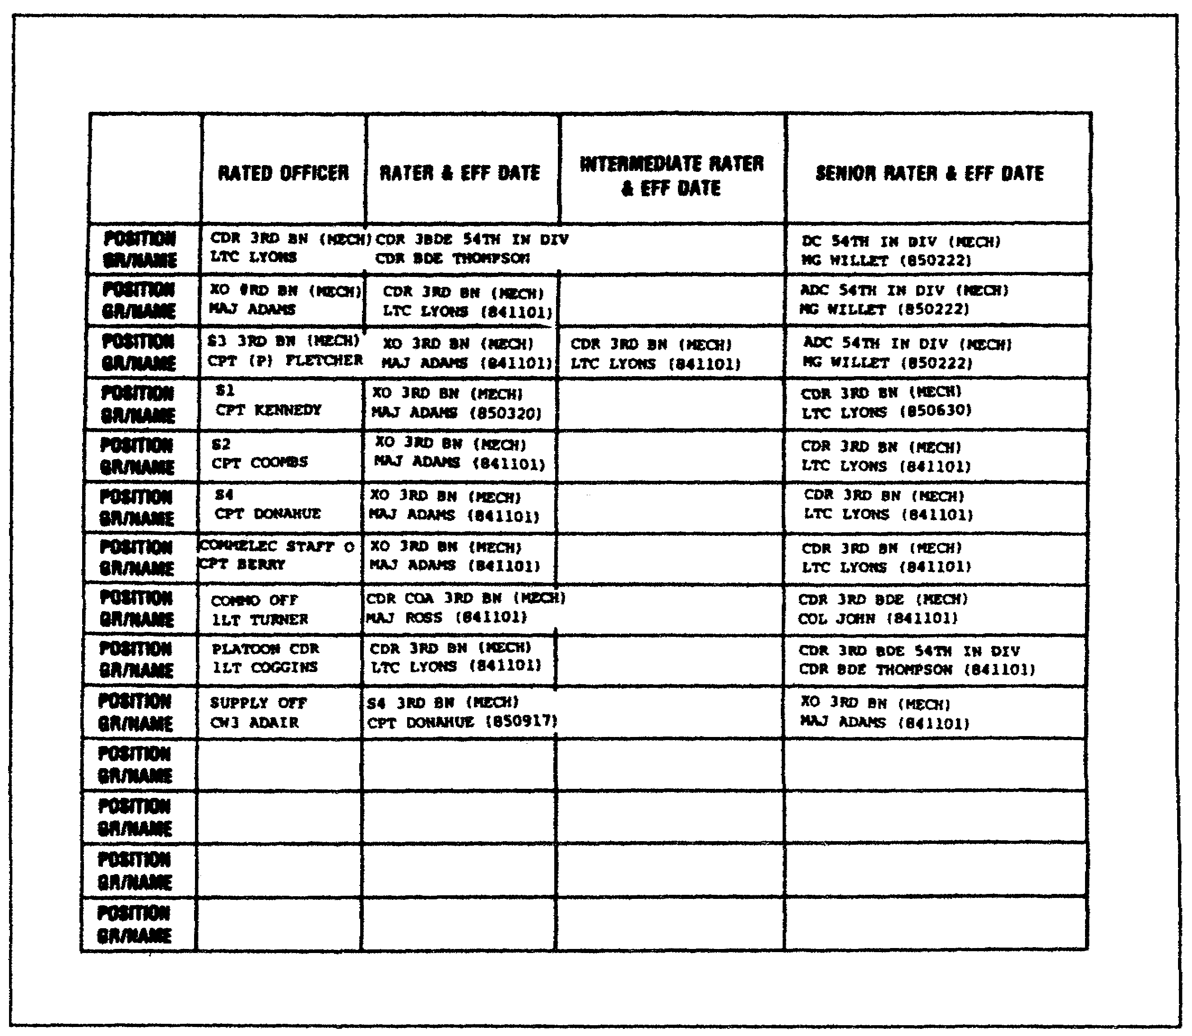

Figure 5-2. Suggested rating chain.

b. The Rater. The rater is the person in the rating chain who is most familiar with the day-to-day performance of the rated officer. Normally, the rater is the immediate supervisor of the rated officer. As such, he is senior by date of rank, if not by grade. He must be in the position a minimum of 90 days in order to give an evaluation report. (There are a few exceptions to this rule. These exceptions will be noted later in this subcourse).

c. The Intermediate Rater. An intermediate rater should be designated when there is a level of supervision between the rater and the senior rater. The intermediate rater must meet certain grade qualifications. For example, a chaplain must be rated by another chaplain in the rating chain whenever possible. A

QM3517 5-12

battalion chaplain is part of the special staff. Therefore, the commander rates him. If an individual is rated by a commander, then the rated individual is usually senior-rated by the next higher commander--in this case a brigade commander. The brigade chaplain fits nicely into the slot of intermediate rater, fulfilling rater, senior rater, and chaplaincy requirements.

d. The Senior Rater. The senior rater is the senior rating official in the rating chain. The senior rater evaluates the rated officer from a broad organizational perspective. He rates the officer's potential. In addition, the senior rater normally performs the final rating-chain review. A senior rater normally is assigned based on the following requirements:

o He must be in the line of supervision.

o He is at least a major.

o He is two grades higher than the rated officer. When he rates a lieutenant colonel or a colonel, the senior rater must be one grade higher.

o He is in the position for at least 60 days.

e. Rules for Designating Raters. Figure 5-1 depicts the rules for designating raters. For example, a rater must be an officer. The rater normally is senior to the rated officer by the date of his rank. For instance, a major rates a second lieutenant (2LT).

The following rules provide more detailed information concerning the requirements that must be met in designating raters.

(1) Rank. The rater must be an officer of the US or allied armed forces or an employee of a US government agency (including nonappropriated fund employees). An exception occurs when the restrictions on non-DOD rating officials that are stated in the following note apply.

NOTE: An exception states that only military and civilian employees of the DOD, including nonappropriated fund employees, may use the DA Form 67-8 for their evaluations. All non-DOD employees who serve as rating officials submit their evaluations in a letter report.

5-13 QM3517

(2) Supervisory Status. The rater normally is the immediate supervisor of the rated officer. The immediate supervisor is the individual who directs, and is most responsible for, the rated officer's performance.

(3) Senior Status. The rater must be senior to the rated officer in grade or date of rank. Exceptions to this rule are as follow:

o The rater may be in a command position. If so, then he may rate an officer who is of the same grade but who is senior in date of rank. However, the rater must have been assigned to command by the direction of the president and must have command authority over the rated officer. In such cases, the rater attaches a copy of his assignment-to-command order as an enclosure to the rated officer's report.

o The rater may be an officer in a command position. If so, then he may rate an officer over whom he has command authority and who is senior in date of rank but ineligible by law or regulation to command troops other than those of his own branch, service, or department. In such cases, the rater attaches a copy of the written assumption-of-command as an enclosure to the rated officer's report.

o The rater may be an officer who is selected for promotion and who is in an authorized position for his new grade. If so, then he may rate an officer whom he supervises if, after his promotion, he will be senior to the rated officer.

o A civilian rater has no minimum grade requirement. However, he must be the officially designated supervisor of the rated officer.

o An officer in a joint headquarters or activity may rate an officer who is senior in date of rank. However, the rated officer must NOT be a US officer. The senior rater must be at least one grade senior to the rated officer. Each instance must be approved in writing by the next senior Army member of the command or the activity. A copy of the approval must be sent to HQDA as an enclosure to the DA Form 67-8.

QM3517 5-14

o Commanders normally are rated by the next-higher commander. However, an exception to this rule is allowed when a staff officer or a higher level commander is the logical choice as the commander's immediate supervisor because of functional, geographical, or technical supervision requirements.

Figure 5-2 depicts a suggested rating chain. The dates in the parentheses are the assignment dates for the rating officials. Figure 5-2 shows that the officials designated the battalion executive officer (XO)(MAJ Adams) as the rater for the S2 on 841101. MAJ Adams became the rater of the S1 (CPT Kennedy) on 850320.

The interpretation is that the Army assigned CPT Kennedy his S1 duties on 850320.

f. Promotable Grade Factors. In determining the rater's eligibility, consider the following:

o A rater who is selected for promotion and who is in an authorized position for the new grade is considered to be serving in the new grade. The symbol "P" is put next to his current grade on DA Form 67-8.

o A rater who is selected for promotion and who is NOT in a position that is authorized for the new grade is considered to be serving in his current grade. The symbol "P" will NOT be put next to his current grade on the DA Form 67-8.

g. Loss of a Rating Chain Member. When the Army relieves a rating official or he becomes incapacitated, he is NOT permitted to evaluate a rated officer. Special rules apply when a rating chain member is unable to submit an accurate evaluation.

(1) Rule 1. When an intermediate rater or a senior rater is removed from the rating chain, it is handled as a routine change. A new rating official is designated.

(2) Rule 2. When a rater is removed from the rating chain, a determination must be made as to whether the minimum requirements for an evaluation report have been met.

(a) Minimum Requirements NOT Met. If the minimum requirements have NOT been met, then the period becomes nonrated. A new rater must be designated.

5-15 QM3517

(b) Minimum Requirement Met. If the minimum requirements have been met, then the following conditions apply:

o The remaining raters perform the evaluation report.

o The intermediate rater must have served in the rated officer's rating chain for a period of 60 days.

If there is no intermediate rater, or if the intermediate rater has NOT met the 60-day requirement, then a senior rater performs the rater's function. If the senior rater has NOT met the 60-day requirement, then the period becomes nonrated. When the senior rater assumes the role of the rater, he serves as both the rater and the senior rater.

(c) Rater Function by Intermediate or Senior Rater. The intermediate rater or the senior rater may perform the rater's function. If so, then the number of months in the rating period block (Part 1m) of DA Form 67-8 is computed using the period that the substitute rating official has been in the chain.

h. Supervisors Serving as Both Rater and Senior Rater. At the company level, there rarely is a case in which the supervisor would serve as both the rater and the senior rater. This would occur when the rater, under the normal rating chain rules, causes a senior official to perform as the senior rater when he does NOT desire to serve as the senior rater. These senior officials could include the Secretary of Defense, the Chairman of the Joint Chiefs of Staff, or commanders-in-chief.

i. Dual Supervision. Dual supervision occurs when two separate chains of command supervise and assign duties to the rated officer. The rating chain must represent both supervisory chains of command. There are two ways to accomplish this.

(1) Divided Rating Chain. The first method divides the rating chain between the two supervisory chains of command. Alternatively, the parent unit selects the rater and the senior rater and the nonparent unit provides the intermediate rater. To establish the rating chain, consider the significance of the duties that each chain of command supervises and the seniority of the different supervisors.

(2) Nonparent-Unit Supervisor Comments. At times, the first method is not practical. In that case, the nonparent-unit supervisor submits the written comments concerning the rated officer's duty performance to the rater. These comments are prepared as an enclosure to the DA Form 67-8 report.

QM3517 5-16

PART B - DA FORM 67-8-1

1. Purpose of the DA Form 67-8-1.

Many officers have complained that no one counseled them or that no one counseled them properly. The current system addresses this complaint with DA Form 67-8-1, shown in Figure 5-3 and Figure 5-4). This may reduce or remove the complaints and involve the rated officer personally in the evaluation process.

a. Start of Rating Period. At the start of each rating period, the rated officer prepares a single copy of DA Form 67-8-1. The personnel officer completes Parts I and II. The rater and the rated officer develop a working copy together.

b. Discussion Within 30 Days. Within the first 30 days of each rating period, the rater and the rated officer have a face-to-face discussion of the rated officer's duties and objectives. Each officer initials the DA Form 67-8-1 in Part III to certify that the face-to-face discussion took place.

c. Dialogue Focuses on Duties. The dialogue focuses on the principal duty and any additional duties that the rated officer is to perform. The rater makes each of the following points clear to the rated officer:

o What he is to do.

o What he is NOT to do.

o What pitfalls to avoid.

o What helpful hints the rater has for the rated officer.

o What local policies apply.

NOTE: Remember that the main function of each DA Form 67-8 is to describe how the officer has performed a principal duty.

Part IV, item "a" of DA Form 67-8-1 is used for the duty description.

d. Performance Objectives. Part IV, item "b" calls for a consideration of any major performance objectives which the rater may establish at this time. Many officers, upon viewing the form, have assumed automatically that the Army was adopting the management-by-objectives technique. This is a faulty assumption.

5-17 QM3517

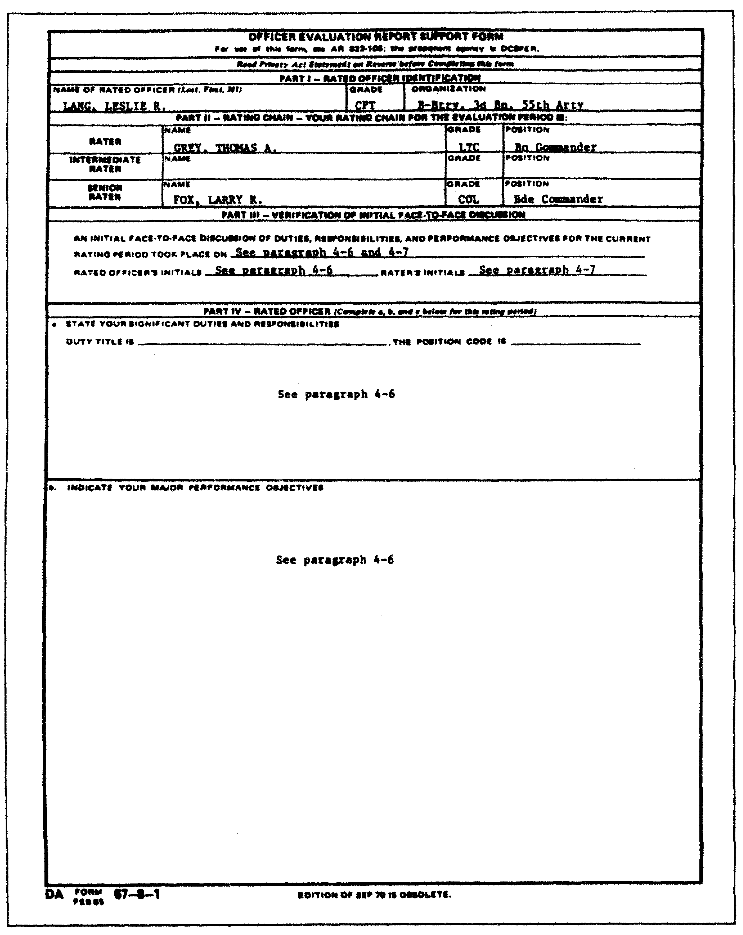

Figure 5-3. DA Form 67-8-1 (front).

QM3517 5-18

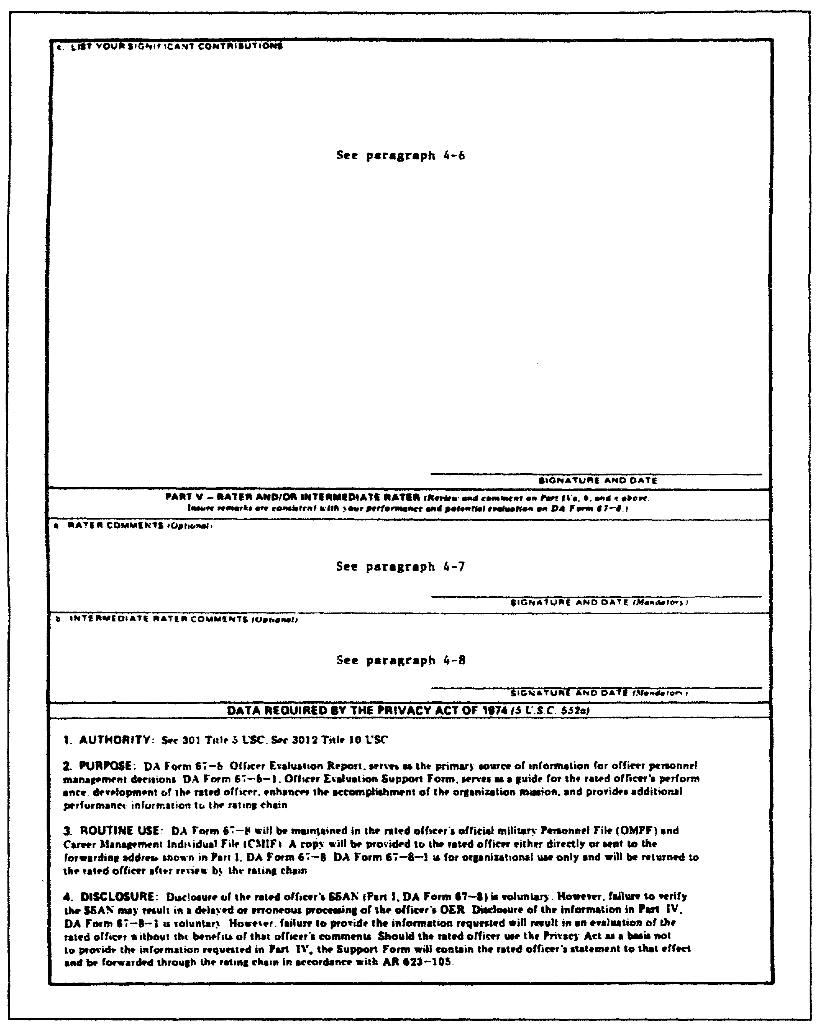

Figure 5-4. DA Form 67-8-1 (back).

5-19 QM3517

To quote from AR 623-105:

The communication process should be adjusted to the local situation. The process is determined by the nature of the mission, the style and personality of the rater, and the experience of the rated officer. The process, as described in this regulation, does not attempt to force any specific type of leadership style on the rating chain. (For example, objectives can be set by the rater, jointly developed by both the rater and the rated officer, or suggested by the rated officer. It is meant only to encourage and take advantage of increased mission-related communications.

e. Objectives to Accomplish. It is quite possible that, in some situations, the only viable objective would be for the rated officer to accomplish his principal duty. HQDA stresses that each rater must think positively about his responsibility and make the discussion a meaningful, relevant dialogue. The regulation suggests that the rater consider the following types of objectives:

(1) Routine. Routine objectives deal with repetitive duties. These duties ordinarily do not produce visible results. However, if they are NOT done properly, there could be serious consequences. The following are example of routine objectives:

o Process administrative discharges within a 45-day period.

o Carry out a program that ensures timely responses to suspense items.

(2) Problem-Solving. Problem-solving objectives deal with problem situations. These objectives should allow time for dealing with problems without disrupting other objectives. The following are examples of problem-solving objectives:

o Prepare for logistical support for activating a battalion.

o Reduce the sudden rise in the AWOL rate.

(3) Innovative. Innovative objectives create new or improved methods of operation. These may involve a degree of risk because they are untried ideas. The following are examples of innovative objectives:

o Create and carry out a new property accountability system.

o Develop and test a new maintenance program.

QM3517 5-20

(4) Personal Development. The rater orients objectives that further the professional growth of the rated officer or his subordinates toward the skills that help in careers or job performances. These may be in any assignment. The following are examples of personal development objectives:

o Complete a correspondence course or additional civilian education.

o Improve a subordinate's knowledge in his area of responsibility by developing a study program of Army publications.

f. DA Form 67-8-1 Update. During the rating period, the rater uses DA Form 67-8-1 to update or to revise additional duties, objectives, or priorities. Often, events have a way of altering the best plans and intentions. It is for this reason that many officers prefer to have DA Form 67-8-1 written initially.

g. Preparation of the DA Form 67-8-1. At the end of each rating period, the Military Personnel Division (MPD) prepares DA Form 67-8 in part. The MPD then sends it to the rated officer. At this time, the rated officer prepares a new original DA Form 67-8-1 by completing only Parts IVa, b, and c. He reenters his initials in Part III to signify that the face-to-face discussion did take place earlier.

If he did NOT meet any objectives, he explains why. In Part IV, item "c", he describes any significant contributions that he made to his career, his personnel, or his unit's mission. Thus, the rated officer does participate in his evaluation by ensuring that the following actions occur:

o A completed job description is provided.

o Any objectives that he meets or contributions that he makes are called to each rating official's attention.

It is easy during a year's time to forget or to overlook significant accomplishments. A rated officer will not forget what he has done if he has well-written statements of fact that can be transcribed verbatim to his DA Form 67-8.

h. Signature and Date. The rated officer signs and dates DA Form 67-8-1 and DA Form 67-8. He passes both forms to his rater.

i. Rater Review. The rater reviews DA Form 67-8-1 and signs his name in Part Va. He reenters his initials in Part III. If he wishes to clarify, amplify, or disagree with the rated

5-21 QM3517

officer's comments, then the rater may so indicate in Part V. He completes his portion of DA Form 67-8 and passes both forms to the intermediate rater (if any) or to the senior rater.

j. Intermediate Rater. If there is an intermediate rater, then his actions are the same as the rater's. He signs DA Form 67-8-1, completes his part of DA Form 67-8, and sends both forms to the senior rater.

k. Senior Rater. The senior rater uses DA Form 67-8-1 to prepare his portion of DA Form 67-8. Then, he returns the DA Form 67-8-1 to the rated officer. Usually, the senior rater is somewhat distant from the rated officer's work area. Therefore, reading DA Form 67-8-1 helps to make him aware of the rated officer's duty situation before he makes his evaluation. This makes DA Form 67-8-1 a communication device. While it is an official document, it does NOT become a part of the officer's official file.

l. Next Period. After an annual report, an officer may remain in the same job, under the same rater. However, in the next report period, the rater must issue a new DA Form 67-8-1 and repeat the entire process.

m. New Rater Assigned. The DA Form 67-8-1 process has another advantage. When a new rater is assigned, the rated officer can read DA Form 67-8-1 to his new rater. Doing so brings him up to date on the local situation and his assigned duties.

2. Proper Use of the DA Form 67-8-1.

As mentioned previously, many officers have complained that no one gave them proper counseling during their military careers. The Army is solving this problem with DA Form 67-8-1 (Figure 5-3 and Figure 5-4).

Two formal requirements are associated with the rating communication process and DA Form 67-8-1. The rated officer is responsible for the following:

o Discussing with the rater, within the first 30 days after the beginning of the rating period, his duty description and his major performance objectives.

o Reviewing the "Duty Description", the "Major Performance Objectives", and the "Significant Contributions" sections of DA Form 67-8-1 at the end of the rating period.

QM3517 5-22

The rated officer is responsible for all that the rater normally expects of his grade and duty position. The information that the rated officer gains from his discussions with the rater and which is written on DA Form 67-8-1 provides him with an opportunity to participate in the evaluation process. It allows him to present his accomplishments to the rating chain.

DA Form 67-8-1 consists of five major parts. The five parts provide the following information:

o A written record of the rated officer's identification.
o Rating chain.
o Evaluation period.
o List of significant duties.
o Major performance objectives.
o Significant contributions.

DA Form 67-8-1 serves as a guide for evaluating the rated officer's job performance during the evaluation period.

The PSC prepares DA Form 67-8-1. The PSC completes Part I and Part II. Then, the PSC sends it to the rated officer. This is done within 30 days of the start of each rating period.

At the end of a rating period, the rated officer performs the following actions:

o Reviews the final DA Form 67-8-1.

o Reenters his initials and the date of the original counseling.

o Sends it along with other partially prepared DA Form 67-8 documents.

The rated officer completes Part c to indicate his significant contributions during the rating period.

3. DA Form 67-8-1 Completion.

The rated officer must complete DA Form 67-8-1 promptly. It is the decision of the rated officer to determine exactly what information to place on DA Form 67-8-1. However, he is to be advised that the information should document the highlights of his performance. He should emphasize the most-important aspects of his performance. By doing so, he has an excellent opportunity to show his rating chain what he has accomplished. He may describe any significant contributions that he has made. When he completes DA Form 67-8-1, the rated officer must make brief and specific comments.

5-23 QM3517

a. Part IVa of the DA Form 67-8-1. Part IVa of DA Form 67-8-1 asks for the duties and the responsibilities that pertain to the rated officer's job. These include the type of the work that the job requires, not the specific actions that he takes in the job. For example, a platoon leader has the duty of supervising a platoon in combat. Many tasks may be associated with that function, depending on the platoon. However, the duty remains the same. If there is something special about an assignment, then it is included in this section of the form.

Duty descriptions are important to the people at DA who manage the rated officer's career. Entries in Part IVa provide the basis for a duty description that appears on DA Form 67-8. Thus, the rated officer should state his duties and responsibilities clearly, concisely, and realistically.

b. Part IVb of the DA Form 67-8-1. Part IVb of DA Form 67-8-1 asks the rated officer for performance objectives. Objectives can be set--

o by the rater.

o using the suggestions of the rated officer.

o through a joint development by both the rater and the rated officer.

It is very important that the statements be specific and reflect what the rated officer and the rater have agreed upon. The rated officer should compare performance objectives to the criteria for the objectives. The more criteria that he satisfies, the better.

NOTE: The objectives may seem vague after they have been written. If so, then the rated officer should go back to the rater and get clarification. The rated officer should NOT try to work on an objective if he is NOT sure of what the rater expects of him.

c. Part IVc of the DA Form 67-8-1. As instructed by DA Form 67-8-1 Part IVc, the rated officer puts down his most significant jobs during the rating period. When he states these jobs, he should do so as simply as possible. He must take special care to include facts and figures. A rating official is going to get more out of DA Form 67-8-1 if the rated officer has written, "reduced vehicle downtime from 60 percent to 10 percent" instead of "reduced vehicle deadline rate".

When the rated officer completes Parts IVa, b, and c, he signs and dates both his DA Form 67-8-1 and his DA Form 67-8. He then passes both forms to his rater.

QM3517 5-24

The rater reviews the support form and signs Part Va. He may clarify, amplify, or disagree with the rated officer's comments. Upon completing his portion of DA Form 67-8, the rater forwards DA Form 67-8-1 and DA Form 67-8 to the senior rater.

d. The Support Officer Evaluation Report Process. Even though an officer may remain in the same job under the same rater after an annual report, the rated officer prepares a new DA Form 67-8-1 and repeats the entire process.

The OER support process has an important advantage. As stated previously, a new rater may take over. In this case, the rated officer can read DA Form 67-8-1 to the new rater and bring him up to date on the local situation and the rated officer's assigned duties.

NOTE: If there is an intermediate rater, then he completes and signs Part Vb. The senior rater reviews both OER documents. He returns the DA Form 67-8-1 support form to the rated officer and completes the DA Form 67-8.

4. DA Form 67-8-1 Reviews.

The first step in reviewing the support form is to make sure that the information that is entered in Part I and Part II is correct. Although the PSC fills in Parts I and II of the support form, errors occasionally do occur.

Ensure that none of the following errors has occurred:

o Wrong names have been entered in the blocks.
o Right names have been entered, but in the wrong blocks.
o Wrong grade and duty assignment have been entered.
o Wrong organization has been entered.

Make sure that the following information matches:

o Names.
o Grades.
o Position.
o Organization.

Next, look for certain sections on the support form where the rater may have omitted information accidentally. The rater may miss an entry such as the date of a face-to-face meeting between the rated officer and himself. He may forget to enter the officer's position code. The rater can find the position code on DA Form 4037 (Officer's Record Brief [ORB]).

5-25 QM3517

Finally, check to see that the rated officer has signed and dated the support form (Part IVc).

Compare the rating chain and the ORB with DA Form 67-8-1. See whether there are errors on the DA Form 67-8-1 support form.

NOTE: The narrative entries that are made on the report only support instruction. DO NOT consider them as typical or representational.

PART C - DA FORM 67-8

1. Occasions for Reports.

Certain conditions or situations require the submission of an evaluation report. Refer to the following subparagraphs for details concerning these occasions.

a. Personnel Evaluated. Submit reports on all commissioned officers and WOs when reports are due. Generals and lieutenant generals are the only exceptions to this requirement.

b. Period Covered. Submit a complete DA Form 67-8 or DA Form 1359 (Service School Academic Report) to cover each period of an officer's service in an active status. You will not evaluate or rate some periods, but you must account for all periods in a subsequent report. This means that the beginning date of each report, except for the first, begins with the day following the last day of the last report.

c. Report Period and Rating Period Distinction. Under the DA Form 67-8 system, you must make a distinction between the period that is covered by the report and the rating period. While the two periods can be identical, often the rating period is shorter. The rating period is the amount of time for which an officer actually is evaluated for the performance of one duty under one rater. The period that is covered sums up all the time that has elapsed since the last report through the final day of the current report.

(1) Minimum Rating Period. The minimum rating period is 90 calendar days. However, there are exceptions to the 90-day rule.

(2) Nonrated Period. In determining whether 90 or more calendar days have elapsed, exclude nonrated periods. A nonrated period occurs when an officer--

o has a rater change or a job change before 90 calendar days have elapsed and the unit did NOT render a DA Form 67-8.

QM3517 5-26

o is in a travel status or a leave status between stations or assignments.

o attends school for at least 30, but fewer than 60, calendar days, and the school does NOT evaluate him on an Academic Report.

o goes on TDY for 30 or more consecutive days to serve on a DA selection board or court-martial.

o is a newly commissioned officer who is programmed to attend a basic course but who has NOT yet attended the course and who is NOT rated upon departure for school.

o is a newly commissioned officer who has a period of 30 or more consecutive days during which he is on leave; is AWOL; is hospitalized; is in confinement or is under arrest; or is on permissive TDY.

2. Rating Period.

As previously mentioned, the rating period is that period within the "Period Covered" during which the rated officer serves in the same position under the same rater. The "Period Covered" is the period that begins with the day that follows the "Thru" date of the last report. The "Period Covered" runs through the day prior to the event which causes the rater to render a DA Form 67-8. The "Period Covered" and the rating period always end on the same date (the "Thru" date). However, the beginning date ("From") of the "Period Covered" may not be the same as the date that begins the rating period.

a. Nonrated Periods. For officers, record nonrated periods in pencil in Part X ("Remarks") in the ORB. Retain these entries in the ORB until you transcribe the dates to DA Form 67-8. At that time, erase the pencil entries from the ORB.

b. Rated Months. Part I, item "q", of DA Form 67-8, requires an explanation for all nonrated periods which are excluded from the rated months that are listed in Part I, item "m". Determine rated months by counting each day in the rating period (minus any nonrated time such as 35 consecutive days in the hospital) and dividing the total by three. If the remainder is 15 or more, then increase the remainder to the next whole month. If the remainder numbers 14 or fewer, then do not increase it.

5-27 QM3517

c. Time Dimension. The rated months are significant because
they give a time dimension to DA Form 67-8 and indicate the
following to the users of the report:

o How much time the officer had to learn the job.

o How long a period he had to demonstrate his ability to perform his job.

o How long his rater had to train him and to evaluate his performance.

3. Report Completion.

This paragraph provides instructions on how to complete DA Form 67-8-1. In the Army, officers are--

o promoted.
o reassigned.
o assigned to troop duty.
o sent to school.
o separated.

a. Review DA Form 67-8. To perform these actions effectively and fairly, the Army uses the appropriated evaluation reports. Evaluation reports are so important to the DA and to the rated officer that great care must be taken in preparing them. Since several individuals prepare a DA Form 67-8, you must review it. To ensure accuracy, review DA Form 67-8 BEFORE and AFTER you complete it. Review it for accuracy and completeness. Refer to the sample DA Form 67-8 that is shown in Figure 5-5 and Figure 5-6. The entries refer to the paragraph numbers of AR 623-105 (Officer Evaluation Reporting System).

b. Check DA Form 67-8 for Errors. To review a DA Form 67-8 to ensure that the entries made are correct, you must know what errors are possible. There are three types of errors:

o Errors in administrative data.
o Errors caused. by rating chain officials.
o Errors caused by the rated officer.

Consisting of seven parts, DA Form 67-8 provides a factual and an objective measurement of the rated officer's--

o professional attributes.
o performance of duty.
o potential.

QM3517 5-28

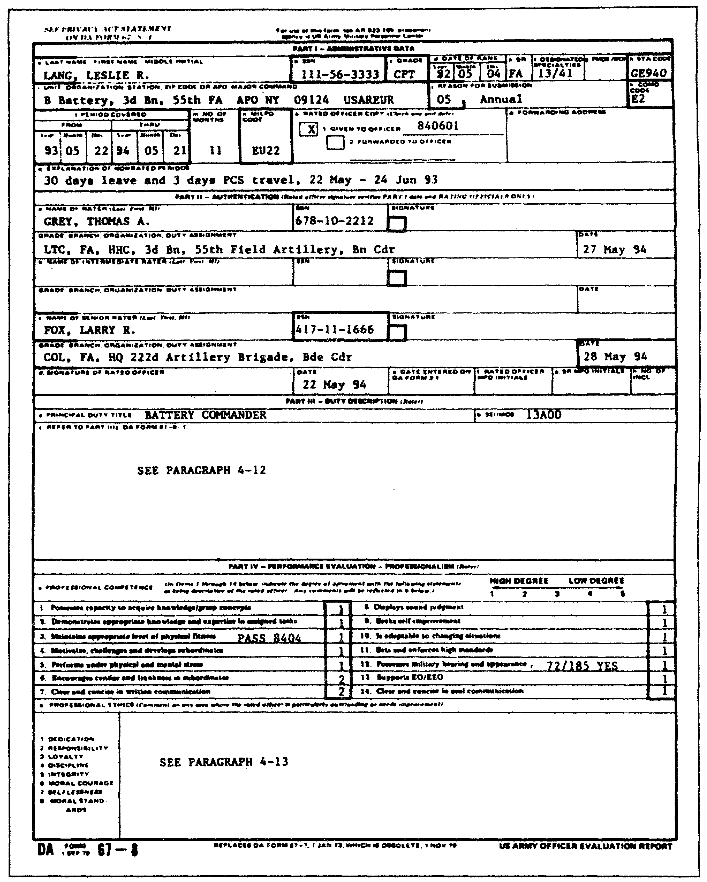

Figure 5-5. DA Form 67-8 (front).

5-29 QM3517

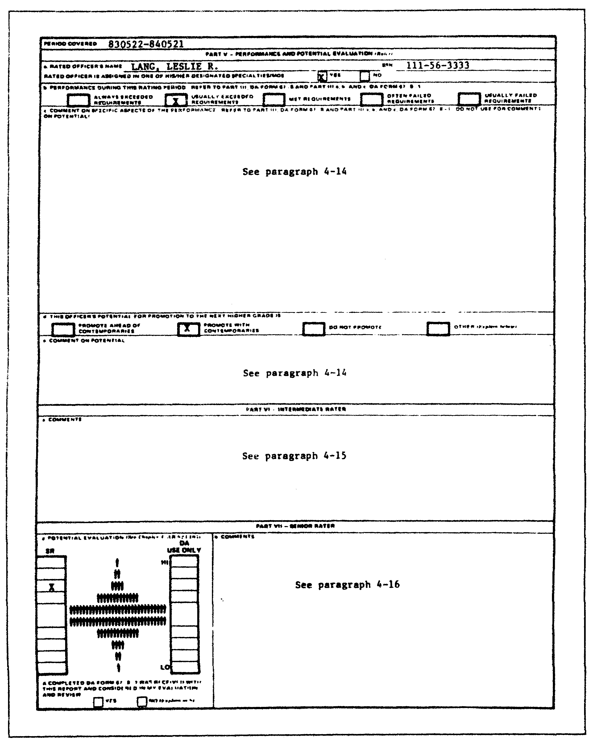

Figure 5-6. DA Form 67-8 (back).

QM3517 5-30

Each part of DA Form 67-8 asks for a different type of information. The following paragraphs outline each part of a DA Form 67-8 to show you how to spot these types of errors easily when you review DA Form 67-8.

4. Part I--Administrative Data.

Part I of DA Form 67-8 contains information that applies to the rated officer, the rating period, and the reason for submitting the report.

The servicing PSC or the administrative office completes Part I. When the PSC prepares the officer's DA Form 67-8, it uses his ORB for much of the data.

a. Rating Periods. Refer to the following subparagraphs and bullets for an explanation as to how to compute the evaluation period. The following subparagraphs and bullets also explain how to compute nonrated periods and the number of rated months.

(1) Period Covered. The "Period Covered" (item 1 on DA Form 67-8) is the period which extends from the day following the "Thru" date of the last report to the date of the event which causes the report to be written.

(a) Rating Period. The rating period is that period within the "Period Covered" during which the rated officer serves in the same position under the same rater who is writing the report. The "Period Covered" and the rating period always end on the same date (the "Thru" date). However, the beginning date of the rating period may not be the same as the beginning date of the "Period Covered" (the "From" date). For example, an officer who departs on PCS on 1 July receives a change-of-duty report with a "Thru" date of 30 June. After five days of travel and 20 days on leave, he reports for duty. He receives a change of-duty report. The "Period Covered" on this report is 1 July ("From") to 31 Oct ("Thru"). However, the rating period is from 26 July to 31 October. The entry for this example would be "26 July to 31 October". The entry for item "q" would be "25 days PCS leave and travel" or "25 days Casual".

(b) Nonrated Period. Determine nonrated periods by the status of the rated officer. There are three types of nonrated periods. Refer to the following bullets and Figure 5-7 for descriptions of these three nonrated periods.

o Periods, regardless of the number of days, between the date that an officer departs one duty position and begins performance in a new duty position.

5-31 QM3517

o Periods, regardless of the number of days, spent performing in a duty position during which the rated officer or the rater DOES NOT meet the minimum requirement for a report to be rendered. This includes periods that are spent at a school for which an academic evaluation report is NOT required. In the example in subparagraph 4a(1)(a) of this part of this lesson, if you had changed duty on 1 October rather than on 1 November, then the period 26 July to 30 September also would be nonrated. The entry for item "q" would be "25 days PCS leave and travel; 67 days change of duty".

o Periods which total 30 or more consecutive days that occur during the rated period and that are spent on leave; AWOL; in the hospital; in confinement; or under arrest. Periods which total 30 or more consecutive days that occur during the rated period and that are spent in any of the following ways also are nonrated periods: on permissive TDY; on TDY or SD serving as a member of a DA selection board or court-martial. Periods which total 30 or more consecutive days that occur during the rated period and that are spent in any of the following ways also are nonrated periods: on TDY or SD attending a course of instructions scheduled for fewer than 60 calendar days; or attendance at Combined Arms Service and Staff School (CAS³).

NOTE: With the exception of CAS³, attendance at a career progression course of any length is rated on an academic evaluation report in accordance with AR 623-1 (Academic Evaluation Reporting System). The same procedure applies to attendance at other courses that are more than 60 days in length.

All other periods of TDY or SD other than those involving service as a member of a DA selection board or a court-martial or attendance in a course of instruction which is scheduled to last fewer than 60 calendar days are rated periods. (Refer to Figure 5-8.)

QM3517 5-32

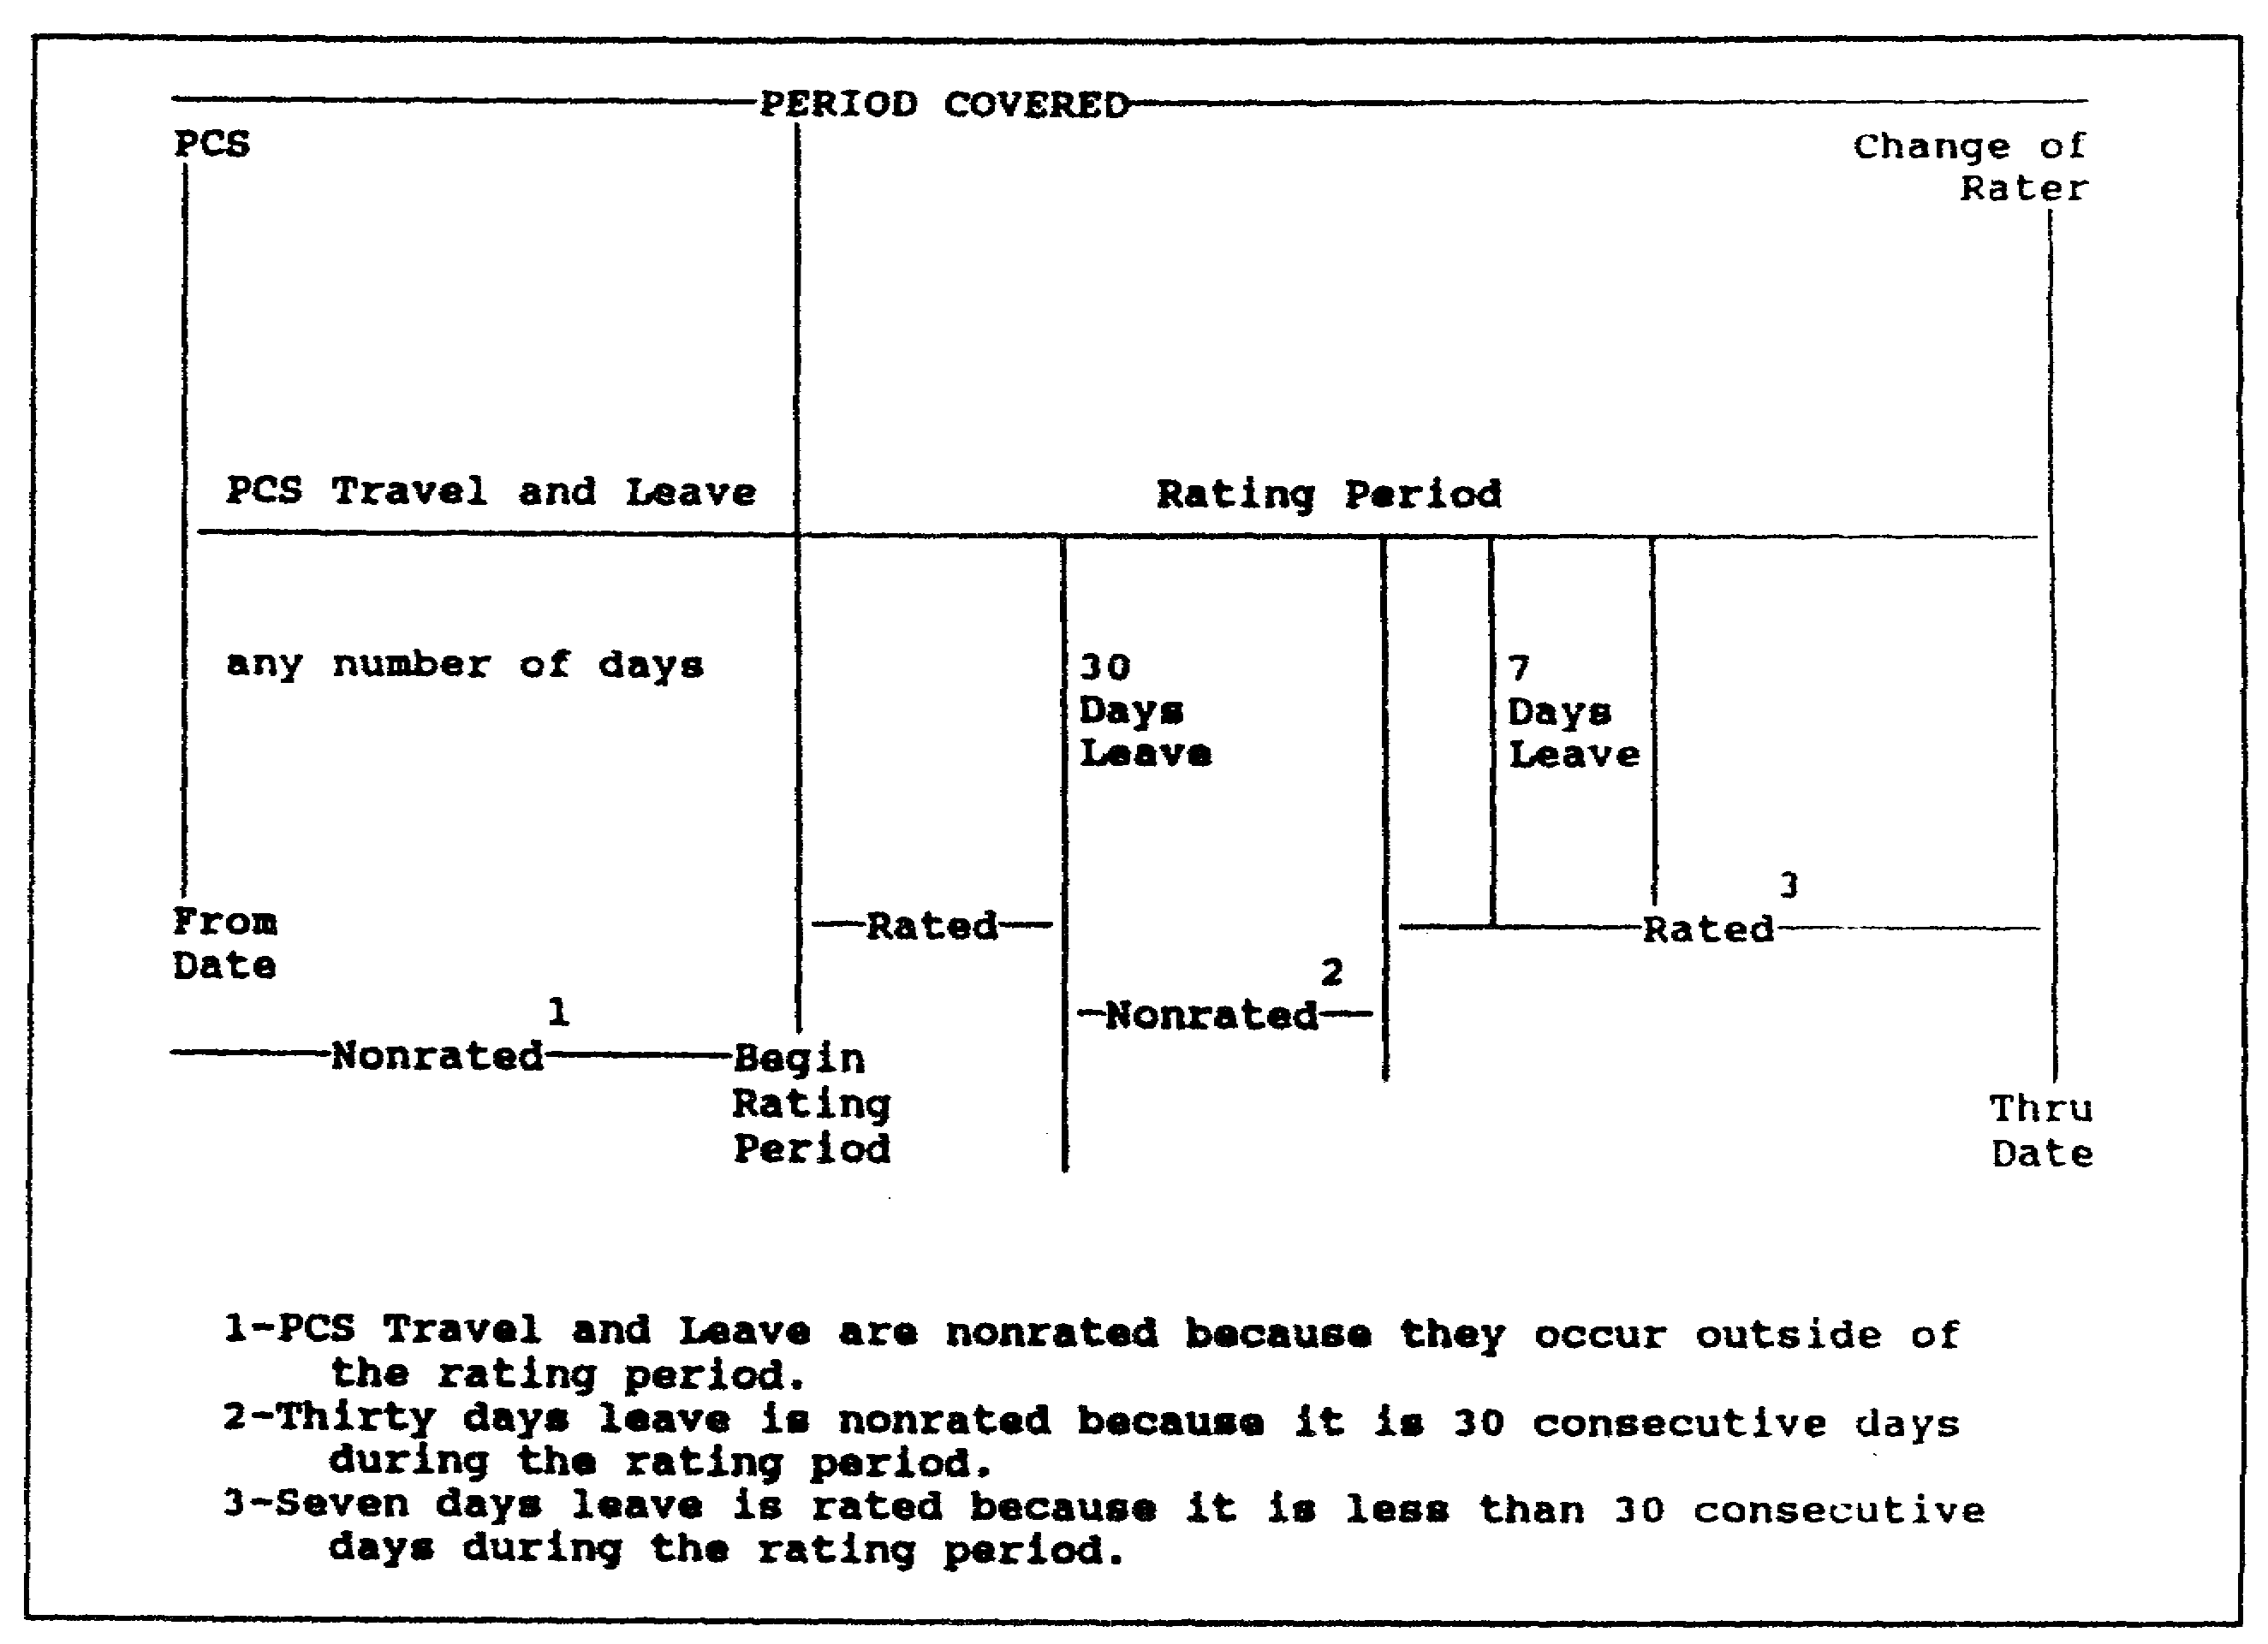

Figure 5-7. Example of nonrated periods.

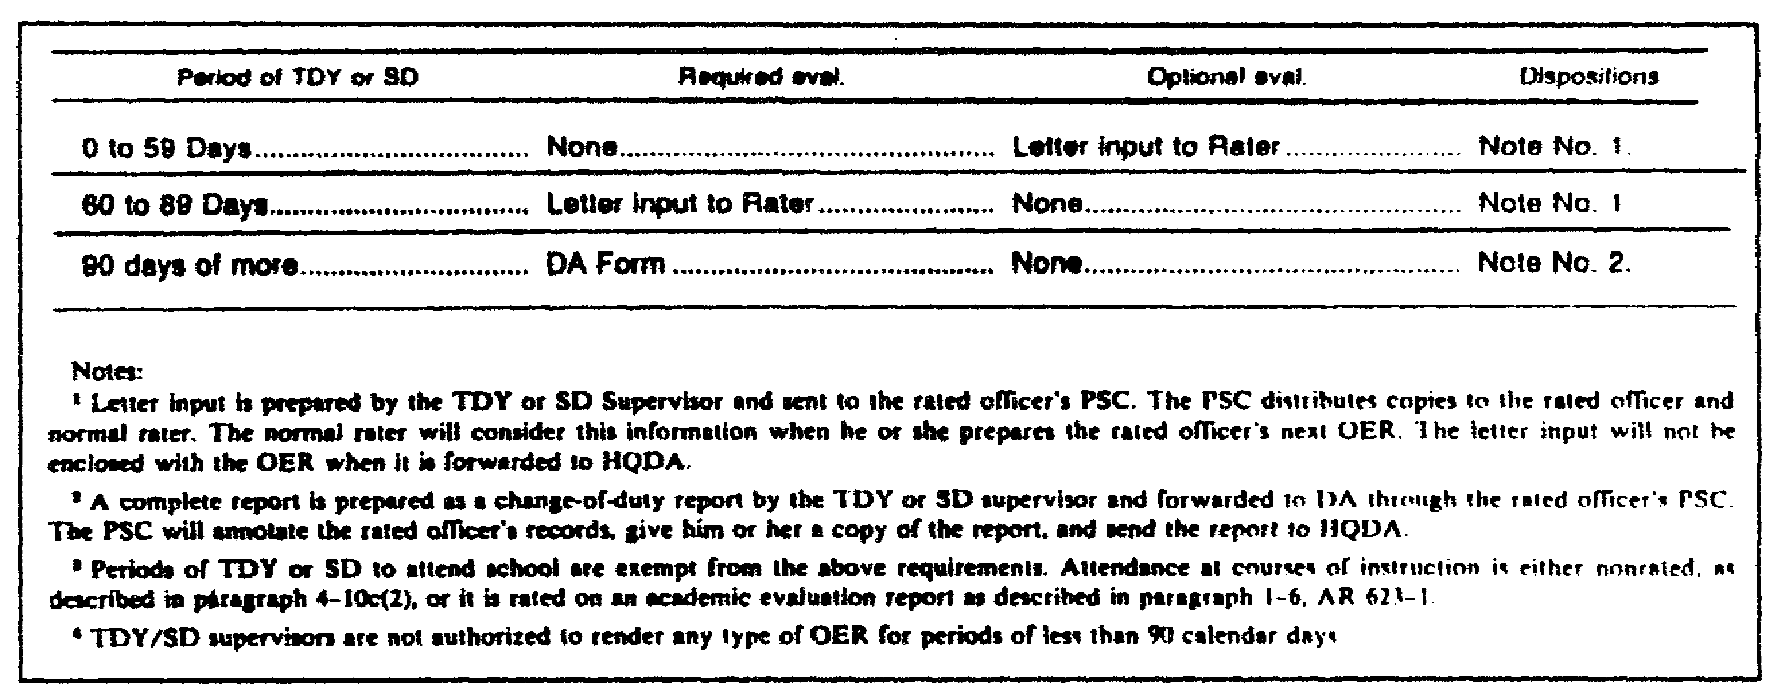

Figure 5-8. Temporary duty and special duty not related
to principal duty (other than TDY to attend school).

5-33 QM3517

(2) Computation of Number of Days Needed f or a Report. To determine whether the rated officer has the number of days that are needed for a report, determine the rating period. Count the number of the calendar days that the rated officer has served under his present rater in his present position since the beginning of the rated period. Deduct from this total all the nonrated periods of the type that is described in the third bullet in subparagraph 4a(1)(b) of this part of this lesson. DO NOT count nonrated periods that occurred prior to the rating period. If the resulting number of days is equal to or greater than the minimum number of days needed for a report, then a report may be submitted.

(3) Computation of the Number of Rated Months. Compute the number of the rated months (item "m", Part I, of DA Form 67-8). To do so, divide the basic rating period (subparagraph 5a(1)(c) of this part of this lesson) by 30. DO NOT use the "Period Covered" by the report. If 15 or more days are left after dividing by 30, count them as a whole month. For example, 130 days is four months; 140 days is four months and 20 days, and is entered as five months.

b. Entries. With the exception of items "o" and "p", you must complete all the following items before you send the report to the rated officer for authentication. Refer to the following subparagraphs for detailed instructions concerning each entry.

(1) Items "a" and "b"--Name and SSN. This is self-explanatory. Capitalize the name.

(2) Item "c"--Grade. Enter an authorized abbreviation of the rated officer's grade--for example, "CPT" or "LTC". The rated officer may have been selected for promotion and may be serving in an authorized position for the grade to which he is to be promoted. If this is the case, then enter a "P" next to his current grade--for example, "CPTP" or "LTCP". If the rated officer is NOT assigned to a position authorized the higher grade, then DO NOT use the "P". The rated officer may have been frocked to a higher grade and may be serving in an authorized position for the grade to which he has been frocked. If so, then enter the frocked grade. If the rated officer has been frocked to a higher grade and is NOT yet serving in an authorized position requiring the higher grade, then enter the lower grade.

(3) Item "d"--Date of Rank. Enter the date of rank for the grade in which the rated official is serving as of the "Thru" date of the report. The rated officer may have been frocked to a higher grade and may be serving in an authorized position for the grade to which he has been frocked. If so, then enter the effective date of the frocking. If the rated officer has been frocked to a higher grade and is NOT yet serving in an authorized

QM3517 5-34

position requiring the higher grade, then enter the date of rank of the lower grade.

(4) Item "e"--Branch. Enter the appropriate basic branch abbreviation. For general officers (GO), enter "GO". For WOs, enter the HQDA Management group-for example, "MM" or "GA".

(5) Item "f"--Designated Specialties. Enter the codes which identify the commissioned officer's designated branch, functional area, or skills. For special branch officers, enter the officer's primary specialty skill identifier. For GOs, enter "OOB".

(6) Item "g"--PMOS. Enter the primary military occupational specialty (PMOS) for WOs.

(7) Item "h"--Station Code. Enter the code for the rated officer's station.

(8) Item "i"--Unit Organization Station, Zip Code or APO, Major Command. This is self-explanatory.

(9) Item "j"--Reason for Submission. Enter the code and the reason for which the report is being submitted. For a list of these codes, refer to the extracts of AR 623-105, Appendix K. These extracts are in Appendix B at the end of this subcourse.

(10) Item "k"--Command Code. Enter the code for the rated officer's MACOM. For a list of these codes, refer to the extracts of AR 623-105, Appendix K. These extracts are in Appendix B at the end of this subcourse.

(11) Item "l"--Period Covered. The "From" date is the day following the last day ("Thru") in the preceding report. The "Thru" date is the date of the event that is the reason for the report except for change-of-duty and change-of-rater reports. The "Thru"' date on a change-of-duty or a change-of-rater report is the day before the change. For rated officers who sign out on terminal leave, the "Thru" date is the date prior to the day that the terminal leave begins.

(12) Item "m"--Number of Rated Months. Enter the number of the rated months. This is computed by dividing the basic rating period by 30. DO NOT use the "Period Covered" by the report. If 15 or more days are left after dividing by 30 count them as a whole month.

(13) Item "n"--military personnel center (MILPO) Code. Enter the four-character alphanumeric PSC code of the rated officer's servicing PSC.

5-35 QM3517

(14) Item “o”--Rated Officer Copy. Check the box that indicates the disposition of the rated officer's copy of the report.

(15) Item "p"--Forwarding Address. Enter the forwarding address provided by the rated officer if he left before getting a copy of the completed DA Form 67-8.

(16) Item "q"--Explanation of Nonrated Periods. List and explain all nonrated periods. Ensure that your entries describe each nonrated period--for example, "890701-890815, casual"; "890816-890920, leave". Individual periods of 90 days or more (60 for school) normally require a report. Provide a full explanation of such periods-for example, "891001-891205, CAS³".

(17) Part I Review. While you review DA Form 67-8, compare the entries in Part I with the information that is contained in the ORB. The following data should be the same. They should be entered correctly on DA Form 67-8:

o Name.
o SSN.
o Grade.
o Date of rank.
o Branch.
o Designated specialties.

Review the first line of DA Form 67-8. Compare the data in the ORB with the entries in Part I. The reason for submitting DA Form 67-8 may be due to a change of rater. You can find the date on the ORB. Section X ("Remarks") of the ORB may show that the Army is reassigning someone's rater. The unit is responsible for informing the PSC. However, the PSC tracks anticipated changes (PCS or retirement) on a suspense log. The "From" date is the day after the last report ended. The "Thru" date is the day prior to the event that causes the report. Thus, the "Thru" date is the day before the change in rater. Your review should show that the "From" date matches the information contained in the ORB and that the "Thru" date is correct for the change of rater.

Refer to the extracts of AR 623-105, Appendix K. These extracts are in Appendix B at the end of this subcourse. They contain the "Codes for Use with the DA Form 67-8". Use these codes to match the numerical code with the correct stated reason.

Now, compare the "Date of Last OER" shown in the ORB for the officer to item 2 in his DA Form 67-8. (Look directly under Section VIII of the ORB.)

QM3517 5-36

Because DA-Form 67-8 is an annual report, the "Thru" date is one year from the "From" date, less one day.

If there were any nonrated periods, enter them in item "q" of DA Form 67-8. List nonrated periods in Section X ("Remarks") of the ORB. For example, if an officer had been delayed en route to a new assignment from 931220 to 931231, then make the following entry:

12 days delay en route - 20 Dec 93 - 31 Dec 93

You may enter dates a in day-month-year format or in a year-month-day (YYMMDD) format.

To determine the number of the months that are covered by the rating period, subtract the number of nonrated days from the total number of days covered in the period.

In figuring days, use the Julian calendars shown in Figure 5-9 and Figure 5-10. Refer to the Julian calendars to determine the number of days in item "1". Since the two dates are in different years, perform your calculation in two parts.

Now, review item "m" of Part I of DA Form 67-8. Is the number of the months correct?

Compare the entries that are shown in Section X ("Remarks") of an
officer's ORB with item "1" of his DA Form 67-8.

You can incorrectly write entries which contain numbers. You may transpose the numbers, place entries in the wrong block, or omit them. When reviewing Part I, check items "b", "d", "f,", and "h". Each of these items contains numbers.

Ensure that items "a", "b", "c", "d", "e", and "f" are correct. Item "g" may be blank because an officer is NOT a WO. For item "h", you can find the rated station code in the following documents:

o AR 525-1.
o DA Pamphlet 525-12.
o DA Pamphlet 525-13.

Now, review the second line of an officer's DA Form 67-8. Item "i" asks for the following information:

o Unit.
o Organization.
o Station.
o Zip Code (or APO).
o MACOM.

5-37 QM3517

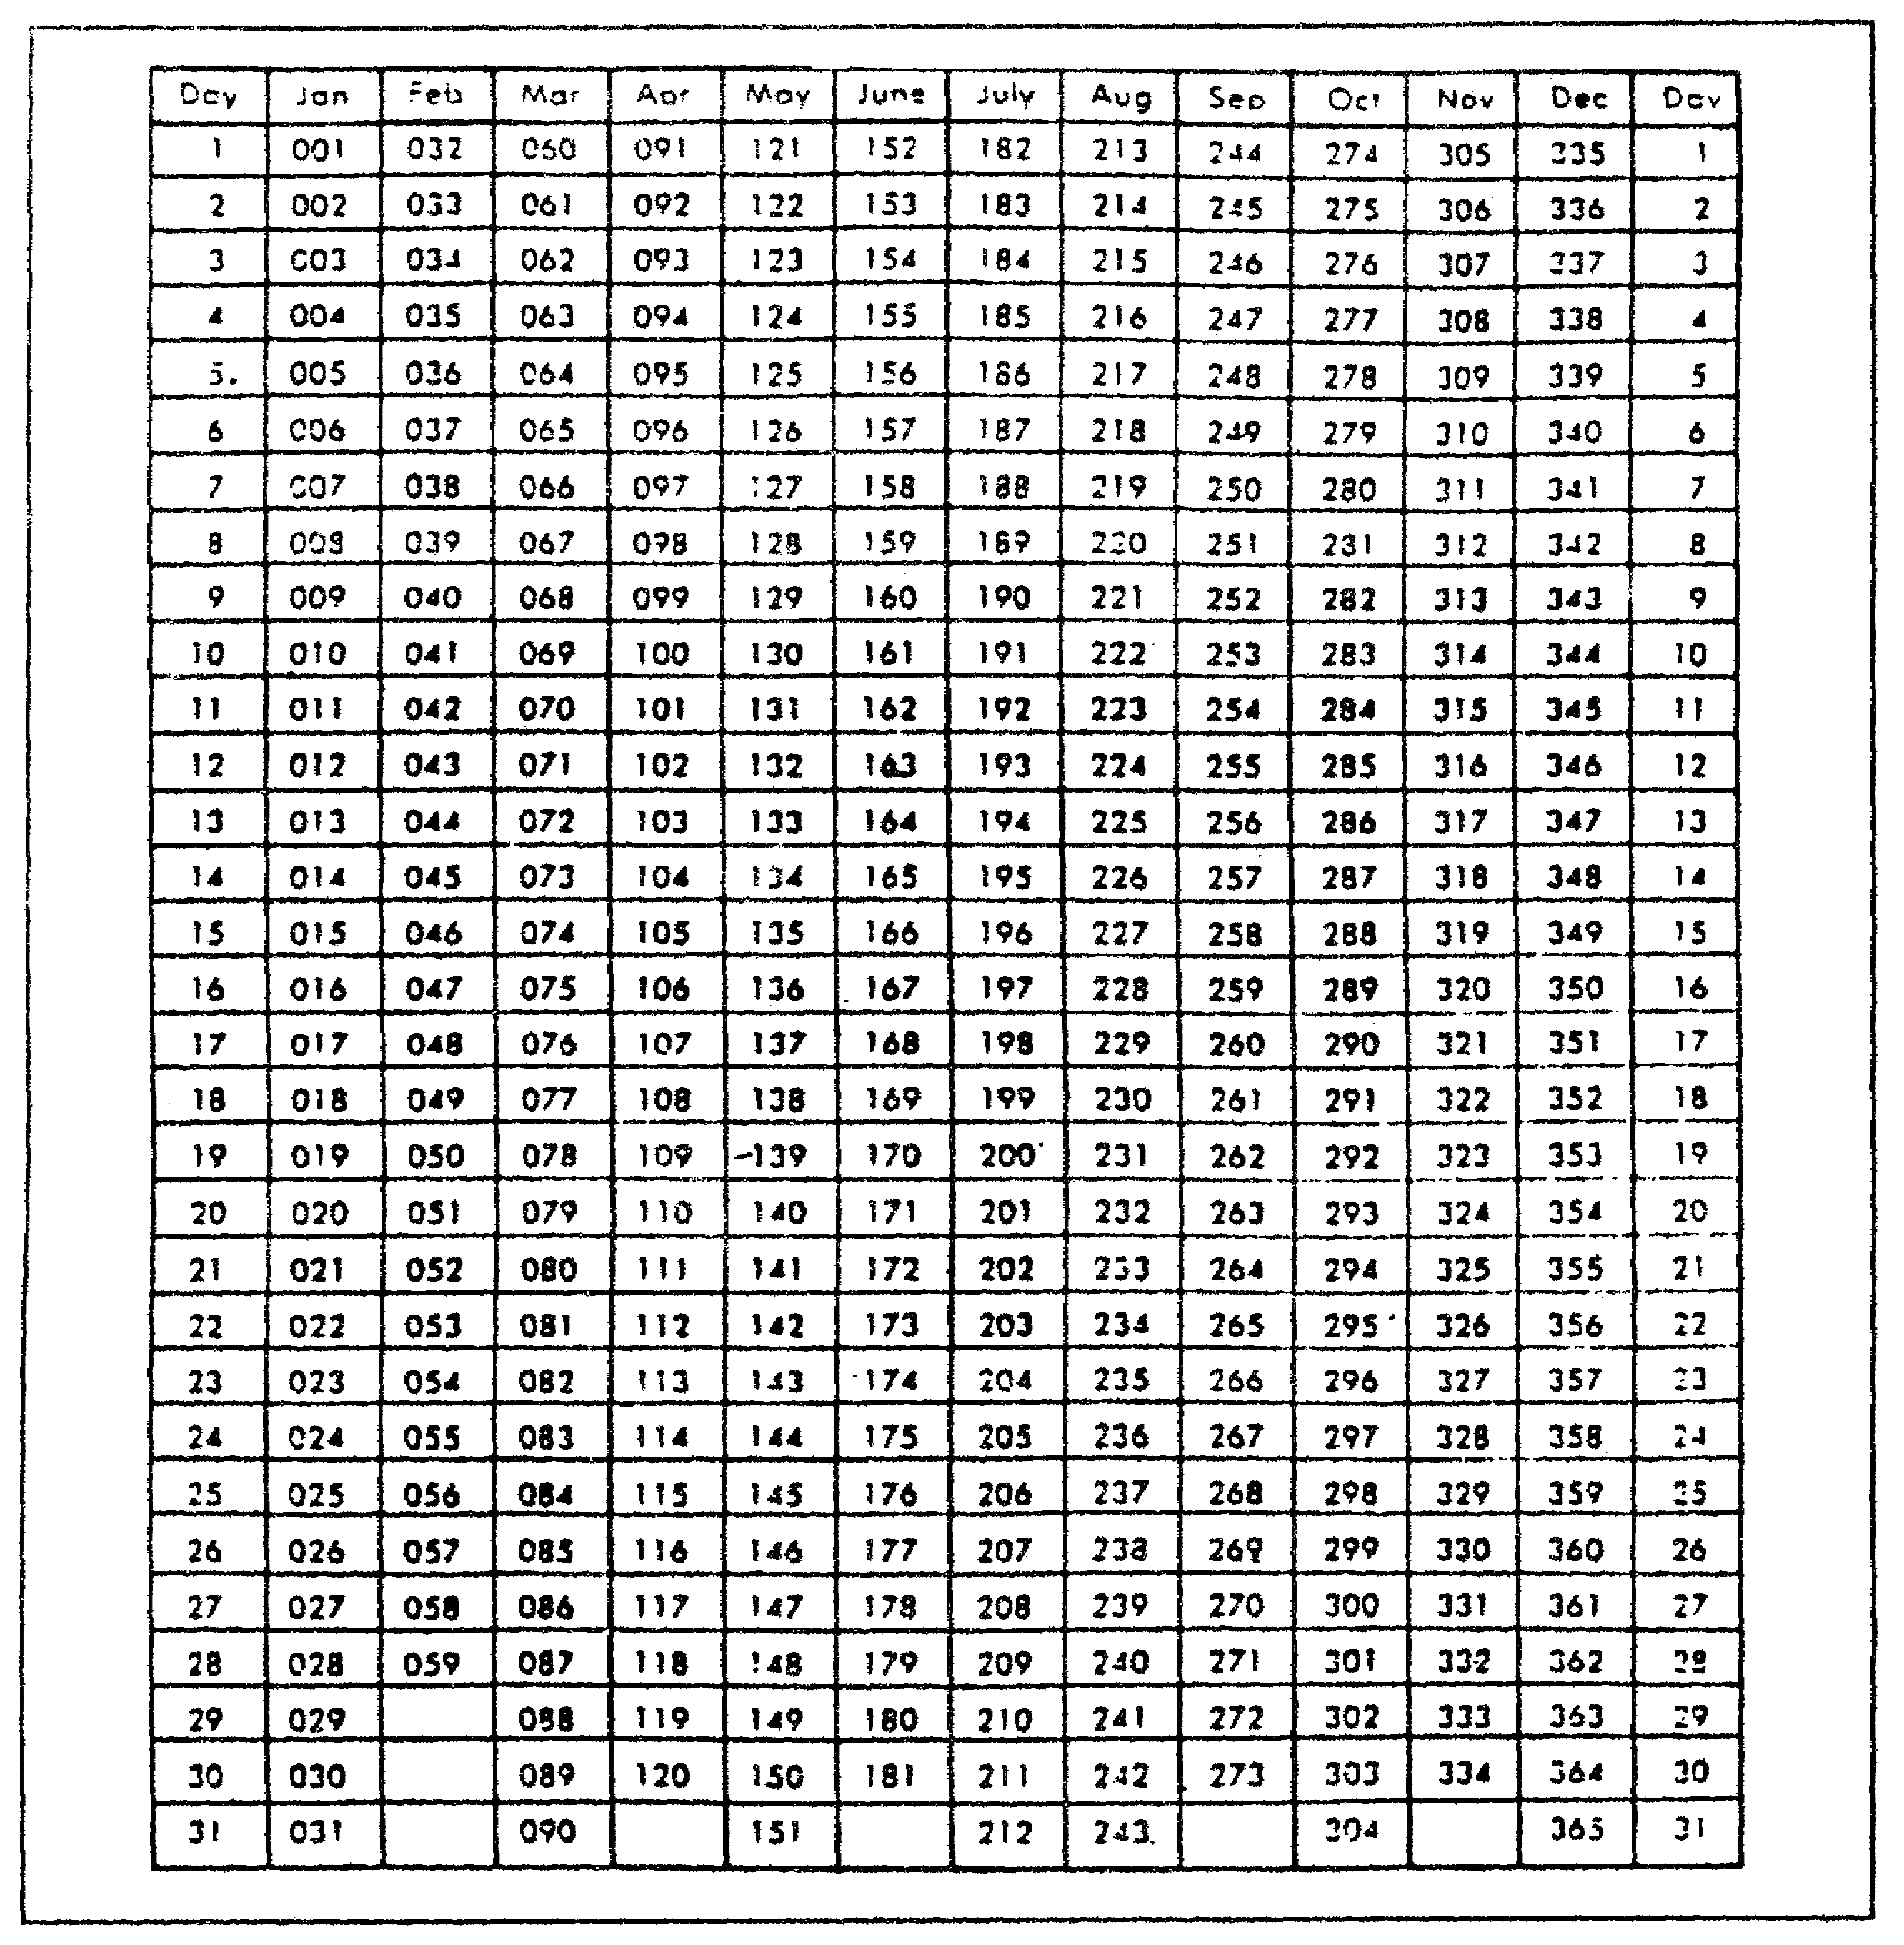

Figure 5-9. Julian date calendar (perpetual).

You can find this information in Section IX of the ORB.

Item "j" contains a numeric code and a written reason for submitting DA Form 67-8. Always verify that the code matches the stated reason for the evaluation. AR 623-105, Appendix K, lists the numeric codes and a brief description of the reason for submitting the reports.

QM3517 5-38

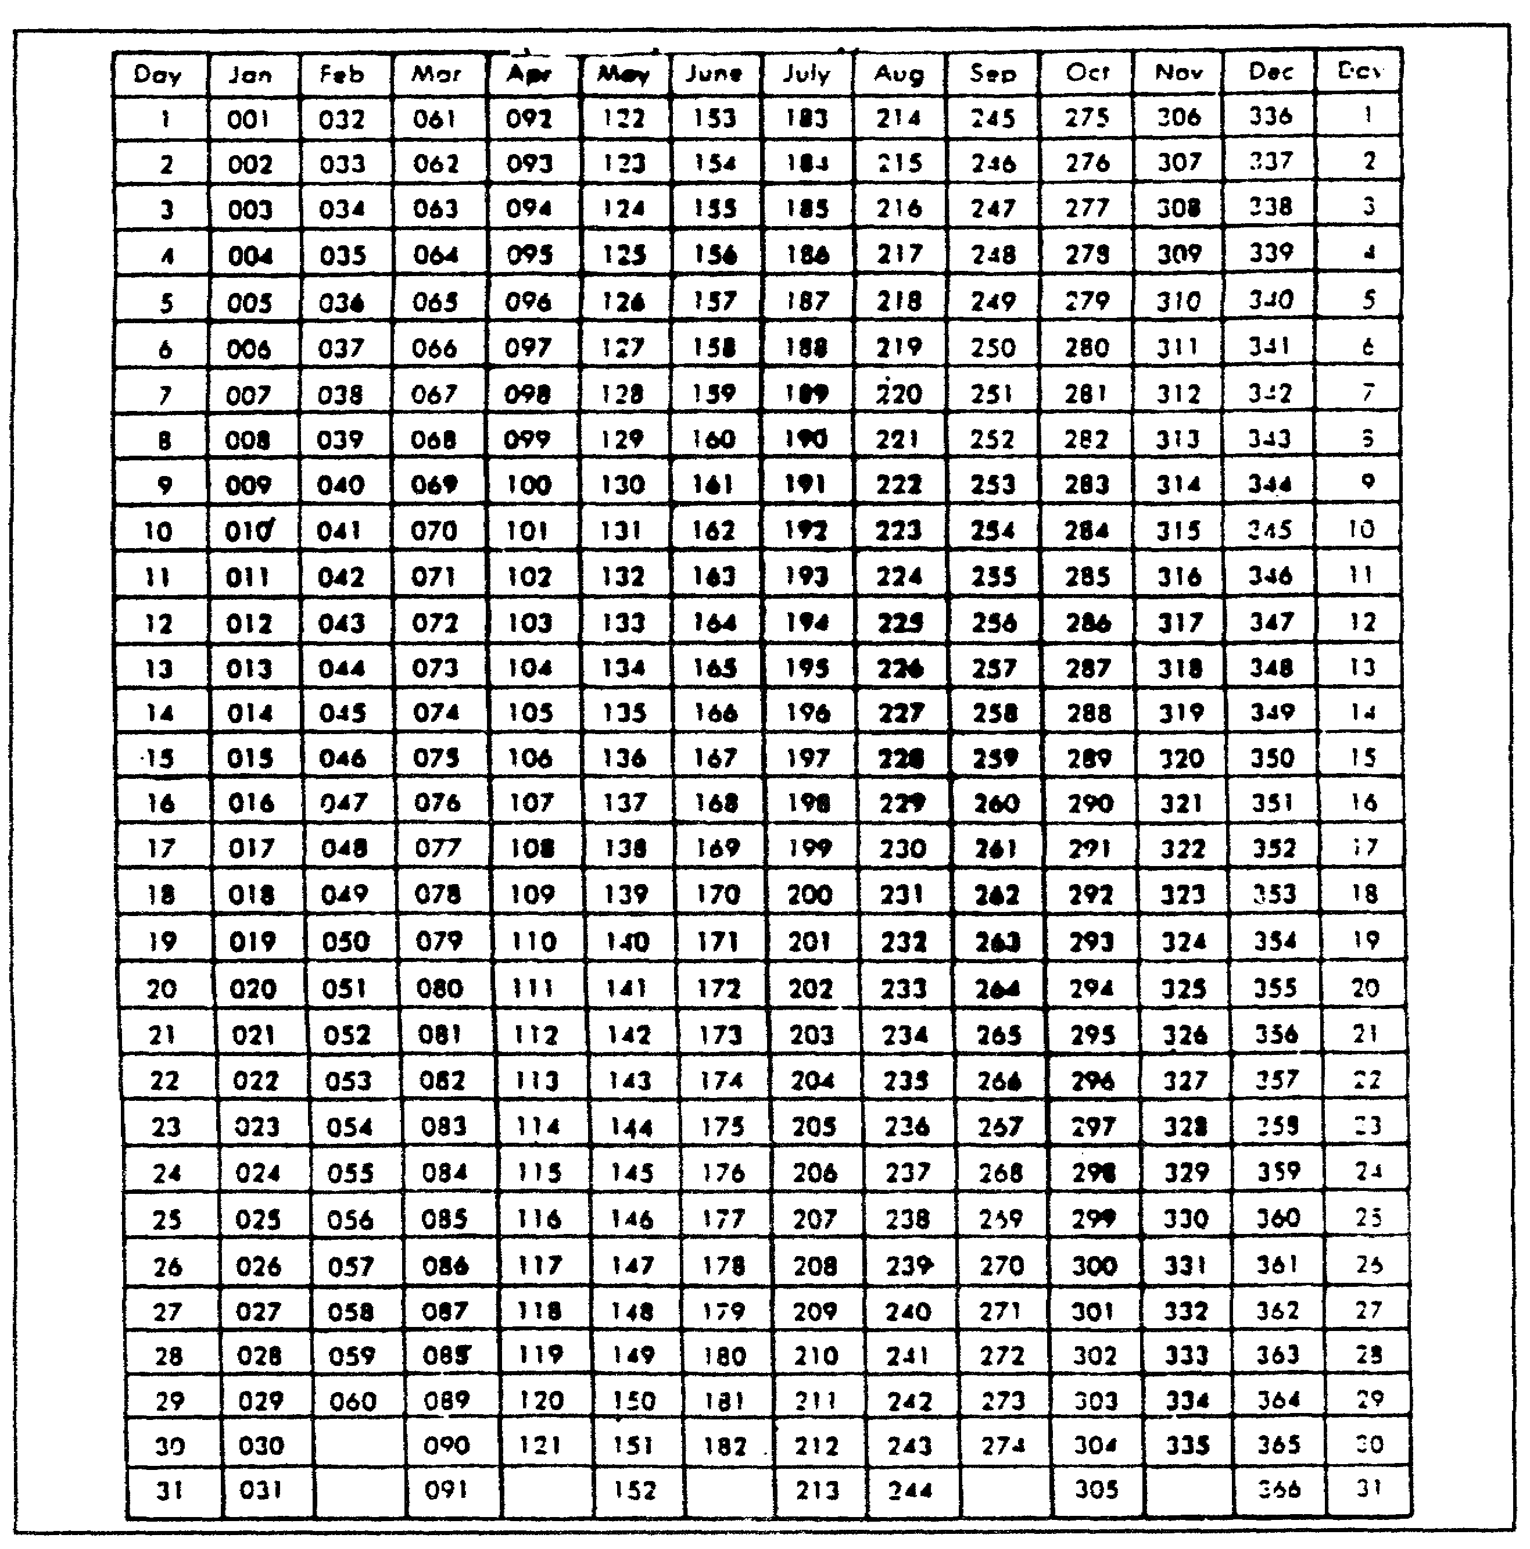
Figure 5-10. Julian date calendar (for leap years only).

Now, compare item "j" of DA Form 67-8 with the extracts of AR 623-105, Appendix K. These extracts are in Appendix B at the end of this subcourse. Are the entries in item "j" correct?

Enter the MACOM code in item "k". To verify MACOM codes, use AR 680-29 (Military Personnel, Organization, and Type of Transaction Codes). Check items 1 and "q" to ensure that the information is correct. AR 623-105, Chapter 4, Section III,

5-39 QM3517

discusses in detail how to determine the period that is covered. You can verify the date that is entered in the "From" block by comparing it with the date that is entered in the ORB.

Now look at item "1" of the officer's DA Form 67-8. Determine whether you correctly have entered the period that is covered. Compare it to the date of the last report on the ORB. The "From" date should be the day following the last day of the last report. The "Thru" date in item "1" is the day prior to the event that caused the report.

Now, make sure that you have entered the correct MILPO code in item "n". You can find these four-character codes in AR 680-29.

Check items "o" and "p". If the officer is given a copy of his completed DA Form 67-8, then box 1 will have a check mark. There should be no entry in item "p". However, if the rated officer leaves his command before the unit completes the DA Form 67-8, then there should be a check mark in box 2 of item '"o". Check to make sure that you have entered a correct forwarding address in item "p".

5. Part II--Authentication.

The rater and the rated officer use Part II for authentication after each completes his parts of the form at the end of the rating period. Authentication data are NOT entered for a nonparent-unit supervisor who is submitting a letter-report enclosure in accordance with the following subparagraphs. Refer to the following subparagraphs for details concerning this part of DA Form 67-8:

a. Filled Out By Personnel. The PSC or the administrative office fills out Part II by entering the names, ranks, positions, and SSNs of the rating officials. It is important that the information contained in Part II is accurate.

The PSC ensures that the data that identify the rating officials are accurately entered on the report. It also ensures that duty assignment entries show position titles. All grade entries must be current (as of the "THRU" date) grades and a "P" must be added, if appropriate. A "P" is added to the senior rater's grade only if he is in an authorized position for the grade to which he is promoted. A rating official who has been frocked to a higher grade and who is serving in an authorized position for which he has been frocked enters the frocked grade.

Rating officials make entries which differ with regard to various conditions. Refer to the following subparagraphs for details concerning these entries.

QM3517 5-40

Authentication data are NOT entered for a nonparent-unit supervisor who is submitting a letter-report in accordance with subparagraph 5b of this part of this lesson.

b. Exception to Authentication Data Entry Requirement. It may not be practical to designate a nonparent-unit supervisor as the rater. In this case, the intermediate rater, the senior rater, and the nonparent-unit supervisor submit written comments concerning the rated officer's duty performance to the designated rater. These comments address that portion of the rated officer's duties that the nonparent-unit supervisor directs. The nonparent-unit supervisor prepares these comments as described in the following bullets:

o Prepare enclosures for attachment to an OER in the format that is shown for letter reports in AR 623-105. Limit the enclosure to one page.

o In paragraph one of the letter, state that the enclosure is being submitted because the rated officer is serving under dual supervision as described in AR 623-105, paragraph 3-18.

o In paragraph two of the letter, describe that portion of the rated officer's duties and responsibilities that were supervised by the nonparent-unit supervisor.

o In paragraph three, describe any particular strengths or weaknesses in professionalism that the rated officer displays.

o In paragraph four, describe the rated officer's performance with regard to the requirements of the duty position.

o In paragraph five, describe the rated officer's potential for service in positions of greater responsibility at higher grades.

The nonparent-unit supervisor attaches his comments as an enclosure to the evaluation report. He evaluates only if he has been a designated member of the published rating chain for at least 90 calendar days prior to the "Thru" date of the report. If the dual supervisor has NOT been in the position for the 60-day period that is required to evaluate, then the senior rater, in his review capacity, so indicates in Part VIIb.

c. The Verifying of Signatures. The rated officer enters his most recent APFT performance and height and weight data in Part IV. He then signs and dates the report before sending it to

5-41 QM3517

the rater. The rated officer's signature verifies the accuracy of the following information:

o Administrative data in Part I (except item "o").
o Rating officials in Part II.
o APFT and height and weight data in Part IV.

This action increases the administrative accuracy of DA Form 67-8 since the rated officer is most familiar with, and interested in, this information. Confirmation of the administrative data normally precludes an appeal by the rated officer based on inaccurate administrative data. The rated officer may sign the report before the "Thru" date of the report.

d. No Signature. If the rated officer is unable, or fails, to sign DA Form 67-8 because of administrative inaccuracy, then the senior rater resolves the problem. If it cannot be resolved satisfactorily, then the senior rater explains why in Part VIIb of DA Form 67-8. If the rated officer signs the report after any of the rating officials, then the senior rater must explain the reason for this in Part VIIb. However, DO NOT delay the report if it lacks the rated officer's signature.

e. Rating Officials' Signatures. Each rating official signs and dates the report before sending it to the next rating official or to the HQDA. Their signatures verify all the entries on the form at the time of their respective signatures. The date entered may NOT be prior to the "Thru" date or the date of the rated officer's, or any preceding rating official's, signature.

f. "X" in Small Box. Rating officials who sign the form but give no rating or who submit their evaluation on a letter report place an "X" in the small box on the left side of their respective signature blocks. Otherwise, this block is left blank. This box controls the computer editing of DA Form 67-8 at HQDA and has nothing to do with the rating.

NOTE: After the report is completed, the PSC ensures that the rating officials have signed the report. The PSC advises the appropriate rating officials of any discrepancies before further processing.

g. Items "e" through "h"--PSC Responsibilities. Leave item "e" blank. The rated officer's military personnel officer enters his initials in item "f" before forwarding DA Form 67-8 to HQDA. This entry attests that the report has been reviewed administratively. Item "g" is for the initials of the senior rater's PSC. Item "h" indicates the total number of enclosures.

QM3517 5-42

h. Review of Part II. To review a DA Form 67-8 for correct entries regarding the rating chain requires knowledge of the types of errors for which to look. Several types of errors may occur:

o Entering the wrong rater and senior rater names.
o Entering the correct names, but in the wrong blocks.
o Entering signatures in the wrong blocks.
o Entering incorrect signature dates.

These types of errors do occur, but not often.

The first step in reviewing Part II of DA Form 67-8 is to find, on the rating chain, the name of the officer whom you are rating. Once you find his name, locate the rater's name and the name of the senior rater.

The rating chain shows who should complete each part of DA Form 67-8.

Now, check Part II of DA Form 67-8 against the rating chain to find out whether the rater's name, the name of the intermediate rater, and the name of the senior rater are entered correctly.

NOTE: An actual rating chain should include the dates on which the unit assigned each officer as a rating official.

Ensure that the rater's name, the name of the intermediate rater, and the name of the senior rater are entered in the correct block in Part II.

If the rater requires a referral, then the senior rater refers the completed report to the rated officer for acknowledgement and comment before sending it to the HQDA. The rated officer acknowledges the receipt of the referral letter and indicates whether the rating or the remarks are incorrect. Ensure that the comments are factual and concise. Limit the comments to matters that relate directly to the evaluation on DA Form 67-8.

The rated officer's comments DO NOT constitute an appeal or a request for a commander's inquiry. If the senior rater decides that the comments may affect the rated officer's evaluation, then he may refer them to other rating officials.

In addition to checking Part II for correct names and signatures, check the following information of both the rater and the senior
rater:

o Grade.
o Branch.

5-43 QM3517

o Organization.
o Duty Assignment.

You can find this information on DA Form 67-8-1 and the published rating chain.

Notice that there is a small box to the left of each rating official's signature. Use this box only under the following conditions:

o The rating official is signing the form, but is NOT giving a rating.

o The rating official is submitting the rating on a letter report.

Otherwise, leave the box blank.

Rating officials must sign and date the report before sending it to the next rating official or to the HQDA. Their signatures verify all the entries on the form at the time that they signed the document. Ensure that the date that is entered is NOT prior to the "Thru" date or the date of the rated officer's, or any preceding rating official's, signature.

Leave blocks "e" through "g" in Part II blank. The PSC completes these blocks.

6. Part III--Duty Description.

Ensure that Part III is completed. It is based on the rated officer's entries on DA Form 67-8-1, if appropriate. Part III begins the evaluation of the rated officer's job.

a. Items "a" and "b"--Principal, Duty Title and Specialty Skill Identifier or Military Occupational Specialty. In item "a", the principal duty title is entered. It shows the type of the work that is required rather than frequently changing tasks. In item "b", the position requirement code which identifies the rated officer's duty position is entered. This entry contains, as a minimum, the first five characters of the position requirements code; seven characters if an additional skill identifier (ASI) is required; or nine characters if a language identification is needed.

b. Item "c"--Refer to Part IIIa of the DA Form 67-8-1. In item "c", the rated officer's duties and responsibilities are described in detail. The descriptions must be clear and concise. They must emphasize the specific functions that are required of the rated officer. Conditions that are peculiar to the assignment are to be noted. For example, active component

QM3517 5-44

officers who are assigned to full-time support duties with RC units or RC officers who are assigned to active units often perform functions which are peculiar to that duty. In order to ensure due consideration of these factors, these conditions are noted in the duty description. As a minimum, the description includes the principal duties and significant additional duties. When a WO is serving in a commissioned officer position, the approval authority from HQDA is cited in Part IIIc
(AR 611-112, paragraph 1-7e).

Part IVa of DA Form 67-8-1 should help in the completion of this section.

When an officer is serving under dual supervision, the statement "Officer serving under dual supervision" must be entered as the first line of the duty description. If the nonparent-unit supervisor gives his evaluation in a letter report, then the first line of the duty description states: "Officer serving under dual supervision, enclosure attached". If the nonparent-unit supervisor is NOT providing an enclosure, then the duty description is to be developed jointly by the supervisors in each chain of command.

c. Reviewing Part III. In reviewing Part III, ensure that the following actions are taken:

o All blocks and items are completed.

o There are no spelling or typographical errors.

o Excessive abbreviations and acronyms have been avoided. Members of a promotion board will not all be from the rated officer's branch. Therefore, they may not know the branch-specific acronyms.

For example, entries in certain areas of Part III may be missing. Scan areas carefully to make certain that officials have made an entry in each block.

According to AR 623-105, paragraph 4-12, the duty description of Part III of DA Form 67-8 is based on the rated officer's entries on DA Form 67-8-1, if appropriate. The duty description is an outline of the normal requirements of a specific duty position. It shows the type of the work that is required rather than frequently changing tasks.

7. Part IV--Performance Evaluation.

The rated officer and the rater complete Part IV of DA Form 67-8. The rater evaluates the rated officer's professional competence and ethics.

5-45 QM3517

Complete Part IV of the DA Form 67-8, except for the APFT entry in Part IVa, item 3, and the height and weight entry in Part IVa, item 12. The rated officer enters (typed) these data, as shown in Figure 5-5. For example, item 3 may have "PASS 8404" and item 12 may have "72/185 YES".

Part IV lists those attributes that define professionalism for the Army officer. These attributes apply across all grades, positions, branches, and specialties. They are the professional ethics that are needed to maintain public trust and confidence and the qualities of leadership and management that are needed to maintain an effective officer corps. These attributes are on DA Form 67-8 to emphasize and reinforce professionalism.

a. Block "a"--Professional Competence. Indicate, on a scale of 1 to 5 (1 being high), how well each statement describes the rated officer. Place any comments on strengths or weaknesses in the comments part of block "b". Comments, if provided, must refer to a specific attribute. A sample reference is "(a.5) This officer's calm, confident manner sets the example for his soldiers". Note exceptional or unsatisfactory performance in the comments part of block "b". These rater comments are mandatory to explain or to clarify ratings of 4 or 5 in Part IVa. The rater's comments are required for certain entries that are related to APFT or height and weight entries.

When the rated officer has no subordinates, place "NA" in item 4 and item 6. These are the only items which may reflect "NA". In item 13, rating officials consider the extent and the effectiveness of an officer's involvement in, and support for, equal opportunity (EO). Support for Equal Employment Opportunities (EEO) applies when the rated officer has equal employment opportunity responsibilities. For example, he is able to influence personnel actions affecting Army civilian employees. Actions to consider include the following:

o Commitment to affirmative action goals.
o Procedures for selection, assignment, and training.
o Procedures for recognition and discipline.
o Procedures for grievance handling.

b. Block "b"--Professional Ethics. Comment on any of the following eight professional ethics in which the rated officer is outstanding or needs improvement.

o Dedication--commitment to the goals and the missions of the Army and the country.

o Responsibility--acceptance of complete responsibility for the mission and for the welfare of the organization.

QM3517 5-46

o Loyalty--faithful and willing support of subordinates, peers, and superiors.

o Discipline--willing and intelligent obedience to regulations and to lawful orders and the initiation of appropriate actions in the absence of orders.

o Integrity--honesty in word and deed.

o Moral courage--willingness to state candidly and to support resolutely one's convictions; NOT a "yes-man".

o Selflessness--willingness to subordinate self and career for the mission and the organization.

o Moral standards--maintenance of high standards of personal conduct on and off duty.

If the rating official provides comments, then he must refer to a specific ethic. For example: "(b.2) This officer's acceptance of responsibility for his unit's welfare reflects his maturity as a leader".

c. Review of Part IV. As is the case in Part III, check to make sure that all the blocks in Part IV are completed. This part evaluates the rated officer's professional competence and ethics.

Evaluate the rated officer on 14 items of professional competence on a scale of 5 to 1. When you give a score of 4 or 5, you must enter an explanation in block "b". Reference all comments by block number and item number.

The rated officer enters the following data in Part IVa:

o Whether he passed or failed the APFT.
o Date of APFT.
o Height.
o Weight.
o Whether he met height and weight standards.

You must explain "FAIL", "PROFILE", and "NO" entries. You must explain when you have NOT entered the information above. The rated officer may exceeds the height and weight standards but meet the body fat measurements. If so, then you must explain the "YES" response in Part IVb.

Compare the scores and the narratives in an officer's DA Form 67-8 if this has been done.

5-47 QM3517

If the rated officer had no subordinates during the rated period, then you may place an "NA" entry in item 4 and item 5. All other items in Part IVa must have a score.

Next, check to see if you have referenced the comments in Part IVa to the correct block numbers and item numbers. For example, you might reference comments on performance under stress (a.5) . You should reference a comment on written communication as (a.7).

Comments in Part IVb should reflect any of the eight professional ethics in block "b". For example, you might reference a comment on dedication as (b.1). You might reference a comment on integrity as (b.5). Part IVb may contain comments that you reference to attributes from Part IVa.

Part IV contains areas in which information may be incorrect or inconsistent. For example, the period that is covered may not be the same as the date in Part I. You find the "Period Covered" on Part IV, on the reverse side of DA Form 67-8. This date may be missing. Compare Part I and Part IV of DA Form 67-8. Determine whether the entry is correct.

8. Part V--Performance and Potential Evaluation.

In Part V, you evaluate the performance and the potential of the rated officer. Consider the following primary questions:

o How did the rated officer do?
o How can the rated officer do?

Use Part V of the DA Form 67-8 for your evaluation of the rated officer's performance and potential. Note that Part V rates the officer's total performance BEFORE you evaluate his potential. Again, only the rater completes Part V.

According to AR 623-105, paragraph 4-14, the PSC indicates with a check in a block in this part whether this assignment is in one of the rated officer's specialties or MOSs. This reminds rating officials of this information when they make their evaluations. DA selection boards and career managers will be aware of the specialty information when the HQDA reviews the reports.

AR 623-105 outlines detailed instructions for Part V as follows:

a. Block "a". The PSC or the administrative office enters the rated officer's name and SSN. They indicate whether the branch, the functional area, the skill or the MOS for the assigned duty is the rated officer's branch, functional area, skill or MOS.

QM3517 5-48

b. Block "b". Compare the rated officer's performance with the duty requirements. The focus is on results and how they were achieved. Place an "X" in the appropriate box.

c. Block "c". Comment on specific aspects of performance only. These comments are mandatory. In this block, regulations DO NOT permit any comments on the rated officer's potential or what should happen to him in the future. As a minimum, comments should address the following:

o Key items mentioned in the duty description in Part III.

o Duty description, objectives, and contributions mentioned on the DA Form 67-8-1, if appropriate.

d. Block "d". The rater completes this block. By placing an "X" in the appropriate box, he compares the rated officer's potential for promotion with that of the rated officer's contemporaries. The rater marks the "Other" box in block "d" for cases that DO NOT fit the promotion recommendations. For example, he may use this box for WOs in grade CW4. The rater may use the "Other" box for COLs (06) if he wishes to recommend retention on active duty without advocating promotion to brigadier general. When he uses this block, the rater includes a potential evaluation in Part Ve. He may use the "Other" block for reports that he makes according to AR 623-105 (Officer Failing Selection for Promotion), paragraph 5-11. He may NOT use this block with entries in block "e" as a gimmick to highlight promotion recommendations. He more appropriately describes these recommendations by other blocks.

e. Block "e". The rater also completes this block. He amplifies his evaluation of the rated officer's potential. His comments are mandatory. The rater need not limit his comments to a discussion of the rated officer's promotion potential. His comments may focus on any aspect of what ought to happen to the rated officer in the future, such as assignments and education. The rated officer may be retiring or may be scheduled for release to the USAR after 20 or more years of active duty. If this is the case, then the rater indicates the grade and the assignment for which the rated officer should be recalled to active duty in the event of mobilization (for example, grade of COL, installation Director of Personnel and Community Activities [DPCA]). This applies only if the report is the rated officer's last active duty report.

5-49 QM3517

f. Review of Part V. The rater begins his review by seeing whether the MILPO has correctly entered the following information in Part Va:

o Officer's name (last, first, middle initial).
o Officer's SSN.

In the review of Part V, the rater ensures that there are no spelling or typographical errors. He verifies that the correct box is marked with an "X" regarding designated specialties or MOS. He confirms this information from the ORB.

He checks Part Va to ensure that the information on DA Form 67-8 is completed correctly. Whereas the PSC completes Part Va, the rater supplies all other information. He comments on the officer's performance and describes his potential for promotion.

The rater scans block "b" of Part V. Choosing one of five boxes, he compares the rated officer's job performance with his duty requirements.

The rater scans the comments in block "c". He makes sure that the narrative deals with job performance only. These comments should NOT address the rated officer's potential in this section. The rater reviews DA Form 67-8 to see that the narrative in Part V, block "c", is appropriate.

The rater uses block "d" to evaluate the rated officer's potential. He selects one of the four boxes and enters an "X". He uses the "OTHER" box for cases that DO NOT fit the promotional recommendation. For example, the rater uses this box for WOs. In addition, he uses the "OTHER" box when the rated officer has failed selection for promotion.

The rater ensures that the comments that are entered in block "e" of Part V deal with potential only. It is incorrect to include a narrative on the rated officer's job performance. The only other comment that the rater may make in block "e" is one explaining the use of the "OTHER" box in block "d". This comment may include recommendations for schooling or assignments.

Now, the rater reviews blocks "d" and "e" of DA Form 67-8. Are the entries appropriate?

9. Part VI--Intermediate Rater.

If an intermediate rater is assigned in the rating chain, then the intermediate rater completes Part VI. This is the only part of the DA Form 67-8 that the intermediate rater completes.

QM3517 5-50

These mandatory comments in Part VI should relate to the rated officer's performance and potential. The intermediate rater may NOT have been in the position of intermediate rater for the minimum number of days that are required for him to evaluate the rated officer. In this case, he enters the following statement: "I am unable to evaluate the rated officer because I have not been his intermediate rater for the required number of days".

If the intermediate rater performs the rater's functions, then he completes the rater's parts of the form. In this case, Part VI cites only the authority and the reasons for the intermediate rater's assumption of the rater's responsibilities.

The intermediate rater reviews Part VI in the same way as the rater reviews Part V.

The intermediate reviewer makes sure that there are no spelling or typographical errors.

10. Part VII--Senior Rater.

The senior rating official uses Part VII of DA Form 67-8 to evaluate the potential of the rated officer. Refer to the following subparagraphs for details concerning his use of this part of the report.

a. Block "a"--Compares with Other Officers. The senior rating official makes his evaluation by comparing the rated officer's potential with all other officers of the same grade (or grade groupings, in the case of a lieutenant). His evaluation is based on the premise that, in a representative sample of 100 officers of the same grade grouping (Armywide), the relative potential of such a sample will approximate a bell-shaped (normal) distribution pattern. The pattern means that, in such a representative sample, only one officer can reasonably be expected to be placed in the top block. The probability of having an officer of such potential is one in 100. The senior rater completes the rating by placing an "X" in the appropriate box of the senior rater (SR) column. He indicates the receipt and the review of the rated officer's DA Form 67-8-1 by placing an "X" in the "Yes" block. Otherwise, he places an "X" in the "No" block.

b. Block "b". The senior rater enters comments in this block. In most cases, these address his evaluation of tie rated officer's potential. However, they may address performance, administrative review, or the rater's or the intermediate rater's evaluations. Anything unusual about the report, such as the following areas of concern, will also be noted this block:

o APFT and height and weight data.

5-51 QM3517

o Lack of explanatory comments.

o Inability, or refusal, of the rated officer to complete DA Form 67-8-1.

o Fact that the rated officer's signature is out of sequence.

o Changes in an evaluation that result from the rated officer's comments.

o Multiple referrals to the rated officer.

If the senior rater's evaluation is based on infrequent observations of the rated officer, then he may note this fact in his comments.

c. Mandatory Comments. Certain comments by the senior rater are mandatory. When the senior rater has NOT been in the position the minimum number of the days that are necessary for him to render a report, he must enter the following statement: '"I am unable to evaluate the rated officer because I have not been his senior rater for the required number of days".

d. Senior Rater Serving as Rater. In those cases in which the senior rater also serves as the rater, he completes the rater's portion of the report and the senior rater's evaluation, in Part VIIa, of the rated officer's potential. He need NOT use Part VIIb (the senior rater's comments) to evaluate the rated officer. However, he uses it to cite the authority for his action as both the rater and the senior rater or in any other exceptional circumstances. (Refer to AR 623-105, paragraphs 3-16b(2) and 3-17.) The senior rater signs the report in the senior rater's and the rater's signature blocks.

e. "DA USE ONLY" Column. The DA uses this column to record the senior rater's rating history or profile. The profile contains all OERs that the senior rater has rendered for the rated officer's grade or grade grouping and that have been accepted as correct by the DA. The purpose of the profile is to place the rated officer's OER in perspective by revealing the senior rater's general rating tendency. The DA determines the grade in which a promotable rated officer is considered to be serving by the manner in which his grade is entered in Part Ic of DA Form 67-8. For example, an MAJ who is selected for promotion and who is in a position that is authorized by his new grade is profiled as an LTC. An MAJ who is selected for promotion but who is NOT serving in a position that is authorized by his new grade is profiled as an MAJ.

QM3517 5-52

f. Part VII Review. The senior rater reviews Part VII. To do so, he uses the following procedures:

o Check to see whether the senior rater has rated the officer. Make sure that there is an "X" in the SR column.

o Check to see whether the senior rater has indicated whether he has received the officer's DA Form 67-8-1. To do so, look at the boxes at the bottom of DA Form 67-8. Ensure that an "X" has been placed in one of the two boxes. If the senior rater does NOT meet the requirements to rate, then he must say so (and why) in the narrative.

o Ensure that you have made comments on the rated officer's job performance and potential.

o Ensure that the column marked "DA USE ONLY" is left blank.

o Check for misspellings and typographical errors.

o Ensure that all the items in Part VII of DA Form 67-8 are completed.

11. Appeal of a DA Form 67-8.

The appeal system protects the Army's interests and ensures fairness to the rated officer. The following subparagraphs provide an overview of the appeal process.

a. Assumptions. Consider an evaluation report accepted by HQDA to be--

o administratively correct.

o prepared by properly designated rating officials.

o the opinion of the rating officials at the time of preparation.

An officer who appeals an evaluation report must submit substantial evidence to support this claim that the report is--

o administratively incorrect.
o lacking in objectivity.
o in violation of AR 623-105.

A request that merely alleges that a rating is unjust does NOT provide substantial evidence.

5-53 QM3517

b. Responsibility. The rated officer has primary responsibility for the following:

o Preparing the appeal.
o Getting supporting evidence.

PSC is responsible for advising the soldier. PSC provides reasonable administrative assistance and ensures that the appeal is administratively correct.

c. Basis For Submitting Appeal. The appeal must prove clearly that there was noncompliance with the regulation or that the facts cited in the report are NOT correct.

The appeal must be based on documentary and third-party evidence. Statements from a rating official that indicate a change of mind are NOT acceptable as proof unless the rating official has become aware of new and favorable information.

The Army processes appeals as administrative matters, NOT as legal ones. The only report for which there is a submission time limit (five years from the date of PSC certification) is DA Form 2166-7. Academic Evaluation Report (AER) appeals have no time limit.

A denied appeal cannot be resubmitted unless there is new and compelling evidence.

The policies and the procedures for submitting an appeal are outlined in AR 623-105, Chapter 9.

12. Academic Reports.

AR 623-1, Section III describes the procedures for preparing academic reports. Refer to this publication for instructions on how to fill out the form in AR 623-1.

Schools prepare Service School Academic Evaluation reports on DA Form 1059 (Service School Academic Evaluation Report) (Figure 5-11), for all Army members who attend courses of instruction for 60 or more days. DA Form 1059-1 (Civilian Institution Academic Evaluation Report) is used for attendance at a civilian institution. The Army now uses the DA Form 1059-2 (Senior Service College Academic Evaluation Report) exclusively for officers who complete instruction at senior service colleges.

QM3517 5-54

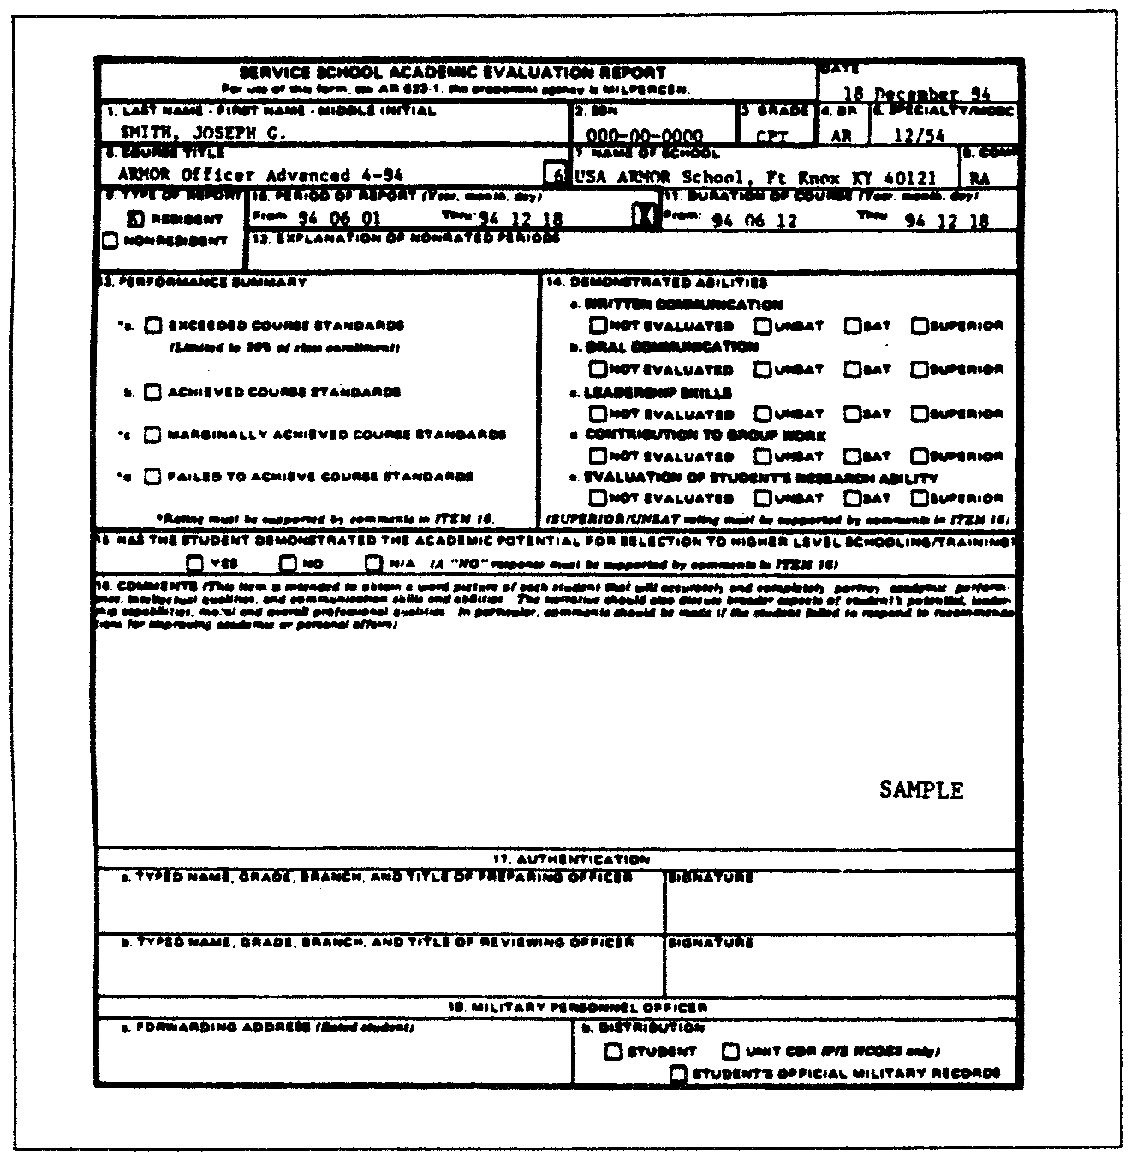

Figure 5-11. DA Form 1059.

5-55 QM3517

LESSON 5

PRACTICE EXERCISE

The following items will test your grasp of the material covered in this lesson. There is only one correct answer for each item. When you complete the exercise, check your answers with the answer key that follows. If you answer any item incorrectly, study again that part of the lesson which contains the portion involved.

Situation: You are a staff officer evaluating an officer using DA Form 67-8. Use this situation to answer questions 1 through 8.

1. What is the design purpose of the OERS?

A. To provide supervisors a useful tool for counseling and advising subordinates.
B. To provide a continuous measure of an officer's overall value to the service.
C. To ensure that you have covered all periods of an officer's service by some type of evaluation report.
D. To develop composite scores for screening and segregating a manageable number of records for detailed analysis and study.

2. The three kinds of evaluations given under the OES are

A. duty, school, and DA.
B. equipment, school, and DOD.
C. promotion, training, and elimination.
D. promotion, retention, and training.

3. Who initiates the DA Form 67-8?

A. Your unit.
B. The MPD.
C. The PSC.
D. MILPERCEN.

4. Who must be at least an MAJ?

A. The rater.
B. The intermediate rater.
C. The senior rater.
D. The reviewer.

QM3517 5-56

5. A rated officer is preparing DA Form 67-8-1. He prepares

A. one copy.
B. two copies.
C. three copies.
D. four copies.

6. A requirement that is associated with the rating communication process is that the rated officer is responsible for discussing his

A. duty description and major performance objectives.
B. career development and personal problems.
C. good points and performance of duty.
D. duty obligations and potential for improvement.

7. What is the minimum rating period with regard to DA Form 67-8?

A. 30 days.
B. 90 days.
C. One training year.
D. One school term.

8. In Part VII of DA Form 67-8, the senior rater evaluates the rated officer's

A. duty performance.
B. leadership qualities.
C. potential.
D. career problems.

5-57 QM3517

LESSON 5

PRACTICE EXERCISE

ANSWER KEY AND FEEDBACK

Item Correct Answer and Feedback

1. b. To provide a continuous measure of an officer’s overall value to the service.

The Army designed the OERS to provide a continuous measure of the officer’s overall value to the service. Individual reports provide specific information on performance in a certain duty position during a specific time.
(page 5-3, para 1b)

2. A. Duty, school, and DA.

Under the OES, you evaluate an officer on his performance and potential by these three kinds of evaluations.
(page 5-4, para 2b)

3. C. The PSC.

The field PSC initiates DA Form 67-8 by sending the rated officer a partially completed DA Form 67-8, and DA Form 67-8-1. (The rated officer is responsible for initiating his support form.) (page 5-8, para 4)

4. C. The senior rater.

To be assigned as the senior rater, an officer normally must be at least an MAJ, in the line of supervision, two grades higher than the rated officer, and in the position for at least 60 days. (page 5-13, para 8d)

5. A. One copy.

At the start of each rating period, he prepares a single copy of DA Form 67-8-1. The rater and the rated officer develop a working copy together. (page 5-17, para 1a)

QM3517 5-58

6. A. duty description and major performance objectives.

He discusses this with his rater within the first 30 days after the beginning of the rating period. At the end of the rating period, he reviews the duty description section, the major performance objectives section, and the significant contributions section of DA Form 67-8. (page 5-22, para 2)

7. B. 90 days.

The minimum rating period is 90 calendar days.
(page 5-26, para 1c(1))

8. C. potential.

This evaluation, along with other aspects of the report, tells the Army how well the rated officer has done his job.
(page 5-51, para 10)

5-59 QM3517

